Assignment 1

**Course**: WEB322

**Instructor**: Kadeem Best

**Name**: Minsu Kim

**Student** **ID**:141134189

**Due** **Date**: Thursday, Feb 13, 2020

**Contents**

1. Home---------------------------------------------------------------------------------
   1. Functionality
   2. Header
   3. Navigation Bar
   4. Footer
   5. Promotional Section
   6. Product Category Section
   7. Best Seller Section
2. Product Page------------------------------------------------------------------------
   1. Functionality
   2. Design
3. Customer Registration/ Login----------------------------------------------------
   1. Functionality
   2. Design
4. 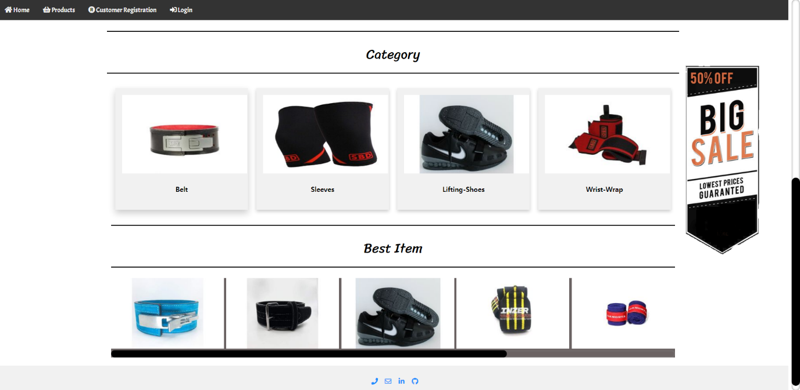**Home**
   1. Functionality
      1. In the main page, main layout of HTML that can be reused different views of the others. Placeholder called {{{body}}} where main content should be rendered.
   2. Header
      1. In the main.handlebar created header with logo and title. With CSS managed background property for better header design.
   3. Navigation Bar
      1. Designed with navigation bar, with <a> and href attributes for linking rendering template file
   4. Promotional Section
      1. Insert banner image in side <div> box
   5. Product Category Section
      1. Inserting static data from database into a template with helper of iteration
      2. Create a display for a product view with cards done with CSS
   6. Best Seller Section
      1. Having functionality accomplished JavaScript that only shows the static data from the product database that has Boolean bestseller class id “yes ”. Otherwise, hide data that has Boolean bestseller class id “no”.
      2. Create a horizontal scroll bar with CSS and inserting bestseller product cards inside of the div box. ‘
   7. Footer
      1. Create footer includes contact information with icon from FontAwesome.
5. 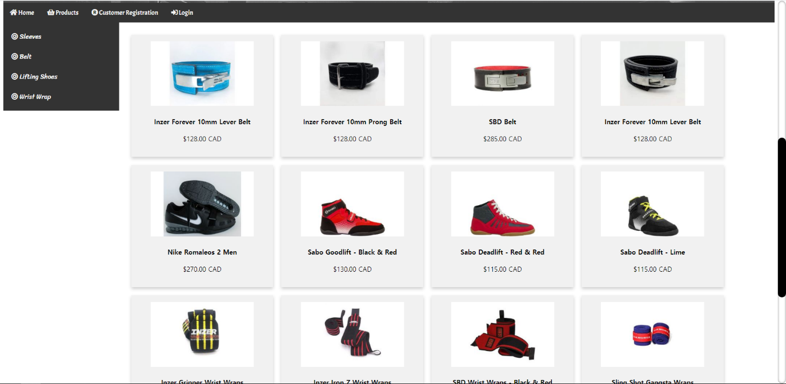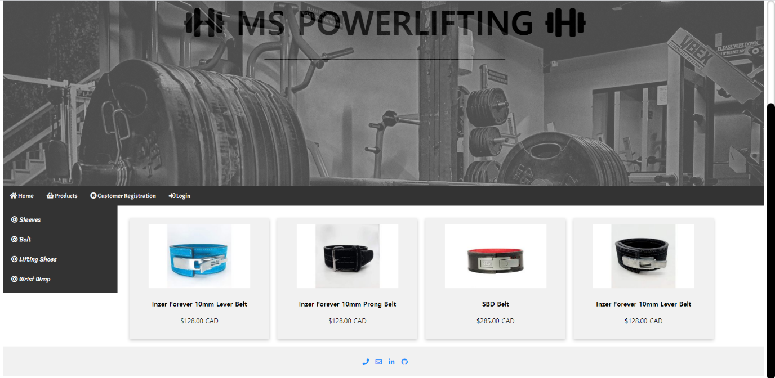**Product Page**
6. Functionality
7. Inserting static data from database into a template with helper of iteration
8. Add functionality with query and type. On side navigation bar has 4 categories of products. In href attribute made query type and made function with JavaScript with one argument. When the user clicks one of the categories in the navigation bar. It only shows the selected category.
9. Design
10. Create side navigation bar with four categories.
11. Fetched cards from static database.
12. 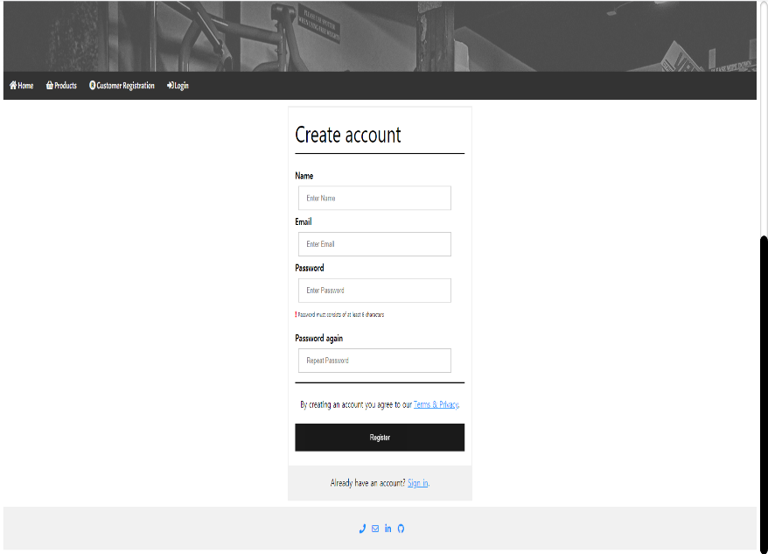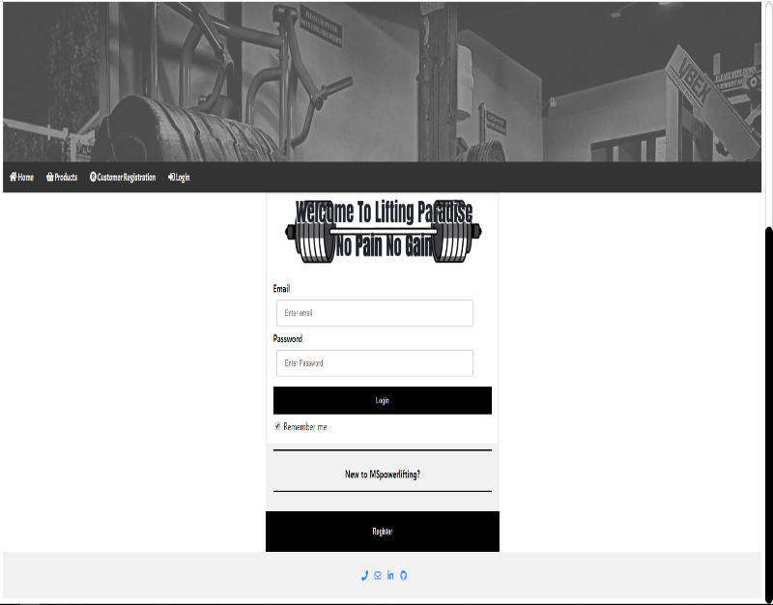**Customer Registration/Login**
    1. Functionality
       1. Create form with POST method because of security aspect and with validation that user has to fill in every blank box.
       2. Allows to user click sign-in button that link to login page, in case of user already has an account.
       3. Allows to user click register button that link to registration page, in case of user does not have an account