CS 300 - Project One
Monica Kim
October 11, 2026

Overview
The purpose of this program is to help academic advisors at ABC University (ABCU) access computer science course information. The program will read course data from a file, store course numbers, names, and prerequisites, and allow advisors to view all courses in alphanumeric order or search for a specific course. I will compare three data structures: vector, hash table, and binary search tree, to determine which would work best for the program.
- Course Structure and File Validation
The same course information will be stored in each data structure.
DEFINE STRUCTURE Course
courseNumber
courseName
prerequisites as a list
END STRUCTURE
FUNCTION readCourseFile(fileName)
CREATE an empty list called courseData

OPEN the course file

IF the file cannot be opened
DISPLAY "Error: File could not be opened"
RETURN failure
END IF

WHILE there are lines remaining in the file

READ the next line
SPLIT the line using commas

IF there are fewer than 2 values
DISPLAY "Error: Invalid file format"
CLOSE the file
RETURN failure
END IF

IF courseNumber or courseName is empty
DISPLAY "Error: Missing course information"
CLOSE the file
RETURN failure
END IF

CREATE a new Course object

SET Course.courseNumber to the first value
SET Course.courseName to the second value
SET Course.prerequisites to an empty list

FOR each remaining value
ADD the value to Course.prerequisites
END FOR

ADD Course to courseData

END WHILE

CLOSE the file

FOR each Course in courseData

CHECK that courseNumber is not duplicated

IF a duplicate courseNumber exists
DISPLAY "Error: Duplicate course number"
RETURN failure
END IF

FOR each prerequisite in Course.prerequisites

SEARCH courseData for a matching courseNumber

IF no matching courseNumber exists
DISPLAY "Error: Prerequisite course does not exist"
RETURN failure
END IF

END FOR

END FOR

RETURN courseData
END FUNCTION
- Pseudocode for Vector Data Structure
FUNCTION loadVector(fileName)
SET courseData = readCourseFile(fileName)

IF reading failed
RETURN failure
END IF

CREATE an empty vector called courses

FOR each Course in courseData
ADD Course to the courses vector
END FOR

RETURN courses
END FUNCTION
FUNCTION searchVector(courses, courseNumber)
FOR each Course in courses

IF Course.courseNumber equals courseNumber
RETURN Course
END IF

END FOR

RETURN not found
END FUNCTION
FUNCTION printVectorCourses(courses)
COPY courses into sortedCourses

CALL quickSort(sortedCourses, 0, size - 1)

FOR each Course in sortedCourses
DISPLAY Course.courseNumber
DISPLAY Course.courseName
END FOR
END FUNCTION
FUNCTION quickSort(courses, low, high)
IF low is greater than or equal to high
RETURN
END IF

SELECT a pivot courseNumber

PARTITION courses so smaller courseNumbers are before the pivot and larger courseNumbers are after it

CALL quickSort for the left portion
CALL quickSort for the right portion
END FUNCTION
- Pseudocode for Hash Table Data Structure
FUNCTION loadHashTable(fileName)
SET courseData = readCourseFile(fileName)

IF reading failed
RETURN failure
END IF

CREATE an empty hash table

FOR each Course in courseData

CREATE a hash key using Course.courseNumber

INSERT Course into the correct hash table bucket

IF a collision occurs
STORE the Course using collision handling
END IF

END FOR

RETURN hashTable
END FUNCTION
FUNCTION searchHashTable(hashTable, courseNumber)
CREATE a hash key using courseNumber

SEARCH the matching hash table bucket

IF courseNumber is found
RETURN Course
ELSE
RETURN not found
END IF
END FUNCTION
FUNCTION printHashTableCourses(hashTable)
CREATE an empty vector called sortedCourses

FOR each bucket in hashTable

FOR each Course in the bucket
ADD Course to sortedCourses
END FOR

END FOR

CALL quickSort(sortedCourses, 0, size - 1)

FOR each Course in sortedCourses
DISPLAY Course.courseNumber
DISPLAY Course.courseName
END FOR
END FUNCTION
- Pseudocode for Binary Search Tree Data Structure
FUNCTION loadBinarySearchTree(fileName)
SET courseData = readCourseFile(fileName)

IF reading failed
RETURN failure
END IF

CREATE an empty binary search tree

FOR each Course in courseData
CALL insertCourse(binarySearchTree, Course)
END FOR

RETURN binarySearchTree
END FUNCTION
FUNCTION insertCourse(binarySearchTree, Course)
IF the tree is empty
CREATE a new node containing Course
SET the new node as root
RETURN
END IF

SET currentNode to root

WHILE currentNode is not empty

IF Course.courseNumber is less than currentNode.courseNumber

IF the left child is empty
INSERT Course as the left child
RETURN
ELSE
MOVE to the left child
END IF

ELSE IF Course.courseNumber is greater than currentNode.courseNumber

IF the right child is empty
INSERT Course as the right child
RETURN
ELSE
MOVE to the right child
END IF

ELSE
DISPLAY "Error: Duplicate course number"
RETURN
END IF

END WHILE
END FUNCTION
FUNCTION searchBinarySearchTree(binarySearchTree, courseNumber)
SET currentNode to root

WHILE currentNode is not empty

IF courseNumber equals currentNode.courseNumber
RETURN currentNode.Course

ELSE IF courseNumber is less than currentNode.courseNumber
MOVE to the left child

ELSE
MOVE to the right child
END IF

END WHILE

RETURN not found
END FUNCTION
FUNCTION printTreeCourses(binarySearchTree)
CALL printInOrder(root)
END FUNCTION
FUNCTION printInOrder(currentNode)
IF currentNode is empty
RETURN
END IF

CALL printInOrder(currentNode.left)

DISPLAY currentNode.courseNumber
DISPLAY currentNode.courseName

CALL printInOrder(currentNode.right)
END FUNCTION
- Pseudocode for Course Info and Prerequisites
FUNCTION printCourseInformation(dataStructure, courseNumber)
SEARCH the selected dataStructure for courseNumber

IF Course is not found
DISPLAY "Course not found"
RETURN
END IF

DISPLAY Course.courseNumber
DISPLAY Course.courseName

IF Course.prerequisites is empty
DISPLAY "Prerequisites: None"

ELSE
DISPLAY "Prerequisites:"

FOR each prerequisite in Course.prerequisites

SEARCH the dataStructure for the prerequisite courseNumber

IF prerequisite Course is found
DISPLAY prerequisite Course.courseNumber
DISPLAY prerequisite Course.courseName
END IF

END FOR

END IF
END FUNCTION
- Pseudocode for Main Menu
FUNCTION main()
CREATE an empty dataStructure

SET coursesLoaded to false
SET choice to 0

WHILE choice does not equal 4

DISPLAY "1. Load Course Data"
DISPLAY "2. Print Course List"
DISPLAY "3. Print Course Information"
DISPLAY "4. Exit"

GET user choice

IF choice equals 1

ASK user for fileName

CALL the appropriate load function

IF loading was successful
SET coursesLoaded to true
DISPLAY "Courses loaded successfully"
ELSE
DISPLAY "Unable to load courses"
END IF

ELSE IF choice equals 2

IF coursesLoaded is true
CALL the appropriate printCourses function
ELSE
DISPLAY "Please load course data first"
END IF

ELSE IF choice equals 3

IF coursesLoaded is true
ASK user for courseNumber
CALL printCourseInformation(dataStructure, courseNumber)
ELSE
DISPLAY "Please load course data first"
END IF

ELSE IF choice equals 4

DISPLAY "Thank you for using the ABCU Course Advisor"

ELSE

DISPLAY "Invalid menu option"

END IF

END WHILE
END FUNCTION
- Big O Runtime and Memory Analysis
For the runtime analysis, n represents the number of courses, and p represents the total number of prerequisite references. Each line that performs a simple assignment, comparison, or display has a cost of O(1). Loops and function calls depend on how many times they execute.

Runtime Cost Analysis
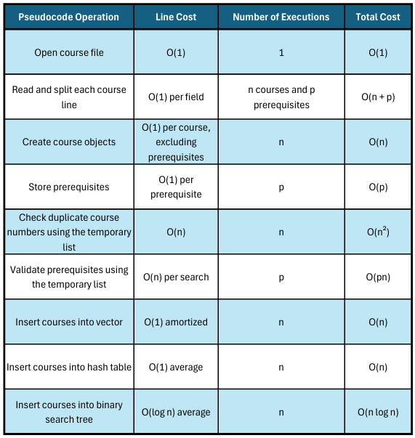
The file-reading and validation process has a runtime of O(n² + pn) because the temporary list is searched repeatedly for duplicate course numbers and prerequisites. This is shared by all three data structures in the pseudocode above.
After validation, the efficiency of the insertion process depends on the selected data structure. Vector insertion is O(1) amortized per course, hash table insertion is O(1) on average, and binary search tree insertion is O(log n) on average when reasonably balanced.

Data Structure Performance Comparison
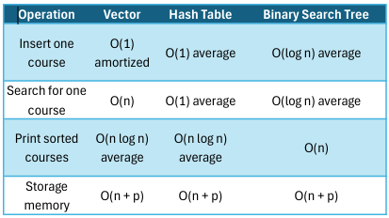
The vector is efficient for adding records, but searching requires checking courses one at a time. The hash table offers the fastest average search time, although collisions can slow it down. The binary search tree provides efficient searching when reasonably balanced and uses an in-order traversal to display courses in order.
All three data structures require O(n + p) memory to store the course records and prerequisites. The hash table also requires space for its buckets, while the binary search tree needs extra pointers for each node. Sorting a copied vector requires additional temporary memory. The file-loading process also uses a temporary course list, increasing peak memory usage.
An ordinary binary search tree may become unbalanced. In that situation, searching and inserting can take O(n) per operation rather than O(log n).
- Advantages and Disadvantages of Each Data Structure
Vector
The biggest advantage of using a vector is that it is easy to understand and implement. Courses can be added to the end of the vector efficiently, and all the information is stored together. However, finding a specific course can take longer because the program may have to search through every course. The vector also requires sorting before displaying the courses in alphanumeric order.
Hash Table
A hash table is useful because searching for a specific course is very fast on average. This would be helpful for academic advisors who regularly look up course information and prerequisites. However, hash tables do not automatically keep courses in order. The program would need to copy the information into another structure and sort it before printing the complete course list. Hash collisions can also affect performance.
Binary Search Tree
A binary search tree stores course information based on course numbers, allowing the program to move left or right when searching. This makes searching efficient when the tree is reasonably balanced. Another advantage is that an in-order traversal prints the courses in alphanumeric order without an additional sorting algorithm. However, a regular binary search tree can become unbalanced if courses are inserted in a certain order, which can make searching slower.
- Final Recommendation
After comparing all three data structures, I would recommend using a binary search tree for ABC University.
The academic advisors have two main requirements: they need to display all computer science courses in alphanumeric order, and they need to search for individual courses and their prerequisites. A binary search tree handles both tasks effectively because it organizes the course information by course number.
One of the biggest reasons I would choose the binary search tree is its ability to print the courses in order using an in-order traversal. Unlike a vector or hash table, the binary search tree does not require an additional sorting step. This makes displaying the complete course list more straightforward.
A hash table would be faster for individual course searches on average, but it would require extra processing to display the courses in order. A vector would be easier to implement, but its O(n) search time makes it less efficient as the number of courses increases.
The binary search tree offers a good balance between searching and displaying sorted course information. Its average search time is O(log n) when reasonably balanced, and an in-order traversal runs in O(n) time. If ABCU expands its course offerings, using a self-balancing binary search tree would help maintain that performance.
Overall, I believe the binary search tree is the best option for ABCU because it directly supports the advisors' requirements while keeping the course information organized and accessible.

