CS 300 – Project One: Runtime and Memory Analysis

- Big O Runtime and Memory Analysis
For the runtime analysis, n represents the number of courses, and p represents the total number of prerequisite references. Each line that performs a simple assignment, comparison, or display has a cost of O(1). Loops and function calls depend on how many times they execute.
Runtime Cost Analysis
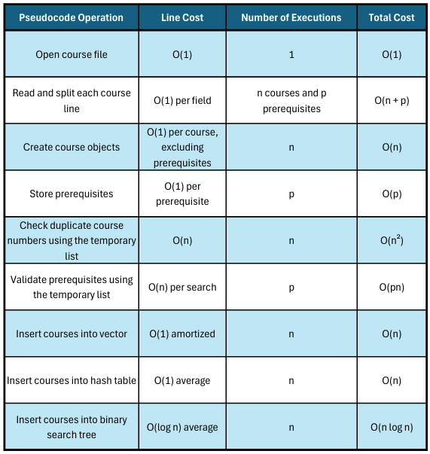
The file-reading and validation process has a runtime of O(n² + pn) because the temporary list is searched repeatedly for duplicate course numbers and prerequisites. This is shared by all three data structures in the pseudocode from Project One.
After validation, the efficiency of the insertion process depends on the selected data structure. Vector insertion is O(1) amortized per course, hash table insertion is O(1) on average, and binary search tree insertion is O(log n) on average when reasonably balanced.
Data Structure Performance Comparison
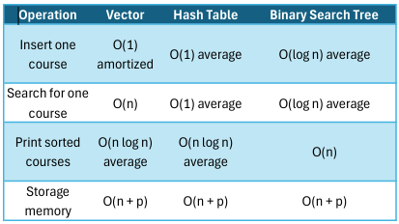
The vector is efficient for adding records, but searching requires checking courses one at a time. The hash table offers the fastest average search time, although collisions can slow it down. The binary search tree provides efficient searching when reasonably balanced and uses an in-order traversal to display courses in order.
All three data structures require O(n + p) memory to store the course records and prerequisites. The hash table also requires space for its buckets, while the binary search tree needs extra pointers for each node. Sorting a copied vector requires additional temporary memory. The file-loading process also uses a temporary course list, increasing peak memory usage.
An ordinary binary search tree may become unbalanced. In that situation, searching and inserting can take O(n) per operation rather than O(log n).
- Advantages and Disadvantages of Each Data Structure
Vector
The biggest advantage of using a vector is that it is easy to understand and implement. Courses can be added to the end of the vector efficiently, and all the information is stored together. However, finding a specific course can take longer because the program may have to search through every course. The vector also requires sorting before displaying the courses in alphanumeric order.
Hash Table
A hash table is useful because searching for a specific course is very fast on average. This would be helpful for academic advisors who regularly look up course information and prerequisites. However, hash tables do not automatically keep courses in order. The program would need to copy the information into another structure and sort it before printing the complete course list. Hash collisions can also affect performance.
Binary Search Tree
A binary search tree stores course information based on course numbers, allowing the program to move left or right when searching. This makes searching efficient when the tree is reasonably balanced. Another advantage is that an in-order traversal prints the courses in alphanumeric order without an additional sorting algorithm. However, a regular binary search tree can become unbalanced if courses are inserted in a certain order, which can make searching slower.
- Final Recommendation
After comparing all three data structures, I would recommend using a binary search tree for ABC University.
The academic advisors have two main requirements: they need to display all computer science courses in alphanumeric order, and they need to search for individual courses and their prerequisites. A binary search tree handles both tasks effectively because it organizes the course information by course number.
One of the biggest reasons I would choose the binary search tree is its ability to print the courses in order using an in-order traversal. Unlike a vector or hash table, the binary search tree does not require an additional sorting step. This makes displaying the complete course list more straightforward.
A hash table would be faster for individual course searches on average, but it would require extra processing to display the courses in order. A vector would be easier to implement, but its O(n) search time makes it less efficient as the number of courses increases.
The binary search tree offers a good balance between searching and displaying sorted course information. Its average search time is O(log n) when reasonably balanced, and an in-order traversal runs in O(n) time. If ABCU expands its course offerings, using a self-balancing binary search tree would help maintain that performance.
Overall, I believe the binary search tree is the best option for ABCU because it directly supports the advisors' requirements while keeping the course information organized and accessible.

