Original database diagram:
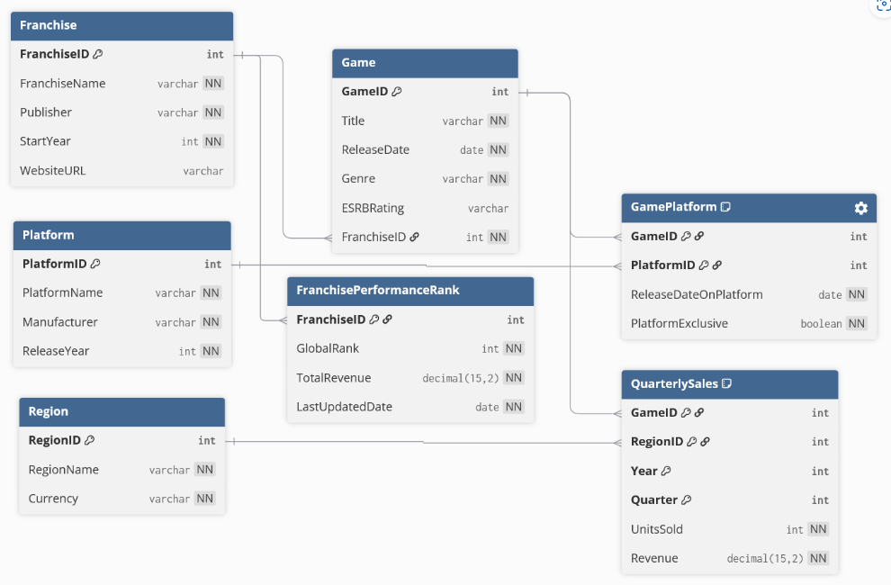
database_er.md, linked below.
https://github.com/mking8329/Mking_COP3710_VideoGameProject/blob/486116929a0d0da2940ac841292adcb2ec91d871/database_er.md

Table |  | BCNF status
Franchise | Key: FranchiseID  Dependencies:  - FranchiseID  - FranchiseName  - Publisher  - StartYear  - WebsiteURL | In BCNF, as
Platform | Key: PlatformID  Dependencies:  - PlatformName  - Manufacturer  - ReleaseYear | In BCNF
Region | Key: RegionID  Dependencies:  - RegionName  - Currency | In BCNF
Game | Key: GameID  Dependencies:  - Title  - ReleaseDate  - Genre  - ESRBRating  - FranchiseID | In BCNF
Game Platform | Key: GameID, PlatformID  Dependencies:  - ReleaseDateOnPlatform  - PlatformExclusive | In BCNF
Quarterly Sales | Key: GameID, RegionID, Year, Quarter  Dependencies:  - UnitsSold  - Revenue | In BCNF
Franchise  Performance  Rank | Key: FranchiseID  Dependencies:  - GlobalRank  - TotalRevenue  - LastUpdatedDate | In BCNF

Database is already in BCNF. Every table has a defined key, which all non-keys depend on, and no partial or transitive dependencies exist.
Code for implementing database.
--Franchise
CREATE TABLE Franchise (
FranchiseID NUMBER GENERATED BY DEFAULT AS IDENTITY,
FranchiseName VARCHAR2(150) NOT NULL,
Publisher VARCHAR2(150) NOT NULL,
StartYear NUMBER(4) NOT NULL,
WebsiteURL VARCHAR2(255),
CONSTRAINT PK_Franchise PRIMARY KEY (FranchiseID),
CONSTRAINT UQ_Franchise_Name UNIQUE (FranchiseName),
CONSTRAINT CK_Franchise_StartYear CHECK (StartYear >= 1950)
);

--Platform
CREATE TABLE Platform (
PlatformID NUMBER GENERATED BY DEFAULT AS IDENTITY,
PlatformName VARCHAR2(100) NOT NULL,
Manufacturer VARCHAR2(100) NOT NULL,
ReleaseYear NUMBER(4) NOT NULL,
CONSTRAINT PK_Platform PRIMARY KEY (PlatformID),
CONSTRAINT UQ_Platform_Name UNIQUE (PlatformName),
CONSTRAINT CK_Platform_Year CHECK (ReleaseYear >= 1970)
);

--Region
CREATE TABLE Region (
RegionID NUMBER GENERATED BY DEFAULT AS IDENTITY,
RegionName VARCHAR2(100) NOT NULL,
Currency VARCHAR2(50) NOT NULL,
CONSTRAINT PK_Region PRIMARY KEY (RegionID),
CONSTRAINT UQ_Region_Name UNIQUE (RegionName)
);

--Game
CREATE TABLE Game (
GameID NUMBER GENERATED BY DEFAULT AS IDENTITY,
Title VARCHAR2(200) NOT NULL,
ReleaseDate DATE NOT NULL,
Genre VARCHAR2(100) NOT NULL,
ESRBRating VARCHAR2(10),
FranchiseID NUMBER NOT NULL,
CONSTRAINT PK_Game PRIMARY KEY (GameID),
CONSTRAINT FK_Game_Franchise
FOREIGN KEY (FranchiseID)
REFERENCES Franchise(FranchiseID)
ON DELETE CASCADE
);

--GamePlatform (Junction Table)
CREATE TABLE GamePlatform (
GameID NUMBER NOT NULL,
PlatformID NUMBER NOT NULL,
ReleaseDateOnPlatform DATE NOT NULL,
PlatformExclusive NUMBER(1) DEFAULT 0 NOT NULL,
CONSTRAINT PK_GamePlatform PRIMARY KEY (GameID, PlatformID),
CONSTRAINT FK_GP_Game
FOREIGN KEY (GameID)
REFERENCES Game(GameID)
ON DELETE CASCADE,
CONSTRAINT FK_GP_Platform
FOREIGN KEY (PlatformID)
REFERENCES Platform(PlatformID)
ON DELETE CASCADE,
CONSTRAINT CK_GP_Exclusive CHECK (PlatformExclusive IN (0,1))
);

--QuarterlySales
CREATE TABLE QuarterlySales (
GameID NUMBER NOT NULL,
RegionID NUMBER NOT NULL,
Year NUMBER(4) NOT NULL,
Quarter NUMBER(1) NOT NULL,
UnitsSold NUMBER NOT NULL,
Revenue NUMBER(15,2) NOT NULL,
CONSTRAINT PK_QuarterlySales
PRIMARY KEY (GameID, RegionID, Year, Quarter),
CONSTRAINT FK_QS_Game
FOREIGN KEY (GameID)
REFERENCES Game(GameID)
ON DELETE CASCADE,
CONSTRAINT FK_QS_Region
FOREIGN KEY (RegionID)
REFERENCES Region(RegionID)
ON DELETE CASCADE,
CONSTRAINT CK_QS_Quarter CHECK (Quarter BETWEEN 1 AND 4),
CONSTRAINT CK_QS_Units CHECK (UnitsSold >= 0),
CONSTRAINT CK_QS_Revenue CHECK (Revenue >= 0)
);

--FranchisePerformanceRank
CREATE TABLE FranchisePerformanceRank (
FranchiseID NUMBER NOT NULL,
GlobalRank NUMBER NOT NULL,
TotalRevenue NUMBER(15,2) NOT NULL,
LastUpdatedDate DATE NOT NULL,
CONSTRAINT PK_FranchisePerformanceRank PRIMARY KEY (FranchiseID),
CONSTRAINT FK_FPR_Franchise
FOREIGN KEY (FranchiseID)
REFERENCES Franchise(FranchiseID)
ON DELETE CASCADE,
CONSTRAINT CK_FPR_Rank CHECK (GlobalRank > 0),
CONSTRAINT CK_FPR_Revenue CHECK (TotalRevenue >= 0)
);

Tables after running the code.

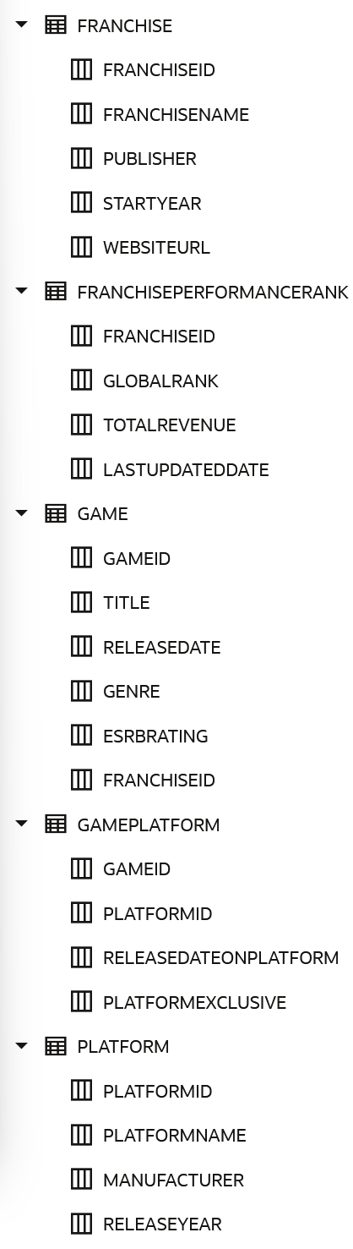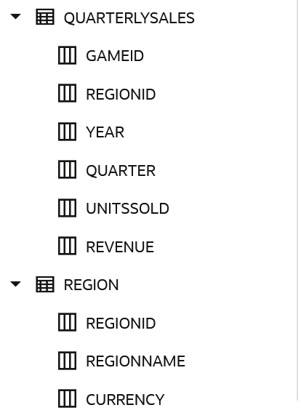

Sample Data [Not final, just for demonstration.]
