Button A to decrease sensitivity to noise

Button B to increase sensitivity to noise
(if really loud, press this a few times until the lights do not flash)
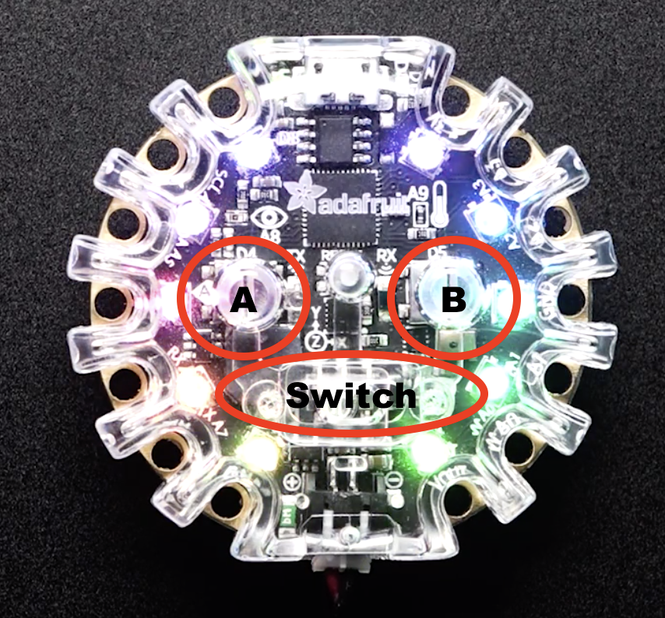

Switch to the left for loudness to trigger LED lights

Switch to the right for constant LED lights

