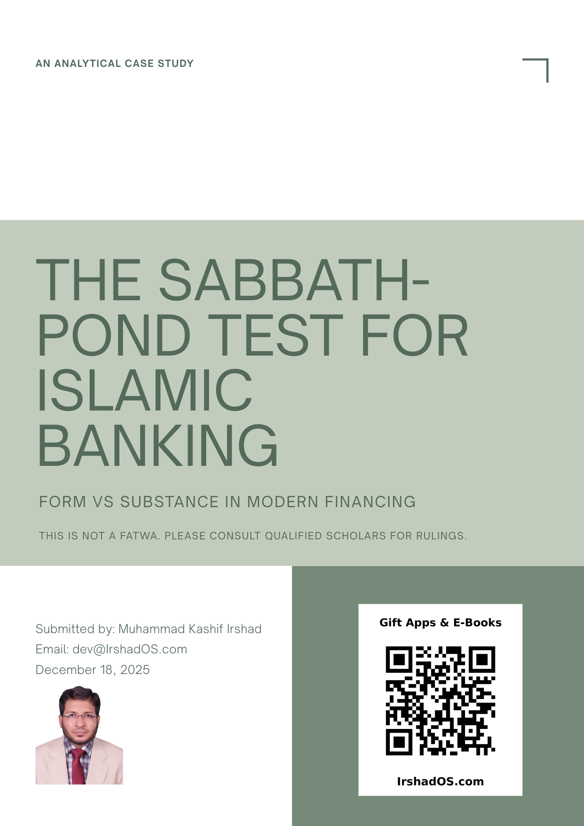

1) Why this booklet exists
Some people hear “Islamic Banking” and assume the entire system is automatically free of riba. Others feel the opposite: it is conventional interest wearing Islamic terminology. This booklet is meant to make the actual problem visible, so discussion becomes honest, not emotional.

2) The core question (reframed clearly)
Here is the question, tightened into a public-facing form that a reader (and a bank officer) can answer precisely:
- If a financing deal gives cash today and takes back more cash tomorrow with a fixed schedule and collateral, what makes it non-riba in substance?
- If the deal is broken into multiple agreements (sale + lease + promises + unit purchases), is this a real difference — or a Sabbath-style workaround where each piece looks “halal” alone, but the combined outcome is still the prohibited outcome?
- In home financing / asset financing: when does ownership actually transfer — at the beginning, gradually, or only at the end? Who bears real ownership risk during the term?
- What were the practical welfare pathways in the Prophetic society and early Islamic governance (risk-sharing, public welfare, interest-free support), and how do they differ from “debt with a halal label”?

3) What Meezan Bank eBooks say (summary of IslamicBanking.txt)
Source note: IslamicBanking.txt is taken from Meezan Bank eBooks / Meezan Bank online sources.

3.1 The riba problem (as defined in the text)
A key framing presented is: riba in loans is an extra amount that is pre-fixed and conditional on time — money is lent, and a predetermined addition is taken back because time passed. So the issue isn’t “profit” as a concept; the issue is a guaranteed increase attached to a loan.

3.2 What Islamic banking claims to replace it with
The text presents Islamic finance as using contracts other than interest-bearing loans, such as:
- Profit-and-loss sharing: Musharakah and Mudarabah
- Trade-based modes: e.g., Murabahah (cost-plus sale)
- Leasing-based modes: Ijarah (rent for usufruct of an owned asset)
- Modern structures: Sukuk, investment funds, securitization — with emphasis that compliance depends on real ownership and real risk, not just forms

3.3 A “spirit” example inside the text (important)
The text includes a microfinance-style concept where depositors’ funds go into a Musharakah/Mudarabah pool, profits are shared, and the risk is borne by the pool/depositors (not magically guaranteed), while the bank earns as mudarib. That’s close to the real Islamic finance ethos: returns tied to enterprise activity and shared risk — not “rent on money as money.”

4) The Sabbath (Sabat) story in the Qur’an — and why it matters here (Tafheem-ul-Quran)
Project-file reference: Tafheemul Quran 1–6 (discussion of Ashab al-Sabt; see Qur’an 7:163 and 2:65).

4.1 What the Qur’an narrates (the coastal-town test)
The Qur’an mentions a community from Bani Israel living near the sea. They were commanded to treat Saturday (Sabat) as a sacred boundary — a day set apart from worldly earning and hunting. Allah tested them in a very specific way: on Saturdays, fish would appear openly and abundantly near the shore; on other days, fish would not appear in that same tempting way.

4.2 The “Sabbath pond” workaround (the trick that looks lawful in parts)
Tafheem-ul-Quran explains the key move that made this incident famous: instead of openly breaking the command, some people engineered a workaround by splitting one prohibited reality into multiple “separately defensible” steps. In plain language: they dug side-channels/side-ponds or set traps so fish would enter and get secured on Saturday, then they collected the fish on Sunday and argued, “We didn’t fish on Saturday — we only collected later.”

4.3 How the Qur’an frames the real sin (form vs substance)
The moral point is not the pond; it is the mindset: treating Allah’s command like a puzzle to beat. Changing the label while preserving the prohibited outcome is exactly what makes this story a warning for later people.

4.4 The Sabbath-Pond Test (applied to Islamic banking)
So the Sabbath-Pond Test for Islamic banking is simple:
- If Islamic finance genuinely changes the economic reality into trade/lease/partnership with real ownership and real risk, then it is not the same thing as interest.
- But if the economic reality remains “cash now, more cash later, fixed and secured,” and only the paperwork is divided into multiple contracts so each part looks defensible, then it risks becoming a Sabbath-pond style workaround.
Definition: If you cannot explain the transaction as a real trade/lease/partnership without smuggling in a guaranteed rent on money (just redistributed across contracts), the structure is suspect — even if the documents look Islamic.

5) The tension shows up inside the same Meezan source (this matters)

5.1 “Mark-up” can become renaming
The Meezan-sourced text itself warns that “mark-up” can become only a change of name if it merely substitutes an interest-bearing loan in substance.

5.2 Murabahah can be misused as a loan substitute
It also notes that Murabahah (a legitimate sale concept) is often used as a substitute for interest-based financing, and this is why Islamic modes are criticized — because the mode is used as a device to earn interest without calling it interest.

6) Your core case study: mortgage → money → more money → property back

6.1 “Is sale + rent + buy-back just interest in pieces?”
Let’s strip emotion and write the economic story:
- A person needs a house / cash.
- A financier provides funds.
- The person pays back more than received, over time.
- The asset is tied up until payments end.
In a conventional loan: this is principal + interest, secured by collateral. In some Islamic banking structures: it is described using multiple contracts: “sale” to bank + “lease” back (rent) + “purchase back” later (often gradually).
Your challenge in one sentence: If all these steps are designed so the financier ends up with a guaranteed increase tied to time, and the asset is just a legal wrapper, then we’re back to the same prohibited reality — just divided into halal-looking parts.

7) The ownership question you asked (the heart of it)
You asked: “When does the purchase happen — at the beginning when rent/installments start, or at the end after all installments?”

7.1 Two different stories banks may tell (and they are NOT the same)
A) Lease-to-own story: bank owns during term; customer pays rent; ownership transfers at the end via a separate mechanism.
B) Diminishing partnership story: co-ownership from day 1; rent only for bank’s remaining share; customer buys bank’s share gradually; ownership transfers gradually.
If a product claims story (B) but behaves like story (A) or like a secured loan, that’s where the Sabbath-pond concern hits hard.

7.2 The Meezan-source “reality check” principle: real ownership and real risk
A strong compliance principle repeated in Islamic finance literature is: if an arrangement does not represent real ownership and instead only gives a right to receive rentals like a debt claim, it is not Shariah-compliant. So if the bank claims ownership but does not carry ownership risk and the arrangement behaves like “debt + rent-stream,” you have a serious substance problem.

8) A practical checklist (so the public can detect “Sabbath-pond structuring”)
Ask the bank these questions. If answers are vague, that vagueness is itself a signal.

Ownership & risk
- During the term, who is the real owner in a meaningful sense — not just on paper?
- If the asset is destroyed (fire/flood), who bears what?
- Who bears ownership liabilities that normally sit with an owner?

Rent vs “interest in disguise”
- Is rent calculated based on real usufruct + bank’s real share, or mainly benchmarked to money-time?
- If you pay early, does the bank’s total take reduce naturally (as real sale/lease logic would), or does it behave like a fixed interest schedule?

Penalties & guarantees
- Are late-payment penalties treated as income for the bank (major red flag), or handled in a Shariah-restricted way?
- Is the bank’s profit essentially guaranteed no matter what, or is there genuine exposure?

Substance
- If I describe this deal honestly to a normal person, is it: “We jointly bought a house; you rent my share; you buy me out” — or “I gave you money; you will return more money; house is security”?
- If the honest description is the second, the contract stack is at risk of being a workaround.

9) “If this workaround was valid, the Prophet ﷺ would have taught it”
Your argument: the Prophet ﷺ didn’t teach a way to keep the same loan outcome by renaming interest into a sale+rent+buy-back stack. Instead, riba was prohibited clearly and lawful welfare pathways were used. The real question remains: are we using Islamic contracts to do real trade/lease/partnership — or to replicate the loan outcome while escaping the label?

10) Practical welfare pathways (what “real” alternatives look like)

10.1 Risk-sharing finance (not debt replication)
Musharakah / Mudarabah: capital meets enterprise; profit is shared; loss follows rules. This naturally avoids guaranteed rent on money.

10.2 Real-asset leasing (with real ownership risk)
Ijarah becomes meaningful when ownership is real and risk is not dumped fully onto the user.

10.3 Social safety and public welfare
Zakat-based support, waqf-type structures, interest-free support (qard hasan), and public funds that keep people out of debt traps.

11) Conclusion: what this booklet is actually asking for
This is not a “hate Islamic banking” booklet. It’s a transparency and substance booklet. Don’t slice a prohibited outcome into document-friendly pieces. Don’t sell people a label; show them the economic reality. If it’s trade, show real trade. If it’s lease, show real lease. If it’s partnership, show real partnership.

References inside our current project space (names only)
- Meezan Bank eBooks / Meezan online sources: IslamicBanking.txt (the challenged text source).
- Project library (old works available here): Ahkam-ul-Quran (Urdu) Vol 1–6; Tafheemul Quran 1–6; Ihya Ulum al-Din 1–4; Kitab al-Amwal; Kitab al-Kharaj; Mishkat.

