Process Description:

"Bleedthrough" is when the fluorophore from one channel contributes to the intensity in another channel, due to spectral overlap or imperfect filtering. With single-chain (intramolecular) biosensors, the localization of the fluorophores in each channel is always identical, so the bleedthrough contribution is automatically canceled out during the ratioing step. With dual-chain (intermolecular) biosensors, the localization is almost always at least slightly different for the two fluorophores, meaning that bleedthrough must be corrected. This is accomplished by determining bleedthrough coefficients in a separate experiment where each half of the sensor is imaged independently. These coefficients are then used to correct the actual fluorophore images. The coefficients may be calculated from these bleedthrough experiments using the bleedthrough coefficient calculation tool in the “tools” menu (see the user's manual for more information).

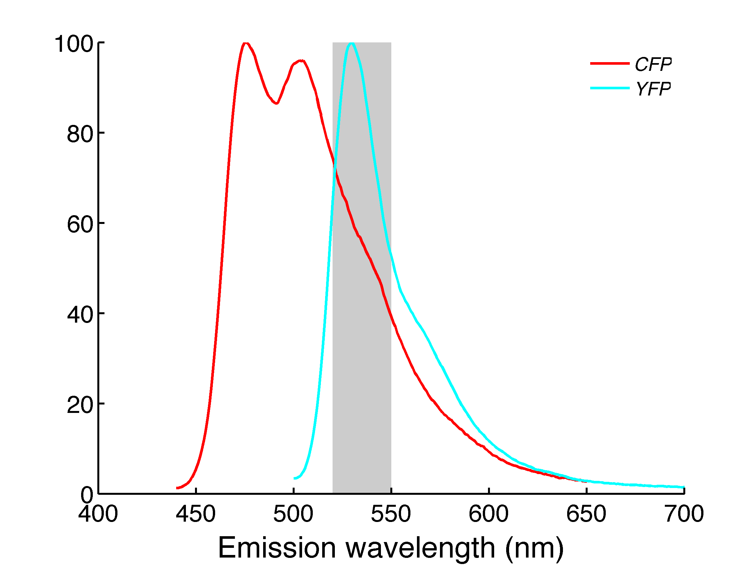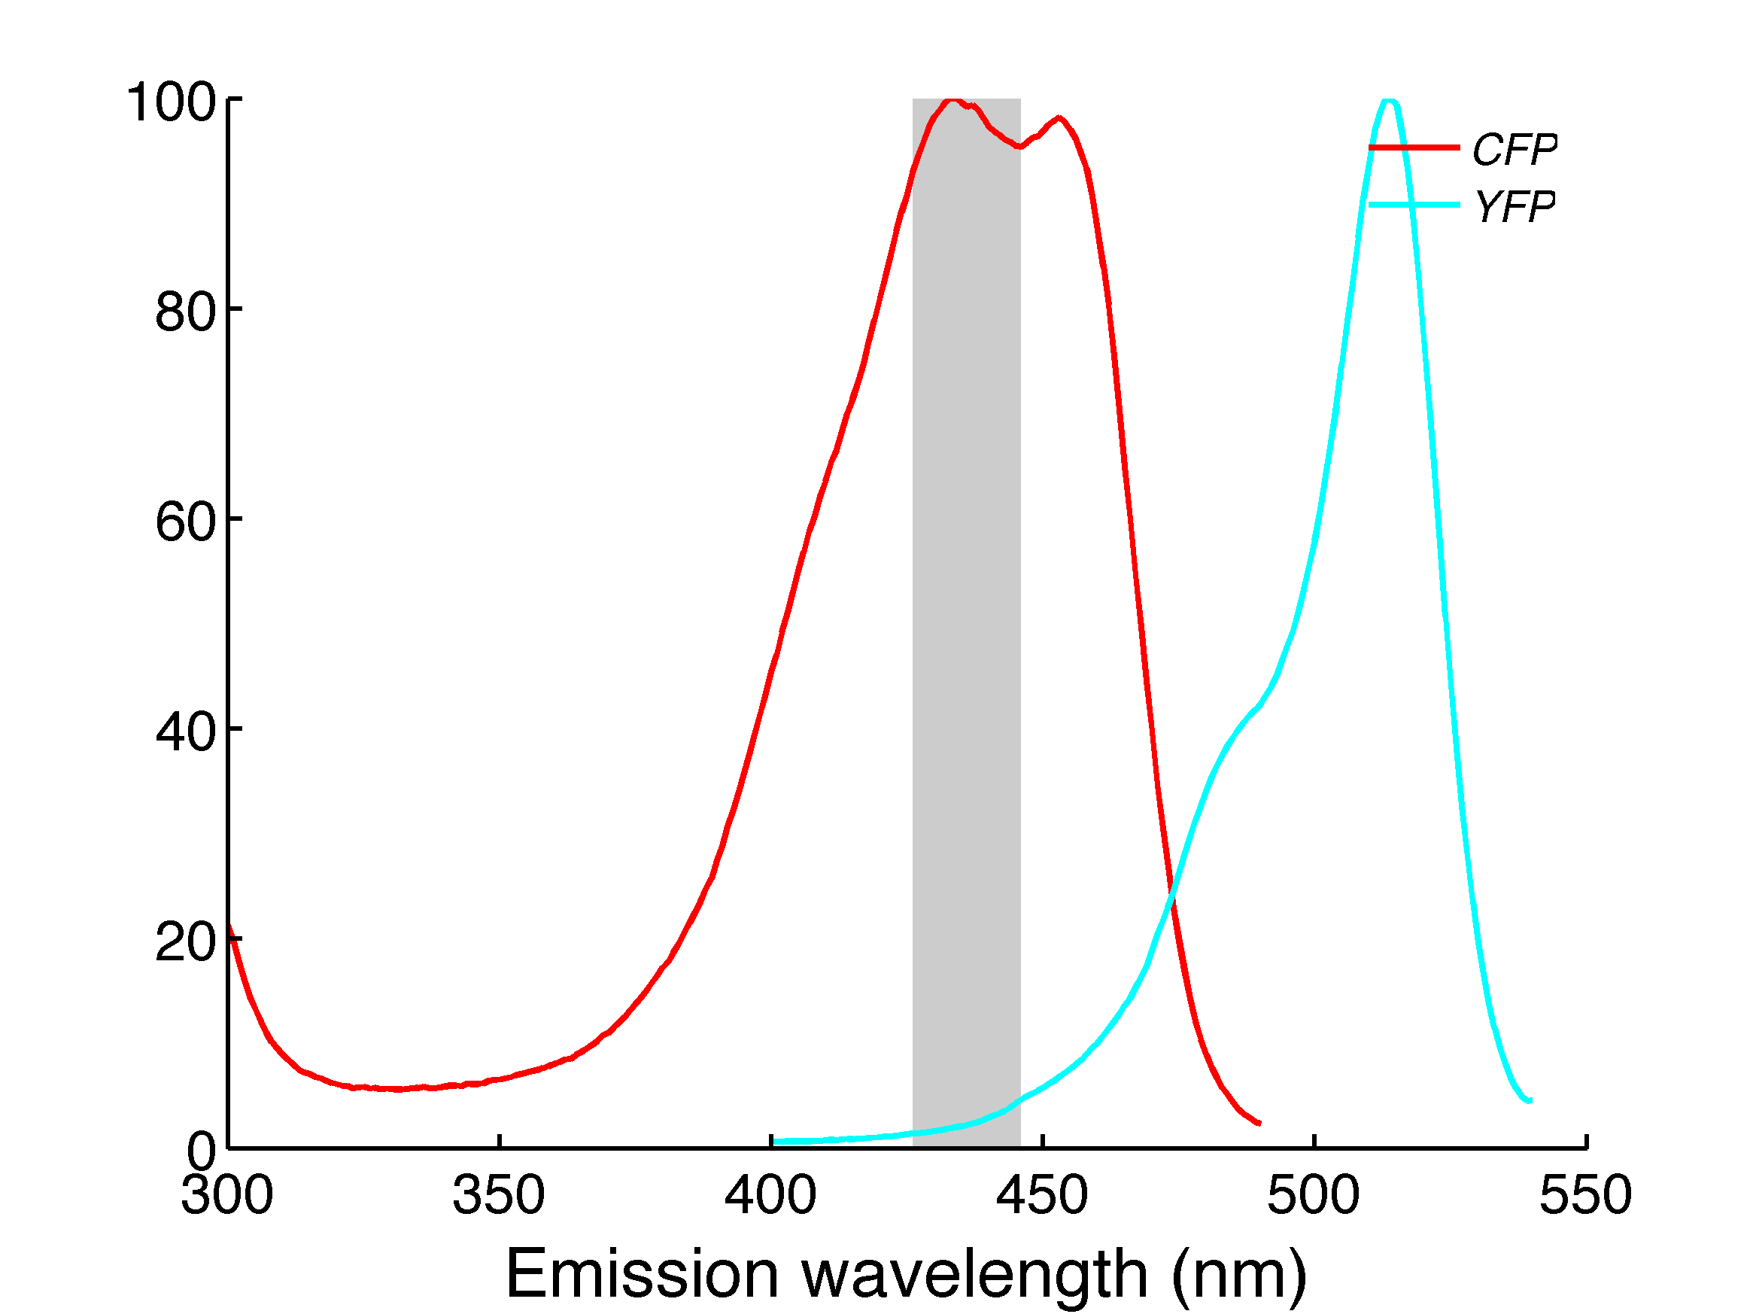
Figure 1. Left: due to overlapping emission spectra, CFP fluorophore emission is collected by the YFP filter set (bleedthrough). Right: due to overlapping excitation spectra, YFP fluorophore is partially excited by the CFP excitation (crosstalk).

Parameter Descriptions:

Input Channel:

This allows you to select the channel to bleedthrough correct. This should be the activity channel (usually FRET) which will be the numerator in the ratio.

Coefficients:

This table allows you to input the correction coefficients determined previously. The first column specifies the coefficients to use for bleedthrough coefficients and the second the coefficients to apply for crosstalk correction. You can specifiy a coefficient for each valid channel e.g. for CFP/YFP FRET, you would use CFP for bleedthrough correction and YFP for crosstalk correction. Note that the same channel cannot be used for both bleedthrough and crosstalk correction.

