LCCB Software Manual – Version 2.0

What’s in v.2.0?

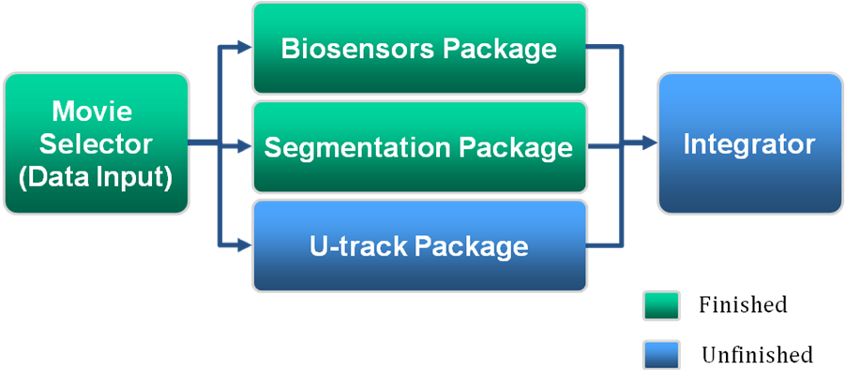
Figure 1: Overall structure

NOTE: For further information regarding Biosensors Package, please refer to page 5 of this document. Remember to check our website for future release: http://lccb.hms.harvard.edu/software.html

New Features in v.2.0:

- Support Multiple-Movie Processing – Multiple movies could be loaded and processed together
- Channel-specific Parameters – Users can choose to set parameters for different channels. These parameters include: excitation wavelength, emission wavelength and exposure time
- Process Recycling mechanism – This mechanism allows users to re-use processed data across different packages
- Movie Data list – Movie data list saves a set of movie data and users can load the multiple movies at once by opening a the movie data list in movie selector
- Visualization Tool – A variety of visualization tools to view result images or overlay data in the software

Installation:

- Extract all the files from the .zip file you downloaded into a sub-directory of the default matlab directory (the directory matlab starts in when opened).
- Add this directory to the matlab path. This can be done by going to File->Set Path... then click on "Add Folder..." and select the folder you extracted all the files to in step 1.

NOTE: This software requires Matlab 2008a or later. It has been tested on Windows 7, Mac OS X, and Linux, and may have problems on other operating systems.

The software requires the following Matlab toolboxes:
- Image Processing Toolbox
- Statistics Toolbox

If you have any questions, error reports or suggestions to help us improve this software, please send an email to: chuangang_ren@hms.harvard.edu. We look forward to your feedback.

Movie Selector:

To open the movie selector, type “movieSelectorGUI” at the Matlab command line (Fig. 2), and then press enter. Fig 3 shows the movie selector.

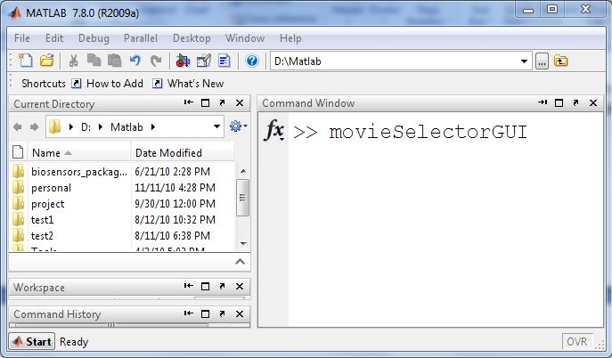
Figure 2: Open movie selector

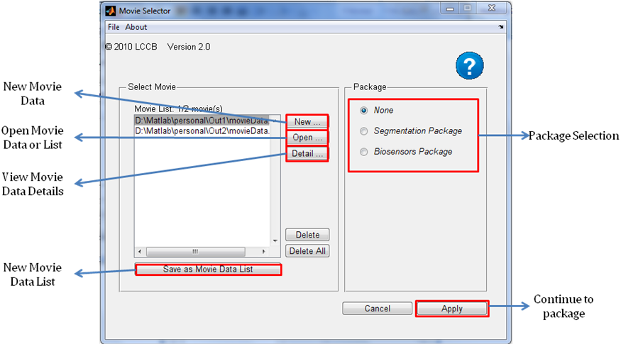

Figure 3: Movie Selector

There are 2 ways to select your movie data:

- Create New Movie Data

- Click “New” button to create new movie data (Fig 4)

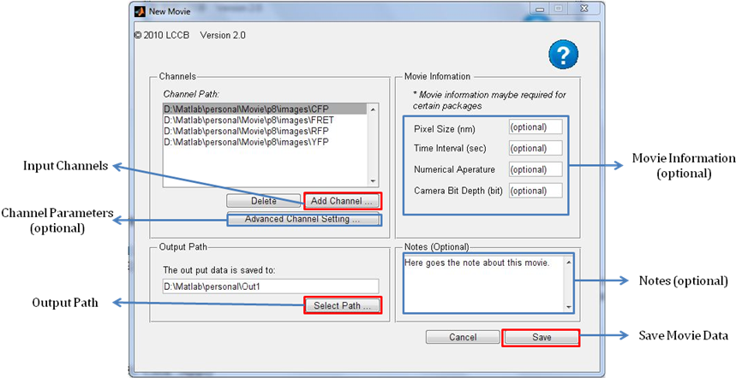
Figure 4: Create New Movie Data

- Define the required(or optional) parameters:

- Input channels: Here you can select folders containing the images for each channel of the movie. Each channel must be in a separate folder, with one .tif file per time point. Note that all channels should have the same number of images

- Output Path: This specifies where the results of the processing will be stored.

- Channel-specific Parameters (optional): excitation wavelength, emission wavelength, exposure time

- Movie Information (optional ): pixel size, time interval, numerical aperature, camera bit depth

- Notes (optional)

- Click “Save”

- Use existing Movie Data

Click “Open” button and select the saved Movie Data or Movie Data List MAT file

Once the movies are selected, their directories will be displayed in the list box in Movie Selector Panel. By clicking “Save as Movie Data List” button; the current movies selected can be saved as a movie data list. The movie data list is saved in a MAT file. To load the same set of movies the next time, open the saved movie data list MAT file by clicking “Open” button. Note that movie data list only copies the directories of movie data instead of the movie data themselves.

Select one of the packages and click “Continue” to process your data.

Open Package Control Panel From Command Line:

Load the Movie Data to Matlab work space. Run “biosensorsPackageGUI(MD)” from command line (MD is the name of the loaded Movie Data variable) to BioSensors Package, or “segmentationPackageGUI(MD)” to Segmentation Package.

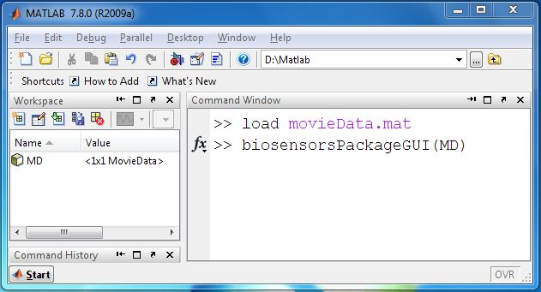

Figure 5: Start package control panel from command line

Package Control Panel:

The overlays of all the packages are similar (BioSensors Packge and Segmentation Package). Take BioSensors Package for example (Fig. 6):

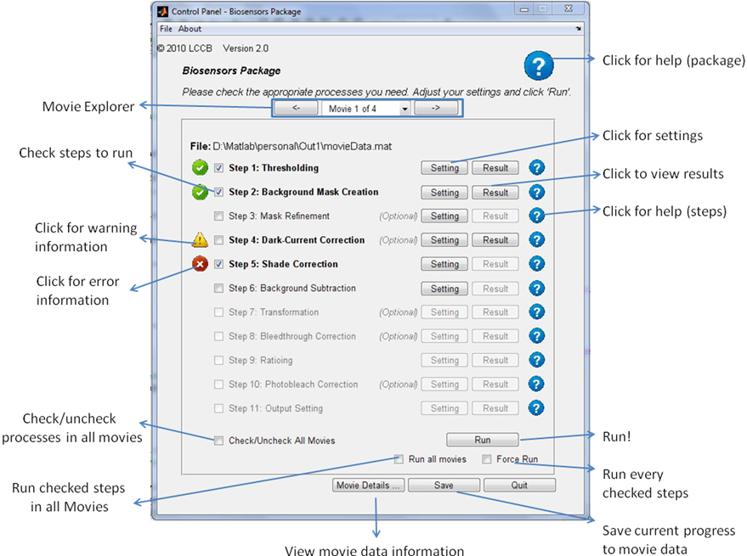
Figure 6: Biosensors Package Control Panel

How to run the steps:

- Select checkboxes of the steps you would like to run. Step that depends on other step(s) cannot be selected until the step(s) they depend on is selected.

- Set up the selected steps before running by clicking the "Setting" button next to the step, and then clicking “Apply” in setting panel.

- Browse through movies using movie explorer

- Click “Run” - By default this will run all selected steps which have NOT yet been successfully run in the current movie. Two following options are provided:
- “Force Run” checkbox - Re-run the steps which have been successfully run.
- “Run all movies” - Run all checked steps in all movies (if more than 1 movies are loaded)

- When a step has been completed, click the corresponding "Result" button to display the results of that step.

Package Documentation

Biosensors Package Documentation

Biosensors package is for processing raw data from fluorescent biosensors into "ratio maps" or "ratio images", which are images that show where and when the protein of interest is active.

These ratio images rely on the comparison of two images - an activity image, whose intensity is proportional to the activation of the protein of interest, and a localization channel, whose intensity is independent of activity but which gives the location of the protein. This allows variation in the concentration of the protein and the thickness of the cell to be separated from the proteins activation. This is accomplished by dividing the activation image by the localization image.

Before the images can be divided, we need to be sure that the only difference between the two images is the activation of the protein. This requires that both images undergo several corrections prior to the ratioing, and a photobleach correction after the ratioing. For more information on these steps, click the help icon next to each step.

Work flow of Biosensors Package:

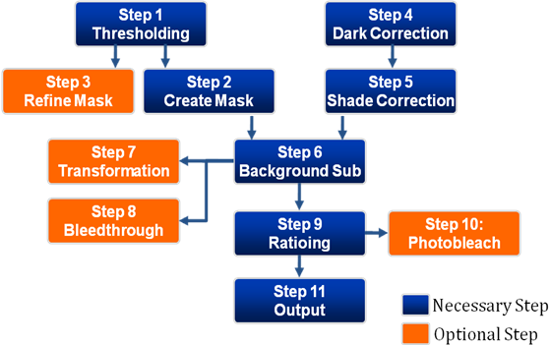
Step 1: Thresholding

This process creates masks for the movie which seperate objects (e.g. cells) from the background. Masks are binary images which contain 1 where there is an object of interest (cell), and zero where there is background. Thresholding creates these masks by finding areas of the image which are brighter than a specific value, called the threshold. These will be created for any channels the user selects, or for all channels by default.

Setting Panel:

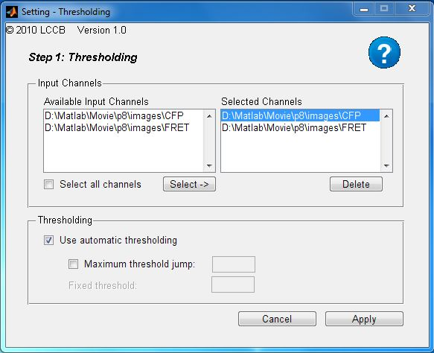

Parameters:

Input Channels: | This allows you to select which channels you want to create masks for. Generally, this is only done for fluorescence channels, and DIC/Phase images are not thresholded. Select the channels by clicking on them in the "Available Input Channels" box and then clicking "Select->" to move them to the "Selected Channels" box. You can un-select a channel by clicking the "Delete" button
Fixed Threshold: | Select this box to allow the software to automatically select a threshold level for each image in each selected channel.
Use Automatic Thresholding: | If you un-check "Use automatic thresholding", then you can manually specify an an intensity value to use for thresholding. This value should be just barely above the average backround intensity in the image.
Maximum Threshold Jump: | This option should be used if the automatic thresholding works on most frames of the movie but fails on a few. If selected, this sets an upper limit on the change of the threshold between frames. For example, if this was set to .5 and the automatically-selected threshold changed by a factor of .51 between two consecutive frames, this new threshold would be ignored and the last good threshold value used.

Step 2: Background Mask Creation

This process uses the (previously created) masks, which label the foreground, to create masks which label the background. To ensure that no foreground is included in these masks, the original masks are "grown" by a user-specified amount. This makes sure that the background mask is far away from any foreground objects.
Setting Panel:

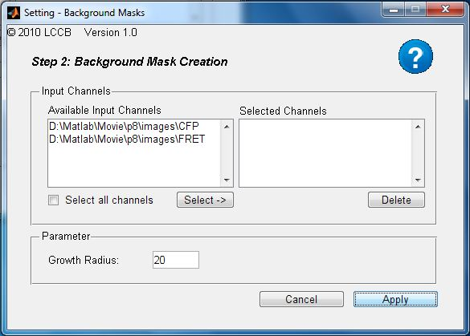

Parameters:

Input Channels: | This allows you to select which channels you want to create background masks for. By default, all channels will have background masks created. These masks are generally used to perform background subtraction. Select the channels by clicking on them in the "Available Input Channels" box and then clicking "Select->" to move them to the "Selected Channels" box. You can un-select a channel by clicking the "Delete" button
Growth Radius: | This parameter determines how much the masks will be "grown" before being used to create background masks. That is, any pixel which is further than this distance away from any mask objects will be considered background

Step 3: Mask Refinement

This process can be used to post-process (and hopefully improve) the masks for selected channels of the movie. This is generally not needed, but can be used in situations where the masks have problems. This is done by removing small background objects, filling any holes in masks, and so on. For more details, see the Settings help for each parameter. The refined masks will replace the existing masks.
Setting Panel:

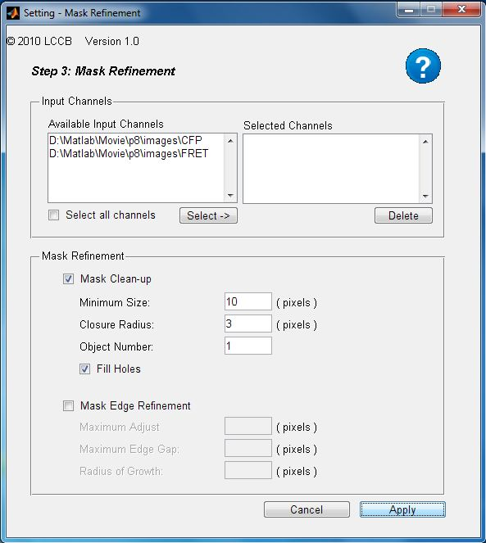

Parameters:

Input Channels: | This allows you to select which channels you want to refine the masks of. By default, all channels will be refined. Select the channels by clicking on them in the "Available Input Channels" box and then clicking "Select->" to move them to the "Selected Channels" box. You can un-select a channel by clicking the "Delete" button
Mask Clean-up: | If this box is checked, the basic mask clean-up procedures will be performed. Either this or "Mask Edge Refinement" must be checked. For descriptions of the individual steps in clean-up, see the parameters described below.
Minimum Size: | This parameter specifies the minimum size (in pixels) of objects which should be kept in the mask. Objects smaller than this size will be removed from the mask. This is useful in removing small areas outside the cell which are included in the mask because they are brighter than background, but are not part of a cell.
Closure Radius: | This parameter specifies the size of a disk that will be used to "close" the mask. This has the effect of connecting objects which are closer together than this radius. It also has the effect of rounding sharp corners of the mask whose radius is smaller than this. For additional help, see the help for imclose.m
Object Number: | This specifies the number of objects to keep in each mask. That is, if Object Number is set to 2, only the two largest objects in the mask will be kept. This is useful for removing larger background objects, or cells which are only partially in the image, while retaining the cell of interest.
Fill Holes: | You guessed it: If this box is checked, any holes in the mask will be filled in. This is useful because sometimes dark areas within the cell (e.g. the nucleus) may not be originally included in the mask. Since cells usually don't have holes in them, filling in these holse is pretty safe.
Mask Edge Refinement: | This is very rarely needed, and doesn't always work. If checked, the edges of the masks will be further refined (This is done after mask clean-up, if it is selected). For more details, and a description of the parameters, see the help section of refineMovieMasks.m

Step 4: Dark Current Correction

"Dark Current" is background electronic noise in the camera used for imaging. This noise is generally a few hundred counts, and is not uniform throughout the image, varying by > 10% within the imaging area of a single camera, and can vary even more between cameras.m. This noise is measured by taking several "dark-current images" - images where there is no light incident on the camera. These images are then used to correct for the inhomogeneity of the dark-current by subtracting the dark-current value from each pixel. If a single camera is being used for all image acquisition, a single set of dark-current images can be used to corret all channels. If different cameras are used, it is best to collect dark images for each camera.
Setting Panel:

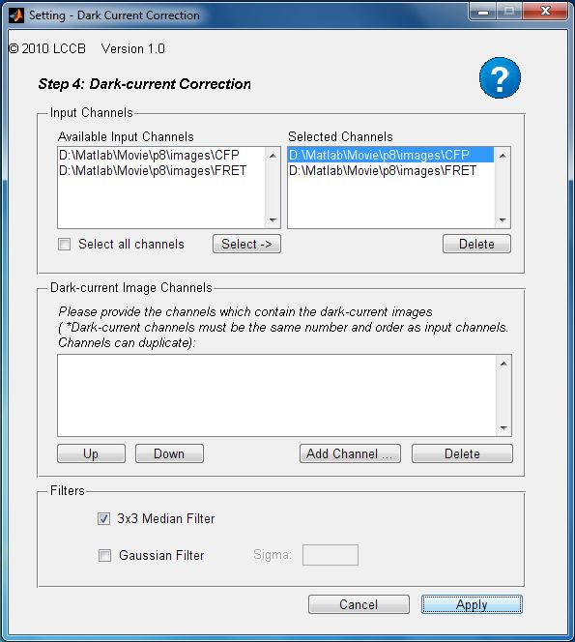

Parameters:

Input Channels: | This allows you to select which channels you want to perform dark-current correction on. This should be applied to all channels that are going to be used for ratioing or bleedthrough correction. Select the channels by clicking on them in the "Available Input Channels" box and then clicking "Select->" to move them to the "Selected Channels" box. You can un-select a channel by clicking the "Delete" button
Dark-Current Image Channels: | This box allows you to specify a directory containing the dark-current images corresponding to each channel to be corrected. You must specify a directory for each channel to be dark-current corrected, but the same directory may be specified multiple times. The directories specified should contain one or more "dark-current images". It is recommended to take 10 or more, as these will be averaged together to improve the correction
3x3 Median Filter: | If this box is checked, a median filter will be applied to the dark-current images prior to their use as a correction. This is usefull because it minizes the contribution of noise in the dark images, and removes "hot pixels" - pixels which have a much higher-than-normal background value (several hundred counts)
Gaussian Filter: | If checked, the dark-current images will also be filtered (smoothed) using a gaussian filter whose sigma is specified by the value in the "Sigma" box. Larger sigmas will give smoother images. This can be used to further reduce noise in the dark-current images and is especially important if only 1 or a few dark-current image(s) are taken.

Step 5: Shade Correction

Shade correction compensates for uneven illumination in the image. The illumination intensity is almost always higher in the center than near the edges of the movie, often by 15-20% or more. This illumination pattern also varies with wavelength, laser, etc. This illumination heterogeneity is corrected by taking "shade images" - images with the same illumination and filter settings but taken of a blank area of a coverslip which contains no fluorescent objects. These images are then used to even-out the illumination in the actualy fluorescence images.

Setting Panel:

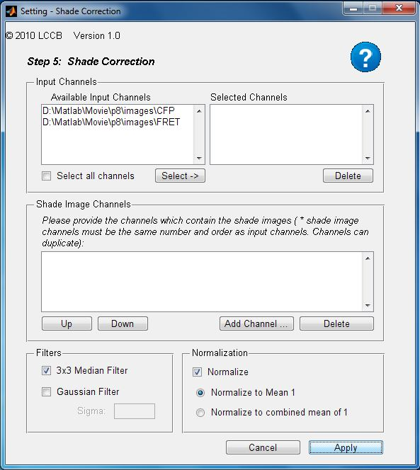

Parameters:

Input Channels: | This allows you to select which channels you want to perform shade correction on. This should be applied to all channels that are going to be used for ratioing or bleedthrough correction. Select the channels by clicking on them in the "Available Input Channels" box and then clicking "Select->" to move them to the "Selected Channels" box. You can un-select a channel by clicking the "Delete" button
Shade Image Channels: | This box allows you to specify a directory containing the shade images corresponding to each channel to be corrected. You must specify a directory for each channel to be shade corrected, but the same directory may be specified multiple times (However, this is not recommended!) The directories specified should contain one or more "shade images". It is recommended to take 10 or more, as these will be averaged together to improve the correction. It is also recommended that separate shade-correction images be taken for each channel to be corrected.
3x3 Median Filter: | If this box is checked, a median filter will be applied to the shade images prior to their use as a correction. This is usefull because it minizes the contribution of noise in the shade images, and removes "hot pixels" - pixels which have a much higher-than-normal background value (several hundred counts)
Gaussian Filter: | If checked, the shade images will also be filtered (smoothed) using a gaussian filter whose sigma is specified by the value in the "Sigma" box. Larger sigmas will give smoother images. This can be used to further reduce noise in the shade images and is especially important if only a small number of shade image(s) are taken. Be careful using this option, as large filter sigmas may introduce artifacts near the edge of the image.
Normalize: | If this box is checked, the shade correction images will be normalized prior to their application. This is highly recommended. Normalization allows the pattern of illumination in the shade images to be used without the actual absolute intensity values affecting the correction.
Normalize to Mean 1: | If this option is selected, each shade correction image will be normalized so that its mean is equal to 1 prior to use in correction.
Normalize to combined mean: | If this option is selected, the shade correction images will be normalized so that the combined mean across all channels to be corrected is equal to 1 prior to their use in correction. This allows the relative illumination intensities in the different shade images to be taken into account when correcting. This option is only useful in certain circumstances, and is not generally recommended.

Step 6: Background Subtraction

Different fluorescence channels and imaging conditions can result in variable background fluorescence - that is, fluorescence in areas where there is no fluorophore. To correct for variations in this background level between channels (and between images) the average background intensity is subtracted from each image. The background area is determined using the background masks, which be created beforehand.
Setting Panel:

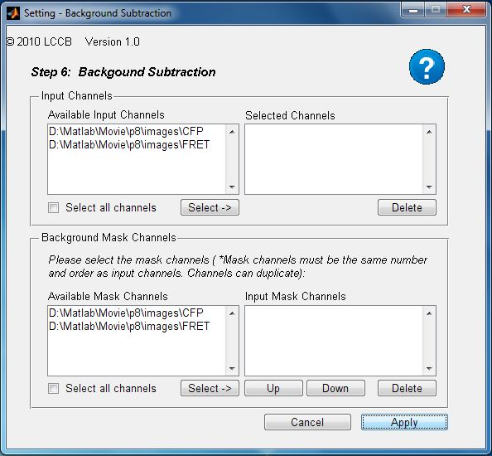

Parameters:

Input Channels: | This allows you to select which channels you want to perform background subtraction on. This should be applied to all channels that are going to be used for ratioing or bleedthrough correction. Select the channels by clicking on them in the "Available Input Channels" box and then clicking "Select->" to move them to the "Selected Channels" box. You can un-select a channel by clicking the "Delete" button
Background Mask Channels: | This allows you to select which channels to take background masks from for background subtraction. The default is to use the masks from the same channel that is being correced. However, in the case that one channel cannot be successfully segmented, you may use masks from a different channel to perform background subtraction on that channel

Step 7: Transformation

This process can be used to correct for misalignment between the different channels in the movie. This is primarily an issue when different cameras are used to acquire the different images, but is often still a problem near the edges of images taken with a single camera, primarily due to chromatic aberration. Misalignment between the channels can cause serious artifacts in the ratio image, especially near the edge of the cell. By transforming one image so that it aligns with the other, this misalignment can be corrected.
Setting Panel:

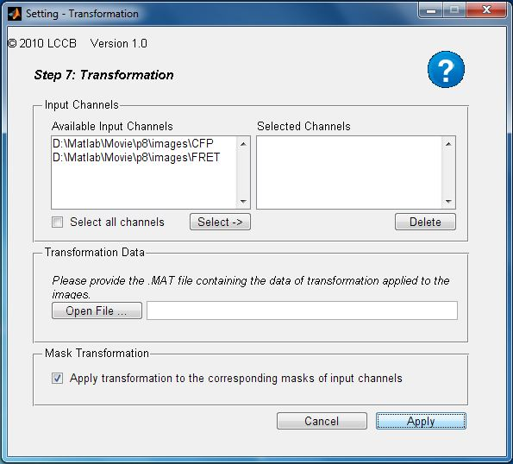

Parameters:

Input Channels: | This allows you to select which channels you want to transform. This should be applied to ONE of the two channels that are going to be used for ratioing (usually the numerator, or FRET channel). Additionally, if bleedthrough correction is to be applied, any channels that will be used in this correction may need to be transformed.
Transformation Data: | This allows you to specify the location of a file which contains the transformation to be applied to the images. This transformation is usually determined using alignment images taken in each channel, either of a grid micrometer, or multispectral beads.
Mask Transformation: | If this box is checked, the masks for the channel to be transformed will also be transformed. This is generally recommended.

Step 8: Bleedthrough Correction

"Bleedthrough" is when the fluorophore from one channel contributes to the intensity in another channel, due to spectral overlap or imperfect filtering. With single-chain (intramolecular) biosensors, the localization of the fluorophores in each channel is always identical, so the bleedthrough contibution is automatically cancelled out during the ratioing step. With dual-chain (intermolecular) biosensors, the localization is slightly different for the two fluorophores. This means this bleedthrough must be corrected. This is accomplished by determining bleedthrough coefficients in a separate experiment where each half of the sensor is imaged independently. These coefficients are then used to correct the actual fluorphore images
Setting Panel:

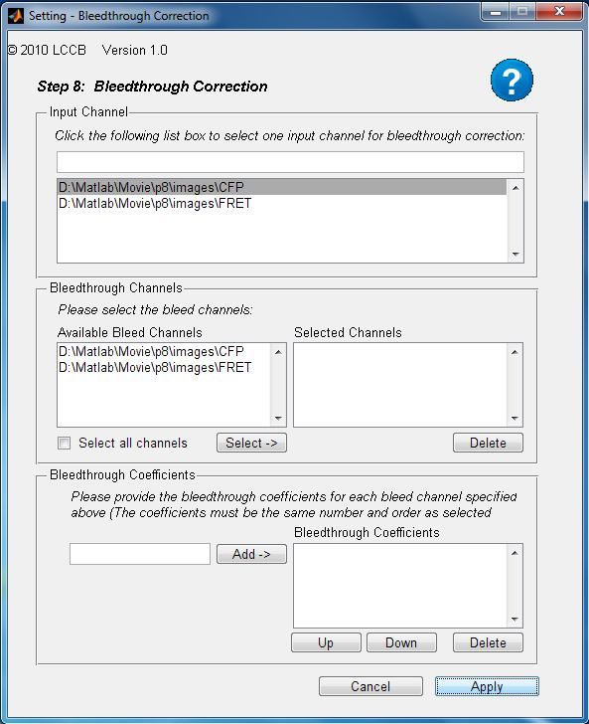

Parameters:

Input Channel: | This allows you to select the channel to bleed-through correct. This should be the activity channel (usually FRET) which will be the numerator in the ratio.
Bleedthrough Channels: | This box allows you to select the channels which contain fluorophores which are bleeding through into the channel selected for correction (Usually CFP and YFP)
Bleedthrough Coefficients: | This is where you can input the bleedthrough coefficients that you have determined previously. You must input one coefficient for each bleedthrough channel selected above. Type in the coefficient in the box and then click the "Add->" button.

Step 9: Ratioing

This is the most important step, where the fully-corrected activation channel (usually FRET) is divided by the fully-corrected localization channel (usually CFP). This allows changes in the activation of the protein of interest to be separated from changes in its localization, giving a measure of the protein's signaling state.
Setting Panel:

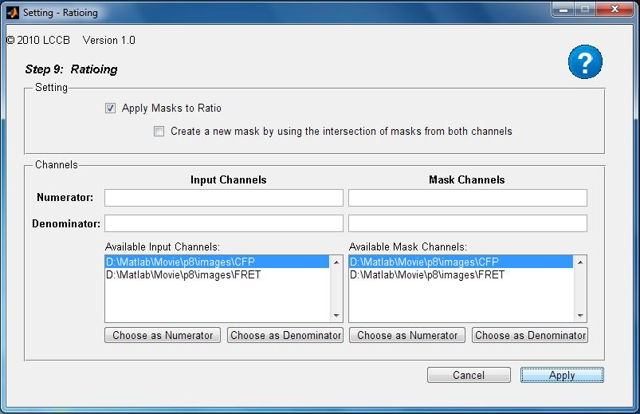

Parameters:

Apply Masks to Ratio: | If this box is checked, any areas in the ratio image which are outside of the masks from either of the channels will be set to zero. This is normally desireable because areas outside the mask are background areas, and the ratio values there are very noisy and meaningless.
Create New Masks: | If this box is checked, new masks will be created and saved for the ratio channel, which are combinations of the masks from the two input channels: Only pixels which are included in both masks will be included in these
Numerator: | This allows you to select which channel is the numerator, or activity channel, in the ratio. This is usually the FRET channel.
Denominator: | This allows you to select which channel is the denominator, or localization channel, in the ratio. This is usually the CFP channel.
Numerator Mask: | This allows you to select which channel to use masks from for the numerator. Normally this is the numerator channel itself, but in the case that the numerator was not successfully segmented, a different channel can be used.
Denominator Mask: | This allows you to select which channel to use masks from for the denominator. Normally this is the denominator channel itself, but in the case that the denominator was not successfully segmented, a different channel can be used.

Step 10: Photobleach Correction

Photobleaching causes the fluorophores in each channel to lose intensity throughout the movie. The rate of photobleaching is usually different in the different channels, and therefore can introduce artifacts in the ratio image if not corrected. This allows the photobleaching to be corrected by fitting a double-exponential to the average intensities in each channel. After the fitting, a figure will be displayed showing the average ratio over time, and the fitted value along with confidence intervals. It is important to inspect this fit to ensure that the correction is valid, and that the confidence intervals are not excessively large.

Setting Panel:

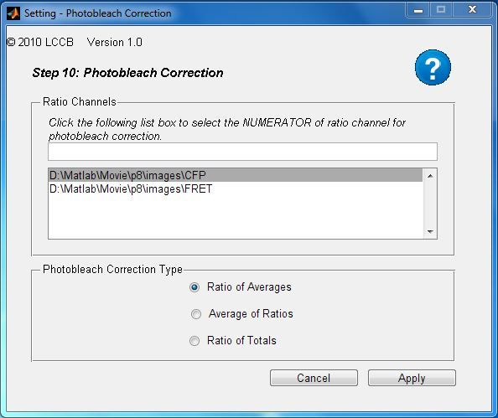

Parameters:

Ratio Channels: | This channel should be set to be the same as the numerator channel used in ratioing (usually FRET).
Ratio of Averages: | This method fits a double-exponential to the ratio of the average intensity in each of the channels used for ratioing, and then uses this fit to correct the ratio images. This is generally the best method.
Average of Ratios: | This method fits a double-exponential to the average of the ratio image, and then uses this fit to correct the ratio images. This will suppress any long-term changes in the ratio, and should only be used if the other methdos fail
Ratio of Totals: | This method fits a double-exponential to the ratio of the total intensity in each of the channels used for ratioing, and then uses this fit to correct the ratio images. This is generally only used when there is a drastic change in cell area throughout the movie. (e.g. the cell rounds up). This sort of change will have a smaller effect on the total intensity than the average intensity, making the total a better measure in these cases.
Step 11: Output

This process allows you to export the ratio images you have created in step 9 (or step 10, if photobleach correction has been applied) as .tif images. This requires multiplying the images by a large number, called a "scale factor". This is necessary because the ratio images themselves are small, non-integer values (usually between .5 and 5), while .tif images can only store positive integer values. If these ratios are converted to integers without multiplying by a scale factor, there would be severe rounding error in the images. Alternatively, you can use the ratio images themselves, which are stored as floating-point matlab .mat files in the movie's output directory.
Setting Panel:

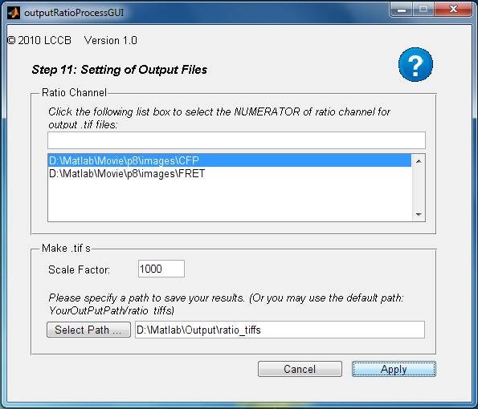

Parameters:

Ratio Channel: | This box allows you to select the channel which is the NUMERATOR of the ratio images you want to export (usually the FRET channel).
Scale Factor: | This is the number that the ratio images will be multiplied by before being saved as .tif images. It is recommended that this number be fairly large (1000 is recommended) to minimize rounding error. It is also important that this number be kept constant among different movies whose ratio images are to be compared.
Select Path: | This allows you to specify the directory to save the .tif ratio images to. They will be saved to a sub-directory of this folder, called "ratio_tiffs", with one .tif file per ratio image.

