ISI2 Exploration 1.4

## Load in the data file, e.g.,

Squirrels <- read.table("http://www.isi-stats.com/isi2/data/Squirrels.txt", sep="\t", header=T, stringsAsFactors = T)  
head(Squirrels)

## Location Length  
## 1 Hemet 263  
## 2 Hemet 256  
## 3 Hemet 251  
## 4 Hemet 242  
## 5 Hemet 248  
## 6 BigBear 274

##Distribution of time

hist(Squirrels$Length)

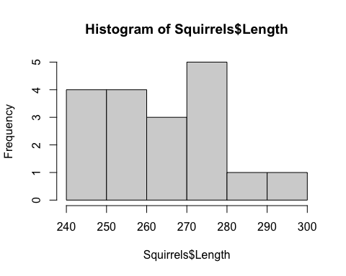

isisummary(Squirrels$Length)

## n Min Q1 Median Q3 Max Mean SD   
## 18.0 242.0 252.0 263.0 273.0 291.0 263.0 13.6

#SStotal  
var(Squirrels$Length)*17

## [1] 3136.5

##Subset by location

library(lattice)  
histogram(~Squirrels$Length | Squirrels$Location)

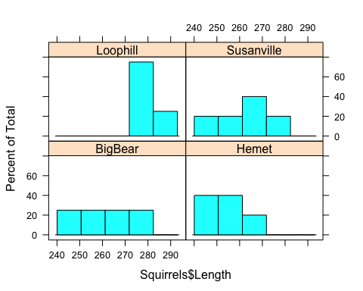

isisummary(Squirrels$Length, Squirrels$Location)

## n Min Q1 Median Q3 Max Mean SD  
## BigBear 4 249 254 260 266 274 261 10.80  
## Hemet 5 242 248 251 256 263 252 7.97  
## Loophill 4 273 277 280 284 291 281 7.59  
## Susanville 5 245 260 263 271 272 262 10.90

**8) Give the standard error of the residuals**

summary(lm(Squirrels$Length~Squirrels$Location))$sigma

## [1] 9.442684

**9) $R^{2}$ components**

aov(Squirrels$Length~Squirrels$Location)

## Call:  
## aov(formula = Squirrels$Length ~ Squirrels$Location)  
##   
## Terms:  
## Squirrels$Location Residuals  
## Sum of Squares 1888.2 1248.3  
## Deg. of Freedom 3 14  
##   
## Residual standard error: 9.442684  
## Estimated effects may be unbalanced

##ANOVA table

anova(lm(Squirrels$Length~Squirrels$Location))

## Analysis of Variance Table  
##   
## Response: Squirrels$Length  
## Df Sum Sq Mean Sq F value Pr(>F)   
## Squirrels$Location 3 1888.2 629.40 7.0589 0.00401 **  
## Residuals 14 1248.3 89.16   
## ---  
## Signif. codes: 0 '***' 0.001 '**' 0.01 '*' 0.05 '.' 0.1 ' ' 1