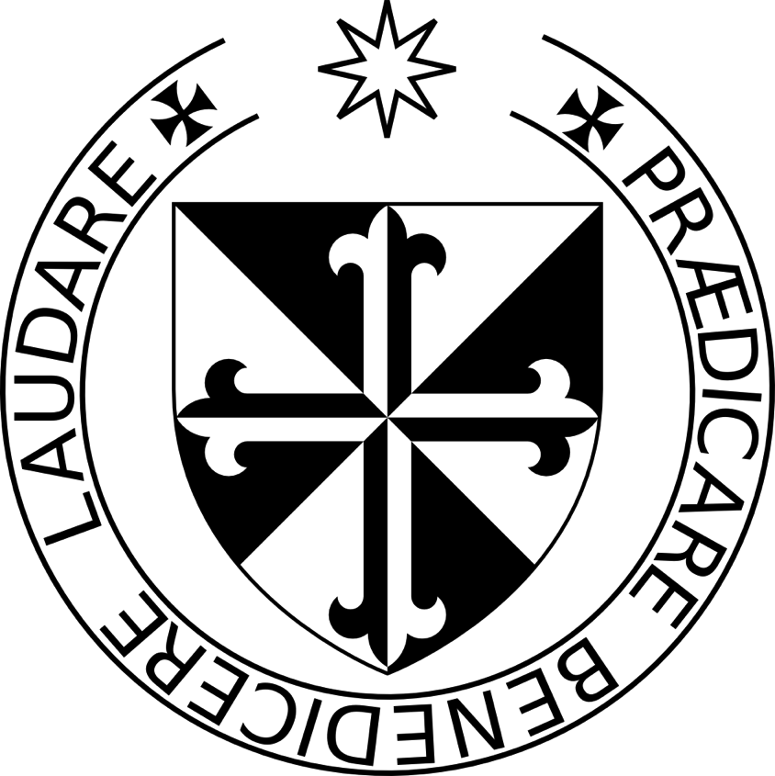

Prayer before Communion

by St. Thomas Aquinas

Almighty and ever-living God, I approach the sacrament of your only begotten Son, Our Lord Jesus Christ. I come sick to the doctor of life, unclean to the fountain of mercy, blind to the radiance of eternal light, and poor and needy to the Lord of heaven and earth.

Lord, in your great generosity, heal my sickness, wash away my defilement, enlighten my blindness, enrich my poverty, and clothe my nakedness. May I receive the bread of angels, the King of Kings and Lord of Lords, with humble reverence, with the purity and faith, the repentance and love, and the determined purpose that will help bring me to God’s saving grace. May I receive the sacrament of the Lord’s body and blood and its reality and power.

Kind God, may I receive the body of your only begotten Son, Our Lord Jesus Christ, born from the womb of the Virgin Mary, and so be received into his mystical body and numbered among his members.

Loving Father, as on my earthly pilgrimage I now receive your beloved Son under the veil of a sacrament, may I one day see Him face to face in glory, who lives and reigns with you forever. Amen.



Prayer before Communion

by St. Thomas Aquinas

Almighty and ever-living God, I approach the sacrament of your only begotten Son, Our Lord Jesus Christ. I come sick to the doctor of life, unclean to the fountain of mercy, blind to the radiance of eternal light, and poor and needy to the Lord of heaven and earth.

Lord, in your great generosity, heal my sickness, wash away my defilement, enlighten my blindness, enrich my poverty, and clothe my nakedness. May I receive the bread of angels, the King of Kings and Lord of Lords, with humble reverence, with the purity and faith, the repentance and love, and the determined purpose that will help bring me to God’s saving grace. May I receive the sacrament of the Lord’s body and blood and its reality and power.

Kind God, may I receive the body of your only begotten Son, Our Lord Jesus Christ, born from the womb of the Virgin Mary, and so be received into his mystical body and numbered among his members.

Loving Father, as on my earthly pilgrimage I now receive your beloved Son under the veil of a sacrament, may I one day see Him face to face in glory, who lives and reigns with you forever. Amen.



Prayer before Communion

by St. Thomas Aquinas

Almighty and ever-living God, I approach the sacrament of your only begotten Son, Our Lord Jesus Christ. I come sick to the doctor of life, unclean to the fountain of mercy, blind to the radiance of eternal light, and poor and needy to the Lord of heaven and earth.

Lord, in your great generosity, heal my sickness, wash away my defilement, enlighten my blindness, enrich my poverty, and clothe my nakedness. May I receive the bread of angels, the King of Kings and Lord of Lords, with humble reverence, with the purity and faith, the repentance and love, and the determined purpose that will help bring me to God’s saving grace. May I receive the sacrament of the Lord’s body and blood and its reality and power.

Kind God, may I receive the body of your only begotten Son, Our Lord Jesus Christ, born from the womb of the Virgin Mary, and so be received into his mystical body and numbered among his members.

Loving Father, as on my earthly pilgrimage I now receive your beloved Son under the veil of a sacrament, may I one day see Him face to face in glory, who lives and reigns with you forever. Amen.



Prayer before Communion

by St. Thomas Aquinas

Almighty and ever-living God, I approach the sacrament of your only begotten Son, Our Lord Jesus Christ. I come sick to the doctor of life, unclean to the fountain of mercy, blind to the radiance of eternal light, and poor and needy to the Lord of heaven and earth.

Lord, in your great generosity, heal my sickness, wash away my defilement, enlighten my blindness, enrich my poverty, and clothe my nakedness. May I receive the bread of angels, the King of Kings and Lord of Lords, with humble reverence, with the purity and faith, the repentance and love, and the determined purpose that will help bring me to God’s saving grace. May I receive the sacrament of the Lord’s body and blood and its reality and power.

Kind God, may I receive the body of your only begotten Son, Our Lord Jesus Christ, born from the womb of the Virgin Mary, and so be received into his mystical body and numbered among his members.

Loving Father, as on my earthly pilgrimage I now receive your beloved Son under the veil of a sacrament, may I one day see Him face to face in glory, who lives and reigns with you forever. Amen.

Prayer after Communion

by St. Thomas Aquinas

Lord, Father, all-powerful and ever-living God, I thank you, for even though I am a sinner, your unprofitable servant, not because of my worth but in the kindness of your mercy, you have fed me with the precious body and blood of your Son, Our Lord Jesus Christ. I pray that this Holy Communion may bring me not condemnation and punishment, but forgiveness and salvation. May it be a helmet of faith and a shield of good will. May it purify me from evil ways and put an end to my evil passions. May it bring me charity and patience, humility and obedience, and growth in the power to do good. May it be my strong defense against all my enemies, visible and invisible, and the perfect calming of all my evil impulses of body and spirit. May it unite me more closely to you, the one true God, and lead me safely through death to everlasting happiness with you. And I pray that you will lead me, a sinner, to the banquet where you, with your Son and Holy Spirit, are true and perfect light, total fulfillment, everlasting joy, gladness without end, and perfect happiness to your saints. Grant this through Christ our Lord. Amen.

Aquilina M. Praying in the Presence of Our Lord. 2002.   
Huntington, IN: Our Sunday Visitor Publications

Provided by the Lay Dominican St. Martin de Porres Fraternity, Hanover, NH, boston3op.com, and   
Knights of Columbus counsels 2656 and 15094

Prayer after Communion

by St. Thomas Aquinas

Lord, Father, all-powerful and ever-living God, I thank you, for even though I am a sinner, your unprofitable servant, not because of my worth but in the kindness of your mercy, you have fed me with the precious body and blood of your Son, Our Lord Jesus Christ. I pray that this Holy Communion may bring me not condemnation and punishment, but forgiveness and salvation. May it be a helmet of faith and a shield of good will. May it purify me from evil ways and put an end to my evil passions. May it bring me charity and patience, humility and obedience, and growth in the power to do good. May it be my strong defense against all my enemies, visible and invisible, and the perfect calming of all my evil impulses of body and spirit. May it unite me more closely to you, the one true God, and lead me safely through death to everlasting happiness with you. And I pray that you will lead me, a sinner, to the banquet where you, with your Son and Holy Spirit, are true and perfect light, total fulfillment, everlasting joy, gladness without end, and perfect happiness to your saints. Grant this through Christ our Lord. Amen.

Aquilina M. Praying in the Presence of Our Lord. 2002.   
Huntington, IN: Our Sunday Visitor Publications

Provided by the Lay Dominican St. Martin de Porres Fraternity, Hanover, NH, boston3op.com, and   
Knights of Columbus counsels 2656 and 15094

Prayer after Communion

by St. Thomas Aquinas

Lord, Father, all-powerful and ever-living God, I thank you, for even though I am a sinner, your unprofitable servant, not because of my worth but in the kindness of your mercy, you have fed me with the precious body and blood of your Son, Our Lord Jesus Christ. I pray that this Holy Communion may bring me not condemnation and punishment, but forgiveness and salvation. May it be a helmet of faith and a shield of good will. May it purify me from evil ways and put an end to my evil passions. May it bring me charity and patience, humility and obedience, and growth in the power to do good. May it be my strong defense against all my enemies, visible and invisible, and the perfect calming of all my evil impulses of body and spirit. May it unite me more closely to you, the one true God, and lead me safely through death to everlasting happiness with you. And I pray that you will lead me, a sinner, to the banquet where you, with your Son and Holy Spirit, are true and perfect light, total fulfillment, everlasting joy, gladness without end, and perfect happiness to your saints. Grant this through Christ our Lord. Amen.

Aquilina M. Praying in the Presence of Our Lord. 2002.   
Huntington, IN: Our Sunday Visitor Publications

Provided by the Lay Dominican St. Martin de Porres Fraternity, Hanover, NH, boston3op.com, and   
Knights of Columbus counsels 2656 and 15094

Prayer after Communion

by St. Thomas Aquinas

Lord, Father, all-powerful and ever-living God, I thank you, for even though I am a sinner, your unprofitable servant, not because of my worth but in the kindness of your mercy, you have fed me with the precious body and blood of your Son, Our Lord Jesus Christ. I pray that this Holy Communion may bring me not condemnation and punishment, but forgiveness and salvation. May it be a helmet of faith and a shield of good will. May it purify me from evil ways and put an end to my evil passions. May it bring me charity and patience, humility and obedience, and growth in the power to do good. May it be my strong defense against all my enemies, visible and invisible, and the perfect calming of all my evil impulses of body and spirit. May it unite me more closely to you, the one true God, and lead me safely through death to everlasting happiness with you. And I pray that you will lead me, a sinner, to the banquet where you, with your Son and Holy Spirit, are true and perfect light, total fulfillment, everlasting joy, gladness without end, and perfect happiness to your saints. Grant this through Christ our Lord. Amen.

Aquilina M. Praying in the Presence of Our Lord. 2002.   
Huntington, IN: Our Sunday Visitor Publications

Provided by the Lay Dominican St. Martin de Porres Fraternity, Hanover, NH, boston3op.com, and   
Knights of Columbus counsels 2656 and 15094