User Guide – Tree Application

September 2016

Version 0.0.1-SNAPSHOT

Table of Contents

1 Introduction 3

1.1 Scope and Purpose 3

1.2 Requirements and deployment 3

1.3 Restrictions 3

2 Functions 4

2.1 Create node 4

2.2 Rename node 4

2.3 Delete node 4

# Introduction

## Scope and Purpose

Tree application used to create and manage tree structure, which uses database in memory. Key functionalities are: create node, update node, remove node, sum (path from root to leaf) only in leafs.

## Requirements and deployment

To use tree application there is need to install all necessary software.

1. Apache Maven 3
2. Java 1.8

Launch:

1. Unzip package
2. Go to application folder in console
3. Build by command in application directory: mvn clean install
4. Run by command in application directory : java –jar web/target/web-0.0.1-SNAPSHOT.jar
5. Go to localhost:8090 in browser

## Restrictions

1. Root node in unmodifiable except create children
2. Leafs have only sum from root to this leaf
3. Rename node to letters cause set value 0.0

# Functions

## Create node

1. Right click on node where you want to create new.
2. Select create from context menu.
3. Click on white page to create.

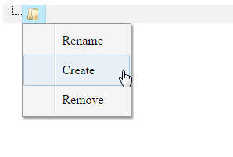

## Rename node

1. Right click on node which you want to change.
2. Select rename from context menu.
3. Put number.
4. Click on white page to rename.

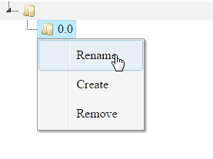

## Delete node

1. Right click on node which you want to delete.
2. Select remove from context menu.

