Apparel Point of Sale (APOS) System

User Guide

CMSC 495
University of Maryland University College (UMUC)

Team Tenacious Turtles

Signatures:

John Walsh

Kevin Boyer

Manoj Kumar

Ryan Harvell

Sean Walters

Vance Molhusen

Approval by Professor Mark Wireman:

Revision | Date | Description
UG - 1 | 09/09/16 | Initial Version
UG- 2 | 09/13/16 | Changes from peer review - 1

Index
Index 4
1 INTRODUCTION 5
1.1 Purpose and Scope 5
1.2 Organization 5
1.3 Points of Contact 5
1.4 Project References 5
1.5 Primary Business Functions 5
1.6 Glossary 5
2 SYSTEM CAPABILITIES 6
2.1 Purpose 6
2.2 General Description 6
3 DESCRIPTION OF SYSTEM FUNCTIONS 6
3.1 Log-In Function 6
3.1a Detailed Description of Log-In Function 6
3.1b Preparation of Log-In Function Inputs 6
3.1c Results of Log-In Function 7
3.2 Transactions Function 7
3.2a Detailed Description of Transactions Function 7
3.2b Preparation of Transactions Function Inputs 7
3.2c Results of Transactions Function 7
3.3 Inventory Lookup Function 10
3.3a Detailed Description of Inventory Lookup Function 10
3.3b Preparation of Inventory Check Function Inputs 10
3.3c Results of Inventory Check Function 10
3.4 Transaction Report Function 11
3.4a Detailed Description of Transaction Report Function 11
3.4b Preparation of Transaction Report Function Inputs 11
3.4c Results of Transaction Report Function 11
4 OPERATING INSTRUCTIONS 12
4.1a Initiate Log-In Operation 12
4.1b Initiate Sales Transaction Operation 13
4.1c Initiate Return Transactions Operation 14
4.1d Initiate Inventory Lookup Operation 14
4.1e Initiate Transaction Report Operation 15
4.2 Maintain Operation 16
4.3 Terminate and Restart Operations 16
5 ERROR HANDLING 16
5.1 HELP FACILITIES 16

INTRODUCTION

Purpose and Scope
The purpose of this user guide is to provide users with procedures on how to use the Apparel Point of Sale (APOS) system. This guide will include the procedures on how to log into the system, how to complete a sales transaction, how to complete a sales return, how to complete an inventory lookup, and how to generate a transactions report. Anything other than these functions will not be in the scope of this user guide and may be included in future releases.

Organization
This user guide will start off by providing an overview of the capabilities and functions of the Apparel Point of Sale (APOS) system and then it will cover the specific input and outputs of each individual function. Lastly, it will provide step-by-step instructions on how to use the functions of the system, how to handle any errors that are encountered while interacting with the system and what avenues are available to seek help.

Points of Contact
Any member of the Tenacious Turtles development team can be contacted for assistance with the enclosed user guide.

Project References
Tenacious Turtles APOS Project Plan

Primary Business Functions
The user of the Apparel Point of Sale System (APOS) will be an employee of the Tenacious Turtles Clothing company. They will be responsible for using the system to manage the in-store clothing transactions and to track and display store clothing inventory/sales information.

Glossary
Interface – portal that enables a user to interact with a system
APOS – Apparel Point of Sale

SYSTEM CAPABILITIES

Purpose
The purpose of the Apparel Point of Sales (APOS) system is to provide an interface that employees of the Tenacious Turtles Clothing company can use to process in-store clothing transactions (including sales and returns) and to display sales metrics and inventory information for the company.

General Description
The Apparel Point of Sales (APOS) system will provide the following functions:
Log-in – will be used to authenticate users who need to access the system. Users with-out appropriate log-in credentials will not be able to access the system.
Transactions – will be used to complete in-store clothing sales and return transactions.
Inventory Lookup – will be used to look-up and display clothing supply information.
Transaction Report – will be used to generate and display transactions report based on date range

DESCRIPTION OF SYSTEM FUNCTIONS

3.1 Log-In Function
This section provides the title of the specific system function.

3.1a Detailed Description of Log-In Function
This function will be used to authenticate users to the Apparel Point of Sale (APOS) system. This will ensure only authorized users are able to access the system. The user will be responsible for interacting with the log-in interface which will consist of entering their store number, log-in ID and password. For execution of the function, the user will select the log-in button once the above information has been inputted.

3.1b Preparation of Log-In Function Inputs
Store Number – Number identifying store where employee/user works
- Accepts integers of specified length
Log-In ID – ID assign to company employee
- Accepts alphanumeric string
Password – password selected by company employee
- Accepts alphanumeric string, including special characters, length of at least 12 characters
Log-In button – button used to initiate credential verification

All inputs must be inputted before the Log-In button is selected, if not, the system will not process the log-in request. The fields can be filled-in in any order

3.1c Results of Log-In Function
Once the user enters the required inputs and successfully authenticate they will be presented with the transaction screen for the Apparel Point of Sale (APOS) system.

3.2 Transactions Function

3.2a Detailed Description of Transactions Function
This function will be used to process sales and return transactions within the Apparel Point of Sale (APOS) system. For sales transactions the user will need to select whether they will be processing a sales or return transaction using the provided button. For a sales transaction they will input the UPC code and units for the product that is being purchased by the customer. For a return transaction the user will need to enter the sales receipt number. The complete transaction button should be selected once the above information has been entered.

3.2b Preparation of Transactions Function Inputs
Type of Transaction – selection between sales and return transactions
- One of the options need to be selected
UPC Code – Code assigned to individual pieces of clothing
- Accepts integers of specified length
Units – number of unique products being purchased
- Accepts integers of specified length
Sales Receipt Number – Receipt number given to a specific transaction in order to process return
- Accepts integers of specified length
Receipt Number - Receipt identifying number used for product returns
- Accepts integers of specified length
Complete transaction button – button to initiate processing of transaction

The Transaction GUI should be filled out in the following order:
- Type of transaction
- UPC Code for purchase or Sales Receipt Number for return
  - If purchase enter number of units
Operations of sales and returns functions are explained in detailed in Section 4.

3.2c Results of Transactions Function

Successful completion of sales and return transactions will generate specific receipts. Once the receipts have been generated the user will be forwarded back to the transactions screen. See examples of receipts below:

Example of sales transaction receipt:

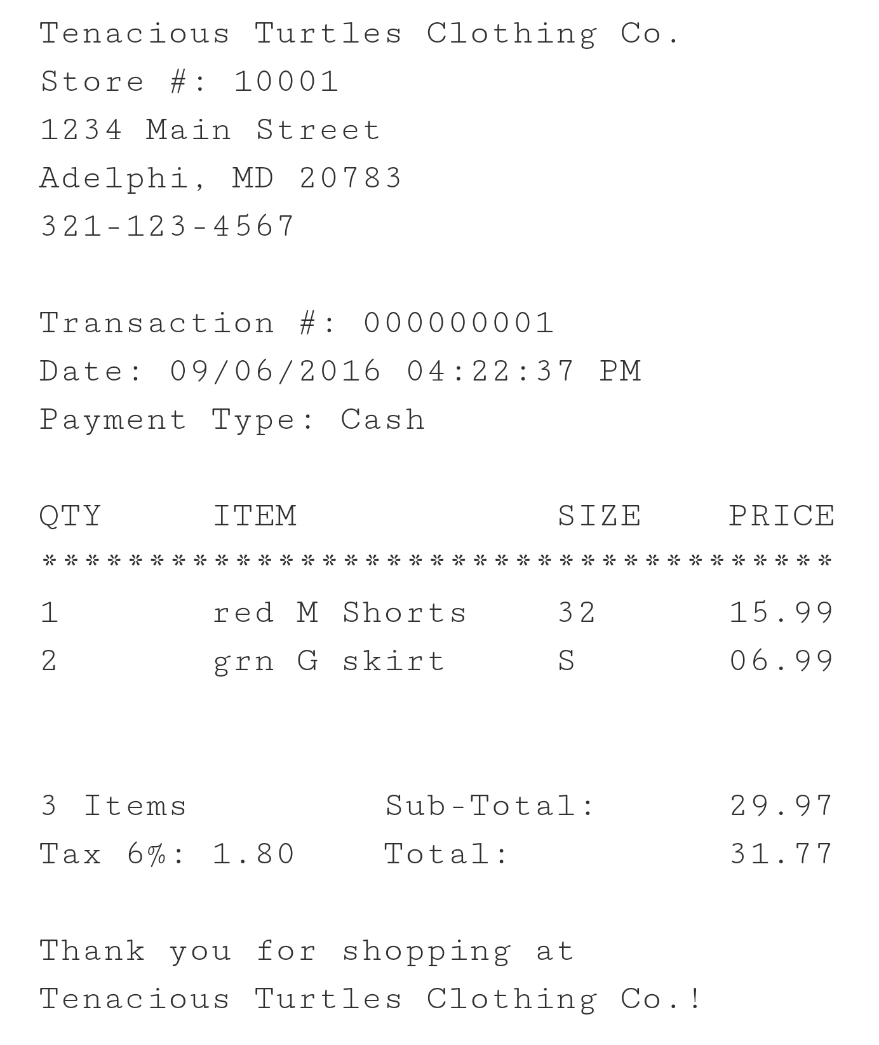

Example of return transaction receipt:

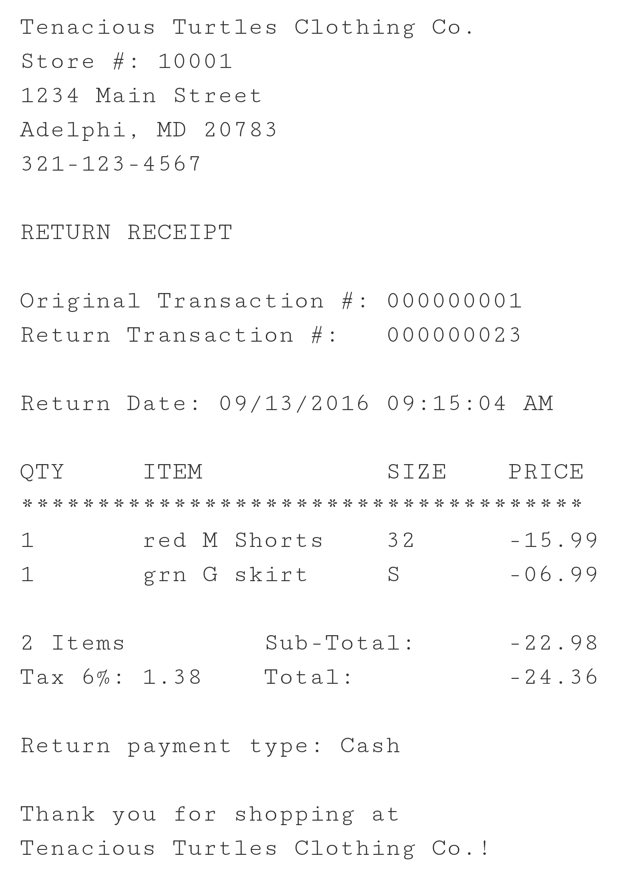

3.3 Inventory Lookup Function

3.3a Detailed Description of Inventory Lookup Function
This function will be used by employees to query their clothing inventory. The user will be responsible for inputting the UPC code and any other identifying information (Style, Color, Size, Gender) for the product they are inquiring about and then selecting the search button that is provided.

3.3b Preparation of Inventory Check Function Inputs
UPC Code – Code assigned to individual pieces of clothing
- Accepts integer of specified length
Style – Style of apparel
- Accepts alphabetic characters of variable length
Color – color of apparel
- Accepts alphabetic characters of variable length
Size – size of apparel
- Accepts sizes: S, M, L, XL, XXL
Gender – gender apparel is designed for
- Accepts M or F
Search button – button used to initiate search of inventory

The UPC Code will need to be entered before the search button can be selected. If the button is selected with no UPC Code, no results will be displayed. The other fields/options are optional. All of the fields can be filled-in in any order.

3.3c Results of Inventory Check Function
The inventory check function will display a list of products that meet the criteria that was entered by the user. After the inventory has been reviewed the user will be forwarded back to the transactions screen.

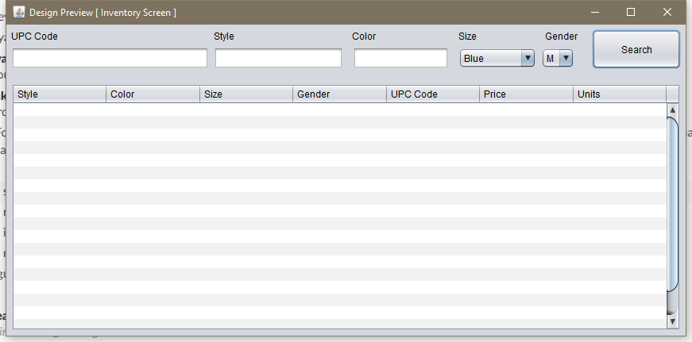

3.4 Transaction Report Function

3.4a Detailed Description of Transaction Report Function
This function will provide a transaction report to the user. The report will contain a summary of the sales and returns for a date range. The user will be responsible for inputting the date range that the report should be run for and any other fields specific to the situation (Transaction Type, UPC Code, Style, Color, Size, Gender, Associate) then selecting the Generate Report. See image below

3.4b Preparation of Transaction Report Function Inputs

Date Range – Date range for which report is to be run for
- Only accept date format integers
Transaction Type – Type of transactions for the report
- Select sales or returns only
UPC Code – Code assigned to individual pieces of clothing
- Accepts integer of specified length
Style – Style of apparel
- Accepts alphabetic characters of variable length
Color – color of apparel
- Accepts alphabetic characters of variable length
Size – size of apparel
- Accepts sizes: S, M, L, XL, XXL
Gender – gender apparel is designed for
- Accepts M or F
Associate – Accepts alphabetic characters of variable length

The only fields that are required to be filled in is the date range, all other fields are option and can be filled-in in any order. Without a date range specified, the report will not be generated.

3.4c Results of Transaction Report Function

This function will produce a visual report for the company personnel to view. After the report is reviewed the user will be forwarded back to the transactions screen. See image below

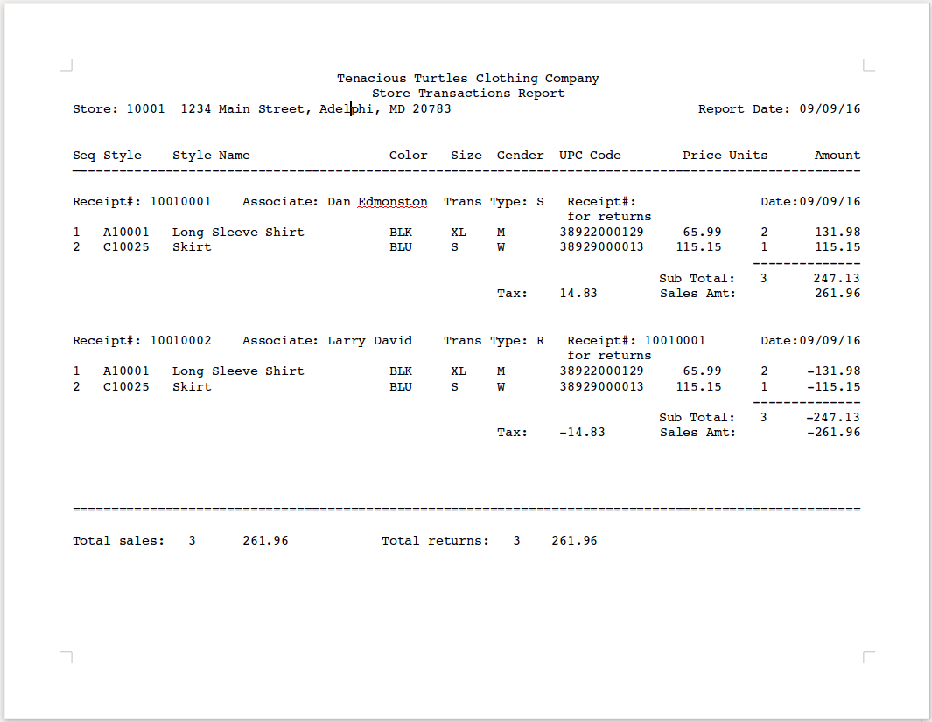

OPERATING INSTRUCTIONS

4.1a Initiate Log-In Operation
The software can be downloaded from the github repository at:

https://github.com/vancefm/CMSC495_Project

Upon initialization of APOS system, users are greeted by the login screen. They must input their store number, ID, and password in order to access any other functions provided by the program. The will then need to select the Log-In button. See image below

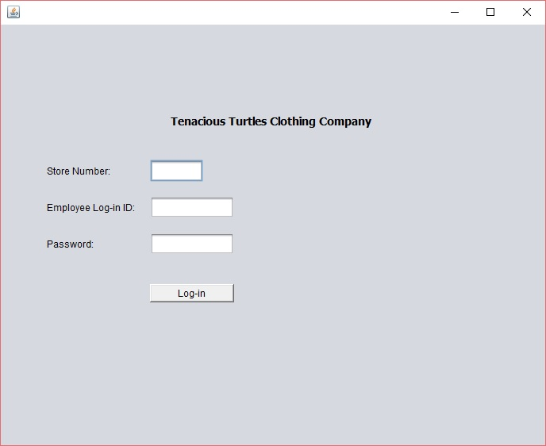

4.1b Initiate Sales Transaction Operation
Once logged into APOS system the user will select the transaction type of Sales. Next the UPC Code and units for the product/s the customer is purchasing will need to be inputted. Finally, to complete the transaction the user will select the Complete Transaction button. See image below

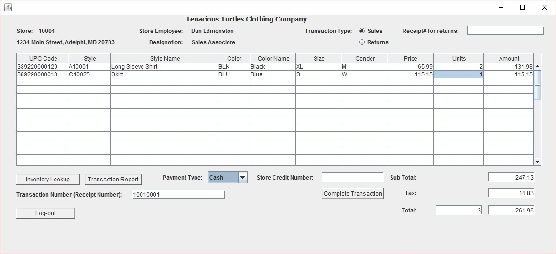

4.1c Initiate Return Transactions Operation
Once logged into APOS system the user will select the transaction type of Returns. Next the Receipt number will need to be entered to pull up purchase information. Lastly, the user will select the Complete Transaction button to complete the return. See image below

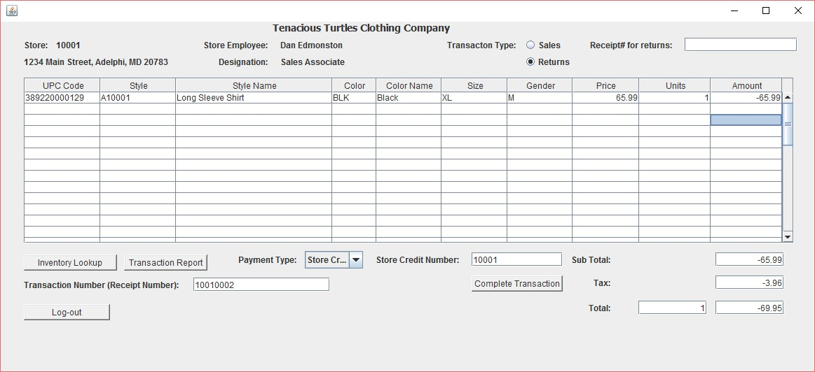

4.1d Initiate Inventory Lookup Operation
From the APOS system transactions screen the user will select the Inventory Lookup button located at the bottom left side of the menu. See image below

The user will then be presented with the inventory lookup screen. The user will need to input the UPC code and any other identifying information (Style, Color, Size, Gender) for the product they are inquiring about and then selecting the search button that is provided. See image below.

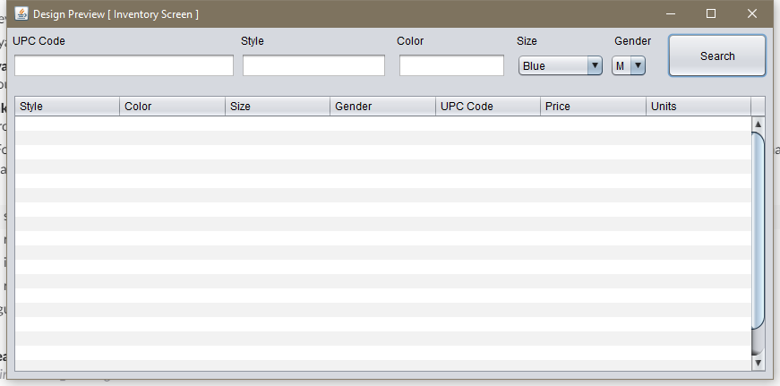

4.1e Initiate Transaction Report Operation
From Transaction screen, user can access Transaction Report Criteria screen. The user will need to enter a date range and then any of the other fields that apply to the situational report. Once all of the appropriate fields have been filled in, the user needs to select the Generate Report button located at the bottom of the menu. See image below
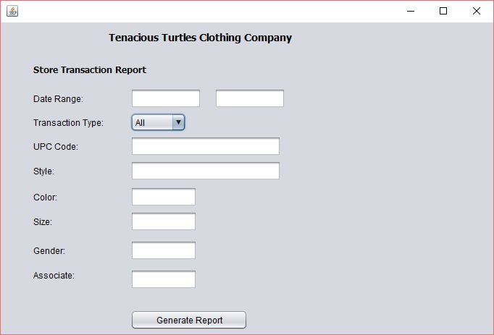

Maintain Operation
Not applicable to this system.

Terminate and Restart Operations
To terminate the software, simply log out and click the “X” in the top right of the program. If the program is not responding, find the process in task manager and manually end it. Simply open the program back up to restart it.

ERROR HANDLING
Error 1.1 - Invalid Store Number

When a user enters an invalid Store Number on Log-in screen, this error will appear. To resolve this error, enter correct Store Number.

Error 1.2 - Invalid Log-in ID or Password

When a user enters the wrong username or password, this error will appear. To resolve this error, ensure the user has the right login information available and inputs it correctly.

Error 2.1 – Invalid Item Entered

When a user enters an invalid UPC number for an item, this error will appear. To resolve this error, enter the correct UPC code.

Error 2.2 - Item not available in inventory.

After entering units, the system checks store inventory for item availability for the entered units. If store inventory does not have enough units, this error will appear. To resolve this error, enter units available by doing inventory look-up operation.

Error 2.3 – Invalid sales receipt for returns

When a user enters an invalid sales receipt number for returns, this error will appear. To resolve this error, enter the correct sales receipt number.

Error 2.4 – Not items to return

After entering a valid sales receipt number for returns, if all items in that sales receipt are already returned, then this error message appears.

HELP FACILITIES
To receive help with the program, contact the service desk by filling out the service request form at https://github.com/vancefm/CMSC495_Project/helpdesk

