SimpleFPV App
The simple fpv (first person view) app turn your android smartphone into a complete fpv system. With this app it is possible to control any rc capable vehicle through an wifi direct connection. The endpoints of this connection are two Android smartphones equippet with the SimpleFPV app
But first it's necessary to setup the system to get everything working.

System Setup
Your need a arduino and a bluetooth module for the arduino. The arduino itself act like a traditional rc receiver on the vehicle and also receive commands from both, rc receiver and the bluetooth module.
For the arduino you need the Serial2PWM sketch for the communication. The bluetooth module has to connect through the uart interface to the arduino. Bind the BT/Arduino converter to the smartphone which is placed next to the vehicle. For how to build up these converter, see the section „Build the Bluetooth and RC to PWM converter“.
If the vehicle and the arduino-bluetooth-rc-receiver combination is working you only need the SimpleFPV app installed on your smartphone to transform your vehicle into a fpv system.
On both smartphones install the SimpleFPV app. The app on the smarthone next to the vehicle should run in vehicle mode. The other smartphone should run in control center mode.
Activate the wifi-direct mode at both smartphones and bind it together. If this is done, both of the devices have an point-to-point (p2p) ip address. In the settings the ip of the device is shown. Usually it starts with „192.168.49.“. Now put into each ip into the opposite device. If this is done, every device know how to „talk“ to the other one.
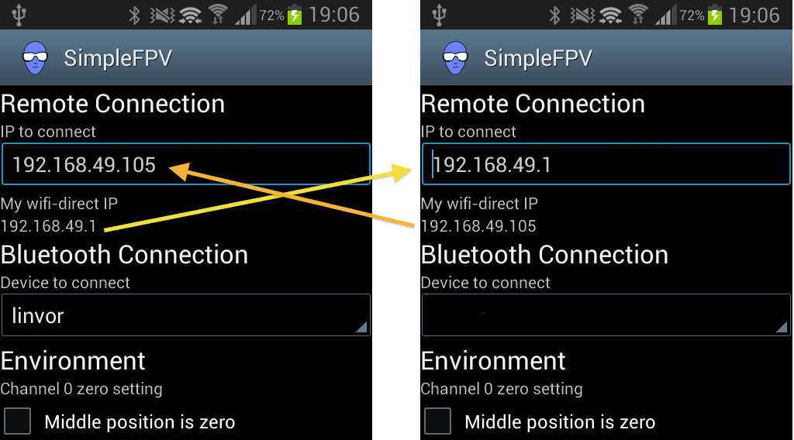
For the smartphone next to the vehicle, you should choose the bluetooth module on the settings page.
Some models does have the stop movement position on middle Stick position (Some cars with reverse for example). Others have the stop movement on the lower Stick position. This default setting can be set.
For controlling the model you have to use a game pad connected to the smartphone which is in „cround control“ mode. Some Android smartphones support bluetooth gamepad, some support usb gamepad with a USB-OTG cable.
You also need a frame and 2 lenses for to use the smartphone as video goggle. Check out Durovis Open Dive or something similar.

Build the Bluetooth and RC to PWM converter
It's easy to build. You just need a Arduino (Pro Mini for example) and a Bluetooth module with UART interface. Follow these steps:
- Change the speed of the Bluetooth module to 115200 Baud.
(for example send a „AT+BAUD8“ to your Bluetooth module)
- Upload the Arduino sketch Serial2PWM (available on the mobile2power website) or connect the Bluetooth module with your MultiWii board.
- Connect the power of your model with the Arduino (BEC)
- Connect the appropriate PWM pins of the Arduino with the signal input of your model (Servo, ESC)
- Connect the UART/serial pins of the Bluetooth module with the UART/serial pins of your Arduino and don't forget power and ground.
That's it. Now your converter should be ready. After you have bounded the Bluetooth module with the smartphone it should be showed in the options menu of the App.

Enhanced version
There is also another Arduino sketch available (SerialAndRC2PWM) to use an additional rc receiver on the arduino. This enhanced version uses the pins 2, 4, 5, 6 and 7 on the arduino board for the input of the receiver channels. The pin 7 is uses to switch between the control of the model through the rc receiver and the control through the Bluetooth module as in the simple converter version described above.
This is really helpful if you want to be shure to have all the time the full control of your model. It's comparable to a traditional studend-instructor rc setup.

How to use SimpleFPV
As mentioned bevore the App has two modes for operation. There is one to control with all the input capabilities for the user. The other mode act like a „bridge“ to the vehicle in terms of controlling it. All the control inputs are received from the „control center“ through the internet and transfered through bluetooth to the arduino which itself send the pwm signal to the vehicle.
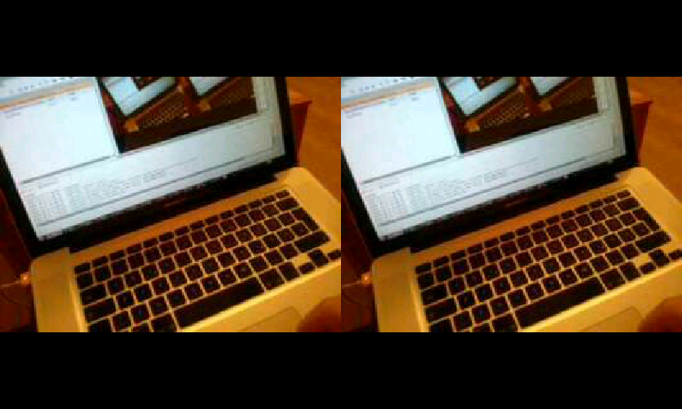
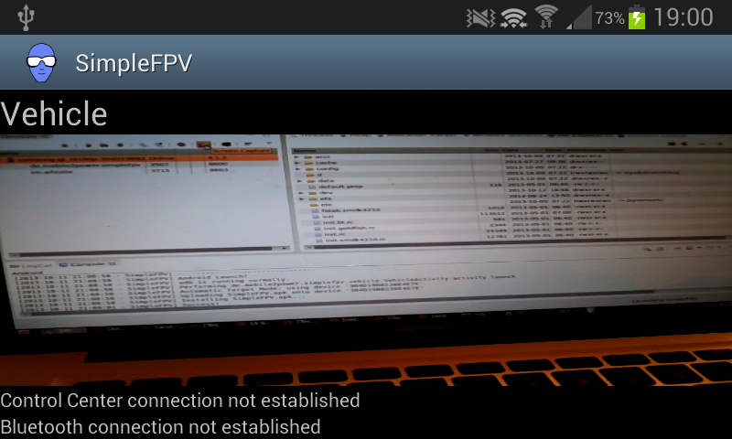
On the screenshots above you can see the „vehicle mode“ on the left side and the „control center mode“ on the right side.
To switch between the modes and also to configure the app as well as to initiate the connection to each other, there are several menu items as you can see on the following screenshots.
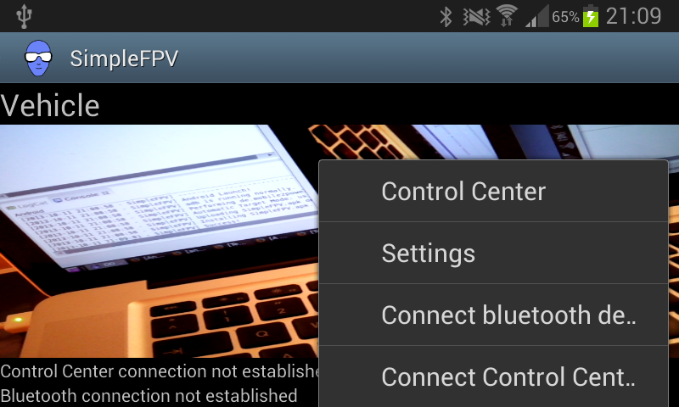
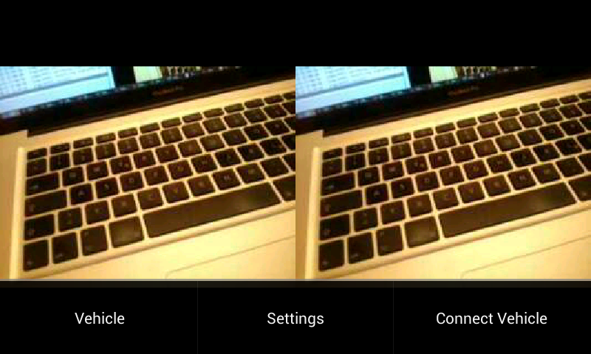
If everything is configured and both apps are running in the appropriate mode you can connect all parts with the connect menu items. If the connection is established you can choose „connect ground control“ and „connect vehicle“ at nearly the same time.
If both apps have connected each other, the live preview appears on the control center.

Warning
The wifi direct connection might not be reliable. There are a lot of things which can interrupt the connection between both smartphones. Therefore DO NOT CONTROL any vehicle ONLY with this App which can cause several damages in case of a communication error! For example all kind of AIRCRAFT.

Appendix - Data Format
The data format is the same as used by the MultiWii project (version 2.1). The App send's all the time all channel information. It consist of 22 bytes. The first three byte contains the start sequence. It's followed by the payload length and the packet type (200 = RCDATA). After that 8 integer values with the size of 16 bit contain the channel information. The last byte is a checksum builded just by XOR through all bytes except the start sequence.

No. | Name | Value / Range | Comment
1 – 3 | Startsequence | '$M>'
4 | Data length | 16 | 8 channels * 2 byte
5 | Packet type | 200 | RCDATA
6 – 7 | Channel1 | 1000 – 2000 | 6:low, 7:high byte
8 – 9 | Channel2 | 1000 – 2000 | 8:low, 9:high byte
10 – 11 | Channel3 | 1000 – 2000 | 10:low, 11:high byte
12 – 13 | Channel4 | 1000 – 2000 | 12:low, 13;high byte
14 – 15 | Aux | 1000 – 2000 | Not used
16 – 17 | Move Channel1 | 1000 – 2000 | 16:low, 17:high byte
18 – 19 | Move Channel2 | 1000 – 2000 | 18:low, 19:high byte
20 – 21 | Move Channel3 | 1000 – 2000 | 20:low, 21:high byte
22 | Checksum | 0 – 255 | XOR byte 4 to 21

