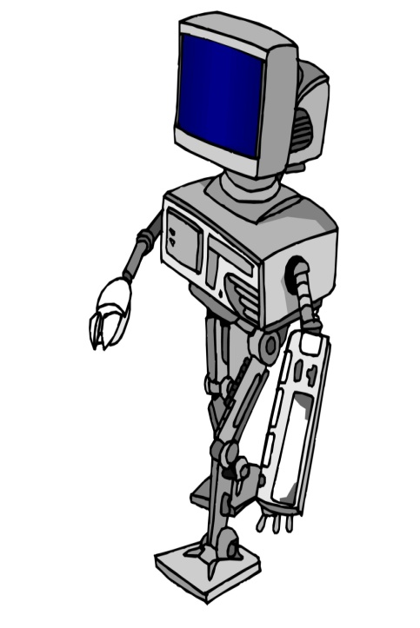Mask-Detector

**What is AI?**

For years, it was thought that computers would never be more powerful than the human brain, but as development has accelerated in modern times, this has proven to be not the case. AI as a concept refers to computing hardware being able to essentially think for itself, and make decisions based on the data it is being fed. AI systems are often hugely complex and powerful, with the ability to process unfathomable depths of information in an extremely quick time in order to come to an effective conclusion.

**Why Mask-Detection?**

In these tough COVID-19 times, it is very helpful if we could find the person without mask so that others stay protected so to do so we build a very simple and basic Convolutional Neural Network (CNN) model using TensorFlow withKeras library to detect if a person is wearing a face mask or not.

**How It works?**

It is based on the Convolutional neural Networks for classification of the images captured which are present in captured format. This could be further extended to realtime detection of face mask with the usage of openCV library and some other functionalities of Keras and TensorFlow. The code for the project is provided in the “mask-detector.ipynb” file with the training and testing dataset present in respective folders.

By:-

Manish