Academic Year 2015/2016
Warsaw University of Technology
Faculty of Electronics and Information Technology
Electrical and Computer Engineering
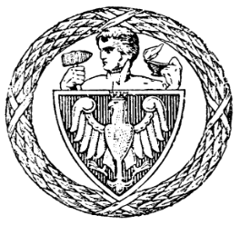
Master OF SCIENCE THESIS
Marek Lewandowski
Multi partition transactions in Cassandra
Supervisor
dr inż. Jacek Lewandowski

Evaluation:

Signature of the Head
of Examination Committee
Studies: Computer Science
Specialization: Computer Information System Engineering
Starting Date of Studies: 2013.10.01

Signature of the Student

Master of Science Examination
Examination was held on: 2016
With the result:
Final Result of the Studies:
Suggestions and Remarks of the B.Sc. Examination Committee:

