

***Business Process Guide -***

***Financial Aid Reports***

**Version *1.1***

***3/20/2018***

Table of Contents

Version Control 1

Regent Data Views Overview 2

Prerequisites and Assumptions 2

Reference Documents 2

1-Introduction 3

2-How to Access the Financial Aid Report Server 4

Summary 4

Accessing Report Server and Running Reports 4

*Favorites* 6

*Searching For Reports* 7

*Change View Layout* 8

*Running Reports* 8

3-UW FLEX Financial Aid Reports 10

Summary 10

Financial Aid Report Categories 10

Financial Aid Report Details – Award Related 11

*Anticipated Aid with Account Balances – ALL_UWC* 12

*Anticipated Aid with Account Balances_ALL_UWM* 14

*Anticipated Aid with Account Balances GTO_UWC* 16

*Anticipated Aid with Account Balances GTO_UWM* 18

*Anticipated Aid with Student Breaks* 20

*Award Change History Report* 22

*Award Change History by ID* 24

*Award Letter* 26

*COD Award Disb ErrorCode 039* 29

*COD Award Disb ErrorCode Selection* 31

*MPN and ELC Missing – for students with accepted award* 33

*Student Awards ALL* 35

*Student Awards by Institution* 37

*Students Awarded by Date Range* 39

*Students Accepted Unsub but not Sub* 41

*Students Awarded Pell with Prior Bach Degree* 43

*WI Students Awarded Pell* 44

Financial Aid Report Details – Data Discrepancies 45

*Attendance = True when Last Attended Date is null* 46

*Deleted Courses – 1st 7 digits of External Course ID = PRISM ID* 47

*Duplicate courses* 48

*External Course ID First 7 digits not equal to External ID2* 50

*Inactive Records that should be active* 51

*Last Attended Date Not Equal to Course End Date* 52

*Last Attended Date & Letter Grade null for Course End Dates passed* 54

*Letter Grade = W and Withdrawal Date Less than Start Date* 56

*Repeats Should be YES* 58

*Students Missing Flex ID* 60

*Withdrawal Date < Course Start and Attendance = true* 61

*Withdrawal Date Not Equal Last Attendance Date* 63

*Withdrawal Date Not Null and Quality Points <> ZERO* 64

*Withdrawal Date NULL and Letter Grade In Progress (IP, PR)* 65

Financial Aid Report Details – Disbursements 67

*Disbursements Paid by Campus* 68

*Disbursements Paid by Campus and Date Range* 70

*Disbursements Paid by FA Year and Fund* 72

*Disbursements Paid by Student ID* 74

Financial Aid Report Details – ISIR and Verification 76

*HS Completion Required* 77

*ISIR – No Taxes Filed* 79

*ISIR Received – APS Needed* 81

*ISIR Received ALL – Select Dates* 83

*ISIR Received By Institution – Select Dates* 85

*ISIR Received By Institution – Select Dates* 86

Financial Aid Report Details – Miscellaneous Reports 87

*Enrollment Data – ALL Institutions* 88

*FA Funnel Data* 89

*Graduation Date Populated on SBL* 90

*Reconciliation Report* 91

*Reconciliation Report By Fund* 92

*SAP – Completion Rate by Student* 94

*SAP – Completion Rate w/PayPeriod by Student* 95

*Student Cost of Attendance by Financial Aid Year* 96

*Student Course Data by ID* 97

*Student Debt Letter Data* 98

# Version Control

|  |  |  |  |
| --- | --- | --- | --- |
| Version # | Version Date | Revised By | Description of Change |
| Initial Draft | 7/11/2017 | Maria Lindquist | Original draft, process steps, screenshots |
| 1.1 | 3/20/2018 | Maria Lindquist | Additional reports added |
|  |  |  |  |
|  |  |  |  |
|  |  |  |  |

# Regent Data Views Overview

Regent Data Extract Views are used to obtain data that cannot be currently obtained via the Regent 8 application or to obtain large amounts of data which if accessed via Regent 8 may have a negative impact on application performance.

## Prerequisites and Assumptions

Before you can run Regent Data View Reports the following needs to happen:

| Prerequisites and Assumptions | |
| --- | --- |
| Prerequisite/Assumption | Detail |
| Access to FA Report Server to run reports | Submit a footprint ticket to get access to run Regent Data View Reports |

## Reference Documents

Below are some documents that are reference throughout this document.

| Prerequisites and Assumptions | |
| --- | --- |
| Item | LINK |
| SBL Data Dictionary |  |
| ISIR Record Layouts |  |
|  |  |
|  |  |

# 1-Introduction

The purpose of this document is to provide information on how users may connect and access the Financial Aid Report Server to run financial aid related reports that will help them in their every day work. It is important to note that the Financial Aid Reports are still undergoing development. Therefore, the reports referenced in this document and the document itself is not finalized.

# 2-How to Access the Financial Aid Report Server

## Summary

The purpose of this section is to provide information on how users can access the Financial Aid Report Server, Run Reports and how to personalize the Financial Aid Report Server dashboard.

## Accessing Report Server and Running Reports

1. To access the report server, you navigate to the following website – <http://ce-sql2016/reports>
2. Enter your network username and password. Click OK.

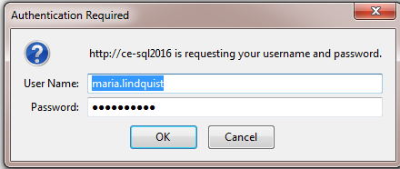

1. The screen should look similar to below.

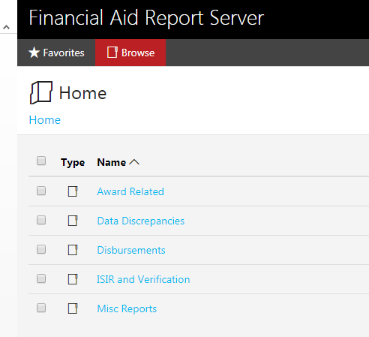

NOTE: If there aren’t any options showing submit a footprint ticket that you are not able to see any report folders on the Financial Aid Report Server. Be sure to include a screen shot.

1. The reports are categorized to the type of report they are. Click on the folder where the report is located that you want to run.

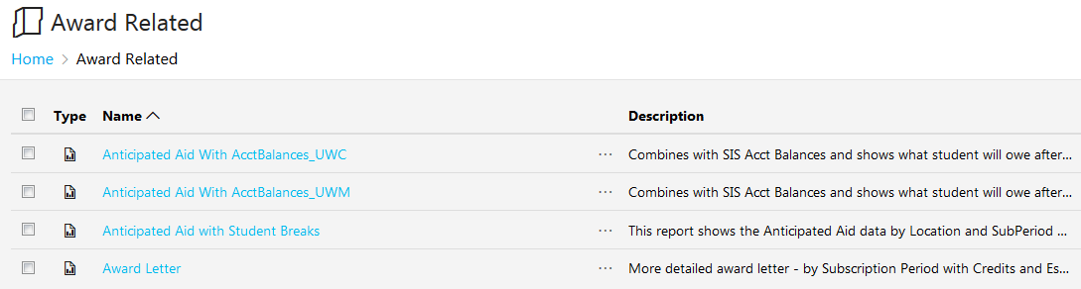

1. You will be able to see the **Description**, **Modified Date** and **Modified by** for each report.
2. To get back to the Home to view the different report folders, click on **Browse**.

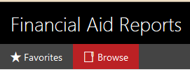

### *Favorites*

1. If you want to set any specific reports as your favorite, right click on the row that contains the Report you want to favorite then click on **Add to Favorite**.

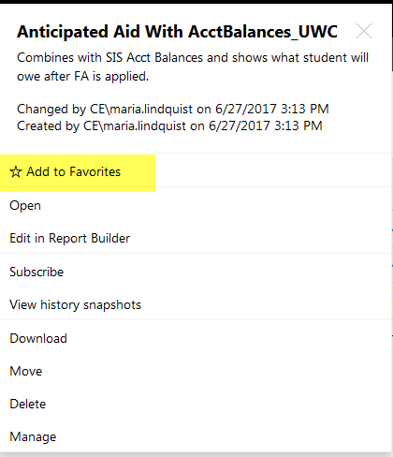

**NOTE:** What is displayed on the above for you depends on your security.

1. After you select Add to Favorite a star will be added to the right of the Report Name.



1. It will also be added to the Favorite section. To access Favorites click on **★Favorites** in the upper left hand side of the screen.

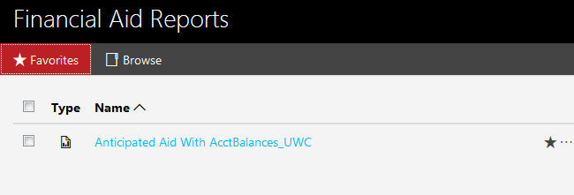

### *Searching For Reports*

1. If you can’t remember where a certain report is located or you didn’t save to your favorites you can use the Search box to type in any part of the title. The Search box is located just below your name on the top right hand side.

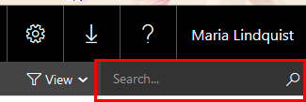

1. Enter any part of the name here and click Enter.

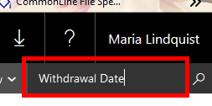

1. Whatever you enter in the Search will display results for name and description that includes what you enter.

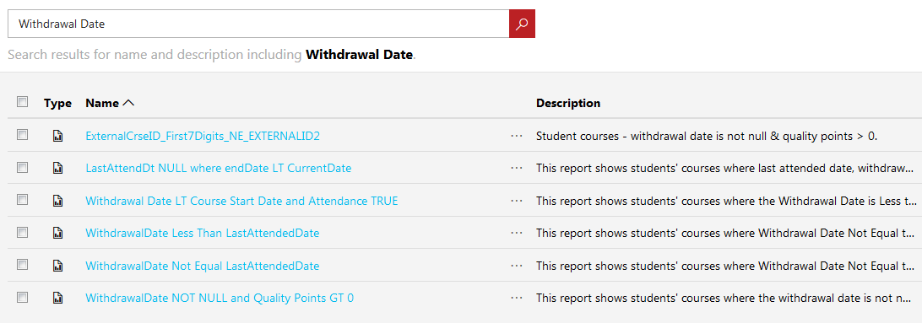

### *Change View Layout*

1. You can also change the View Layout. To do that click on the View drop down and choose the view you would like – Tiles or List. So far we have been viewing a List view. Here is what it looks like for the Tiles view.

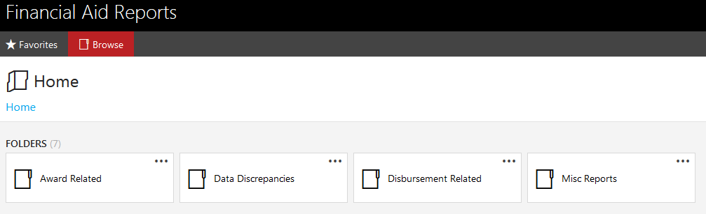

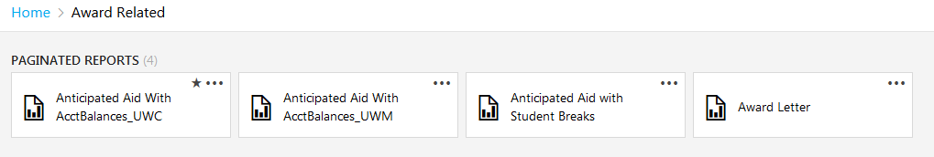

### *Running Reports*

1. To run a report click on the report name that you would like to run and then enter the parameters.
2. After you run the report, you will have different options from this bar to choose to do with the report.



**A** If there is more than one page, you use this to navigate between pages.

**B** If you change the parameters, click on this to refresh/rerun the report.

**C** If there is a parent report, click on this will go back to the Parent report.

**D** Use this to change the size of the report on the screen. Click on the drop down for options.

**E** Use this to save the report in a certain format. Here are the different options:

* Word
* Excel
* PowerPoint
* PDF
* TIFF File
* MHTML (web archive)
* CSV (comma delimited)
* XML File with report data
* Data Feed

**F** Use this to create a printer-friendly PDF version of your report. Once you click on Print, you have the option to change the Page size and orientation.

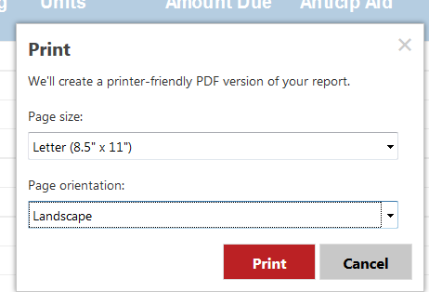

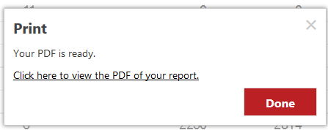

**G** Use this find information on the report such as a student name, etc..

# 3-UW FLEX Financial Aid Reports

## Summary

The purpose of this section is to provide a collection of reports that have been created via Regent Data Extract Views and other systems for operational uses for the Financial Aid and other departments. There will be detailed information about each report that is created and what is its purpose.

## Financial Aid Report Categories

* Award Related – all the reports in this category are related to awarding.
* Data Discrepancies – all the reports in this category are reports designed to make sure that the business rules for the Student Batch Load attributes and elements are being implemented.
* Disbursements – all the reports in this category are related to disbursements.
* ISIR and Verification – all the reports in this category are related to ISIR and Verification Processing
* Miscellaneous Reports – the reports in this category are not yet categorized

NOTE: This is a work in progress list. More categories can be added at a later time.

## Financial Aid Report Details – Award Related

* Anticipated Aid with AcctBalances_ALL_UWC
* Anticipated Aid with AcctBalances_ALL_UWM
* Anticipated Aid with AcctBalances_GTO_UWC
* Anticipated Aid with AcctBalances_GTO_UWM
* Anticipated Aid with Student Breaks
* Award Change History ALL (NEW)
* Award Change History by ID (NEW)
* Award Letter
* COD Award Disb ErrorCode 039
* COD Award Disb ErrorCode Selection
* MPNandELCMissing-AwardAccept
* Student Awards ALL
* Student Awards by Institution
* Students Accepted Unsub Before Sub
* Students Awarded by Date Range
* Students Awarded Pell with Prior Bach Degree
* WI Students Awarded Pell

### *Anticipated Aid with Account Balances – ALL_UWC*

**Report Description**

The Anticipated Aid with Account Balances for UW Colleges report shows all the students enrolled for the specific term, their balance on the run date and if they are receiving enough aid that will cover their balance.

**System(s):** Regent, PRISM

**Business Purpose/Use**

On the 11th day of classes, if a student hasn’t paid their balance does not have enough financial aid to cover it, they will be dropped for non-payment.

**Who Uses Report:** FA Coordinators, Registrar’s Office

**Frequency:** 12th day of the month

**Pre-Requisite**

Before running this report, a query will need to be ran from PRISM, a CSV generated and then imported into the Regent Data Views Database (will be scheduled in the future).

**Report Criteria Notes**

* Subscription Period = IF Disbursement Adjusted Release Date is null, THEN use Disbursement Scheduled Date ELSE use the Disbursement Adjusted Release Date, but if the Disbursement Adjusted Release Date = 10/1/xxxx then use the Scheduled Disbursement Date.
* Disbursement Status Code = SCHEDULED
* Award Status Code = ACCEPTED

**Report Prompts:** None

**Navigation:** Award Related > Anticipated Aid with AcctBalances_ALL_UWC

**Example of Report**

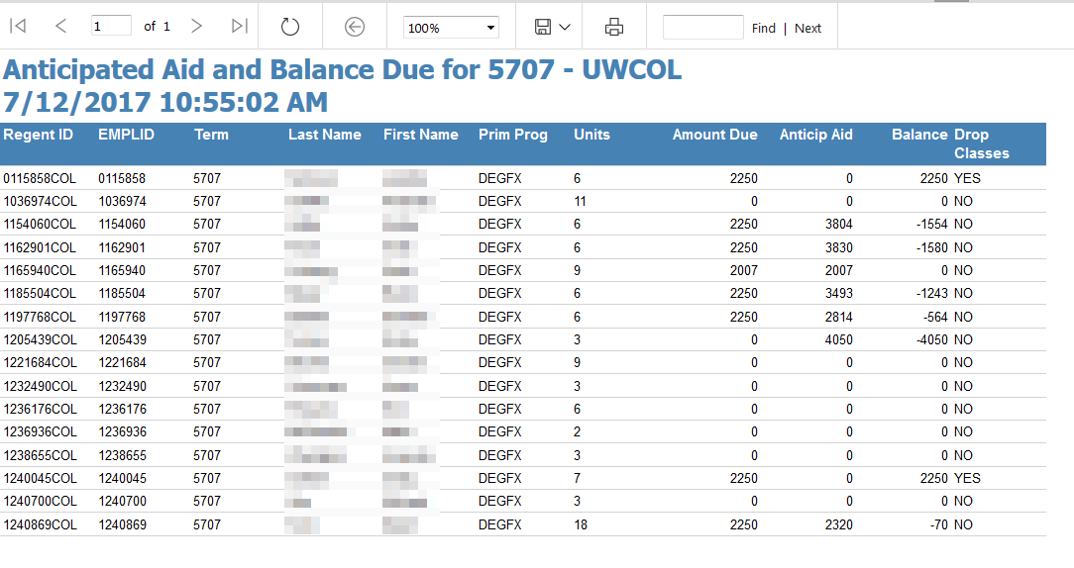

**Technical Specs:** See GitHub repository for current specs.

**Columns**

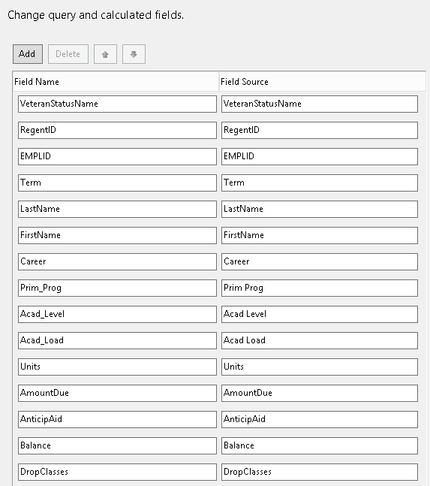

**Tables/Views**

|  |  |
| --- | --- |
| **Table/View Name** | **Type** |
| FLEXAcctBalancesUWC | Table (created from SSIS Package) |
| dataExtract_Student_View | View |
| dataExtract_StudentDetail_View | View |
| dataExtract_AwardDisbursement_View | View |
| dataExtract_StudentBreak_View_v001 | View |
| dataExtract_CourseData_View | View |

**Parameters - NONE**

### *Anticipated Aid with Account Balances_ALL_UWM*

**Description**

The Anticipated Aid with Account Balances for UW Milwaukee report shows all the students enrolled for the specific term, their balance on the run date and if they are receiving enough aid that will cover their balance.

**System(s):** Regent, PAWS

**Business Purpose/Use**

On the 11th day of classes, if a student hasn’t paid their balance does not have enough financial aid to cover it, they will be dropped for non-payment.

**Who Uses Report:** FA Coordinators, Registrar’s Office

**Frequency:** 12th day of the month

**Pre-Requisite**

Before running this report, a query will need to be ran from PAWS, a CSV generated and then imported into the Regent Data Views Database (will be scheduled in the future).

**Report Criteria Notes**

* Subscription Period = IF Disbursement Adjusted Release Date is null, THEN use Disbursement Scheduled Date ELSE use the Disbursement Adjusted Release Date, but if the Disbursement Adjusted Release Date = 10/1/xxxx then use the Scheduled Disbursement Date.
* Disbursement Status Code = SCHEDULED
* Award Status Code = ACCEPTED

**Report Prompts: NONE**

**Navigation:** Award Related > Anticipated Aid with AcctBalances_ALL_UWM

**Example of Report**

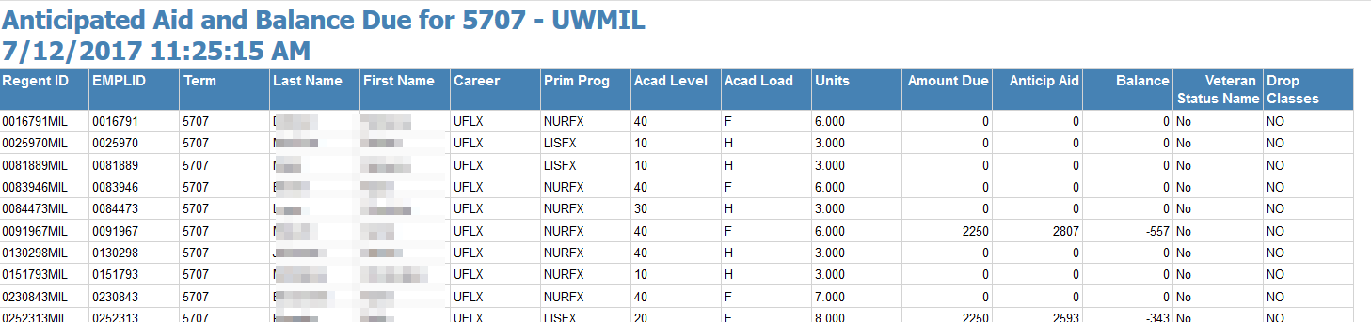

**Technical Specs:** See GitHub repository for current specs.

**Columns**



**Tables/Views**

|  |  |
| --- | --- |
| **Table/View Name** | **Type** |
| FLEXAcctBalancesUWC | Table (created from SSIS Package) |
| dataExtract_Student_View | View |
| dataExtract_StudentDetail_View | View |
| dataExtract_AwardDisbursement_View | View |
| dataExtract_StudentBreak_View_v001 | View |
| dataExtract_CourseData_View | View |

**Parameters - NONE**

### *Anticipated Aid with Account Balances GTO_UWC*

**Description**

The Anticipated Aid with Account Balances for UW Colleges report shows all the students enrolled for the specific term, their balance on the run date and if they are receiving enough aid that will cover their balance. This report only shows students with an SIS Account Balance greater than zero.

**System(s):** Regent, PRISM

**Business Purpose/Use**

The purpose of this report is for the Bursar to find out what students still owe a balance on the day tuition is due each month so she can personally contact.

**Who Uses Report:** FA Coordinators, Registrar’s Office

**Frequency:** Generated Daily

**Pre-Requisite**

Before running this report, a query is required to run in PRISM in which a CSV is generated and then imported into the Regent Data Views Database (scheduled).

**Report Criteria Notes**

* Subscription Period = IF Disbursement Adjusted Release Date is null, THEN use Disbursement Scheduled Date ELSE use the Disbursement Adjusted Release Date, but if the Disbursement Adjusted Release Date = 10/1/xxxx then use the Scheduled Disbursement Date.
* Disbursement Status Code = SCHEDULED
* Award Status Code = ACCEPTED
* SIS Amount Due > ZERO

**Report Prompts: NONE**

**Navigation:** Award Related > Anticipated Aid with AcctBalances_GTO_UWC

**Example of Report**

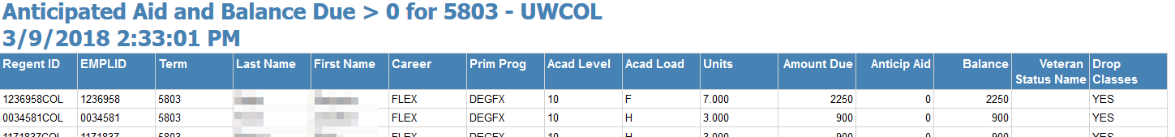

**Technical Specs:** See GitHub repository for current specs.

**Columns**



**Tables/Views**

|  |  |
| --- | --- |
| **Table/View Name** | **Type** |
| FLEXAcctBalancesUWC | Table (created from SSIS Package) |
| dataExtract_Student_View | View |
| dataExtract_StudentDetail_View | View |
| dataExtract_AwardDisbursement_View | View |
| dataExtract_StudentBreak_View_v001 | View |
| dataExtract_CourseData_View | View |

**Parameters - NONE**

### *Anticipated Aid with Account Balances GTO_UWM*

**Description**

The Anticipated Aid with Account Balances for UW Milwaukee report shows all the students enrolled for the specific term, their balance on the run date and if they are receiving enough aid that will cover their balance. This report only shows students with an SIS Account Balance greater than zero.

**System(s):** Regent, PAWS

**Business Purpose/Use**

The purpose of this report is for the Bursar to find out what students still owe a balance on the day tuition is due each month so she can personally contact.

**Who Uses Report:** FA Coordinators, Registrar’s Office

**Frequency:** Generated Daily

**Pre-Requisite**

Before running this report, a query is required to run in PAWS in which a CSV is generated and then imported into the Regent Data Views Database (scheduled).

**Report Criteria Notes**

* Subscription Period = IF Disbursement Adjusted Release Date is null, THEN use Disbursement Scheduled Date ELSE use the Disbursement Adjusted Release Date, but if the Disbursement Adjusted Release Date = 10/1/xxxx then use the Scheduled Disbursement Date.
* Disbursement Status Code = SCHEDULED
* Award Status Code = ACCEPTED
* SIS Amount Due > ZERO

**Report Prompts: NONE**

**Navigation:** Award Related > Anticipated Aid with AcctBalances_GTO_UWM

**Example of Report**

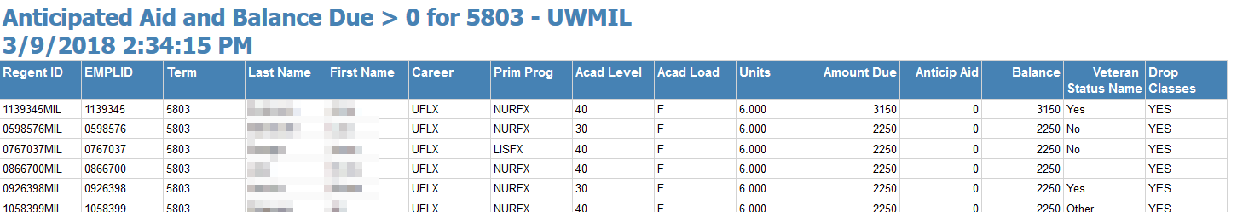

**Technical Specs:** See GitHub repository for current specs.

**Columns**



**Tables/Views**

|  |  |
| --- | --- |
| **Table/View Name** | **Type** |
| FLEXAcctBalancesUWC | Table (created from SSIS Package) |
| dataExtract_Student_View | View |
| dataExtract_StudentDetail_View | View |
| dataExtract_AwardDisbursement_View | View |
| dataExtract_StudentBreak_View_v001 | View |
| dataExtract_CourseData_View | View |

**Parameters - NONE**

### *Anticipated Aid with Student Breaks*

**Description**

The Anticipated Aid with Student Breaks report shows all the students enrolled for the specific term who is receiving financial aid and if they have breaks.

**System(s):** Regent

**Business Purpose/Use**

On the 11th day of classes, if a student hasn’t paid their balance does not have enough financial aid to cover it, they will be dropped for non-payment.

**Who Uses Report:** FA Coordinators

**Frequency:** Ad hoc basis

**Pre-Requisite:** None

**Report Criteria Notes**

* Subscription Period = IF Disbursement Adjusted Release Date is null, THEN use Disbursement Scheduled Date ELSE use the Disbursement Adjusted Release Date, but if the Disbursement Adjusted Release Date = 10/1/xxxx then use the Scheduled Disbursement Date.
* Disbursement Status Code = SCHEDULED
* Award Status Code = ACCEPTED

**Report Prompts**

* Location – pick from drop down the Institution you want to run the report for
* Sub Period – enter the subscription period you want to see the report for.
* Break End Date – enter the day before the course start date of the subscription period.
* Course Start Date – the course start date of the subscription period (ex. 7/2/2017)

**Navigation:** Award Related > Anticipated Aid with Student Breaks

1. Pick the location from the Drop Down
2. Enter the Subscription Period (ex. 5710)
3. Enter **Course Start Date** in the format MM/DD/YYYY or click on the calendar to pick the exact date.

**Example of Report**

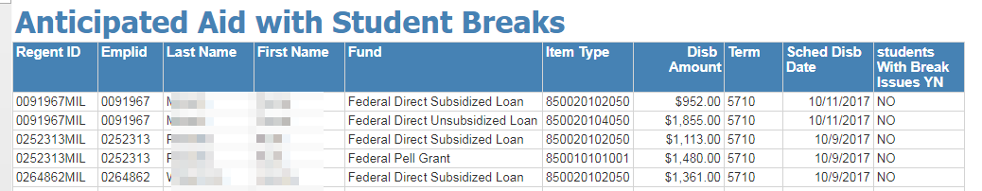

**Technical Specs:** See GitHub repository for current specs.

**Columns**

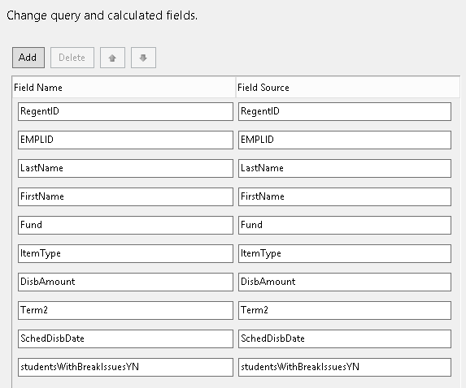

**Tables/Views**

|  |  |
| --- | --- |
| **Table/View Name** | **Type** |
| dataExtract_AwardDisbursement_View | View |
| dataExtract_Student_View | View |
| dataExtract_StudentBreak_View_v001 | View |
| dataExtract_CourseData_View | View |

**Parameters**

* @location
* @CrseStart
* @SubPeriod

### *Award Change History Report*

**Description**

This report shows all the students with their award history.

**System(s):** Regent

**Business Purpose/Use**

The purpose of the Award Change History is to see a student award history

**Who Uses Report:** FA Coordinators

**Frequency:** On an adhoc basis

**Pre-Requisite:** Student needs to be awarded in Regent 8.

**Report Criteria Notes:** NONE

**Report Prompts:** NONE

**Navigation:** Award Related > Award Change History ALL

**Example of Report**

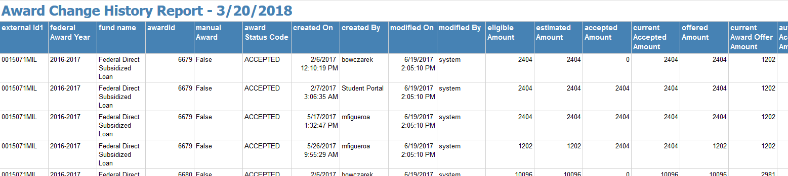

**Technical Specs:** See GitHub repository for current specs.

**Columns**

|  |  |
| --- | --- |
| **Field Name** | **Field Source** |
| externalId1 | externalId1 |
| federalAwardYear | federalAwardYear |
| fund_name | fund_name |
| awardid | awardid |
| manualAward | manualAward |
| awardStatusCode | awardStatusCode |
| createdOn | createdOn |
| createdBy | createdBy |
| modifiedOn | modifiedOn |
| modifiedBy | modifiedBy |
| eligibleAmount | eligibleAmount |
| estimatedAmount | estimatedAmount |
| acceptedAmount | acceptedAmount |
| currentAcceptedAmount | currentAcceptedAmount |
| offeredAmount | offeredAmount |
| currentAwardOfferAmount | currentAwardOfferAmount |
| autoAcceptedAmount | autoAcceptedAmount |
| paidAmount | paidAmount |
| Amount | Amount |
| loanPeriodStartDt | loanPeriodStartDt |
| loanPeriodEndDt | loanPeriodEndDt |
| awardPeriodStartDt | awardPeriodStartDt |
| awardPeriodEndDt | awardPeriodEndDt |
| awardPeriod | awardPeriod |

**Tables/Views**

|  |  |
| --- | --- |
| **Table/View Name** | **Type** |
| dataExtract_Award_View_v002 | View |
| dataExtract_AwardChange_View_v001 | View |
| dataExtract_LoanPeriod_View_v001 | View |
| dataExtract_Fund_Config_View | View |

**Parameters: NONE**

### *Award Change History by ID*

**Description**

This report shows the award history for a select student ID.

**System(s):** Regent

**Business Purpose/Use**

The purpose of the Award Change History is to see a student’s award history

**Who Uses Report:** FA Coordinators

**Frequency:** On an adhoc basis

**Pre-Requisite:** Student needs to be awarded in Regent 8.

**Report Criteria Notes:** NONE

**Report Prompts:** NONE

**Navigation:** Award Related > Award Change History by ID

**Example of Report**

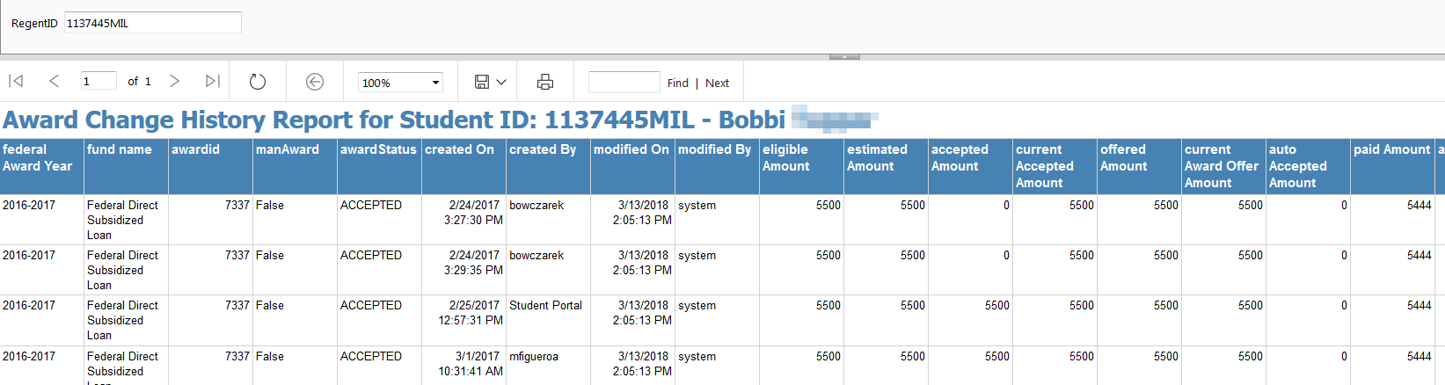

**Technical Specs:** See GitHub repository for current specs.

**Columns**

|  |  |
| --- | --- |
| **Field Name** | **Field Source** |
| externalId1 | externalId1 |
| federalAwardYear | federalAwardYear |
| fund_name | fund_name |
| awardid | awardid |
| manualAward | manualAward |
| awardStatusCode | awardStatusCode |
| createdOn | createdOn |
| createdBy | createdBy |
| modifiedOn | modifiedOn |
| modifiedBy | modifiedBy |
| eligibleAmount | eligibleAmount |
| estimatedAmount | estimatedAmount |
| acceptedAmount | acceptedAmount |
| currentAcceptedAmount | currentAcceptedAmount |
| offeredAmount | offeredAmount |
| currentAwardOfferAmount | currentAwardOfferAmount |
| autoAcceptedAmount | autoAcceptedAmount |
| paidAmount | paidAmount |
| Amount | Amount |
| loanPeriodStartDt | loanPeriodStartDt |
| loanPeriodEndDt | loanPeriodEndDt |
| awardPeriodStartDt | awardPeriodStartDt |
| awardPeriodEndDt | awardPeriodEndDt |
| awardPeriod | awardPeriod |

**Tables/Views**

|  |  |
| --- | --- |
| **Table/View Name** | **Type** |
| dataExtract_Award_View_v002 | View |
| dataExtract_AwardChange_View_v001 | View |
| dataExtract_LoanPeriod_View_v001 | View |
| dataExtract_Fund_Config_View | View |

**Parameters: NONE**

### *Award Letter*

**Description**

The Award Letter is a report in letter format. The award letter here is a more detailed award letter for the student. It includes estimated tuition based on the number of classes a students is taking/intending to take and the number of credits.

**System(s):** Regent

**Business Purpose/Use**

The anticipated aid is not imported into the partner institution for current and future subscription periods. Because of this a more detailed award letter to students is required so that students know about how much aid they will be receiving and can plan ahead if they will be required to pay out of pocket. This is also something that cannot be generated in Regent.

**Who Uses Report:** FA Coordinators

**Frequency:** On an adhoc basis

**Pre-Requisite:** Student needs to be awarded in Regent 8.

**Report Criteria Notes**

* Tuition Amounts = If number of classes > 1 then 2250 else use 900.
* Out of Pocket Amount = Estimated Tuition - Sum of ACCEPTED Amount

**Report Prompts**

* Regent ID – enter the external ID 1 that displays in Regent 8 (ex. 1234567COL)
* Start Date – this is the program start date that you want to be listed first on the award letter (Subscription Period).

**Navigation:** Award Related > Award Letter

1. Enter the Regent ID with the Institution designation at the end.
2. Enter the start date using the MM/DD/YYYY format or pick from the calendar.
3. Click View Report

**Example of Report/Letter**

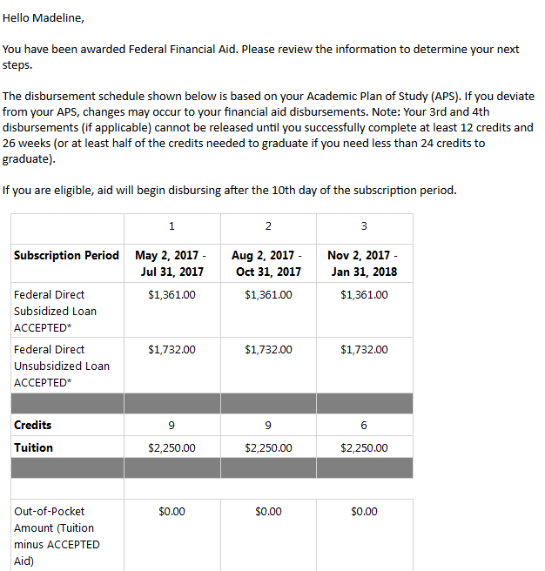

**Technical Specs:** See GitHub repository for current specs.

**Columns**

|  |  |
| --- | --- |
| **Field Name** | **Field Source / Expression** |
| Index_group | Index_group |
| externalId1 | externalId1 |
| startDate | startDate |
| endDate | endDate |
| fund_name | fund_name |
| disbursement_netAmount | disbursement_netAmount |
| FirstName | FirstName |
| LastName | LastName |
| award_awardStatusCode | award_awardStatusCode |
| disbursement_disbursementStatusCode | disbursement_disbursementStatusCode |
| numCourses | numCourses |
| SumRegUnits | SumRegUnits |
| Tuition_1 | Tuition_1 |
| Tuition | =IIf(Fields!numCourses.Value > 1,2250,900) |
| AcceptedTotal | =IIf(Fields!award_awardStatusCode.Value="ACCEPTED",Fields!disbursement_netAmount.Value,0) |
| Offered Total | =IIf(Fields!award_awardStatusCode.Value="OFFERED",Fields!disbursement_netAmount.Value,0) |
| OutOfPocketAccepted | =Fields!Tuition.Value - Fields!AcceptedTotal.Value |
| OutOfPocketOffered | =Fields!Tuition_1.Value - Fields!disbursement_netAmount.Value |

**Tables/Views**

|  |  |
| --- | --- |
| **Table/View Name** | **Type** |
| dataExtract_AwardDisbursement_View | View |
| dataExtract_CourseData_View | View |
| dataExtract_Student_View | View |

**Parameters:**

* @RegentID
* @StartDate

### *COD Award Disb ErrorCode 039*

**Description**

This report shows students who have a COD Error Code = 039 for either the Award Error Code or the Disbursement Error Code

**System(s):** Regent

**Business Purpose/Use**

The purpose of this report is to be able find out who has issues with their COD File and try to figure out how to resolve.

**Who Uses Report:** FA Coordinators, FA Manager

**Frequency:** On an adhoc basis

**Pre-requisite:** None

**Report Criteria Notes**

* AwardErrorCode like ‘039%’
* DisbursementErrorCode like ‘039%’

**Report Prompts:** None

**Navigation:** Award Related > COD Award Disb ErrorCode 039

**Example of Report**

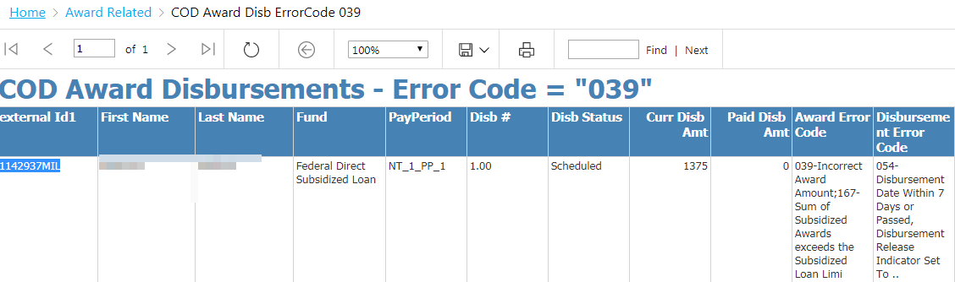

**Technical Specs:** See GitHub repository for current specs.

**Columns**

|  |  |
| --- | --- |
| **Field Name** | **Field Source / Expression** |
| externalId1 | externalId1 |
| firstName | firstName |
| Fund | Fund |
| PaymentPeriod | PaymentPeriod |
| lastName | lastName |
| DisbursementNumber | DisbursementNumber |
| DisbursementStatus | DisbursementStatus |
| CurrentDisbursementAmount | CurrentDisbursementAmount |
| DisbursementPaidAmount | DisbursementPaidAmount |
| DisbursementDate | DisbursementDate |
| AwardErrorCode | AwardErrorCode |
| DisbursementErrorCode | DisbursementErrorCode |

**Tables/Views**

|  |  |
| --- | --- |
| **Table/View Name** | **Type** |
| report_DataSet_CODAwardDisbursement_View | View |

**Parameters:** NONE

### *COD Award Disb ErrorCode Selection*

**Description**

This report allows the person running the report to show students who have a select COD Error Code for either the Award Error Code or the Disbursement Error Code

**System(s):** Regent

**Business Purpose/Use**

The purpose of this report is to be able find out who has issues with their COD File and try to figure out how to resolve.

**Who Uses Report:** FA Coordinators, FA Manager

**Frequency:** On an adhoc basis

**Pre-requisite:** None.

**Report Criteria Notes**

* AwardErrorCode like Entered Error Code
* DisbursementErrorCode like Entered Error Code

**Report Prompts:** None

**Navigation:** Award Related > COD Award Disb ErrorCode Selection

**Example of Report**

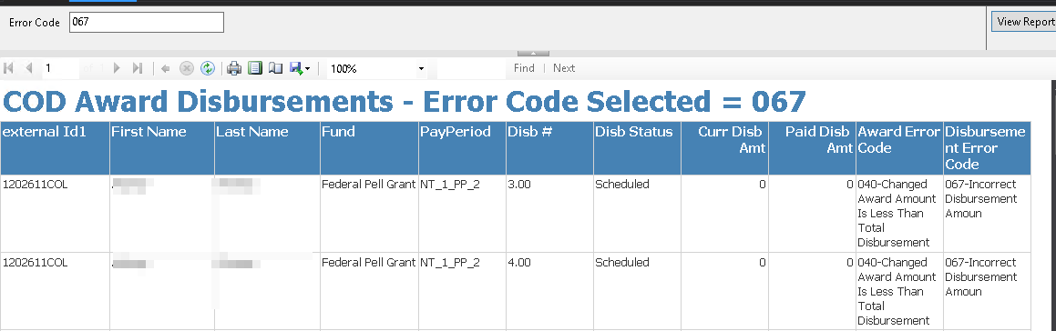

**Technical Specs:** See GitHub repository for current specs.

**Columns**

|  |  |
| --- | --- |
| **Field Name** | **Field Source / Expression** |
| externalId1 | externalId1 |
| firstName | firstName |
| Fund | Fund |
| PaymentPeriod | PaymentPeriod |
| lastName | lastName |
| DisbursementNumber | DisbursementNumber |
| DisbursementStatus | DisbursementStatus |
| CurrentDisbursementAmount | CurrentDisbursementAmount |
| DisbursementPaidAmount | DisbursementPaidAmount |
| DisbursementDate | DisbursementDate |
| AwardErrorCode | AwardErrorCode |
| DisbursementErrorCode | DisbursementErrorCode |

**Tables/Views**

|  |  |
| --- | --- |
| **Table/View Name** | **Type** |
| report_DataSet_CODAwardDisbursement_View | View |

**Parameters:**

* @ErrorCode

### *MPN and ELC Missing – for students with accepted award*

**Description**

This report shows students who have accepted loans but are missing their MPN and or ELC.

**System(s):** Regent

**Business Purpose/Use**

The purpose of this report is to be able find out what students who have accepted loans but are missing their MPN and or ELC. This will be used to reach out to students to remind them.

**Who Uses Report:** FA Coordinators, FA Manager

**Frequency:** On an adhoc basis

**Pre-requisite:** None.

**Report Criteria Notes**

* Document External ID = FAMPN or FAELC with a status of NEEDED
* Fund Source = Federal
* Fund Type = Loan
* Award Status Code = ACCEPTED
* Accepted Amount > 0

**Report Prompts:** None

**Navigation:** Award Related > MPNandELCMissing-AwardAccept

**Example of Report**

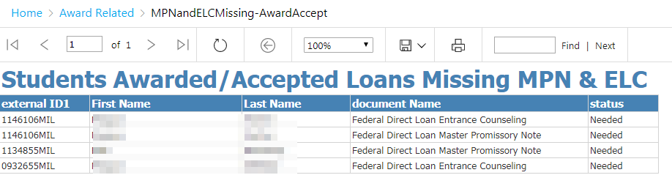

**Technical Specs:** See GitHub repository for current specs.

**Columns**

|  |  |
| --- | --- |
| **Field Name** | **Field Source / Expression** |
| externalId1 | externalId1 |
| firstName | firstName |
| lastName | lastName |
| documentName | documentName |
| Status | status |

**Tables/Views**

|  |  |
| --- | --- |
| **Table/View Name** | **Type** |
| dataExtract_DocumentRequirement_View | View |
| dataExtract_Student_View_v001 | View |
| dataExtract_CourseData_View_v001 | View |
| dataExtract_Award_View_v002 | View |
| dataExtract_Fund_Config_View | View |

**Parameters:** NONE

### *Student Awards ALL*

**Description**

This report shows all student award information for all Financial Aid Years.

**System(s):** Regent

**Business Purpose/Use**

The purpose of this report is to see a list of students and the amounts by each award year that was offered, accepted and disbursed.

**Who Uses Report:** FA Coordinators, FA Manager

**Frequency:** On an adhoc basis

**Pre-requisite:** None

**Report Criteria Notes**

* Document External ID = FAMPN or FAELC with a status of NEEDED
* Fund Source = Federal
* Fund Type = Loan
* Award Status Code = ACCEPTED
* Accepted Amount > 0

**Report Prompts:** None

**Navigation:** Award Related > Student Awards ALL

**Example of Report**

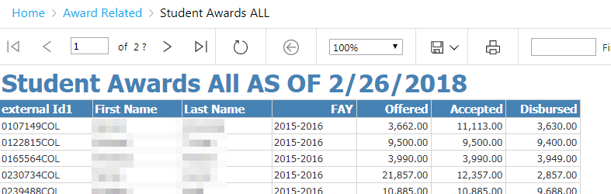

**Technical Specs:** See GitHub repository for current specs.

**Columns**

|  |  |
| --- | --- |
| **Field Name** | **Field Source / Expression** |
| externalId1 | externalId1 |
| firstName | firstName |
| lastName | lastName |
| offeredAmt | offeredAmt |
| AcceptedAmt | AcceptedAmt |
| FederalAwardYear | FederalAwardYear |
| PaidAmt | PaidAmt |

**Tables/Views**

|  |  |
| --- | --- |
| **Table/View Name** | **Type** |
| dataExtract_Award_View_v002 | View |
| dataExtract_LoanPeriod_View_v001 | View |
| dataExtract_Student_View_v001 | View |

**Parameters:** NONE

### *Student Awards by Institution*

**Description**

This report first show the breakdown of student awards by Financial Aid Year (FAY) – counts, Offered, Accepted and Disbursed. When you click on the + sign next to the FAY, you can see student details.

**System(s):** Regent

**Business Purpose/Use**

The purpose of this report is to see amounts by aid year (counts, awarded, accepted, disbursed) and then also have the option to see details behind each aid year.

**Who Uses Report:** FA Coordinators, FA Manager

**Frequency:** On an adhoc basis

**Pre-requisite: None**

**Report Criteria Notes**

* Document External ID = FAMPN or FAELC with a status of NEEDED
* Fund Source = Federal
* Fund Type = Loan
* Award Status Code = ACCEPTED
* Accepted Amount > 0

**Report Prompts:** Institution

**Navigation:** Award Related > Student Awards by Institution

**Example of Report**

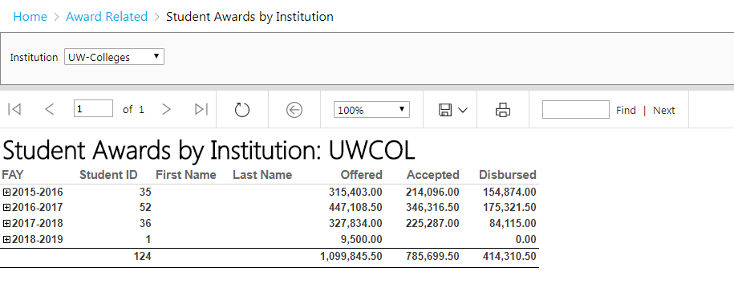

**Click on the + next to 2015-2016 and it will look like the following:**

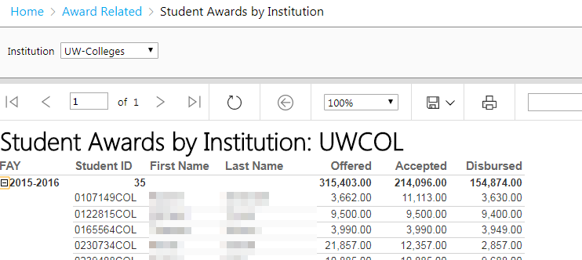

**Technical Specs:** See GitHub repository for current specs.

**Columns**

|  |  |
| --- | --- |
| **Field Name** | **Field Source / Expression** |
| externalId1 | externalId1 |
| firstName | firstName |
| lastName | lastName |
| offeredAmt | offeredAmt |
| AcceptedAmt | AcceptedAmt |
| FederalAwardYear | FederalAwardYear |
| PaidAmt | PaidAmt |

**Tables/Views**

|  |  |
| --- | --- |
| **Table/View Name** | **Type** |
| dataExtract_Award_View_v002 | View |
| dataExtract_LoanPeriod_View_v001 | View |
| dataExtract_Student_View_v001 | View |

**Parameters:** Institution

### *Students Awarded by Date Range*

**Description**

This report shows students awards by a select Date Range.

**System(s):** Regent

**Business Purpose/Use**

The purpose of this report is to show a list of student awards by a select Date Range. This can be useful for reconciliation.

**Who Uses Report:** FA Coordinators, FA Manager

**Frequency:** On an adhoc basis

**Pre-requisite:** None

**Report Criteria Notes**

* OfferedAmount > 0

**Report Prompts**

* Location
* Date Range

**Navigation:** Award Related > Student Awards by Date Range

1. Select an Institution and enter To and From Dates. Then Click on **View Report**.

**Example of Report**

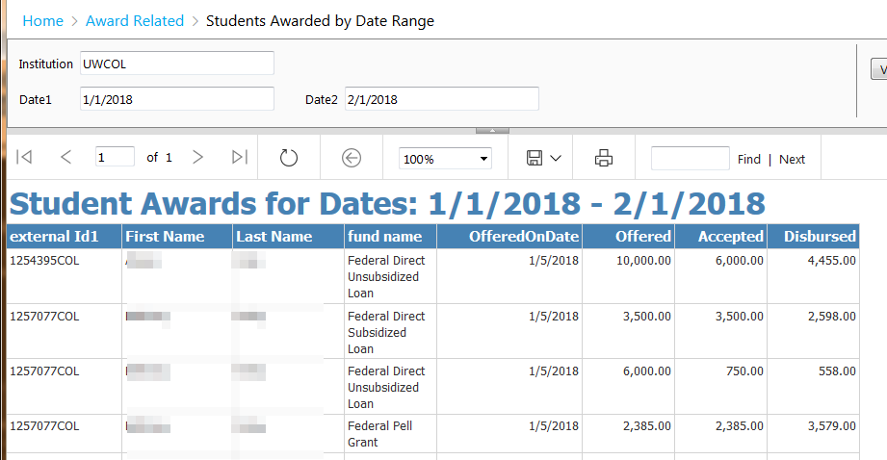

**Technical Specs:** See GitHub repository for current specs.

**Columns**

|  |  |
| --- | --- |
| **Field Name** | **Field Source / Expression** |
| externalId1 | externalId1 |
| firstName | firstName |
| lastName | lastName |
| offeredOnDate | offeredOnDate |
| offeredAmt | offeredAmt |
| AcceptedAmt | AcceptedAmt |
| fund_name | fund_name |
| PaidAmt | PaidAmt |

**Tables/Views**

|  |  |
| --- | --- |
| **Table/View Name** | **Type** |
| dataExtract_Award_View_v002 | View |
| dataExtract_LoanPeriod_View_v001 | View |
| dataExtract_Student_View_v001 | View |
| dataExtract_Fund_Config_View | View |

**Parameters:**

* @Institution
* @Date1
* @Date2

### *Students Accepted Unsub but not Sub*

**Description**

This report shows students who have accepted unsubsidized loans before accepted subsidized loans.

**System(s):** Regent

**Business Purpose/Use**

The purpose of this report is to know which students accepted unsubsidized loans before accepting subsidized loans.

**Who Uses Report:** FA Coordinators, FA Manager

**Frequency:** On an adhoc basis

**Pre-requisite:** None.

**Report Criteria Notes**

* Fund Name = Federal Direct Unsubsidized Loan but not exists where Fund Name = Federal Direct Subsidized Loan

**Report Prompts:** None

**Navigation:** Award Related > Students Accepted Unsub Before Sub

**Example of Report**

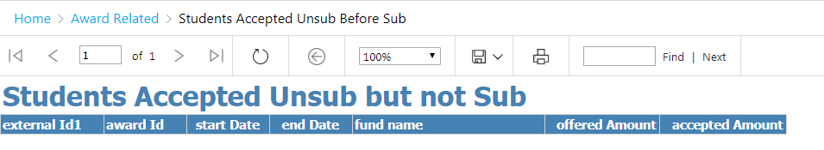

**Technical Specs:** See GitHub repository for current specs.

**Columns**

|  |  |
| --- | --- |
| **Field Name** | **Field Source / Expression** |
| financialAwardBeginDate | financialAwardBeginDate |
| externalId1 | externalId1 |
| studentid | studentid |
| awardId | awardId |
| awardPeriodId | awardPeriodId |
| externalID1 | externalID1 |
| fund_name | fund_name |
| startDate | startDate |
| endDate | endDate |
| offeredAmount | offeredAmount |
| acceptedAmount | acceptedAmount |

**Tables/Views**

|  |  |
| --- | --- |
| **Table/View Name** | **Type** |
| dataExtract_Fund_Config_View | View |
| dataExtract_Award_View_v002 | View |

**Parameters:**

* None

### *Students Awarded Pell with Prior Bach Degree*

**Description**

This report shows students who have been awarded Pell that have a Prior Bachelor Degree.

**System(s):** Regent

**Business Purpose/Use**

The purpose of this report is to show a list of students who have been awarded Pell that have a Prior Bachelor Degree.

**Who Uses Report:** FA Coordinators, FA Manager

**Frequency:** On an adhoc basis

**Pre-requisite:** None

**Report Criteria Notes:**

Fund Description like %Pell% and User Defined Field BACH_DEGREE = Y

**Report Prompts:** None

**Navigation:** Award Related > StudentsAwardedPell w PriorBachDegree

**Example of Report**

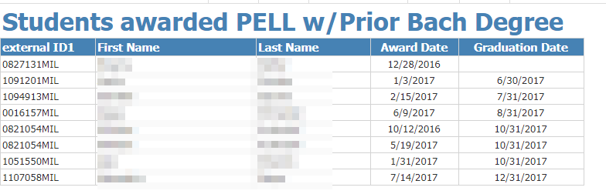

**Technical Specs:** See GitHub repository for current specs.

**Columns**

|  |  |
| --- | --- |
| **Field Name** | **Field Source / Expression** |
| externalId1 | externalId1 |
| FirstName | FirstName |
| LastName | LastName |
| offeredOnDate | offeredOnDate |
| GraduationDate | GraduationDate |

**Tables/Views**

|  |  |
| --- | --- |
| **Table/View Name** | **Type** |
| dataExtract_Fund_Config_View | View |
| dataExtract_Award_View_v002 | View |
| dataExtract_Student_View_v001 | View |
| report_DataSet_StudentDocuments_View | View |
| dataExtract_StudentInstitutionallyDefinedData_View | View |

**Parameters:** None

### *WI Students Awarded Pell*

**Description:** This report shows students who are a legal residence of Wisconsin that have been awarded Pell.

**System(s):** Regent

**Business Purpose/Use**

The purpose of this report is to show a list of students that are a legal resident of Wisconsin that have been awarded Pell.

**Who Uses Report:** FA Manager

**Frequency:** On an adhoc basis

**Pre-requisite:** None

**Report Criteria Notes**

Fund Name like %Pell%, Award Status Code = ACCEPTED and ISIR Student State of Legal Residence = W

**Report Prompts:** Financial Aid Year

**Navigation:** Award Related > WI Students Awarded Pell

1. Select a Federal Award Year and then click on View Report.

**Example of Report**

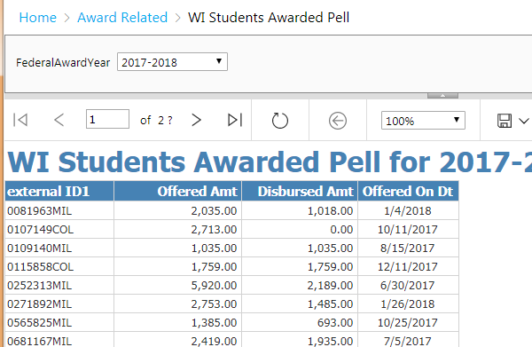

**Technical Specs:** See GitHub repository for current specs.

**Columns**

|  |  |
| --- | --- |
| **Field Name** | **Field Source / Expression** |
| externalId1 | externalId1 |
| offeredAmount | offeredAmount |
| paidAmount | paidAmount |
| offeredOnDate | offeredOnDate |

**Tables/Views**

|  |  |
| --- | --- |
| **Table/View Name** | **Type** |
| dataExtract_Award_View_v002 | View |
| dataExtract_LoanPeriod_View_v001 | View |
| dataExtract_Fund_Config_View | View |
| dataExtract_ISIR_View | View |

**Parameters:** Federal Award Year

**NOTE: This section is not up to date as I have decided I will review the reports here and possibly change them to match the business rules.**

## Financial Aid Report Details – Data Discrepancies

* Active Record – Should be Inactive
* Attendance EQ True when LastAttended is NULL
* Current Classes with NULL Last Attend Date
* Deleted_Correct External Course ID
* Deleted_Letter Grade is not null
* DuplicateCourses – UWMIL-UWCOL
* ExternalCrseID_First7Digits_NE_EXTERNALID2
* Inactive Record – Should be Active
* LastAttendDt and LetterGrade NULL where endDate LT CurrentDate
* Letter Grade NULL where Course End Date Passed
* LetterGrade EQ W and WithdrawDate LT StartDt
* LetterGrade Is In Progress and LAD Not Equal Course End Date
* Repeats Should be Yes
* Students Missing FLEX ID
* Transfers_External and Quality Pts EQ Zero
* Transfers_Internal and Quality Pts EQ Zero
* Withdrawal Date LT Course Start Date and Attendance TRUE
* Withdrawal Date Less Than Last Attended Date
* Withdrawal Date Not Equal Last Attended Date
* Withdrawal Date NOT NULL and Quality Points GT 0
* Withdrawal Date NULL where Letter Grade is In Progress

### *Attendance = True when Last Attended Date is null*

**Description**

This report shows students and courses where the attendance flag is set to TRUE but the last attended date is null

**System(s)**

Regent

**Business Purpose/Use**

The purpose of this report is to find out discrepancies with data – if a student has their attendance flag set to TRUE then their last attended date should not be null or vice versa. If students appear on this report then a footprints ticket needs to be submitted to fix the SBL data extract.

**Who Uses Report**

The FA Coordinators, Funky Tech

**Frequency**

On an adhoc basis

**Pre-requisite**

Student Batch Load runs daily.

**Report Criteria Notes**

* Last Attended Date = NULL
* Attendance Flag = TRUE
* Deleted = FALSE

**Report Prompts:** NONE

**How to run Report**

1. From within the Data Discrepancies folder, choose the **AttendanceEQTrue when LastAttended is NULL** report by clicking on the report name.
2. Since there aren’t any parameters for this report the report will run immediately.

**Example of Report**

### *Deleted Courses – 1st 7 digits of External Course ID = PRISM ID*

**Description**

This report shows UW Milwaukee students taking courses at UW Colleges where the first 7 digits is equal to the PRISM ID and the course has been deleted in Regent.

**System(s):** Regent

**Business Purpose/Use**

The purpose of this report is to make sure we haven’t deleted any courses that are correct.

**Who Uses Report**

Funky Tech

**Frequency**

On an adhoc basis

**Pre-requisite**

Daily Student Batch Daily Run.

**Report Criteria Notes**:

* External ID 3 is equal to first 7 digits of the external course ID
* Course ID does begin with 00 (UW Colleges courses)
* External ID 1 ends with MIL (UW Milwaukee students)
* Withdrawal Date = NULL
* Deleted = TRUE

**Report Prompts**: NONE

**How to run Report**

1. From within the Data Discrepancies folder, choose the **Deleted_CorrectExternalCourseID** report by clicking on the report name.
2. Since there aren’t any parameters for this report the report will run immediately when you select it from the list.

**Example of Report**



### *Duplicate courses*

**Description**

This report shows students who are in programs at UW Milwaukee but have doubles of courses they are taking at UW Colleges.

**System(s)**Regent

**Business Purpose/Use**

The purpose of this report is to find out discrepancies with data – this report finds students who are in programs at UW Milwaukee but have doubles for courses for the same term that they are taking at UW Colleges. If you look at each course within Regent 8 you will notice that the courses both have the same start date but if you drill down further on the student course data you will notice that the external course ID is different for each of the courses. The external course ID should start with externalID3 (which is the PRISM ID).

**Who Uses Report**

FA Coordinators, Funky Tech

**Frequency**

On an adhoc basis

**Pre-requisite**

Daily Student Batch Daily Run.

**Report Criteria Notes**:

* External & Internal Transfer = FALSE
* Course ID begins with 00 (UW Colleges courses)
* External ID 2 = First 7 digits of External Course ID
* UW Milwaukee program student
* Withdrawal Date = NULL
* Deleted = FALSE
* Has the same class in record except the first 7 digits of the external course ID = external ID 3

**Report Prompts**: NONE

**How to run Report**

1. From within the Data Discrepancies folder, choose the **DuplicateCourses – UWMIL @** UWCOL report by clicking on the report name.
2. Since there aren’t any parameters for this report the report will run immediately when you select it from the list. It will briefly say “Loading…” and then you will be presented with the report.

**Example of Report**



### *External Course ID First 7 digits not equal to External ID2*

**Description**

This report shows students where the external course ID’s first 7 digits does not match the external ID 2.

**System(s):** Regent

**Business Purpose/Use**

The purpose of this report is to find out discrepancies with data – this report looks to see if there are any students with courses where the first 7 digits of the external course ID is not equal to the ExternalID. There was a time when the wrong externalID was coming through on the SBL and not all courses were cleaned up.

**Who Uses Report**

FA Coordinators, Funky Tech

**Frequency**

On an adhoc basis

**Pre-requisite**

Daily Student Batch Daily Run.

**Report Criteria Notes**:

* External ID 2 is not equal to first 7 digits of the external course ID
* Course ID does not begin with 00 (UW Colleges courses)
* Withdrawal Date = NULL
* Deleted = FALSE

**Report Prompts**: NONE

**How to run Report**

1. From within the Data Discrepancies folder, choose the **ExternalCrseID_First7Digits_NE_ExternalID2** report by clicking on the report name.
2. Since there aren’t any parameters for this report the report will run immediately when you select it from the list.

**Example of Report**



### *Inactive Records that should be active*

**Description**

This report shows students who have an inactive status in Regent 8 where non-transfer courses that have not been withdrawn have a start date greater than the current date less 180 days.

**System(s)**

Regent

**Business Purpose/Use**

The purpose of this report is to find out discrepancies with data – in order to successfully award students and do other processing within Regent 8, the student is required to be in an active status. If this data is incorrect, submit a footprints ticket to fix the SBL.

**Who Uses Report**

FA Coordinators, Funky Tech

**Frequency**

On an adhoc basis

**Pre-Requisite**

Student Batch Load imports into Regent.

**Report Criteria Notes**

* Active = FALSE (inactive)
* Non-Transfer courses that have not been withdrawn or deleted where the start date is greater than the current date – 180 days.

**Report Prompts:** NONE

**How to run Report**

1. From within Data Discrepancies folder, choose the **Inactive Record – Should be Active** report by clicking on the report name.
2. Since there aren’t any parameters for this report the report will run immediately when you select it from the list.

**Example of Report**

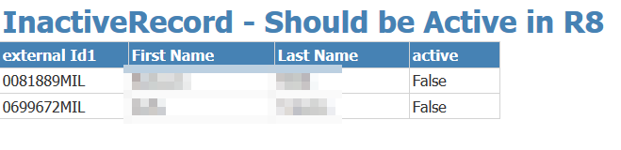

### *Last Attended Date Not Equal to Course End Date*

**Description**

This report shows student courses where the course end date has passed but yet the last attended date does not equal the course end date.

**System(s)**

Regent

**Business Purpose/Use**

The purpose of this report is to find out discrepancies with data – after the course has ended, the last attended date should be updated to the course end date. This is required in order to have awards calculated correctly in Regent 8.

**Who Uses Report**

FA Coordinators, Funky Tech

**Frequency**

On an adhoc basis

**Pre-requisite**

Daily Student Batch Daily Run.

**Report Criteria Notes**

* Non-Transfer Courses (External Transfer and Internal Transfer = FALSE)
* Deleted = FALSE
* Last Attended Date not equal to End Date
* Letter Grade is not null and not equal to FN or W

**Report Prompts**

* NONE

**How to run Report**

1. From within the Data Discrepancies folder, choose the **LastAttendDt Not Equal to Course End Date** report by clicking on the report name.
2. Since there aren’t any parameters for this report the report will run immediately when you select it from the list.

**Example of Report**

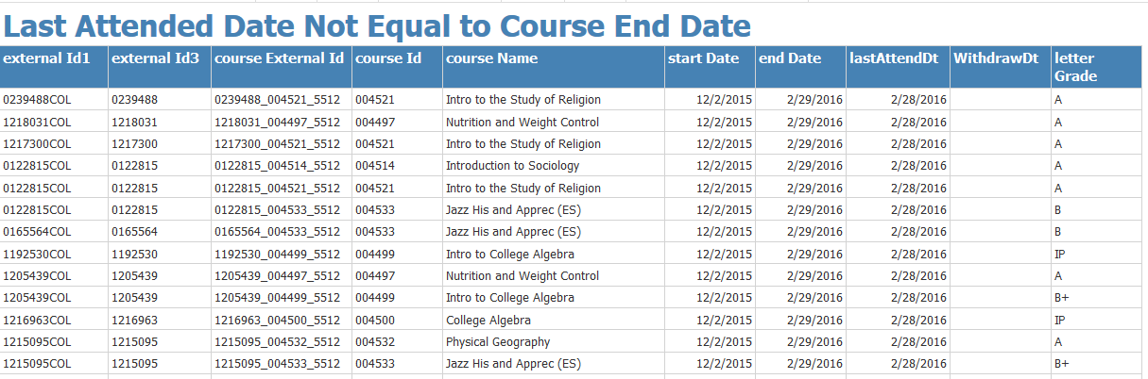

### *Last Attended Date & Letter Grade null for Course End Dates passed*

**Description**

This report shows student courses where the course end date has passed but yet the last attended date and letter grade is null.

**System(s)**

Regent

**Business Purpose/Use**

The purpose of this report is to find out discrepancies with data – after the course has ended, the last attended date should be populated with the course end date and there should be a letter grade unless the course was withdrawn. This is required in order to have awards calculated correctly in Regent 8.

**Who Uses Report**

FA Coordinators, Funky Tech

**Frequency**

On an adhoc basis

**Pre-requisite**

Daily Student Batch Daily Run.

**Report Criteria Notes**

* Last attended = NULL
* Withdrawal Date = NULL
* Letter Grade = NULL
* End Date is less than current date
* Deleted = FALSE

**Report Prompts**

* NONE

**How to run Report**

1. From within the Data Discrepancies folder, choose the **LastAttendDt and LetterGrade NULL where endDate LT CurrentDate** report by clicking on the report name.
2. Since there aren’t any parameters for this report the report will run immediately when you select it from the list.

**Example of Report**

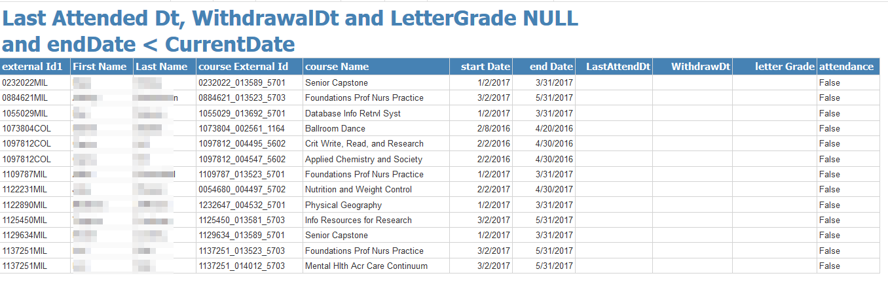

### *Letter Grade = W and Withdrawal Date Less than Start Date*

**Description**

This report shows student courses where the LetterGrade = W and the Withdrawal Date is less than the start date.

**System(s)**

Regent

**Business Purpose/Use**

The purpose of this report is to find out discrepancies with data – Students should not have a letter Grade of W before the class starts.

***Last day to drop a competency set without receiving a “W” grade*** (NOTE: Beyond this date, it is still possible to drop a competency set, but a student will receive a “W” and this will appear on the official student record – see next item below).

* 25th day of subscription period (e.g., January 26 for January subscription period)

***Last day to drop a competency set, with a “W” on the student record***

* 15th day of the second month of the subscription period (e.g. February 15 for January subscription period)

The above information can be found here - <https://flex.wisconsin.edu/important-dates-remember/>

**Who Uses Report**

FA Coordinators, Funky Tech

**Frequency**

On an adhoc basis

**Pre-requisite**

Daily Student Batch Daily Run.

**Report Criteria Notes**

* Letter Grade = W
* Non-Transfer Courses (External Transfer = FALSE; Internal Transfer = FALSE)
* Withdrawal Date is less than Start Date
* Deleted = FALSE

**Report Prompts:** NONE

**How to run Report**

1. From within the Data Discrepancies folder, choose the **LetterGrade EQ W and WithdrawDate LT StartDt** report by clicking on the report name.
2. Since there aren’t any parameters for this report the report will run immediately.

**Example of Report**

### *Repeats Should be YES*

**Description**

This report shows student courses where the Repeat flag should be Yes.

**System(s)**

Regent

**Business Purpose/Use**

The purpose of this report is to find out discrepancies with data – If a student has taken a course before, the repeat flag should be set to True. If this isn’t correct, a student could be inaccurately awarded.

**Who Uses Report**

FA Coordinators, Funky Tech

**Frequency**

On an adhoc basis

**Pre-requisite**

Daily Student Batch Daily Run.

**Report Criteria Notes**

* Non-Transfer Courses (External and Internal Transfer = FALSE)
* Withdrawal Date = NULL
* Deleted = FALSE
* Repeat Flag = FALSE
* Student has the same course in the future

**Report Prompts**

* NONE

**How to run Report**

1. From within the Data Discrepancies folder, choose the **RepeatsShouldBeYes** report by clicking on the report name.
2. Since there aren’t any parameters for this report the report will run.

**Example of Report**

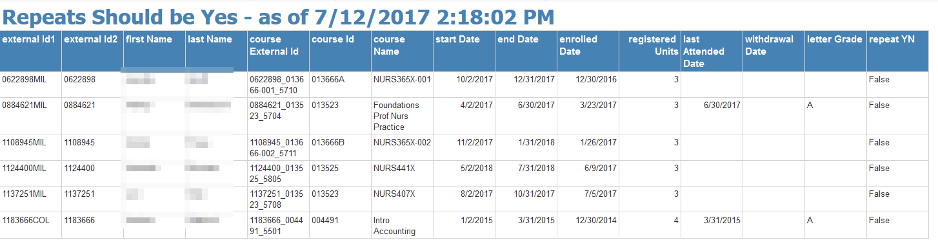

### *Students Missing Flex ID*

**Description**

This report shows active students who are missing their FLEX ID in Regent.

**System(s)**

Regent

**Business Purpose/Use**

The purpose of this report is to find out discrepancies with data – If a student is missing the FLEX ID and they are active in their program, the registrar’s office at UW Milwaukee needs to be contacted to add the FLEX ID accordingly on their side – send an email to [ro-flex@uwm.edu](mailto:ro-flex@uwm.edu) with SUBJECT = Missing FLEX ID; the body of the message should include the PAWS ID and the correct FLEX ID (PRISM ID).

The FLEX ID is used for various internal processes so that the correct student is linked for various external systems. The current systems – APS (SalesForce), D2L, PRISM and PAWS

**Who Uses Report**

FA Coordinators, Funky Tech

**Frequency**

On an adhoc basis

**Pre-requisite**

Daily Student Batch Daily Run.

**Report Criteria Notes**

* External ID 3 = NULL

**Report Prompts**

* NONE

**How to run Report**

1. From within the Data Discrepancies folder, choose the **Students Missing FLEX ID** report by clicking on the report name.

**Example of Report**

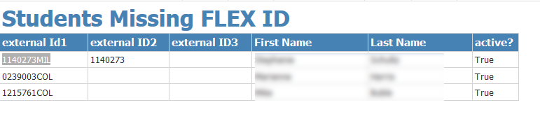

### *Withdrawal Date < Course Start and Attendance = true*

**Description**

This report shows students who have a withdrawal date that is less than the course start date and their attendance flag = TRUE or last Attended Date is NULL.

**System(s)**

Regent

**Business Purpose/Use**

The purpose of this report is to find out discrepancies with data – If a student withdraws before the class started then attendance should be set to FALSE and the Last Attended Date should be NULL. Inaccurate data could cause issues with awarding financial aid correctly.

**Who Uses Report**

FA Coordinators, Funky Tech

**Frequency**

On an adhoc basis

**Pre-requisite**

Daily Student Batch Daily Run.

**Report Criteria Notes**

* Withdrawal Date < Course Start Date
* Attendance Flag = TRUE OR Last Attended Date is not NULL
* Deleted = FALSE

**Report Prompts**

* NONE

**How to run Report**

1. From within the Data Discrepancies folder, choose the **Withdrawal Date LT Course Start Date and Attendance TRUE** report by clicking on the report name.
2. Since there aren’t any parameters for this report the report will run.

**Example of Report**

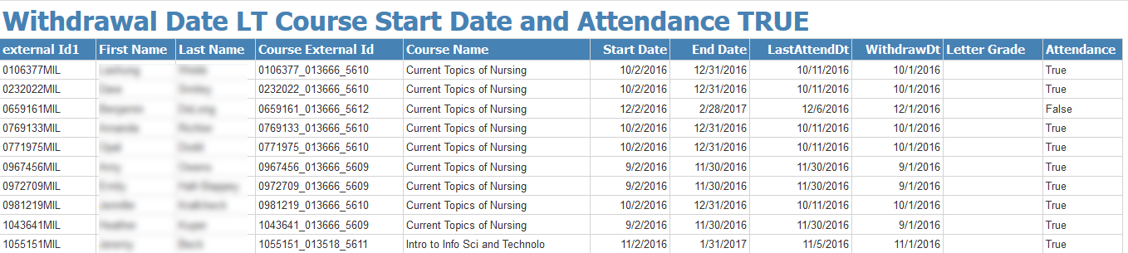

### *Withdrawal Date Not Equal Last Attendance Date*

**Description**

This report shows students courses where the withdrawal date is not equal to the Last Attendance Date.

**System(s)**

Regent

**Business Purpose/Use**

The purpose of this report is to find out discrepancies with data – If a student withdrawal date and last attended date do not match there could be issues with calculating awards or R2T4 correctly.

**Who Uses Report**

FA Coordinators, Funky Tech

**Frequency**

On an adhoc basis

**Pre-requisite**

Daily Student Batch Daily Run.

**Report Criteria Notes**

* Non-Transfer Courses (External and Internal Transfer = FALSE)
* Withdrawal Date is not equal to Last Attended Date
* Deleted = FALSE

**Report Prompts**

* NONE

**How to run Report**

1. From within the Data Discrepancies folder, choose the **Withdrawal Date Not Equal LastAttendedDate** report by clicking on the report name.
2. Since there aren’t any parameters for this report the report will run immediately.

**Example of Report**

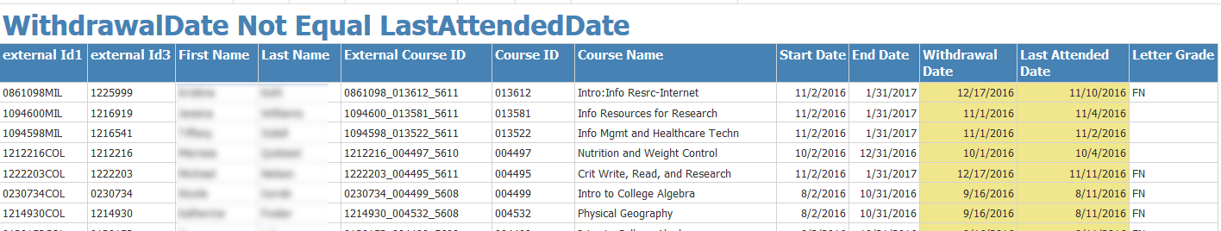

### *Withdrawal Date Not Null and Quality Points <> ZERO*

**Description**

This report shows students courses where the withdrawal date is null and the Quality Points is greater than ZERO.

**System(s)**

Regent

**Business Purpose/Use**

The purpose of this report is to find out discrepancies with data – If a student has a withdrawal date then the quality points should be 0. Data needs to be correct in order for students to be awarded correctly.

**Who Uses Report**

FA Coordinators, Funky Tech

**Frequency**

On an adhoc basis

**Pre-requisite**

Daily Student Batch Daily Run.

**Report Criteria Notes**

* Quality Points is greater than 0
* Withdrawal Date is not NULL
* Deleted = FALSE

**Report Prompts**

* NONE

**How to run Report**

1. From within the Data Discrepancies folder, choose the **WithdrawalDate NOT NULL and Quality Points GT 0** report by clicking on the report name.
2. Since there aren’t any parameters for this report the report will run.

**Example of Report**

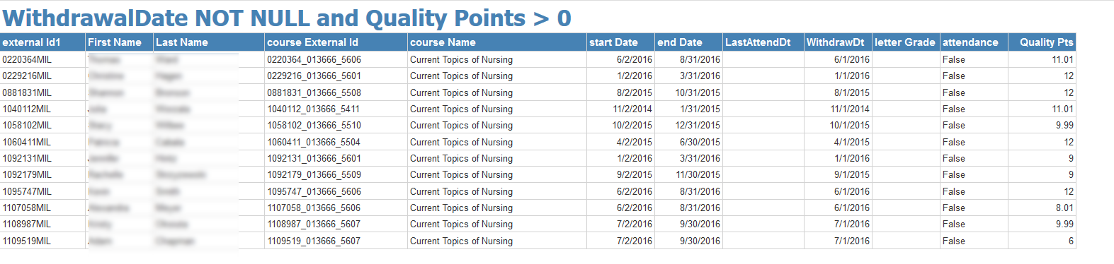

### *Withdrawal Date NULL and Letter Grade In Progress (IP, PR)*

**Description**

This report shows students courses where withdrawal date is NULL and the letter grade is InProgress (UWCOL = IP; UWMIL = PR).

**System(s)**

Regent

**Business Purpose/Use**

The purpose of this report is to find out discrepancies with data – If a student has a letter Grade of In Progress (IP or PR), the withdrawal date should be populated with the course end date. Data needs to be correct in order for students to be awarded correctly. See Business Rule “Letter Grade” https://docs.google.com/document/d/1zOaBWoOTdaI9s70fyNpvJ6uiYIlGOgyqRwHGe8gWb9Y/edit

**Who Uses Report**

FA Coordinators, Funky Tech

**Frequency**

On an adhoc basis

**Pre-requisite**

Daily Student Batch Daily Run.

**Report Criteria Notes**

* Non-Transfer courses (external transfer = FALSE and internal Transfer = FALSE)
* Letter Grade = IP or PR
* Withdrawal Date is not NULL
* Deleted = FALSE

**Report Prompts**

* NONE

**How to run Report**

1. From within the Data Discrepancies folder, choose **WithdrawalDate NULL where LetterGrade is In Progress** report by clicking on the report name.
2. Since there aren’t any parameters for this report the report will run.

**Example of Report**

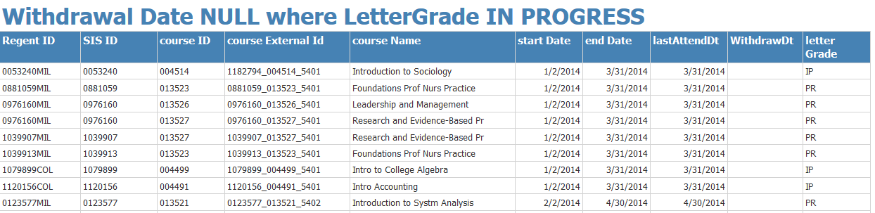

## Financial Aid Report Details – Disbursements

* Disbursements Paid by Campus
* Disbursements Paid by Campus and Date Range
* Disbursements Paid by FAY and Fund
* Disbursements Paid by Student ID

### *Disbursements Paid by Campus*

**Description**

This report shows students who have paid disbursements by select Campus.

**System(s):** Regent

**Business Purpose/Use**

The purpose of this report is to review all paid disbursements by Campus. This can be used to reconcile the Campus to Regent. This also can be used for analytics to show how many students are getting disbursed by program, by fund, aid year, term, etc. (NOTE: One report that you can use to reconcile against is the Amounts by Item Type Report)

**Who Uses Report:** FA Coordinators, FA Manager

**Frequency:** On an adhoc basis

**Pre-requisite:** Students have been disbursed aid.

**Report Criteria Notes:** NONE

**Report Prompts:** Institution

**Navigation:** Disbursement Related > Disbursements Paid by Campus

1. Select Institution from the drop down and click on View Report

**Example of Report**

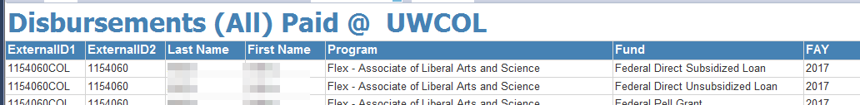

**Technical Specs:** See GitHub repository for current specs.

**Columns**

|  |  |
| --- | --- |
| **Field Name** | **Field Source / Expression** |
| externalId1 | externalId1 |
| externalId2 | externalId2 |
| FirstName | FirstName |
| LastName | LastName |
| FederalAwardYear | FederalAwardYear |
| Fund | Fund |
| locationExternalID | locationExternalID |
| program_programName | program_programName |
| TransAmt | TransAmt |
| Term | Term |
| SchedDisbDate | SchedDisbDate |
| TransDate | TransDate |
| SchedDate | SchedDate |
| AdjReleaseDate | AdjReleaseDate |
| DRIReleaseDate | DRIReleaseDate |
| PrevPdAmt | PrevPdAmt |

**Tables/Views**

|  |  |
| --- | --- |
| **Table/View Name** | **Type** |
| dataExtract_ProcessLog_View | View |
| dataExtract_ESTRecord_View | View |
| dataExtract_Student_View | View |
| dataExtract_AcademicPlan_View | View |

**Parameters:** Institution

### *Disbursements Paid by Campus and Date Range*

**Description**

This report shows students who have paid disbursements by select Campus by a select date range.

**System(s):** Regent

**Business Purpose/Use**

The purpose of this report is to review all paid disbursements by Campus by a select range of dates. This can be used to reconcile the Campus to Regent. This also can be used for analytics to show how many students are getting disbursed by program, by fund, aid year, term, etc. (NOTE: One report that you can use to reconcile against is the Amounts by Item Type Report)

**Who Uses Report:** FA Coordinators, FA Manager

**Frequency:** On an adhoc basis

**Pre-requisite:** Students have been disbursed aid.

**Report Criteria Notes:** NONE

**Report Prompts:** NONE

**Navigation:** Disbursement Related > Disbursements Paid by Campus and Date Range

1. Select Institution and Transaction Date Range. Then Click View Report.

**Example of Report**

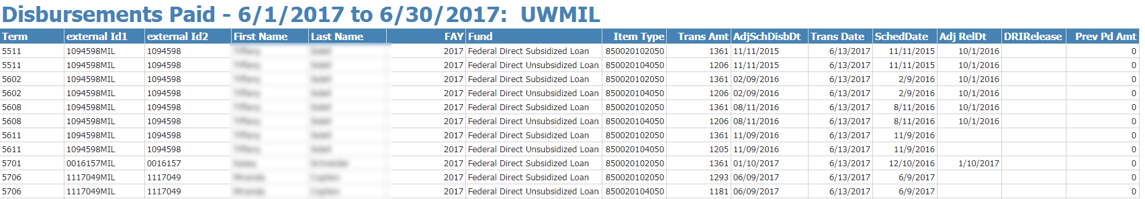

**Technical Specs:** See GitHub repository for current specs.

**Columns**

|  |  |
| --- | --- |
| **Field Name** | **Field Source / Expression** |
| externalId1 | externalId1 |
| externalId2 | externalId2 |
| FirstName | FirstName |
| LastName | LastName |
| FederalAwardYear | FederalAwardYear |
| Fund | Fund |
| ItemType | ItemType |
| locationExternalID | locationExternalID |
| TransAmt | TransAmt |
| Term | Term |
| program_programName | program_programName |
| TransDate | TransDate |
| AdjSchedDisbDt | AdjSchedDisbDt |
| SchedDate | SchedDate |
| AdjReleaseDate | AdjReleaseDate |
| DRIReleaseDate | DRIReleaseDate |
| PrevPdAmt | PrevPdAmt |

**Tables/Views**

|  |  |
| --- | --- |
| **Table/View Name** | **Type** |
| dataExtract_ProcessLog_View | View |
| dataExtract_ESTRecord_View | View |
| dataExtract_Student_View | View |
| dataExtract_AcademicPlan_View | View |
| dataExtract_Fund_Config_View | View |

**Parameters:**

* @Institution
* @Date1
* @Date2

### *Disbursements Paid by FA Year and Fund*

**Description**

This report shows disbursements paid for a select Campus and date range with a breakdown by Financial Aid Year and Fund

**System(s):** Regent

**Business Purpose/Use**

The purpose of this report is to be able to see totals of all disbursements paid by Campus by Financial Aid Year and Fund. This can be used to reconcile the Campus to Regent. This also can be used for analytics to show how many students are getting disbursed by program, by fund, aid year, term, etc. (NOTE: One report that you can use to reconcile against is the Amounts by Item Type Report)

**Who Uses Report:** FA Coordinators, FA Manager

**Frequency:** On an adhoc basis

**Pre-requisite:** Students have been disbursed aid.

**Report Criteria Notes:** NONE

**Report Prompts:** NONE

**Navigation:** Disbursement Related > Disbursements Paid by FAY and Fund

1. Select Institution and enter Transaction Date Range. Click on View Report.

**Example of Report**

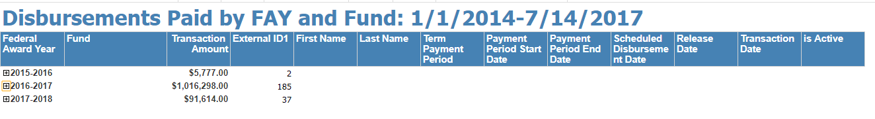

**To drill down to further details – by Fund, click on the + sign next to the Federal Award Year.**

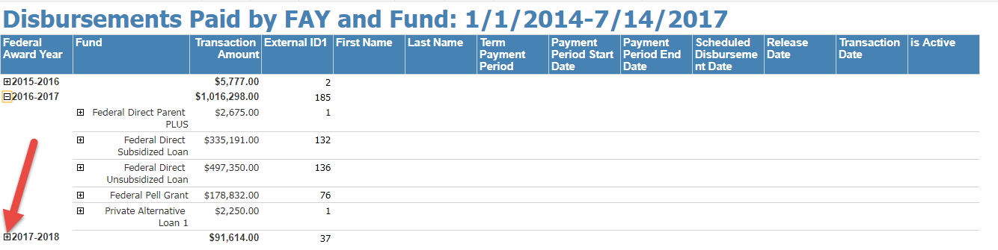

**To drill down to further details – by Student, click on the + sign next to the Fund Type.**

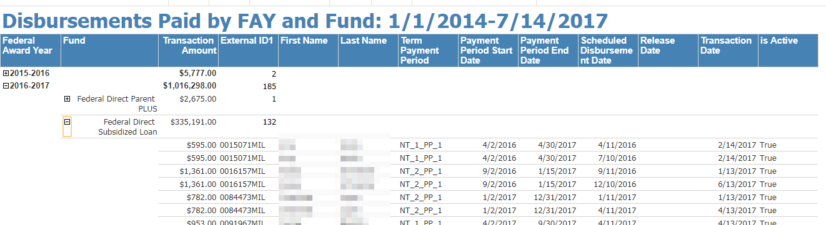

**Technical Specs:** See GitHub repository for current specs.

**Columns**

|  |  |
| --- | --- |
| **Field Name** | **Field Source / Expression** |
| [FederalAwardYear] | [FederalAwardYear] |
| [TransactionAmount] | [TransactionAmount] |
| [ExternalID1] | [ExternalID1] |
| [FirstName] | [FirstName] |
| [LastName] | [LastName] |
| [TermPaymentPeriod] | [TermPaymentPeriod] |
| [PaymentPeriodStartDate] | [PaymentPeriodStartDate] |
| [PaymentPeriodEndDate] | [PaymentPeriodEndDate] |
| [ScheduledDisbursementDate] | [ScheduledDisbursementDate] |
| [ReleaseDate] | [ReleaseDate] |
| [TransactionDate] | [TransactionDate] |
| [isActive] | [isActive] |

**Tables/Views**

|  |  |
| --- | --- |
| **Table/View Name** | **Type** |
| report_DataSet_ESTTransactions_View | View |

**Parameters:**

* @Institution
* @FromDate
* @ToDate

### *Disbursements Paid by Student ID*

**Description**

This report shows disbursements paid for a select Campus and date range but has a breakdown by Financial Aid Year and Fund Type for a select student.

**System(s):** Regent

**Business Purpose/Use**

The purpose of this report is to be able to see totals of all disbursements paid by Campus by Financial Aid Year and Fund. This can be used to easily troubleshoot reconciliation with the Campus to Regent. You can run queries within the SIS to get the same breakdown.

**Who Uses Report:** FA Coordinators, FA Manager

**Frequency:** On an adhoc basis

**Pre-requisite:** Students have been disbursed aid.

**Report Criteria Notes:** NONE

**Report Prompts:** ExterrnalID1

**Navigation:** Disbursement Related > Disbursements Paid by Student ID

1. Enter the External ID 1 for the student (ex. 1234567COL). Click on View Report.

**Example of Report**

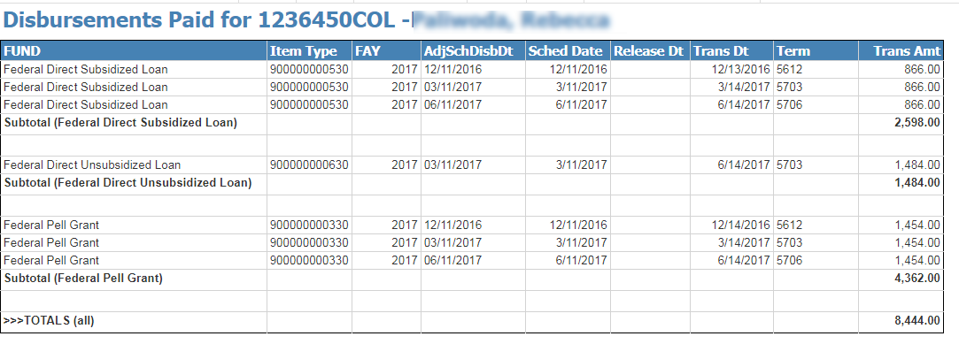

**View Payment Screen in SIS**

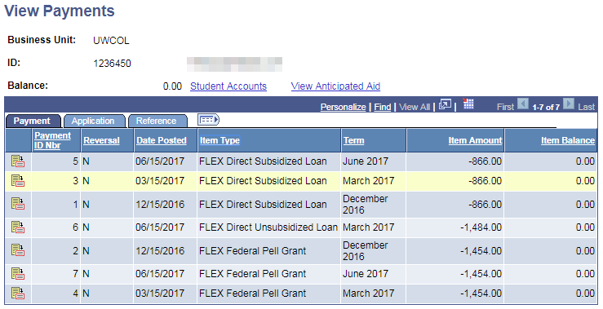

**Technical Specs:** See GitHub repository for current specs.

**Columns**

|  |  |
| --- | --- |
| **Field Name** | **Field Source / Expression** |
| ExternalID1 | ExternalID1 |
| FirstName | FirstName |
| LastName | LastName |
| ItemType | ItemType |
| Fund | Fund |
| TransAmt | TransAmt |
| FederalAwardYear | FederalAwardYear |
| Term | Term |
| AdjSchedDisbDt | AdjSchedDisbDt |
| TransDate | TransDate |
| SchedDate | SchedDate |
| AdjReleaseDate | AdjReleaseDate |
| PrevPdAmt | PrevPdAmt |

**Tables/Views**

|  |  |
| --- | --- |
| **Table/View Name** | **Type** |
| dataExtract_ProcessLog_View | View |
| dataExtract_ESTRecord_View | View |
| dataExtract_Student_View | View |
| dataExtract_AcademicPlan_View | View |
| dataExtract_Fund_Config_View | View |

**Parameters:** ExternalID

## Financial Aid Report Details – ISIR and Verification

* HS Completion Required
* ISIR – No Taxes Filed
* ISIR Received – APS Needed
* ISIR Received ALL – Select Dates
* ISIR Received by Institution – Select Dates

### *HS Completion Required*

**Description**

This report shows students that require High School Completion

**System(s):** Regent

**Business Purpose/Use**

The purpose of this report is to know what students still require the HS Completion Document because the student reports on the FAFSA that his/her high school completion is “other”. To be eligible for federal aid, student must indicate which high school he/she graduated from or whether he/she obtained a GED/HSED or equivalent. This report identifies who needs to verify their high school completion status.

**Who Uses Report:** FA Coordinators

**Frequency:** On an adhoc basis

**Pre-requisite:** Students have filled out the FAFSA and we have received the ISIR.

**Report Criteria Notes**

* Active ISIR, ISIR field – HS Diploma or Equivalent = 4 (Other) and Student doesn’t have the document Name = High School Completion on their record

**Report Prompts:** NONE

**Navigation:** ISIR and Verification > HS Completion Required

**Example of Report**

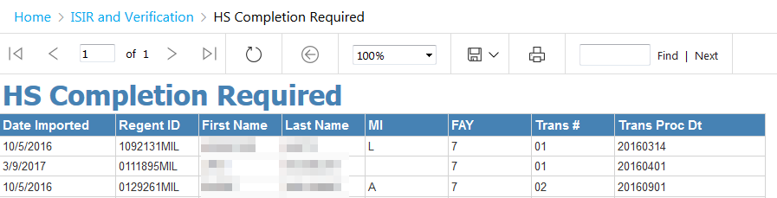

**Technical Specs:** See GitHub repository for current specs.

**Columns**

|  |  |
| --- | --- |
| **Field Name** | **Field Source / Expression** |
| createdOn | createdOn |
| externalId1 | externalId1 |
| studentsFirstName | studentsFirstName |
| locationExternalId | locationExternalId |
| studentsLastName | studentsLastName |
| activeISIR | activeISIR |
| middleInitial | middleInitial |
| yearIndicator | yearIndicator |
| transactionNumber | transactionNumber |
| transactionProcessedDate | transactionProcessedDate |

**Tables/Views**

|  |  |
| --- | --- |
| **Table/View Name** | **Type** |
| dataExtract_ISIR_View | View |
| dataExtract_DocumentRequirement_View | View |

**Parameters:** None

### *ISIR – No Taxes Filed*

**Description**

This report shows students who indicated on the ISIR that they didn’t file taxes.

**System(s):** Regent

**Business Purpose/Use**

The purpose of this report is to be able to get a list of students who on the ISIR said they didn’t file taxes. This alerts the FA Coordinators that there needs to be required documents.

**Who Uses Report:** FA Coordinators

**Frequency:** On an adhoc basis

**Pre-requisite:** Students have an ISIR loaded into Regent.

**Report Criteria Notes:**

* Students Tax Return Completed not equal to 1 or 2

**Report Prompts:** Federal Award Year

**Navigation:** ISIR and Verification > ISIR – No Taxes Filed

1. Pick an award year from the drop down and then click on View Report.

**Example of Report**

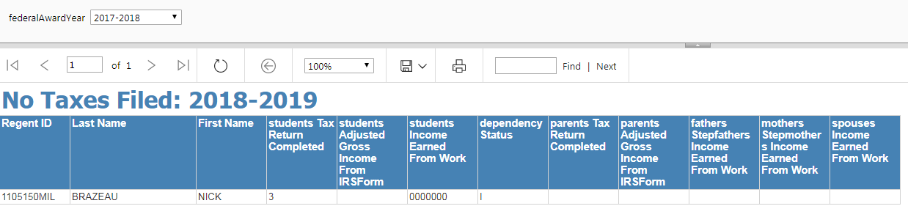

**Technical Specs:** See GitHub repository for current specs.

**Columns**

|  |  |
| --- | --- |
| **Field Name** | **Field Source / Expression** |
| externalID1 | externalID1 |
| studentsLastName | studentsLastName |
| studentsFirstName | studentsFirstName |
| studentsTaxReturnCompleted | studentsTaxReturnCompleted |
| studentsAdjustedGrossIncomeFromIRSForm | studentsAdjustedGrossIncomeFromIRSForm |
| studentsIncomeEarnedFromWork | studentsIncomeEarnedFromWork |
| dependencyStatus | dependencyStatus |
| parentsTaxReturnCompleted | parentsTaxReturnCompleted |
| parentsAdjustedGrossIncomeFromIRSForm | parentsAdjustedGrossIncomeFromIRSForm |
| fathersStepfathersIncomeEarnedFromWork | fathersStepfathersIncomeEarnedFromWork |
| mothersStepmothersIncomeEarnedFromWork | mothersStepmothersIncomeEarnedFromWork |
| spousesIncomeEarnedFromWork | spousesIncomeEarnedFromWork |

**Tables/Views**

|  |  |
| --- | --- |
| **Table/View Name** | **Type** |
| dataExtract_ISIR_View | View |

**Parameters:** None

### *ISIR Received – APS Needed*

**Description**

This report shows ISIRs received where the APS is NEEDED.

**System(s):** Regent

**Business Purpose/Use**

The purpose of this report is to be able to get a list of students where we have received their ISIR but the APS still shows as NEEDED.

**Who Uses Report:** FA Coordinators

**Frequency:** On an adhoc basis

**Pre-requisite:** Students have an ISIR loaded into Regent.

**Report Criteria Notes**

* Federal Award Year = prompt
* Course Start = prompt
* Document Name like %Approved%
* Document Status = NEEDED

**Report Prompts:**

* Federal Award Year
* Course Start Date

**Navigation:** ISIR and Verification > ISIR Received – APS Needed

1. Enter **Course Start Date** and pick an **Award Year** from drop down. **View Report**.

**Example of Report**

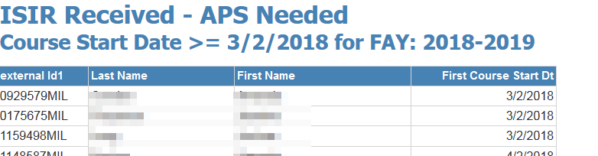

**Technical Specs:** See GitHub repository for current specs.

**Columns**

|  |  |
| --- | --- |
| **Field Name** | **Field Source / Expression** |
| externalID1 | externalID1 |
| LastName | LastName |
| FirstName | FirstName |
| FirstCourseStartDt | FirstCourseStartDt |

**Tables/Views**

|  |  |
| --- | --- |
| **Table/View Name** | **Type** |
| dataExtract_CourseData_View | View |
| dataExtract_Student_View | View |
| dataExtract_ISIR_View | View |
| dataExtract_DocumentRequirement_View | View |

**Parameters:**

* @CrseStart
* @awardYear

### *ISIR Received ALL – Select Dates*

**Description**

This report shows ISIRs received for Select Date Range. **System(s):** Regent

**Business Purpose/Use**

The purpose of this report is to be able to get a list of ISIRs received for a select date range.

**Who Uses Report:** FA Coordinators

**Frequency:** On an adhoc basis

**Pre-requisite:** Students have an ISIR loaded into Regent.

**Report Criteria Notes**

* ISIR Created On (ISIR Imported into Regent) between a date range

**Report Prompts:**

* Course Start Date
* Course End Date

**Navigation:** ISIR and Verification > ISIR Received ALL – Select Dates

1. Enter **Date From** and **Date To** then click on **View Report**.

**Example of Report**

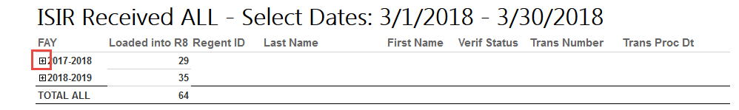

**Clicking on the + sign will show more details**

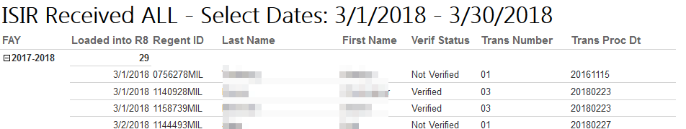

**Technical Specs:** See GitHub repository for current specs.

**Columns**

|  |  |
| --- | --- |
| **Field Name** | **Field Source / Expression** |
| createdOn | createdOn |
| RegentID | RegentID |
| EMPLID | EMPLID |
| FlexID | FlexID |
| LastName | LastName |
| FirstName | FirstName |
| verificationStatusName | verificationStatusName |
| federalAwardYearName | federalAwardYearName |
| transactionNumber | transactionNumber |
| transactionProcessedDate | transactionProcessedDate |

**Tables/Views**

|  |  |
| --- | --- |
| **Table/View Name** | **Type** |
| dataExtract_ISIR_View | View |
| dataExtract_Student_View | View |

**Parameters:**

* @DateFrom
* @ToDate

### *ISIR Received By Institution – Select Dates*

**Description**

This report shows ISIRs received for a select institution by select dates.

**System(s):** Regent

**Business Purpose/Use**

The purpose of this report is to be able to get a list of students where we have received their ISIR by Institution for Select Dates.

**Who Uses Report:** FA Coordinators

**Frequency:** On an adhoc basis

**Pre-requisite:** Students have an ISIR loaded into Regent.

**Report Criteria Notes**

* ISIR Created on (ISIR Import) = select dates
* Institution = prompt values

**Report Prompts:**

* Date From
* To Date
* Institution

**Navigation:** ISIR and Verification > ISIR Received by Institution – Select Dates

1. Pick an **Institution** from drop down, enter **From** and **To Dates**. **View Report**.

**Example of Report**

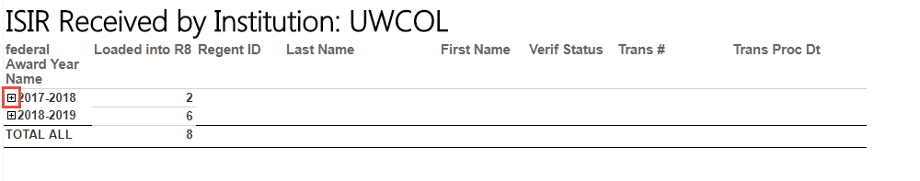

**Clicking on the + will show more details**

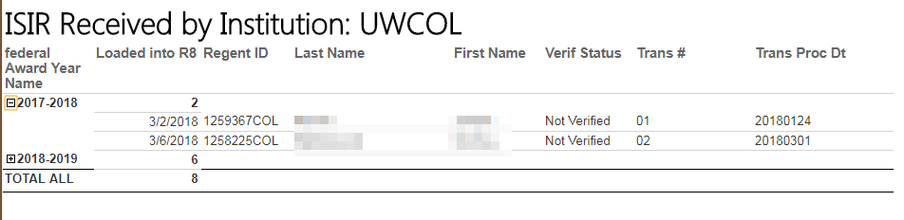

**Technical Specs:** See GitHub repository for current specs.

**Columns**

|  |  |
| --- | --- |
| **Field Name** | **Field Source / Expression** |
| createdOn | createdOn |
| RegentID | RegentID |
| EMPLID | EMPLID |
| FlexID | FlexID |
| LastName | LastName |
| FirstName | FirstName |
| verificationStatusName | verificationStatusName |
| federalAwardYearName | federalAwardYearName |
| transactionNumber | transactionNumber |
| transactionProcessedDate | transactionProcessedDate |

**Tables/Views**

|  |  |
| --- | --- |
| **Table/View Name** | **Type** |
| dataExtract_ISIR_View | View |
| dataExtract_Student_View | View |

**Parameters:**

* @Institution
* @DateFrom
* @ToDate

## Financial Aid Report Details – Miscellaneous Reports

* Enrollment Data Report - ALL
* FA Funnel Data
* Graduation Date Populated on SBL
* IPEDS_S1_PartA
* IPEDS_S1_PartB
* IPEDS_S1_PartB_Matrix
* Reconciliation Report
* Reconciliation Report by Fund
* SAP – Completion Rate by Student
* SAP – Completion Rate w PayPeriod by Student
* Student Cost of Attendance by FAY
* Student Course Data by ID
* Student Debt Letter Data

### *Enrollment Data – ALL Institutions*

**Description**

This report combines enrollment data from both UW Colleges and UW Milwaukee into one report. It includes the term that just finished as well as the current terms in session and the up and coming term. (ex. 5712-5804)

**System(s):** Regent

**Business Purpose/Use**

The purpose of this report is to be able to use for various financial aid process (such as book charge)

**Who Uses Report:** FA Coordinators

**Frequency:** On an adhoc basis

**Pre-requisite:**

* The Enrollment Queries need to execute at the Partner Campus and be FTP’d to CEOEL. The Data needs to be imported (via scheduled SSIS scripts) into Regent Data Views.

**Report Criteria Notes**

* From the UW Colleges Data it matches up Primary Program = NONFX to the UW Milwaukee Data.

**Report Prompts:**

* None

**Navigation:** Misc Reports > EnrollmentData_ALL

**Example of Report**

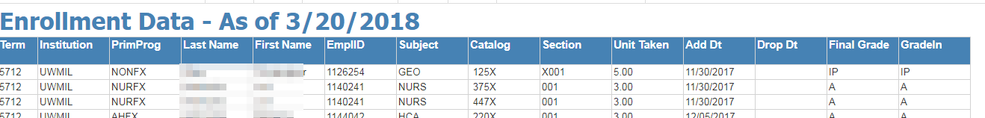

**Technical Specs:** See GitHub repository for current specs.

**Columns**

|  |  |
| --- | --- |
| **Field Name** | **Field Source / Expression** |
| Term | Term |
| Institution | Institution |
| EMPLID | EMPLID |
| PrimProg | PrimProg |
| LastName | LastName |
| FirstName | FirstName |
| Subject | Subject |
| Catalog | Catalog |
| Section | Section |
| UnitTaken | UnitTaken |
| AddDt | AddDt |
| DropDt | DropDt |
| FinalGrade | FinalGrade |
| Gradeln | Gradeln |

**Tables/Views**

|  |  |
| --- | --- |
| **Table/View Name** | **Type** |
| FLEXEnrollmentUWM | Table |
| FLEXEnrollmentUWC | Table |
| dataExtract_Student_View_V001 | View |

**Parameters:** NONE

### *FA Funnel Data*

**Description**

This report

**System(s):** Regent

**Business Purpose/Use**

The purpose of this report is…

**Who Uses Report:** FA Manager, BA

**Frequency:** On an adhoc basis

**Pre-requisite:** None

**Report Criteria Notes:** None

**Report Prompts:** None

**Navigation:** Misc Reports > FA Funnel Data

**Example of Report**

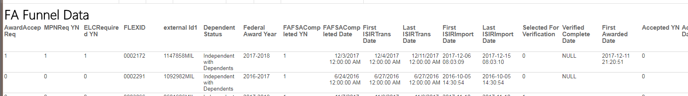

**Technical Specs:** See GitHub repository for current specs.

**Columns**

|  |  |
| --- | --- |
| **Field Name** | **Field Source / Expression** |
| FLEXID |  |
| externalId1 |  |
| DependentStatus |  |
| FederalAwardYear |  |
| FAFSACompletedYN |  |
| FAFSACompletedDate |  |
| FirstISIRTransDate |  |
| LastISIRTransDate |  |
| FirstISIRImportDate |  |
| LastISIRImportDate |  |
| SelectedForVerification |  |
| VerifiedCompleteDate |  |
| FirstAwardedDate |  |
| AwardAcceptanceReq |  |
| AcceptedYN |  |
| AcceptedDate |  |
| ELCRequiredYN |  |
| ELCCompletedYN |  |
| ELCCompletedDate |  |
| MPNRequiredYN |  |
| MPNCompletedYN |  |
| MPNCompletedDate |  |
| DisbursedYN |  |
| SchedDisbDate |  |
| ActualDisbDate |  |
| Federal_Pell_Grant |  |
| Federal_Direct_Subsidized_Loan |  |
| Federal_Direct_Unsubsidized_Loan |  |
| Federal_Direct_Parent_PLUS |  |
| Private_Alternative_Loan_1 |  |

**Tables/Views**

|  |  |
| --- | --- |
| **Table/View Name** | **Type** |
| dataExtract_Award_View_v002 | View |
| dataExtract_LoanPeriod_View_v001 | View |
| dataExtract_Fund_Config_View | View |
| dataExtract_ISIR_View | View |
| dataExtract_DocumentRequirement_View | View |
| dataExtract_AwardDisbursement_View_v001 | View |
| dataExtract_Disbursement_View_v002 | View |

**Parameters:** NONE

### *Graduation Date Populated on SBL*

**Description**

This report shows students who have a graduation date in Regent that came over from the SBL.

**System(s):** Regent

**Business Purpose/Use**

The purpose of this report is to know who has a graduation date that came in on the SBL. When there is a valid graduation date the student should be remapped. This report is needed to find out what students need to be repackaged.

**Who Uses Report:** FA Coordinators, FA Manager

**Frequency:** On an adhoc basis

**Pre-requisite:** Students have applied for Graduation in Student Information System.

**Report Criteria Notes**

* SBL graduation date is not null
* Student has an ISIR
* Academic Plan View graduation date is null

**Report Prompts:** None

**Navigation:** Misc Reports > Graduation Date Populated on SBL

**Example of Report**

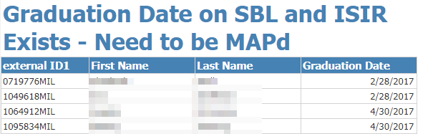

**Technical Specs:** See GitHub repository for current specs.

**Columns**

|  |  |
| --- | --- |
| **Field Name** | **Field Source / Expression** |
| externalId1 |  |
| FirstName |  |
| LastName |  |
| GraduationDate |  |

**Tables/Views**

|  |  |
| --- | --- |
| **Table/View Name** | **Type** |
| report_DataSet_StudentDocuments_View | View |
| dataExtract_ISIR_View | View |
| dataExtract_AcademicPlan_View_v001 | View |

**Parameters:** NONE

### *IPEDS – Section 1 – Part A*

**Description**

This report shows results for IPEDS Section 1 Part A

**System(s):** Regent

**Business Purpose/Use**

The purpose of this report is to use the values generated on the IPEDS form that is required to be filled in annually. Mark Mailleux is responsible for populating this for UW Extension.

**Who Uses Report:** Mark Mailleux

**Frequency:** Annually before February

**Pre-requisite:** Students

**Report Criteria Notes**

* Group 1: Graded FLEX Courses started between 6/2/20xx and 10/31/20xx
* Group 2:
  + Graded FLEX Courses started between 6/2/20xx and 10/31/20xx
  + Sum of Registered Units > 11 where the first class start date is between 6/2/20xx and 10/31/20xx
* Group 2a:
  + Group 2 where student has offered awards for 7/1/20xx and 6/30/20xx
* Group 2b:
  + Group 2 where student has offered Grants and Scholarships for 7/1/20xx and 6/30/20xx

**Report Prompts:**

* Class Start Date 1
* Class Start Date 2
* FA Award Year Date 1
* FA Award Year Date 2

**Navigation:** Misc Reports > IPEDS_S1_PartA

**Example of Report**

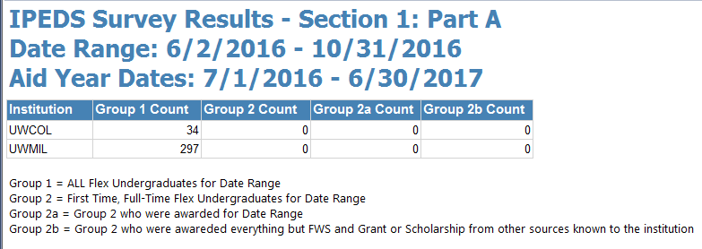

**Technical Specs:** See GitHub repository for current specs.

**Columns**

|  |  |
| --- | --- |
| **Field Name** | **Field Source / Expression** |
| Institution | Institution |
| Group1 | Group1 |
| Group2 | Group2 |
| Group2a | Group2a |
| Group2b | Group2b |

**Tables/Views**

|  |  |
| --- | --- |
| **Table/View Name** | **Type** |
| dataExtract_CourseData_View_v001 | View |
| dataExtract_StudentDetail_View | View |
| dataExtract_Award_View_v002 | View |
| dataExtract_LoanPeriod_View_v001 | View |
| dataExtract_Fund_Config_View | View |

**Parameters:**

* @StartDate1
* @StartDate2
* @FADate1
* @FADate2

### *IPEDS – Section 1 – Part B*

**Description**

This report shows results for IPEDS Section 1 Part B

**System(s):** Regent

**Business Purpose/Use**

The purpose of this report is to use the values generated on the IPEDS form that is required to be filled in annually. Mark Mailleux is responsible for populating this for UW Extension.

**Who Uses Report:** Mark Mailleux

**Frequency:** Annually before February

**Pre-requisite:** Non-Title IV awards from Partner Campus SIS imported into Data Views

**Report Criteria Notes**

* Group 1 = Graded FLEX Courses started between 6/2/20xx and 10/31/20xx
* Group 1 Students awarded any type of financial aid between FA Award Year dates

**Report Prompts:**

* Class Start Date 1
* Class Start Date 2
* FA Award Year Date 1
* FA Award Year Date 2

**Navigation:** Misc Reports > IPEDS_S1_PartB

**Example of Report**

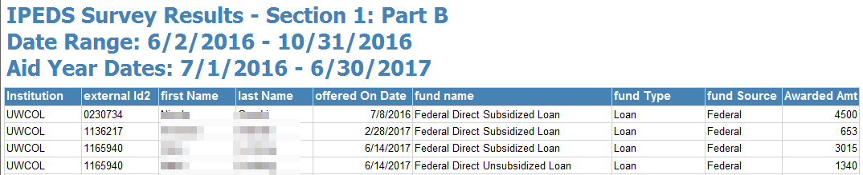

**Technical Specs:** See GitHub repository for current specs.

**Columns**

|  |  |
| --- | --- |
| **Field Name** | **Field Source / Expression** |
| locationExternalId | locationExternalId |
| StudentID | StudentID |
| firstName | firstName |
| lastName | lastName |
| offeredOnDate | offeredOnDate |
| fund_name | fund_name |
| fund_fundType | fund_fundType |
| fund_fundSource | fund_fundSource |
| AwardedAmt | AwardedAmt |

**Tables/Views**

|  |  |
| --- | --- |
| **Table/View Name** | **Type** |
| dataExtract_Award_View_v002 | View |
| dataExtract_LoanPeriod_View_v001 | View |
| dataExtract_Student_View_v001 | View |
| dataExtract_Fund_Config_View | View |
| UWM_NON_TITLEIV | Table created via SSIS Package |

**Parameters:**

* @StartDate1
* @StartDate2
* @FADate1
* @FADate2

### *Reconciliation Report*

**Description**

This report shows students disbursements paid by Institution and Financial Aid Year.

**System(s):** Regent

**Business Purpose/Use**

The purpose of this report is to show students who have had aid disbursed/cancelled and what their amounts are. The report will include all financial aid years. This is used to reconcile the amounts applied in the SIS (Amounts by Item Type Report) to Regent 8.

**Who Uses Report:** FA Coordinators, FA Manager

**Frequency:** Weekly on Mondays, Adhoc

**Pre-requisite:** Students have been disbursed (paid or cancelled).

**Report Criteria Notes**

* Award Status = ACCEPTED
* Disbursement Status <> CANCELLED, DECLINED, OR SCHEDULED
* Location = Prompt Value
* Expression Disbursement Date = IF Disbursement Adjusted Release Date is null, THEN use Disbursement Scheduled Date ELSE use the Disbursement Adjusted Release Date, but if the Disbursement Adjusted Release Date = 10/1/xxxx then use the Scheduled Disbursement Date.
* Subscription Period is based off of the Disbursement Date expression

**Report Prompts:** Location

**Navigation:** Misc Reports > Reconciliation Report

1. Select the Institution from the drop down list. Click on View Report to run the report.

**Example of Report**

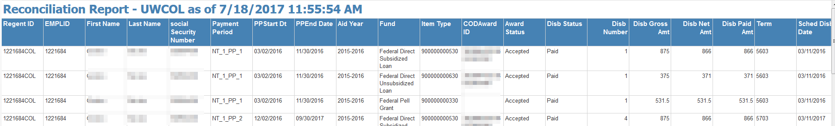

**Technical Specs:** See GitHub repository for current specs.

**Columns**

|  |  |
| --- | --- |
| **Field Name** | **Field Source / Expression** |
| RegentID | RegentID |
| EMPLID | EMPLID |
| FirstName | FirstName |
| LastName | LastName |
| socialSecurityNumber | socialSecurityNumber |
| PaymentPeriod | PaymentPeriod |
| PPStartDt | PPStartDt |
| PPEndDate | PPEndDate |
| AidYear | AidYear |
| Fund | Fund |
| ItemType | ItemType |
| CODAwardID | CODAwardID |
| AwardStatus | AwardStatus |
| DisbStatus | DisbStatus |
| DisbNumber | DisbNumber |
| DisbGrossAmt | DisbGrossAmt |
| DisbNetAmt | DisbNetAmt |
| DisbPaidAmt | DisbPaidAmt |
| Term | Term |
| SchedDisbDate | SchedDisbDate |
| DRIReleaseDate | DRIReleaseDate |

**Tables/Views**

|  |  |
| --- | --- |
| **Table/View Name** | **Type** |
| dataExtract_AwardDisbursement_View |  |
| dataExtract_Student_View |  |
| dataExtract_CODAwardDisbursement_View |  |

**Parameters:**

* @location

### *Reconciliation Report By Fund*

**Description**

This report shows reconciliation amounts by Fund with drilldown to Students.

**System(s):** Regent

**Business Purpose/Use**

The purpose of this report is to show students who have had aid disbursed/cancelled and what their amounts are. The report will include all financial aid years. This is used to reconcile the amounts applied in the SIS (Amounts by Item Type Report) to Regent 8.

**Who Uses Report:** FA Coordinators, FA Manager

**Frequency:** On an adhoc basis

**Pre-requisite:** Students have been disbursed (paid or cancelled).

**Report Criteria Notes**

* Award Status = ACCEPTED
* Disbursement Status <> CANCELLED, DECLINED, OR SCHEDULED
* Location = Prompt Value
* Expression Disbursement Date = IF Disbursement Adjusted Release Date is null, THEN use Disbursement Scheduled Date ELSE use the Disbursement Adjusted Release Date, but if the Disbursement Adjusted Release Date = 10/1/xxxx then use the Scheduled Disbursement Date.
* Subscription Period is based off of the Disbursement Date expression

**Report Prompts:** Location

**Navigation:** Misc Reports > Reconciliation Report by Fund

1. Select the Institution from the drop down list. Click on View Report to run the report.

**Example of Report**

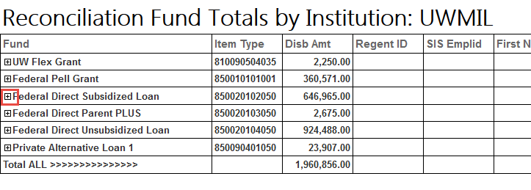

**Clicking on the + sign will show more details for that Fund.**

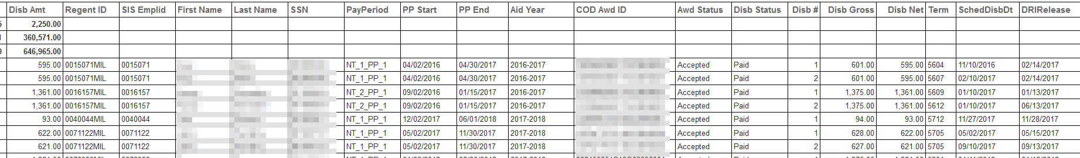

**Technical Specs:** See GitHub repository for current specs.

**Columns**

|  |  |
| --- | --- |
| **Field Name** | **Field Source / Expression** |
| RegentID | RegentID |
| EMPLID | EMPLID |
| FirstName | FirstName |
| LastName | LastName |
| socialSecurityNumber | socialSecurityNumber |
| PaymentPeriod | PaymentPeriod |
| PPStartDt | PPStartDt |
| PPEndDate | PPEndDate |
| AidYear | AidYear |
| Fund | Fund |
| ItemType | ItemType |
| CODAwardID | CODAwardID |
| AwardStatus | AwardStatus |
| DisbStatus | DisbStatus |
| DisbNumber | DisbNumber |
| DisbGrossAmt | DisbGrossAmt |
| DisbNetAmt | DisbNetAmt |
| DisbPaidAmt | DisbPaidAmt |
| Term | Term |
| SchedDisbDate | SchedDisbDate |
| DRIReleaseDate | DRIReleaseDate |

**Tables/Views**

|  |  |
| --- | --- |
| **Table/View Name** | **Type** |
| dataExtract_AwardDisbursement_View |  |
| dataExtract_Student_View |  |
| dataExtract_CODAwardDisbursement_View |  |

**Parameters:**

* @location

### *SAP – Completion Rate by Student*

**Description**

This report shows student completion rate (Credits of Courses Completed / Credits of Courses Attempted) along with the GPA from SIS.

**System(s):** Regent

**Business Purpose/Use:**

The purpose of this report is to show a student completion rate along with GPA from the SIS.

**Who Uses Report:** FA Coordinators, FA Manager

**Frequency:** On an adhoc basis

**Pre-requisite:** Students have been disbursed (paid or cancelled).

**Report Criteria Notes**

* When Location = UWCOL and letterGrade = IP and RepeatYN = True then Attempted Units = 0 else Attempted Units = Attempted Units
* When Quality Points not equal to 0 then completed units = 0
* End Date less than Current Date
* Withdrawal Date is NULL or Withdrawal Date greater than start date
* Letter Grade is not null
* Deleted = 0

**Report Prompts:** Regent ID (EMPLID + Institution 3 letter – ex. 1234567COL)

**Navigation:** Misc Reports > SAP – Completion Rate by Student

1. Enter the Regent ID (ex. 1234567COL). Click on View Report to run the report.

**Example of Report**

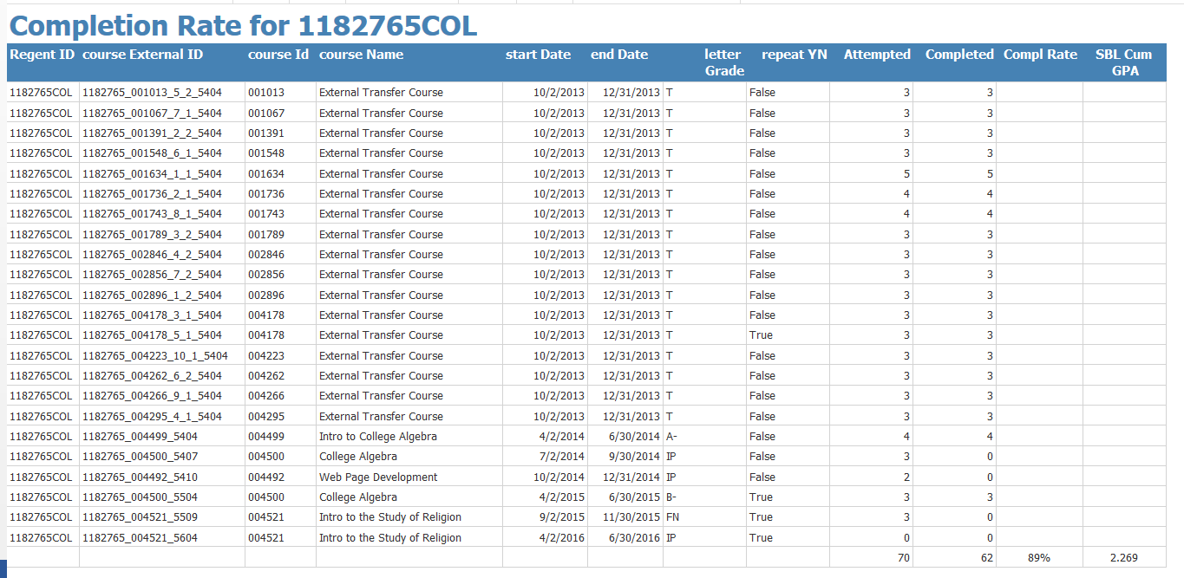

**Technical Specs:** See GitHub repository for current specs.

**Columns**

|  |  |
| --- | --- |
| **Field Name** | **Field Source / Expression** |
| externalID1 | externalID1 |
| courseExternalID | courseExternalID |
| courseId | courseId |
| sisRecord_cumulativeUndergraduateGPA | sisRecord_cumulativeUndergraduateGPA |
| courseName | courseName |
| startDate | startDate |
| endDate | endDate |
| letterGrade | letterGrade |
| repeatYN | repeatYN |
| Attempted | Attempted |
| Completed | Completed |
| qualityPoints | qualityPoints |

**Tables/Views**

|  |  |
| --- | --- |
| **Table/View Name** | **Type** |
| dataExtract_CourseData_View | View |
| dataExtract_AcademicPlan_View_v001 | View |

**Parameters:**

* @StudentID

### *SAP – Completion Rate w/PayPeriod by Student*

**Description**

This report shows student completion rate (Credits of Courses Completed / Credits of Courses Attempted) by payment period along with the GPA from SIS. NOTE: this query is still work in progress.

**System(s):** Regent

**Business Purpose/Use**

The purpose of this report is to show a student completion rate by payment period along with GPA from the SIS.

**Who Uses Report:** FA Coordinators, FA Manager

**Frequency:** On an adhoc basis

**Pre-requisite:** Students have been disbursed (paid or cancelled).

**Report Criteria Notes**

* When Location = UWCOL and letterGrade = IP and RepeatYN = True then Attempted Units = 0 else Attempted Units = Attempted Units
* When Quality Points not equal to 0 then completed units = 0
* End Date less than Current Date
* Withdrawal Date is NULL or Withdrawal Date greater than start date
* Letter Grade is not null
* Deleted = 0
* Course Start Date between Payment Period Start Date and Payment Period End Date

**Report Prompts**

* Regent ID (EMPLID + Institution 3 letter – ex. 1234567COL)

**Navigation:** Misc Reports > SAP – Completion Rate w PayPeriod by Student

1. Enter the Regent ID (ex. 1234567COL). Click on View Report to run the report.

**Example of Report**

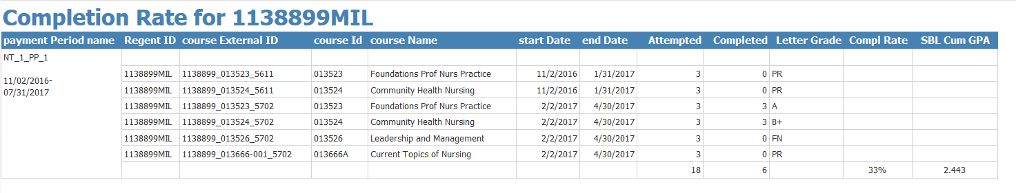

**Technical Specs:** See GitHub repository for current specs.

**Columns**

|  |  |
| --- | --- |
| **Field Name** | **Field Source / Expression** |
| externalID1 | externalID1 |
| courseExternalID | courseExternalID |
| courseId | courseId |
| sisRecord_cumulativeUndergraduateGPA | sisRecord_cumulativeUndergraduateGPA |
| courseName | courseName |
| startDate | startDate |
| endDate | endDate |
| letterGrade | letterGrade |
| repeatYN | repeatYN |
| Attempted | Attempted |
| Completed | Completed |
| paymentPeriod_name | paymentPeriod_name |
| paymentPeriod_startDate | paymentPeriod_startDate |
| paymentPeriod_endDate | paymentPeriod_endDate |

**Tables/Views**

|  |  |
| --- | --- |
| **Table/View Name** | **Type** |
| dataExtract_CourseData_View | View |
| dataExtract_AcademicPlan_View_v001 | View |

**Parameters:**

* @StudentID

### *Student Cost of Attendance by Financial Aid Year*

**Description**

This report shows a student’s Cost of Attendance by the Financial Aid Year.

**System(s):** Regent

**Business Purpose/Use**

The purpose of this report is to show a student’s Financial Aid Year and their Cost of Attendance at a Glance. This can be used to troubleshoot.

**Who Uses Report:** FA Coordinators, FA Manager

**Frequency:** On an adhoc basis

**Pre-requisite:** Students have an ISIR loaded into Regent 8.

**Report Criteria Notes**

* Academic Year Federal Award Year = prompt
* Student ID = prompt

**Report Prompts**

* Federal Award Year
* Regent ID

**Navigation:** Misc Reports > Student Cost of Attendance by FAY

1. Choose Federal Aid Year and enter Regent ID (ex. 1234567COL). View Report.

**Example of Report**

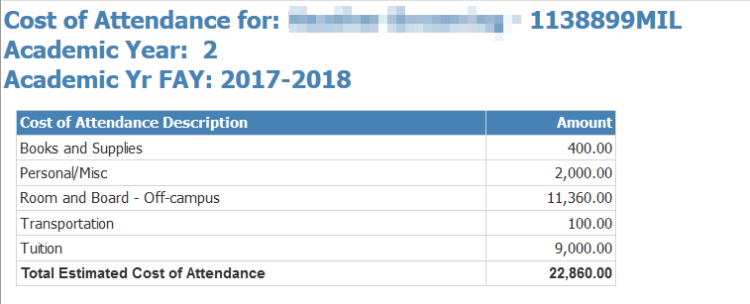

**Technical Specs:** See GitHub repository for current specs.

**Columns**

|  |  |
| --- | --- |
| **Field Name** | **Field Source / Expression** |
| externalID1 | externalID1 |
| FirstName | FirstName |
| LastName | LastName |
| locationExternalID | locationExternalID |
| academicYear_Year | academicYear_Year |
| academicYear_federalAwardYear | academicYear_federalAwardYear |
| enrollmentCostItem_costName | enrollmentCostItem_costName |
| COA_Amt | COA_Amt |

**Tables/Views**

|  |  |
| --- | --- |
| **Table/View Name** | **Type** |
| dataExtract_COA_View | View |
| dataExtract_COADetail_View | View |
| dataExtract_Student_View | View |

**Parameters:**

* @FederalAidYear
* @RegentID

### *Student Course Data by ID*

**Description**

This report shows a select student’s course data.

**System(s):** Regent

**Business Purpose/Use**

The purpose of this report is to show a select student’s courses instead of paging through Regent’s Course Data Tab. This report can be downloaded to Excel for further analysis.

**Who Uses Report:** FA Coordinators, FA Manager

**Frequency:** On an adhoc basis

**Pre-requisite:** Students have enrollment in Regent.

**Report Criteria Notes**

* Student ID = prompt

**Report Prompts**

* Student ID

**Navigation:** Misc Reports > Student Course Data by ID

1. Enter the Regent ID (ex. 1234567COL). View Report.

**Example of Report**

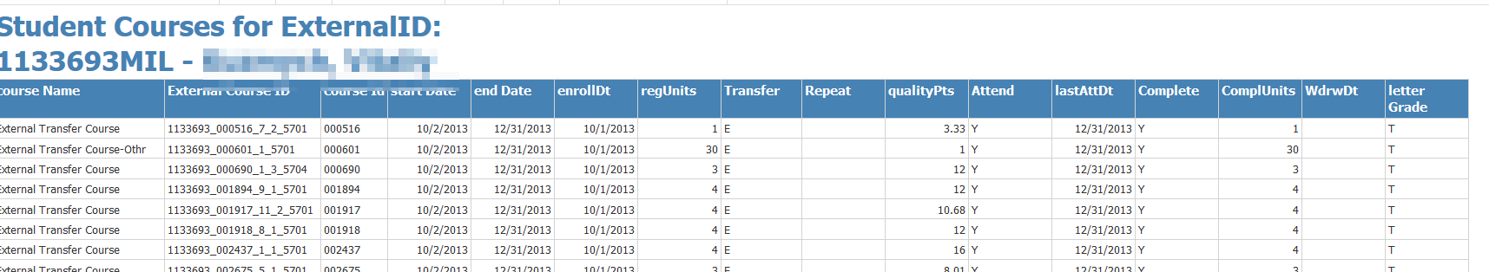

**Technical Specs:** See GitHub repository for current specs.

**Columns**

|  |  |
| --- | --- |
| **Field Name** | **Field Source / Expression** |
| externalID1 | externalID1 |
| FirstName | FirstName |
| LastName | LastName |
| courseExternalId | courseExternalId |
| courseId | courseId |
| courseName | courseName |
| startDate | startDate |
| endDate | endDate |
| enrolledDate | enrolledDate |
| registeredUnits | registeredUnits |
| externalTransferYN | externalTransferYN |
| qualityPoints | qualityPoints |
| lastAttendedDate | lastAttendedDate |
| internalTransferYN | internalTransferYN |
| repeatYN | repeatYN |
| completedUnits | completedUnits |
| withdrawalDate | withdrawalDate |
| attendanceYN | attendanceYN |
| letterGrade | letterGrade |
| TransferType | =IIF(Fields!externalTransferYN.Value = "1","E",IIF(Fields!internalTransferYN.Value = "1","I","")) |
| completedYN | completedYN |
| Repeat | =IIF(Fields!repeatYN.Value="True","Y","") |
| Attendance | =IIF(Fields!attendanceYN.Value="True","Y","") |
| Completed | =IIF(Fields!completedYN.Value="True","Y","") |

**Tables/Views**

|  |  |
| --- | --- |
| **Table/View Name** | **Type** |
| dataExtract_CourseData_View | View |
| dataExtract_Student_View_v001 | View |

**Parameters:**

* @ExternalId1

### *Student Debt Letter Data*

**Description**

This report shows the student debt information that is needed for the Student Debt Letter.

**System(s):** Regent

**Business Purpose/Use**

The purpose of this report is to use the data from this report to generate an email to students. The purpose of the student debt letter is to inform students of the cost of their education as well as any debt they have. NOTE: There is a separate BPD on how to process the Student Debt Letters.

**Who Uses Report:** FA Coordinators, FA Manager

**Frequency:** On an adhoc basis

**Pre-requisite:** Students exist in the Regent 8 system.

**Report Criteria Notes**

* First course start date for the current month process is ran
* Student doesn’t have the Document = Student Debt Letter Sent sent to them within the year
* Award Status = ACCEPTED

**Report Prompts**

* Federal Award Year (COA) – will use the Cost of Attendance figures for the specific Federal Award Year
* Test Email – this is an email you can use to test within MS Word Mail Merge

**Navigation:** Misc Reports > Student Debt Letter

1. Choose federal award year (for Cost of Attendance) and enter test email. View Report.

**Example of Report**

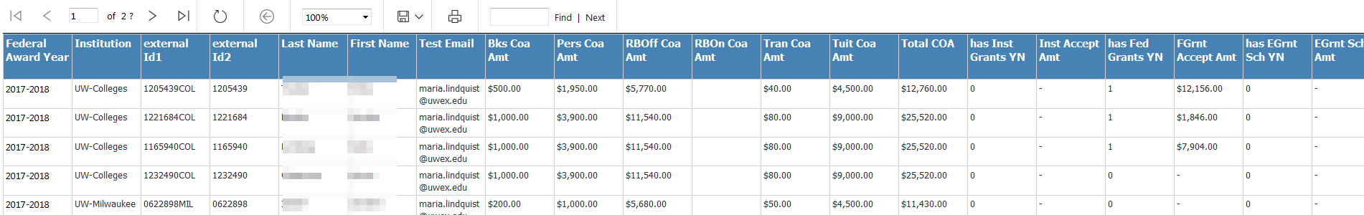

**Technical Specs:** See GitHub repository for current specs.

**Columns**

|  |  |
| --- | --- |
| **Field Name** | **Field Source / Expression** |
| TotalGrantsSchol | =IIF((Fields!FGrntAcceptAmt.Value+Fields!InstAcceptAmt.Value+Fields!InstAcceptAmt2.Value+Fields!InstAcceptAmt3.Value+Fields!EGrntSchAmt.Value) > 0, Fields!FGrntAcceptAmt.Value+Fields!InstAcceptAmt.Value+Fields!InstAcceptAmt2.Value+Fields!InstAcceptAmt3.Value+Fields!EGrntSchAmt.Value, "") |
| studentId | studentId |
| Institution | =IIf(Fields!externalId1.Value Like "*MIL", "UW-Milwaukee", "UW-Colleges") |
| externalId1 | externalId1 |
| TotalCOA | =IIF((Fields!BksCoaAmt.Value+Fields!PersCoaAmt.Value+Fields!RBOffCoaAmt.Value+Fields!RBOnCoaAmt.Value+Fields!TranCoaAmt.Value+Fields!TuitCoaAmt.Value) > 0, Fields!BksCoaAmt.Value+Fields!PersCoaAmt.Value+Fields!RBOffCoaAmt.Value+Fields!RBOnCoaAmt.Value+Fields!TranCoaAmt.Value+Fields!TuitCoaAmt.Value, "") |
| locationExternalID | locationExternalID |
| externalId2 | externalId2 |
| FirstName | FirstName |
| LastName | LastName |
| hasInstGrantsYN2 | hasInstGrantsYN2 |
| hasInstGrantsYN | hasInstGrantsYN |
| hasInstGrantsYN3 | hasInstGrantsYN3 |
| InstAcceptAmt2 | InstAcceptAmt2 |
| InstAcceptAmt3 | InstAcceptAmt3 |
| InstAcceptAmt | InstAcceptAmt |
| hasFedGrantsYN | hasFedGrantsYN |
| FGrntAcceptAmt | FGrntAcceptAmt |
| hasFedSubLnYN | hasFedSubLnYN |
| SubLnAcceptAmt | SubLnAcceptAmt |
| SubLoanInt | SubLoanInt |
| SubLoanAmtRepay | SubLoanAmtRepay |
| SubLoanMonPay | SubLoanMonPay |
| SubLoanEstInt | SubLoanEstInt |
| SubLoanNumPay | SubLoanNumPay |
| hasFedUSubLnYN | hasFedUSubLnYN |
| USubLnAcceptAmt | USubLnAcceptAmt |
| uSubLoanInt | uSubLoanInt |
| uSubAmtRepay | uSubAmtRepay |
| uSubLnMonPay | uSubLnMonPay |
| uSubLnEstInt | uSubLnEstInt |
| uSubLnNumPay | uSubLnNumPay |
| uSubLnEstDefInt | uSubLnEstDefInt |
| hasEGrntSchYN | hasEGrntSchYN |
| EGrntSchAmt | EGrntSchAmt |
| hasPLoanYN | hasPLoanYN |
| BksCoaAmt | BksCoaAmt |
| PLoanAcceptAmt | PLoanAcceptAmt |
| EmailOptInYN | EmailOptInYN |
| RBOnCoaAmt | RBOnCoaAmt |
| StudentEmail | StudentEmail |
| PersCoaAmt | PersCoaAmt |
| RBOffCoaAmt | RBOffCoaAmt |
| CrseStartDt | CrseStartDt |
| TranCoaAmt | TranCoaAmt |
| TuitCoaAmt | TuitCoaAmt |
| TestEmail | @TestEmail |
| FederalAwardYear | @federalAwardYear |
| EstimatedLnFees | =IIf((Fields!SubLnAcceptAmt.Value+Fields!USubLnAcceptAmt.Value) > 0, (Fields!SubLnAcceptAmt.Value+Fields!USubLnAcceptAmt.Value) * .01069,"") |

**Tables/Views**

|  |  |
| --- | --- |
| **Table/View Name** | **Type** |
| dataExtract_Student_View | View |
| dataExtract_CourseData_View | View |
| dataExtract_DocumentRequirement_View |  |
| dataExtract_StudentEmail_View_v001 |  |
| dataExtract_Award_View_v002 |  |
| dataExtract_Fund_Config_View |  |
| dataExtract_LoanPeriod_View_v001 |  |
| dataExtract_AwardDisbursement_View_v001 |  |
| dataExtract_Disbursement_View_v001 |  |
| FLEXGrants_UWC | Table created through SSIS |
| FLEXGrants_UWM | Table created through SSIS |
| dataExtract_Resource_View |  |
| dataExtract_PaymentPeriod_View_v001 |  |
| dataExtract_Enrollment_View_v001 |  |
| dataExtract_AcademicYear_View_v001 |  |
| dataExtract_COA_View |  |
| dataExtract_COADetail_View |  |

**Parameters:**

* @federalAwardYear