Infographics Supporting Docs

Matt Kline

Air Travel

How clients view air travel is a large part of our business. The more they trust us the more travelers we will have. Although we keep improving, without physical evidence our potential clients are likely to trust other travel forms.

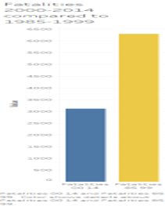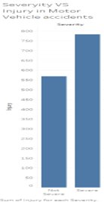

Looking at our first two graphs, we spot 2 things right off the get go: Air travel has cut fatalities in half as they have gotten older and that there are more severe injuries than non-severe injuries in car travel. With the color choices, we want a clear distinction between the 2 year grouping in air travel so it is easy at a glance to tell that current years are much safer in air travel. Also at first glance, the bars for motor vehicles initially look worse than the current grouping of air travel. By keeping those 3 bars the same, it limits the focus to the words on the infographic and the initial comparison of all bars.

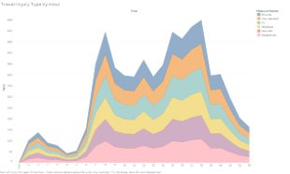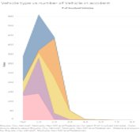

With these 2 graphs, the client is looking at similar color pattern matched to the vehicle type. It makes for a smooth transition between these graphs being directly next to each other. With these graphs, we are able to show that at peak travel hours, any type of local transportation used is at risk of an accident. The more we paint the normal risk the better our improvement to less risk seems.

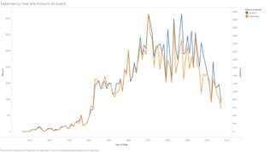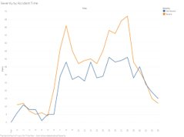

These two graphs use similar color, both relate yellow to severity of the incident. On the air travel, we can see that in the more recent years, even when an incident has occurred, the built in safety features of the plane has allowed for the majority of passengers to remain safe. Looking at the bottom graph, we can see that no matter what time of day, if you are in a motor vehicle accident, than you are likely to end up in a sever case.

Additional Sources:

Accidents graph. (n.d.). Retrieved April 11, 2021, from <http://www.baaa-acro.com/crash-graph?created%5Bmin%5D=2000-01-01&created%5Bmax%5D=2009-12-31>

Air and Space Museum. (2007). *The Era of Mass Air Travel Begins*. Smithsonian National Air and Space Museum. <https://airandspace.si.edu/exhibitions/america-by-air/online/heyday/heyday11.cfm#:~:text=By%20the%20end%20of%20the,travel%20experience%20began%20to%20change>.

Grandi, S. (2016, September 9). *Airplane Crashes Since 1908*. Kaggle. <https://www.kaggle.com/saurograndi/airplane-crashes-since-1908>.

There are 32 Crash datasets available on data.world. (n.d.). Retrieved April 11, 2021, from <https://data.world/datasets/crash>

GitHub link:

<https://github.com/mkline3/DSC640/tree/main/DSC640_Project>