ASSIGNMENT 4

Matthew Kline

2020-09-23

# Markdown Basics

## Favorite Foods

1. Steak
2. Pizza
3. Sushi

## Images

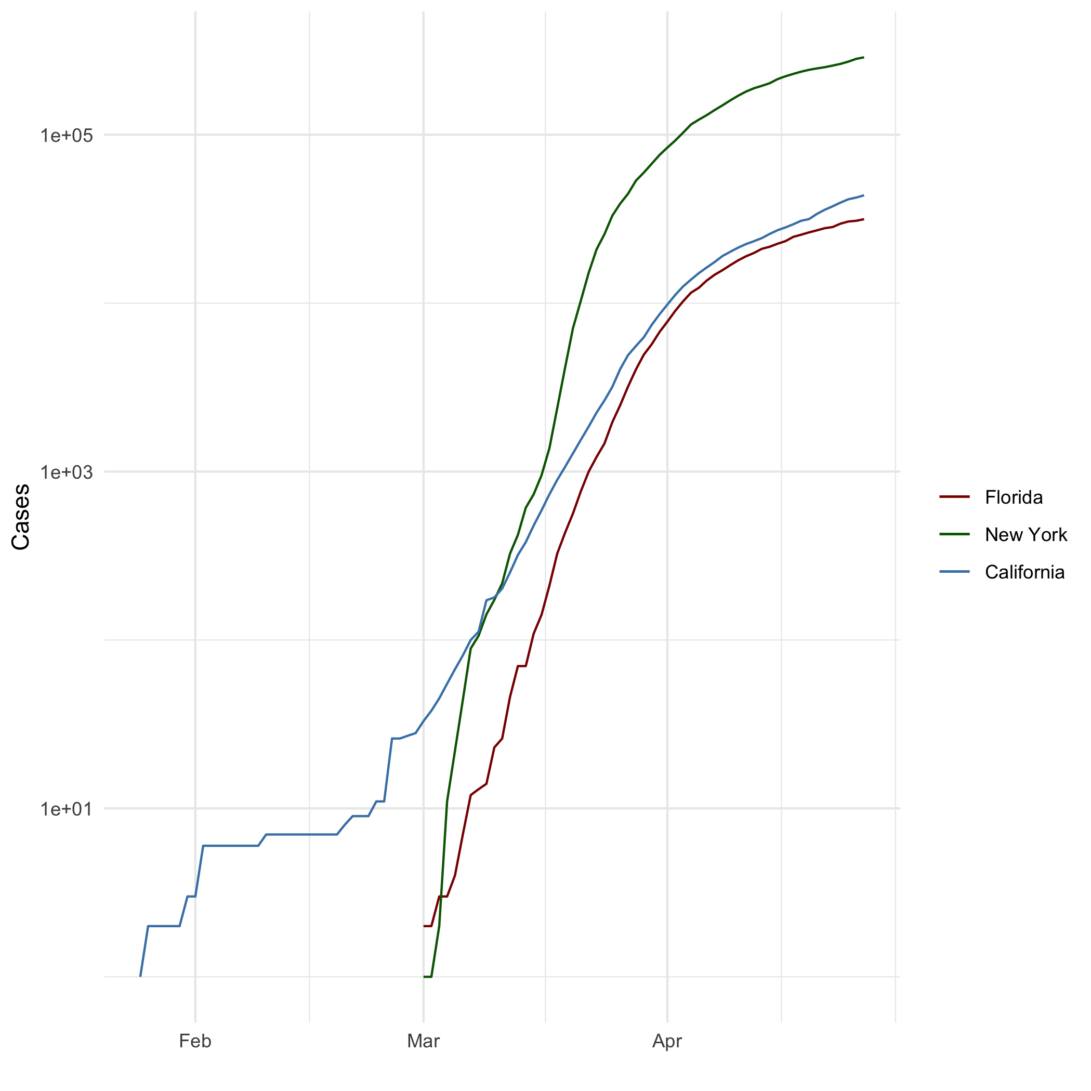

## Add a Quote

“If I don’t have some cake soon, I might die.” - Stanley Hudson, The Office Season 4

## Add an Equation

$A^{2}+B^{2}=C^{2}$

## Add a Footnote

This is a footnote

## Add Citations

* R for Everyone
  + (Lander 2014)
* Discovering Statistics Using R
  + (Field, Miles, and Field 2012)

# Inline Code

## NY Times COVID-19 Data

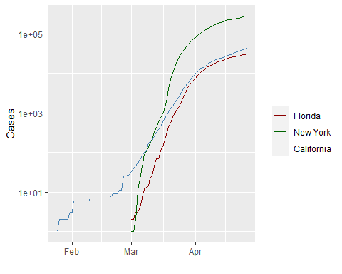

## R4DS Height vs Earnings

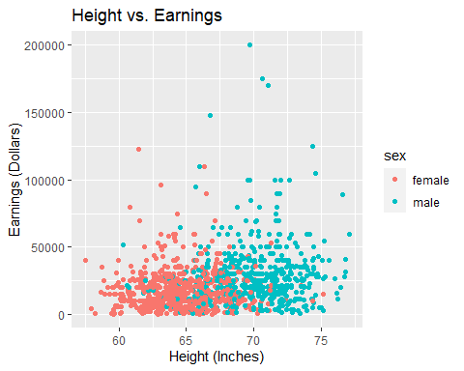

# Tables

## Knitr Table with Kable

name <- c("Aragon", "Bilbo", "Frodo", "Galadriel", "Sam", "Gandalf", "Legolas", "Sauron", "Gollum")  
race <- c("Men", "Hobbit", "Hobbit", "Elf", "Hobbit", "Maia", "Elf", "Maia", "Hobbit")  
in_fellowship <- c(TRUE, FALSE, TRUE, FALSE, TRUE, TRUE, TRUE, FALSE, FALSE)  
ring_bearer <- c(FALSE, TRUE, TRUE, FALSE, TRUE, TRUE, FALSE, TRUE, TRUE)  
age <- c(88, 129, 51, 7000, 36, 2019, 2931, 7052, 589)  
  
characters_df <- data.frame(name, race, in_fellowship, ring_bearer, age)  
  
knitr::kable(characters_df, caption = "One Ring to Rule Them All" )

One Ring to Rule Them All

|  |  |  |  |  |
| --- | --- | --- | --- | --- |
| name | race | in_fellowship | ring_bearer | age |
| Aragon | Men | TRUE | FALSE | 88 |
| Bilbo | Hobbit | FALSE | TRUE | 129 |
| Frodo | Hobbit | TRUE | TRUE | 51 |
| Galadriel | Elf | FALSE | FALSE | 7000 |
| Sam | Hobbit | TRUE | TRUE | 36 |
| Gandalf | Maia | TRUE | TRUE | 2019 |
| Legolas | Elf | TRUE | FALSE | 2931 |
| Sauron | Maia | FALSE | TRUE | 7052 |
| Gollum | Hobbit | FALSE | TRUE | 589 |

## Pandoc Table

|  |  |  |  |  |
| --- | --- | --- | --- | --- |
| Name | Race | In Fellowship? | Is Ring Bearer | Age |
| Aragon | Men | Yes | No | 88 |
| Bilbo | Hobbit | No | Yes | 129 |
| Frodo | Hobbit | Yes | Yes | 51 |
| Sam | Hobbit | Yes | Yes | 36 |
| Sauron | Maia | No | Yes | 7052 |

# References

Field, A., J. Miles, and Z. Field. 2012. *Discovering Statistics Using R*. SAGE Publications. <https://books.google.com/books?id=wd2K2zC3swIC>.

Lander, J. P. 2014. *R for Everyone: Advanced Analytics and Graphics*. Addison-Wesley Data and Analytics Series. Addison-Wesley. <https://books.google.com/books?id=3eBVAgAAQBAJ>.