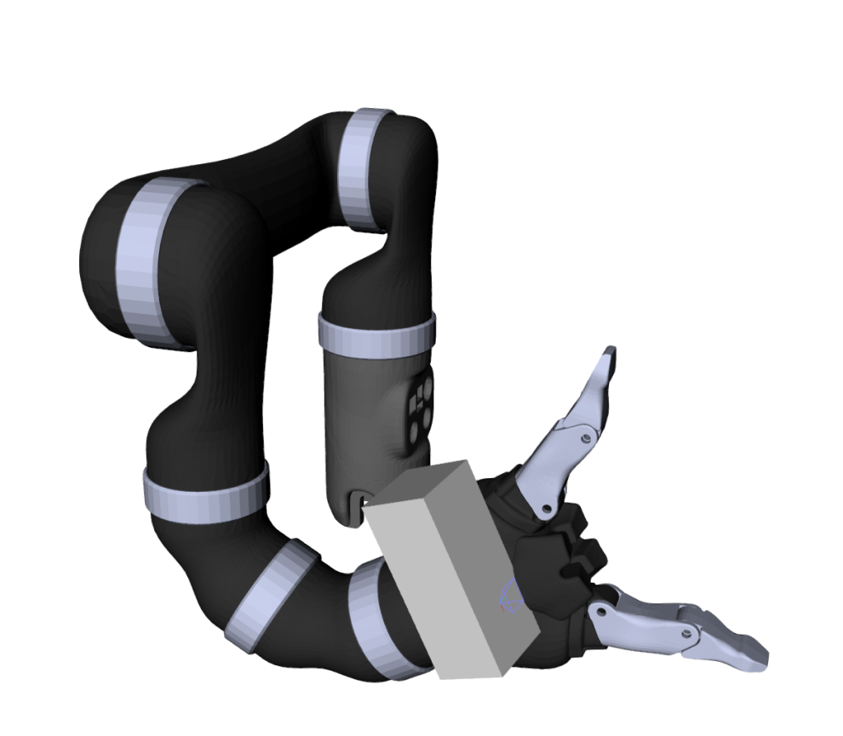
$$Robot at q_{t}$$
$$H_{t}$$
$$..$$
$$∇Φ(z_{..})$$
$$∇Φ(z_{..})$$
$$∇Φ(z_{0, 1})$$
$$∇Φ(z_{0, 0})$$
$$Φ=0$$

