Mark Klobukov

CS 383: Homework 4

Professor Matthew Burlick

2/19/2018

**Part I: Theory**

1) Training examples for an unknown target function:

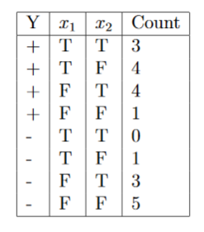

The dataset has two classes: + and – . The total number of data with class + is (3+4+4+1) = 12.   
Total number of data with class – is (0+1+3+5) = 9

(a) What is the sample entropy from this training data?



$$P\left(+\right)=\frac{12}{21} , P\left(-\right)=\frac{9}{21}$$

$$H\left(Y\right)= -\frac{12}{21}\log_{2}{\frac{12}{21}}-\frac{9}{21}\log_{2}{\frac{9}{21}}=0.9852$$

b) What are the IGs for branching on variables $x_{1}$ and $x_{2}$?

$x_{1}:$ $p_{T}=\left(3+4\right)=7, n_{T}=\left(0+1\right)=1$

$p_{F}=\left(4+1\right)=5, n_{F}=\left(3+5\right)=8$

$$remainder\left(x_{1}\right)=\frac{8}{21}(-\frac{7}{8}\log_{2}{\frac{7}{8}-\frac{1}{8}\log_{2}{\frac{1}{8})+\frac{13}{21}(-\frac{5}{13}\log_{2}{\frac{5}{13}-\frac{8}{13}\log_{2}{\frac{8}{13})=0.80212}}}}$$

$$IG\left(x_{1}\right)=H\left(Y\right)-remainder\left(x_{1}\right)=0.9852-0.80212=0.18308$$

$x_{2}:$ $p_{T}=\left(3+4\right)=7, n_{T}=\left(0+3\right)=3$

$p_{F}=\left(4+1\right)=5, n_{F}=\left(1+5\right)=6$

$$remainder\left(x_{2}\right)=\frac{10}{21}(-\frac{7}{10}\log_{2}{\frac{7}{10}-\frac{3}{10}\log_{2}{\frac{3}{10})+\frac{11}{21}(-\frac{5}{11}\log_{2}{\frac{5}{11}-\frac{6}{11}\log_{2}{\frac{6}{11}})}=0.9403}}$$

$$IG\left(x_{2}\right)=H\left(Y\right)-remainder\left(x_{2}\right)=0.9852-0.9403=0.0449$$

(c) Draw the decision tree that would be learned by the ID3 algorithm without pruning from this training data.

2) Five data samples:

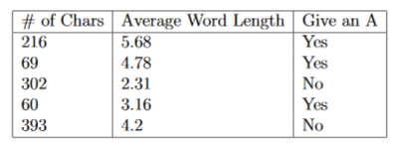

(a) What are the class priors?

Class priors are the probabilities of encountering the class in a dataset. .

$$P\left(A=Yes\right)=\frac{3}{5}, P\left(A=No\right)=\frac{2}{5}$$

(b) Find parameters of the Gaussians.

Standardize data so that there is no unfair bias toward features of different scales. First column of the following matrix represents standardized number of characters, second column is the average word length (also standardized). In the third column, 1/0 correspond to Yes/No.

$$\left[\begin{matrix}0.0551 & 1.2477 & 1 \\ -0.9572 & 0.5688 & 1 \\ 0.6473 & -1.2945 & 0 \\ -1.0192 & -0.6533 & 1 \\ 1.2740 & 0.1313 & 0\end{matrix}\right]$$

Model for “Yes” observations:

# characters:

Avg. word length: