Matthew Klump
November 14, 2001
WRI 327

“Questions for Discussion,” number 3, page 446

Discus issues of ethics or clarity that way come up in regard to the graphics that Rick Ford has produced for McDuff’s annual corporate report. Should these graphics be included in McDuff’s annual report? If so, why? If not, why not and what would you change?

The answer to the first question is that no Rick Ford “interesting” graphics will not be included in McDuff’s annual report because they violate the standards set forth is book section labeled Equal Consideration of Interest.

- The graphics are not honest! When making graphs for any report especially to share owners, you must accurately represent the data by showing all axes on the bar chart, consistently labeling all pieces of the pie chart the same way. I would also get rid of the fancy 3-D effect on the bar chart, it is irrelevant. The pie chart needs some serious work. The pie chart must show precisely how the corporate assets are divided up and labeled directly with all lines. In regard to the bar chart without bars, again it is not years in terms of amount is not shone. I would also get rid of the irrelevant beds for bars and just use real bars!

- The graphics also violate the second law of Ethical Guidelines for Work: Do No Harm. If the stock folders saw these in the report, they would dump the stock they owned in a heart beat.

- It is painfully clear that Beth Chang and Rick Ford did not communicate effectively when working on their respective parts of the annual report graphic cleanup project. It is my guess that if they had talked to each other about what and how their were going about their parts, Rick’s graphics would most likely not have turned out the way they did.

Assignment 7 page 449:

You tell the spreadsheet to create a line graph, with time (in months) on the x-axis, and units sold on the y-axis. Here is the graph below for you:
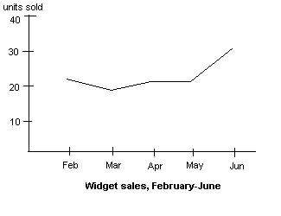
Looks good--the boss can see the jump in units sold in June.
- ???? What is this ???? This graph pretty much tells me much ado about nothing. This graph actually came from a business report I would:
- There is no caption label for the graph, and there is no clear labels on the axes.
- Add the graph caption, and label the axes.
Here's the new graph:
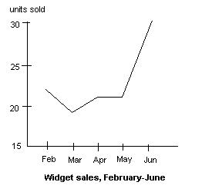
Now that's a jump in sales. You should get your raise any day now.

- Same report, same problem:

- There is no caption label for the graph, and there is no clear labels on the axes.

- Add the graph caption, and label the axes.

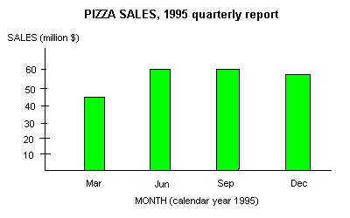
- This bar graph is little bit better:

- The only deficiency I can see is the inability to read the monthly amounts on this bar graph across to the vertical axis.

- The graph needs to add horizontal lines across to mark where the monthly amounts come to.

