Inspired instructions
Revision
2
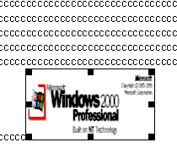
How to Insert an Image with Wrap Text Around it In Microsoft Word 20002
This is only a possibility; I thought a graphic representation of the result might help those who do not know what this process is.

A Guide to Cutting
And Pasting

About these Instructions
These instructions divide into four sections:
- Section 1, “Placing a picture into a document and center aligning it in
the text.”
- Section 2, “Left aligning the picture while the text wraps right.”
- Section 3, “Right aligning the picture while the text wraps left.”
- Section 4, “Moving the object from one place in the document to another
➔ while the text continues to wrap.”

Assumptions
For you, the user, to get the most out off this guild, there are several assumptions made:
- You should have some prior experience with using a computer with a Microsoft Windows 95 or later operating system.
- You should have knowledge of pointing, clicking, selecting, browsing files and file folders.
- You should have an ability to create, add contents, and save new documents in Microsoft Paint and Microsoft Word VERSION WORD 2002 PART OF MICROSOFT OFFICE 2000 PROFESSIONAL
- If any of the above is unclear, it is highly recommended to read How to Use Windows 98 by Douglas A. Hergert (Paperback $7.99 used on Amazon.com)
- If on the other hand the first three points seem too simplistic, this guide is probably not for you.

Before you get started…
There are a few more things you need to know:
- The only materials you will need are access to a computer preloaded with Microsoft Windows 95 or later, Microsoft Paint, Microsoft Word, and you’ll also need two or three disks to save your work.
- The only convention in this guide will uses bold italic to identify different parts of the menu bar, its sub menus, and various other functions inside Word and Paint.
- [This guide uses keyboard short cuts in the instructions. If you are more familiar with menu options, substitute them for the short cuts given.]
- This guide illustrates each point. If the step is unclear, refer to the pictorial or the last step to pick up where you left off.
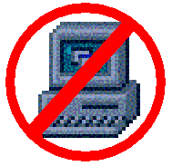
NOTICE: LOSS OF DATA.
If computer turns off abruptly due to
power surge or other cause, you will
lose your work. Save often to your
disk(s). great!

This section will shows you how to cut a picture object inside paint and place it into the middle of your word document with justified text wrapping around your picture.
Section
1
Placing a Picture into a Document and Center Aligning it in the Text
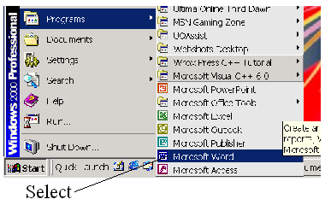
Figure 1: Opening Microsoft Word
- Open Microsoft Word from the Start menu:

- Fill the Blank Document Word Document with text by holding down any letter key for about ten seconds as shown in Figure 2good:
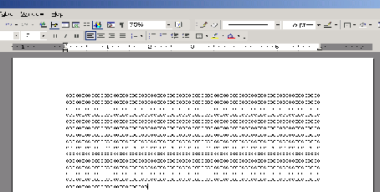Figure 2: Word Document with Text

- Open Microsoft Paint from the Start menu: (Figure3)

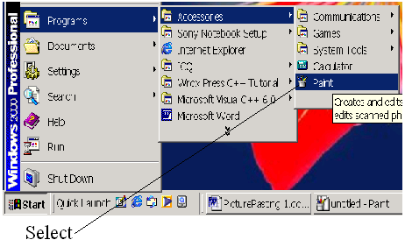

Figure 3: Opening Microsoft Paint
- Press the key combination Ctrl + O to open the Open Dialogue Box inside Microsoft Paint. (Figure 4)
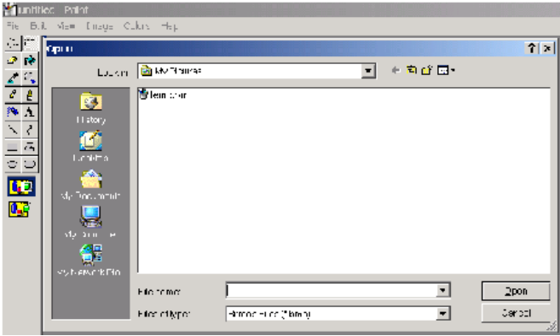

Figure 4: Open Dialogue Box
Should text in the caption follow the conventions?

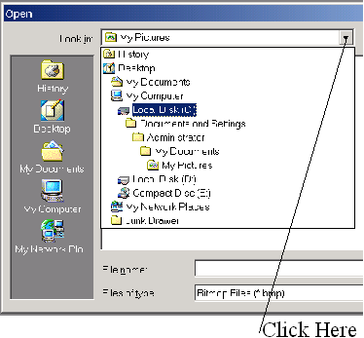
- Click on the pull down List Box right next to the label “Look in:”

Figure 5: Open Dialogue List Box

- Double Click on the first hard disk icon in the list box.
¶
In figure 5 the first hard disk icon is directly below the My Computer icon : good

- Double Click the Windows Main Folder:
¶
In figure 6 it is labeled WINNT. For Windows 95 or later
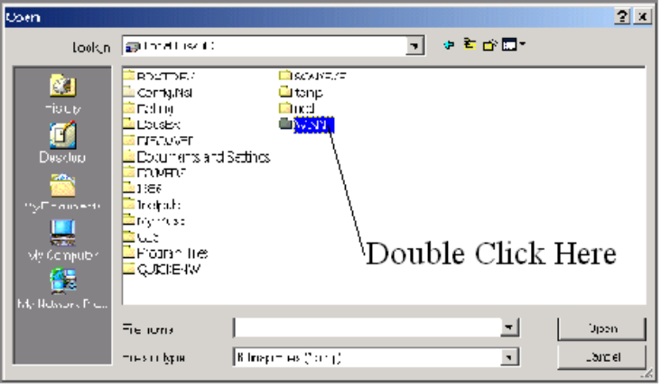
the folder will is labeled Windows.

Figure 6: High lighted Windows Main Folder

- NOTICE: SYSTEM FILE DAMAGE. Changing or deleting the system files will result in loses of computer function. Keep the scope of these instructions to just the windows folder bitmap files.good
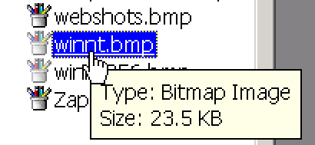
- Double Click any Bit Map file with the icon  to the left of the file just like the one selected in figure 7.

Figure 7: Bit Map File

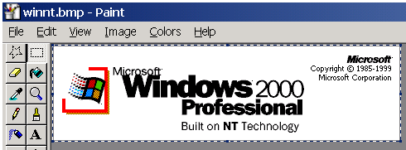
- Press the key combination Ctrl + A to highlight all of the image inside Paint:

Figure 8: Selected Bit Map Image

- Press the key combination Ctrl + X to cut the image out of Paint.
¶
This will places the image into the computer’s Clip Board.
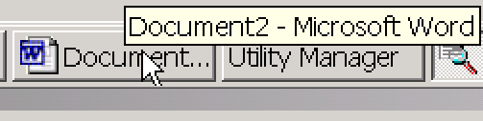
- Click on the Word Document on the task bar:

Figure 9: Task Bar with Word Document

- Press the key combination Ctrl + V to paste the Bitmap into your Word Document as shown in figure 10:

Figure 10: Pasted Picture Inside Word Document

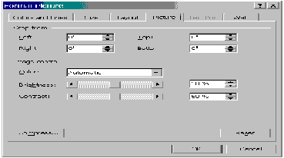
- Double Click the pasted Picture Object in the Word Document to bring up a dialogue box called Format Picture. See figure 11:
Figure 11: Format Picture Dialogue Box

- Click on the tab labeled Layout to bring up a selection of options including word wrapping. See Figure 13.
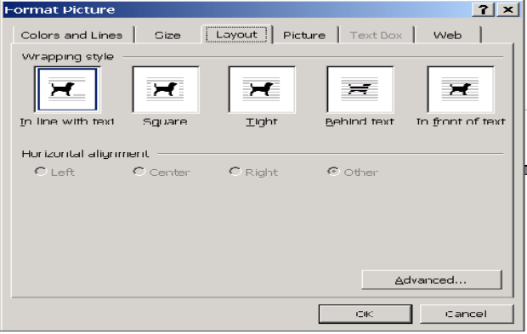

Figure 13: Layout Tab of the Format Picture Dialogue Box

- Select either Square or Tight in the Wrapping Style options for what you’ll be doing. See figure 13.

- Click Center within the Horizontal alignment options. See figure 13.

- Click OK to close the Format Picture dialogue box.

- Click in the word document exactly one line of text below the picture object.

- Press the space bar once.
[Tell what happens or provide a graphic so I know I have done it correctly. Same below.]
- Click again on the same line you clicked on in step 18.

- Press the space bar again.

- Repeat Steps 18 through 21 to see the text wrap around the picture object with the picture centered.

Congratulations, you have successfully cut and pasted a picture into your word document and wrapped the text around it. You are now ready to move onto, Section 2: Left aligning the picture while the text wraps right.great!

Section
2
Left Aligning the Picture While the Text Wraps Right

Now that you have successfully completed section 1, you should have a picture pasted in your word document, and used the format picture dialogue box to center align the picture.good

In this section you will use nearly the same steps to align your picture with the left margin while the text in that place wraps out of the picture’s way to the right.good

- Double Click the picture to open the Format Picture Dialogue Box.
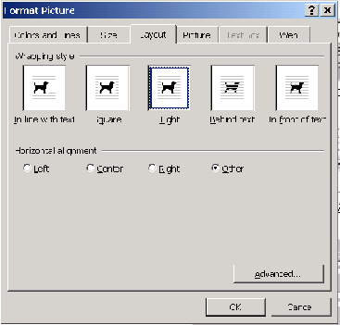

- Click on the Layout tab selected as shown in figure 14:

Figure14: Layout Tab of Format Picture

- Click on the Left Horizontal Alignment Option Box as shown in figure 15.
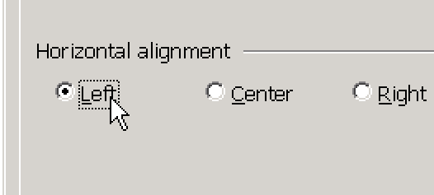
Figure 15: Left Horizontal Alignment Option

- Click OK to close the Format Picture Dialogue Box.

[Add graphic of what it would look like.]
Congratulations, you have successfully completed aligning your picture to the left margin while your text moved out of the way to the right. You are now ready to move onto to move onto, Section 3: “Right aligning the picture while the text wraps left.”good

Section
3

Now that you have completed the steps in the previous section, your picture is aligned to the left side of your word document. You are now ready to align your picture to the right side of your document.good

- Double Click the picture to open the Format Picture Dialogue Box.
Right Aligning the Picture While the Text Wraps Left

- Click on the Layout tab selected as shown in figure 16:

Figure16: Layout Tab of Format Picture

Figure 15: Left Horizontal Alignment Option
- Click on the Right Horizontal Alignment Option Box as shown in figure 15.
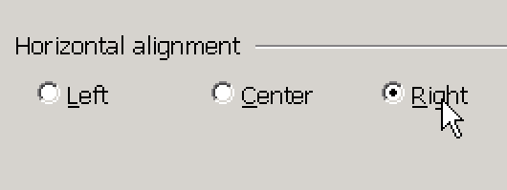

Figure: 17 Right Horizontal Alignment

- Click OK to close the Format Picture Dialogue Box.

Congratulations, you have successfully completed aligning your picture to the right margin while your text moved out of the way to the left. You are now ready to move onto to move onto, Section 4 “Moving the object from one place in the document to another while the text continues to wrap.”

Section
4
Now that you have completed the steps in the previous section, your picture is aligned to the right side of your word document. You are now ready to move your picture inside the document while the text continues to wrap.
Moving the object from one place in the document to another while the text continues to wrap

In this version of Word (Word 2002 of Microsoft Office 2000 Professional), doing any one of the sections one through three of this document will allows you to move your picture around while the text continues to wrap.

In other versions of Microsoft Word (i.e. just Microsoft Office 2000), this is done a different way. See your Microsoft Word Help file for further instructions.

CONGRADULATIONS, you have finished this guide in record time. You can now cut and paste just about anything.

