Inspired instructions
Final Revision
How to Insert an Image and Wrap Text Around it In Microsoft Word 2002
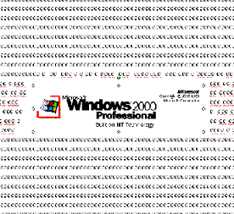
A Guide to Cutting
And Pasting

About these Instructions
These instructions divide into four sections:
- Placing a picture into a document and center aligning it in the text.
- Left aligning the picture while the text wraps right.
- Right aligning the picture while the text wraps left.
- Moving the object from one place in the document to another while the text continues to wrap.

Assumptions
For you, the user, to get the most out off this guild, there are several assumptions made:
- You should have some prior experience with using a computer with a Microsoft Windows 95 or later operating system.
- You should have knowledge of pointing, clicking, selecting, browsing files and file folders.
- You should have an ability to create, add contents, and save new documents in Microsoft Paint and Microsoft Word VERSION WORD 2002 PART OF MICROSOFT OFFICE 2000 PROFESSIONAL
- If any of the above is unclear, it is highly recommended to read How to Use Windows 98 by Douglas A. Hergert (Paperback $7.99 used on Amazon.com)

Before you get started…
There are a few more things you need to know:
- The materials you need are access to a computer preloaded with Microsoft Windows 95 or later, Microsoft Paint, Microsoft Word 2002, and you’ll also need two or three disks to save your work.
- This guide will uses bold italic to identify different parts of the menu bar, its sub menus, and various other functions inside Word and Paint.
- This guide uses keyboard short cuts in the instructions. If you are more familiar with menu options, substitute them for the short cuts given.
- This guide has lots of illustrations. If the step is unclear, refer to the pictorial or the last step to pick up where you left off.

NOTICE: LOSS OF DATA.
If computer turns off abruptly due to
power surge or other cause, you will
lose your work. Save often to your
disk(s).

This section shows you how to cut a picture object inside paint and place it into the middle of your word document with justified text wrapping around your picture.
Section
1
Placing a Picture into a Document and Center Aligning it in the Text
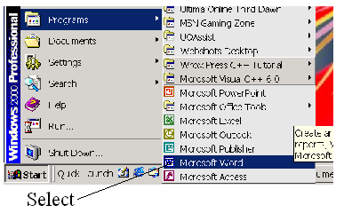
Figure 1: Opening Microsoft Word
- Open Microsoft Word from the menu:

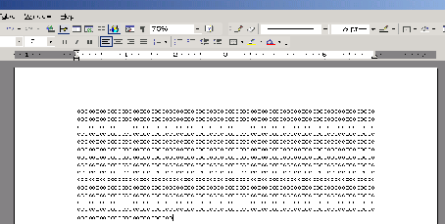
- Open a Word Document with text by selecting the file and open from the bar menu. (Figure 2)
Figure 2: Document With Text
Any word document with text works with this guide.
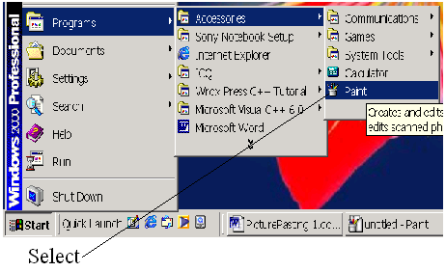
- Open Microsoft Paint from the menu. (Figure 3)
Now that you have your word document and bitmap open for cutting and pasting, please continue with section 1.

Figure 3: Opening Microsoft Paint

- Press the key combination Ctrl + O to open the Open Dialogue Box inside Microsoft Paint. (figure 4)
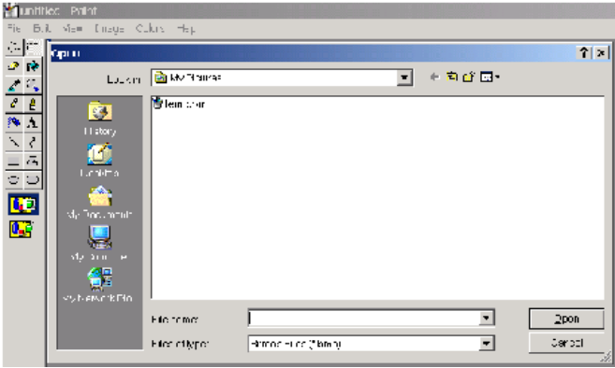

Figure 4: Open Dialogue Box

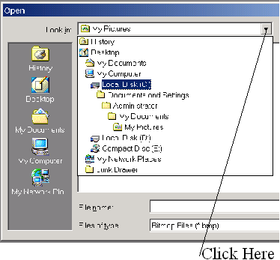
- Click on the pull down List Box right next to the label “Look in:” (figure 5)

Figure 5: Open Dialogue List Box

- Double Click on the first hard disk icon in the list box.
In figure 5 the first hard disk icon is directly below the My Computer icon:

You’ve sure got the hang of this pointing and clicking! Please continue with section 1.

- Double Click the Windows Main Folder:
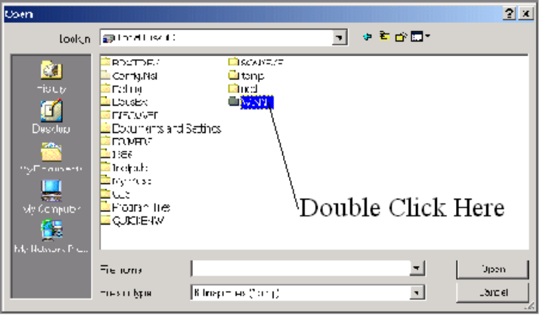
In figure 6 it is labeled WINNT. For Windows 95 or later the folder will is labeled Windows

Figure 6: High lighted Windows Main Folder

NOTICE: SYSTEM FILE DAMAGE. Changing or deleting the system files will result in loss of computer function. Keep the scope of these instructions to just the windows folder bitmap files.

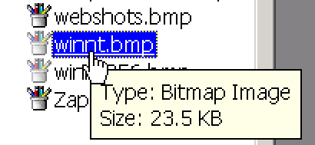
- Double Click any Bit Map file with the icon  to the left of the file just like the one selected in figure 7.

Figure 7: Bit Map File

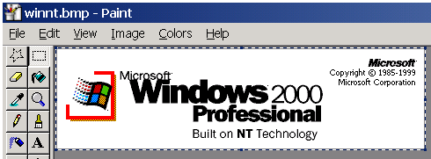
- Press the key combination Ctrl + S to save your picture to a file name you specify to your disk(s). (figure 8)

Figure 8: Selected Bit Map Image

Have you got that picture opened and saved? Good. Please continue with section 1.
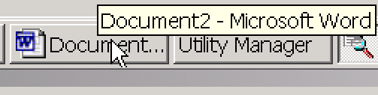
- Click on the Word Document on the task bar: (figure 9)
Figure 9: Task Bar with Word Document

- Press the key combination Ctrl + O to open the image you saved inside Paint.
You may paste the picture from the computer’s Clip Board if you like as another alternative.

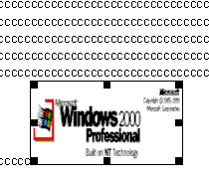
Your document should look nearly just like this as shown in figure 10:

Figure 10: Picture Inside Word Document

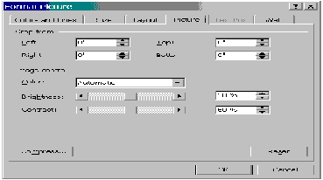
- Double Click the pasted Picture Object in the Word Document to bring up a dialogue box called Format Picture. See figure 11:
Figure 11: Format Picture Dialogue Box

Are you getting the hang of this? Your just two pages from being done with Section 1, please continue.

- Click on the tab labeled Layout to bring up a selection of options including word wrapping. See Figure 12.
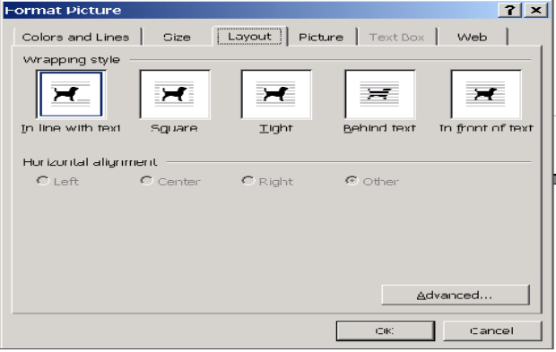

Figure 12: Layout Tab of the Format Picture Dialogue Box

- Select either Square or Tight in the Wrapping Style options for what you’ll be doing. See figure 13.

- Click Center within the Horizontal alignment options. See figure 13.
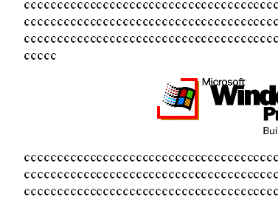
- Click to close the Format Picture dialogue box.

- Click in the word document exactly one line of text below the picture object.
Figure 13: Space Bar Pressed Once
- Press the space bar once. See figure 13.
You’re almost done with Section 1, please continue.

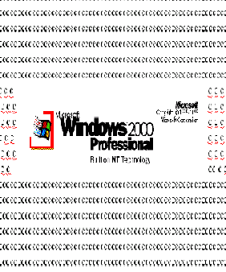
- Click again on the same line you clicked on in step 18.

- Press the space bar again.

- Repeat Steps 18 through 21 to see the text wrap around the picture object with the picture centered. See figure 14.
Figure 14: Wrapped Test Around Picture

Congratulations, you have successfully cut and pasted a picture into your word document and wrapped the text around it. You are now ready to move onto, Section 2: Left aligning the picture while the text wraps right

.

Section
2
Left Aligning the Picture While the Text Wraps Right

Now that you have successfully completed section 1, you should have a picture pasted in your word document, and used the format picture dialogue box to center align the picture.

In this section you use nearly the same steps to align your picture with the left margin while the text in that place wraps out of the picture’s way to the right.

- Double Click the picture to open the Format Picture Dialogue Box.
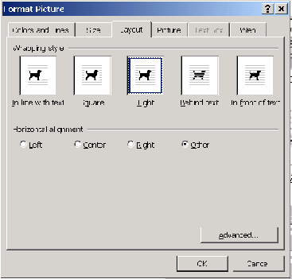

- Click on the Layout tab selected as shown in figure 15:

Figure15: Layout Tab of Format Picture
You’ve got the Format Picture Dialogue Box set correct right? Great. Please continue with Section 2.

- Click on the Left Horizontal Alignment Option Box as shown in figure 16.
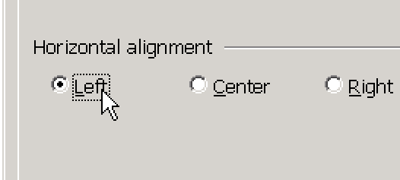
Figure 16: Left Horizontal Alignment Option

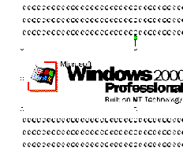
- Click to close the Format Picture Dialogue Box.
See figure 17 to see how your left aligned picture should look.

Figure 17: Left Aligned Picture

Congratulations, you have successfully completed aligning your picture to the left margin while your text moved out of the way to the right. You are now ready to move onto to move onto, Section 3: “Right aligning the picture while the text wraps left.”

Section
3

Now that you have completed the steps in the previous section, your picture is aligned to the left side of your word document. You are now ready to align your picture to the right side of your document.

- Double Click the picture to open the Format Picture Dialogue Box.
Right Aligning the Picture While the Text Wraps Left

- Click on the Layout tab selected as shown in figure 18:

Figure18: Layout Tab of Format Picture

Figure 15: Left Horizontal Alignment Option
Well of course you’ve got the Format Picture Dialogue Box set correct. Please continue with Section 3.
- Click on the Right Horizontal Alignment Option Box as shown in figure 19.
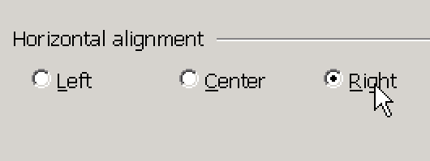

Figure 19: Right Horizontal Alignment

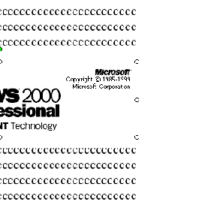
- Click to close the Format Picture Dialogue Box.
See figure 20 to see how your right aligned picture should look.

Figure 20: Right Aligned Text

Congratulations, you have successfully completed aligning your picture to the right margin while your text moved out of the way to the left. You are now ready to move onto to move onto, Section 4 “Moving the object from one place in the document to another while the text continues to wrap.”

Section
4
Now that you have completed the steps in the previous section, your picture is aligned to the right side of your word document. You are now ready to move your picture inside the document while the text continues to wrap.
Moving the object from one place in the document to another while the text continues to wrap
In this version of Word (Word 2002 of Microsoft Office 2000 Professional), doing any one of the sections one through three of this document allows you to move your picture around while the text continues to wrap.

- Double click the picture.

- Select the layout tab.

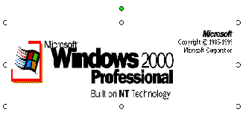
- Select any one of the Horizontal Alignment Options ACCEPT left horizontal alignment to highlite the picture in such a way you can move it about. See figure 21.
Figure 21: Selected Picture Now Moveable

You’re probably tired of reading this by now, there’s just one more note on the next page.
In other versions of Microsoft Word (i.e. just Microsoft Office 2000), this is done a different way. See your Microsoft Word Help file for further instructions.

CONGRADULATIONS, you have finished this guide in record time. You are able to now cut and paste just about anything.

