OwlEval Course Evaluation System

Users Guide
Contents

- Operational Theory
- System Setup
  - Entering users
  - Removing users
  - Changing your password
- Evaluation Management
  - Create Evaluation Keys for Student Login
  - Print Evaluation Keys for Student Login
  - Delete Evaluation Keys and/or Evaluation Results
  - Manually Enter A Single Key
  - Edit an Evaluation
  - View/Save an Evaluation
  - Navigation Button Bar
- Evaluation Completion
  - Evaluation completion process
  - Viewing evaluation results
- Technical information
  - Known issues
  - Login behavior
  - System Layout

Operational Theory

OwlEval was designed to automate the process of collecting student feedback for college courses while guaranteeing anonymity. The interface is entirely web-based and is accessible via the internet by any computer on campus with a web browser and an active internet connection.
OwlEval requires only low level involvement of administrative personnel and simplifies all aspects of the current paper-based evaluation system by removing all data entry requirements. Through the use of OwlEval, administrative personnel (as well as appropriate faculty members) will have access to real-time evaluation information. Users in the system will also have the option of adding questions to their evaluations for more specific and personalized feedback.
System Setup

On initial setup, there will be only one user in the system: “guest”, password “guest.”, user level “adfac.” There are three user levels: faculty, administrator, and adfac. All levels have access to modify their password.

The faculty user level is designed for instructors only and will give them access to evaluation results for their courses and access to adding/removing questions from evaluations in their courses.

The administrator user level will allow access to all evaluation results in addition to creating evaluations and user maintenance. Administrators will not have access to modifying evaluations.

The adfac user level is a combination of both administrator and faculty user levels. This is intended for the case of a department head or administrator who also acts as an instructor. Users with this level of access have no restriction in the system.

- Entering Users

- Log into OwlEval using your provided access code.
- Click on “Add/Remove Users.”
- Enter the new user name in the user name text box
- Select the appropriate user level for the new user and click “Add.”
- Repeat process for additional users.

- Removing Users

  - Log into OwlEval using your provided access code.
  - Click on “Add/Remove Users.”
  - Locate the user you wish to delete in the user table.
  - Click on “Remove” in the user’s row.
  - Repeat for additional removals.

- Changing Your Password

  - Log into OwlEval using your provided access code.
  - Click on “Change Password”
  - Enter your old password and the new password in the boxes provided
  - Click “Submit.”

Evaluation Management

The evaluation administrator uses the following sections. After logging in to the system, from the menu, click on the “Create Evaluation” button. The Evaluation Management page is displayed.

a. Create Evaluation Keys for Student Login
  - From the Evaluation Management page click on the Create Keys button.
  - Select the instructors name from the Instructor Name field. If the desired instructor is not present in the list, the administrator must add the instructor to the users. See the instructions in System Setup above.
  - Enter a five-digit number into the CRN field. Any other number of digits or any non-numeric character will fail.
  - Enter a positive non-zero number into the Number of students in the course field. Any negative number or any non-numeric character will fail.
  - Enter a valid date and time format into the When do you want the evaluation to start? field. Any invalid date or time or a date and time before now will fail. You can use the word now if you want. See http://www.gnu.org/software/tar/manual/html_chapter/tar_7.html for examples of a valid date and time format.
  - Enter a valid date and time format into the When do you want the evaluation to end? field. Any invalid date or time will fail. If the end date and time is not after the start date and time it will fail. You can use the word tomorrow if you want.
  - Click on the Create Keys button.
  - If an error was made it will be displayed. Click on the Back button to go back and enter the information correctly.
  - When the correct information is entered the keys will be created, entered into the database, and displayed on the web page. These keys will now allow the student to log in.
  - Click on the Eval Management button to go back to the Evaluation Management page or click on the Print keys button and follow the instructions in the next section step 3.
b. Print Evaluation Keys for Student Login
  - From the Evaluation Management page, in the center box, select the CRN that is desired to print the keys for.
  - Click on the Print keys for CRN button.
  - The print dialog box will automatically open.
  - Move the print dialog box out of the way as needed so you can read the directions at the top of the web page by clicking the top bar and dragging it to the desired location.
  - Read the top of the web page and set up the font and margins as specified.
  - From the print dialog box select a printer then click Print.
  - Use a paper cutter and cut on the lines and distribute the papers to the students who will fill out the evaluations.
  - Click on the Back button to go back to the Evaluation Management page.
c. Delete Evaluation Keys and/or Evaluation Results
  - This only needs to be done if an error was made or for testing purposes. The student keys will be deleted after the student submits the evaluation or when they expire.
  - From the Evaluation Management page, in the left box, select the CRN that is desired to delete the keys for.
  - Click on the Delete keys for CRN button.
  - The status of deleting the keys is displayed.
  - The Delete Results button will delete all student entries for the CRN displayed on the page. This only needs to be done if an error was made or for testing purposes. This will delete all results for the CRN.
  - To make a single key entry into the database click on the manual button and follow the instructions in the section below step 2.
  - Click on the Back button to go back to the Evaluation Management page.

d. Manually Enter A Single Key

  - From the Evaluation Management page click on the Insert Key button.
  - Select the desired instructor. Enter the CRN, key, time start and time end and click on the Insert Key button.
  - The results are displayed. Click on the Back button to go back to the single key entry page.
  - You may continue to enter keys or click on the Back button to go back to the Evaluation Management page.

e. Edit an Evaluation

  - From the Evaluation Management page click on the Edit Eval button on the top navigation bar.
  - Select the CRN that you want to edit.
  - Click on the Retrieve information for CRN above button.
  - The page will display all information about the CRN. The desired information can be altered then click on the Update information button.
  - The page will display the results of the update.
  - You may either print the keys by clicking the Print keys button or go back by clicking the Back button to go back to the Edit Evaluation page.
  - Click on the Back button to go back to the Evaluation Management page.
e. View/Save an Evaluation

  - From the Evaluation Management page right side box select the CRN that you want to view/save. Select 0 to view/save all information for all CRNs.
  - Click on the View Eval button.
  - The Save HTML Document dialog box will appear. Edit the name in the file name box, navigate to the desired location to save the evaluation, then click on the Save button. This saves the HTML page to the disk.
  - There is a Click to save this page button on the page that can be selected if the above is cancelled.
f. Navigation Button Bar

  - Click on any button on the top Navigation Button Bar to quickly navigate to the desired portion of the site.
  - Click on the Admin Site Map button to display a graphic showing the links between the various pages.

Evaluation Completion

    - Evaluation completion process

When an evaluation is created, the creator will indicate how many evaluations they wish to collect. The system will generate that number of random “keys” for student use when completing the evaluation. The key can only be used once, and only within a specified window of time.

In order to facilitate evaluations perform the following:
- Create an evaluation for the desired CRN
- Print the keys generated
- Distribute the keys to the target student group

Once this is complete, the students will then perform the following:
- On the student login page, enter the key provided
- Complete the evaluation that is presented
- Submit the evaluation, and close the browser window.

Once this is done, the results will be available in real-time to the faculty member and administrative staff.

b.Viewing Evaluation Results

If you have administrative access to the system, then the evaluation results for all CRNs is available to you. If you are a faculty member, then you will only have access to those results that pertain to you.

Viewing results can be done by:
- From the main menu, click “View Evaluation Results”
- Select the CRN(s) for the results you want to view
- Behold the results.

On the results page, demographic information is displayed on the top, multi-choice answers are in the middle, and comments are at the bottom.

In the multi-choice area, you will see a scale with a blue indicator of average above it, and the distribution below. To the right of the scale, you will see the total responses and total who did not respond (but still submitted).
Technical Information

a. Known Issues

b. Login Behavior

The system login behavior demonstrates secure logon. As a student the login will only be allowed if the student submits a valid authorized key. The system will then issue an anonymous student ID to the session and open the evaluation form for completion
.
The staff will login using a username / password combination. Each successful login in will initiate a time stamp at login. The time stamp will enable a ‘timed-out’ behavior to automatically log off the user at expiration of the timed session. The user may close and reopen the browser and log back in using only their username while the prior login has still not timed out.
The following error messages will be displayed in the occurance described below the error message:

-- Invalid login
An invalid login occurs when the data entered is not found in the user database
( possible cause of this error is mistyped username / password combination)
-- Session timeout, please log in again
After a active session is idle for a predetermined time.
(The default timeout is set to 10 minutes)
-- Attempt to enter from a different computer. You must supply a password to switch computers.
Valid login is for local machine only. To change computers the user must login again whether the session has timed-out .
-- Your password is no longer valid, please change it.
This message is displayed whenever a user is required to change their old password and choose a new password.
(i.e. New User , A Requested change of password)

c. System layout

Web site flow:
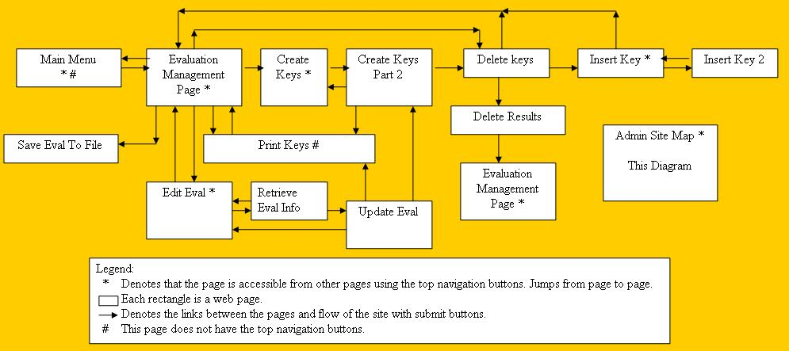

Web Architechure:
