**UI Components During Requirement/Test Case Navigation**

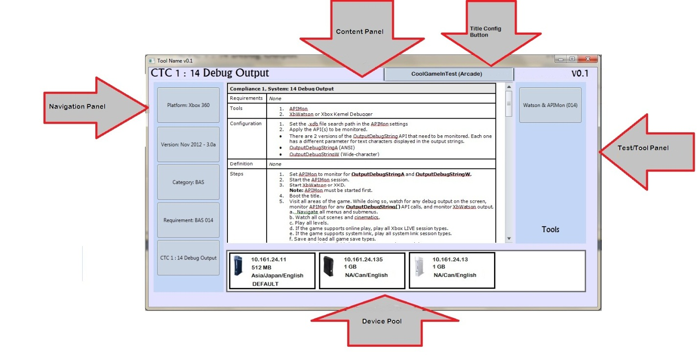

**UI Components During Module Execution**

