Without a default requirement version set, the user will be prompted to select the appropriate platform upon first launch.

Tester selects their platform.

Tester chooses the appropriate version of the requirements for the title being tested.

The choices made previous to this screen will be saved as “default” setting so user will be presented this “Category” selection screen on subsequent launches.

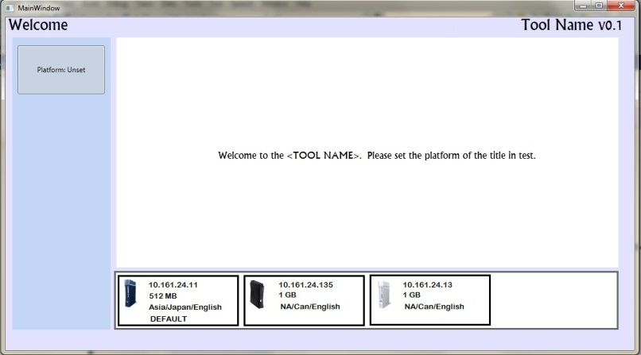

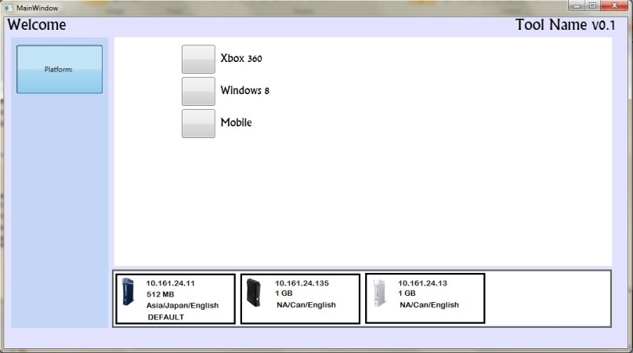

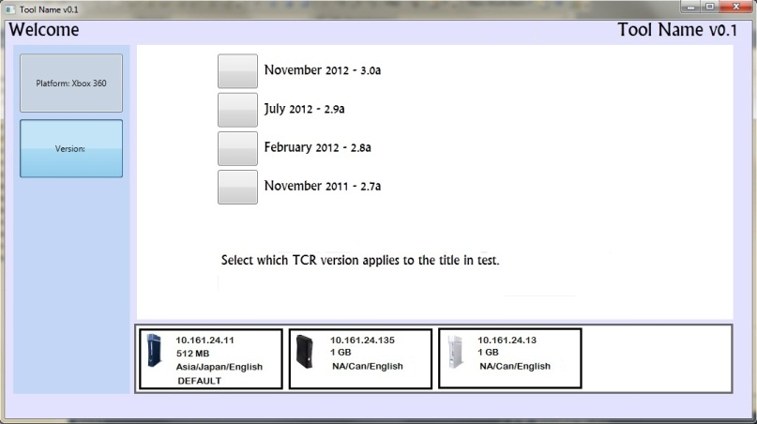

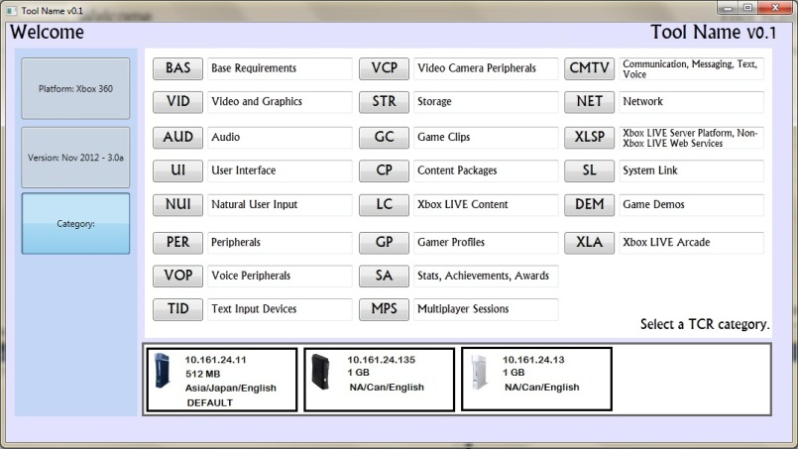

After selecting the category, the tester selects a specific requirement.

The selected requirement’s text appears in the content window, while any associated test cases appear on the panel on the right side of the screen.

When a user selects a test case, the test’s text appears in the content window, while any associated modules appear on the right-side panel.

When a tester chooses a test module, UI elements are rearranged. Left-side navigation panel is hidden while right-side panel expands and is used as launched module’s “display” window. Navigation panel is still accessible

