Civet5

Software for Paper (and more) CVI Processing

Contents

What's New in Civet 5? 2

Concept and Summary: 2

Availability and License: 4

Additional Features: 4

What Civet *Is Not*: 5

Requirements and Customization: 5

Required USAHERDS Enhancements: 5

USAHERDS Web Service 6

Email Distribution: 6

Paid Additional Component: 7

Robot Mode: 7

Support: 7

Upgrading from Civet 4 7

Installation: 8

Upgrading JPedal 8

Configuration in CivetConfig.txt 9

Configuration in CivetTabOrderMap.txt 11

Civet Email Functions 11

Configuring Email and Cover Letter Text 12

Lookup Tables 13

County Lookups 13

USAHERDS Setup Dependencies 14

Handling Failures 15

Using Civet 16

Main Window Views 16

The Edit Window 18

Workflow 26

Known Issues (Bugs) 27

Editing Saved Files 27

Editing Forwarded CVI Files 28

Deleting Saved Files 28

Character Entities in HERDS Data 28

Robot Mode 28

Extractor 28

CO/KS (States') eCVI PDF Issues (Advanced Topic) 28

Preview Mode (Advanced Topic) 32

Experimental Menu (Advanced Topic) 32

VSPS CSV File Import 33

Email Only 33

# What's New in Civet 5?

Civet 5 looks and works very much the same as Civet 3 and 4. The big change is that it only uses the new web service interface from USAHERDS 7 and the new XML data standard from AAVLD/USAHA. By tradition, the major version number in Civet is based on the interface to the back end database. Civet 1 connected to our homegrown database, Civet 2 connected to USAHERDS using direct SQL, Civet 3 used the old SOAP interface to USAHERDS, and Civet 4 used the modern REST web service interface but still supported the old SOAP version.

The biggest change with Civet5 is that it now comes with a true Windows installer—thank you to ej-Technologies for making the commercial installer Install4J available for free for open source non-profit applications such as Civet. With this installer, Civet now installs its own runtime JRE. This is the open-source version so we don't have issues with Oracle's commercial license or with different states running different versions of Java. This JRE is private to Civet so it won't run in browsers or create other security concerns.

One final important change is in the license. (See license.txt) We have added a requirement that any organization that uses Civet must commit a significant effort toward promoting true electronic CVIs. As a bridge from paper CVIs, Civet was never meant to survive this long. At this point the license does not define significant effort by a specific number of hours but you know if you are making an effort or not.

# Concept and Summary:

We, in the South Carolina state vet's office, found ourselves buried in paper interstate certificates of veterinary inspection (CVIs). The file cabinet for storage and snail mail for forwarding to the receiving states was inefficient and expensive. Retrieval was slow. We had an animal health database with the capability of storing images in the form of PDF files and a copy machine capable of scanning stacks of CVIs to PDF. The missing link was a way to get the images into the database along with enough information to find them when needed. Hand entering these into a web-form such as USAHERDS and then manually uploading the image files was just too slow. So we invented Civet.

Civet is a desktop (or laptop) computer program that displays a PDF or a page from a multi-page PDF along with a simple data-entry form. It saves the minimal CVI data along with the page image in USAHERDS CVI area. It provides a number of data entry efficiencies such as automatic premises lookup based on phone number and automatic veterinarian accreditation checking (for outbound CVIs). It then emails the outbound CVIs to the state of destination.

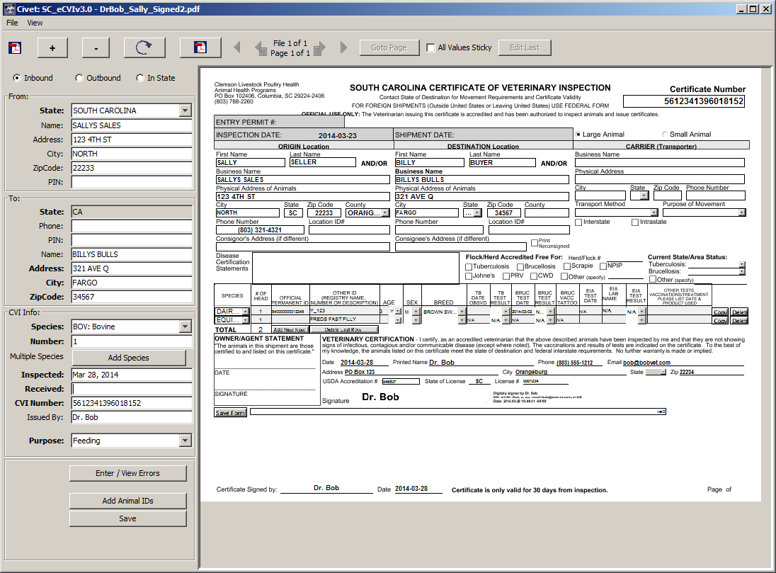

Civet allows users to track errors on CVIs in USAHERDS' CVIErrors table. By entering errors in this way, it is possible to create custom reports on veterinarians' error records for providing feedback, additional training, etc.

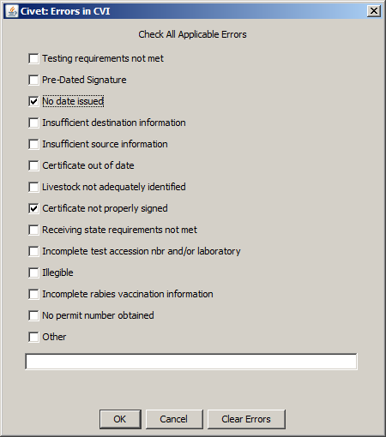

## Availability and License:

We are making Civet freely available under an open source license. With the release of Civet version 3.0 all of the core functionality relies upon USAHERDS' web services rather than direct database calls. The CVIs once entered are transmitted to USAHERDS using the USAHA Standard XML data format with attached files of the original PDF and an xml file with metadata such as the date received by the state vet and any errors. The USAHERDS web services are available in version 6 of USAHERDS. Processing of CO/KS States eCVIs requires a paid third party component.

Civet is released under the LGPL license with the added requirement, "Starting with Civet5 by using this software you agree that your agency will devote a significant effort to promotion of real electronic Certificates of Veterinary Inspection. Civet is not supposed to be a permanent solution."

## Additional Features:

Multiple Modes: A whole stack of CVIs can be scanned into a single multi-page PDF and opened in Civet using its "cut" mode. Each page is treated as a separate CVI—with the ability to add a second page to the previous if found to be a continuation. Or if each CVI is in its own file, a number of files can be opened at once and Civet will cycle through them, filing each as its own attachment in USAHERDS along with the data entered. These modes were hard for users to understand. In version 3.0 the modes are automatically inferred from the files loaded. The user can select any combination of file types and they will be opened in sequence with the appropriate logic. CO/KS "States" eCVIs automatically populate the data fields ready for entry of date received and any errors. This function requires the commercial version of JPedal.

Standalone and "Robot" modes: These modes were not being used and have been dropped from version 5. Contact us if you need either and we may reassess.

Spreadsheet processing: An experimental feature allows import of *most of the information* from the VSPS spreadsheet downloads.

AddOns: This area can accept any Java class implementing the AddOn interface. We have used this in SC to retain some of our database dependent functionality. The interface is there to allow others to develop state-specific add-ons. We use an AddOn to Civet to process swine bulk shipment record spreadsheets into USAHERDS CVI records. These arrive in a couple of company-specific formats that the program handles. A planned enhancement will handle the layout being designed by Kansas. AddOns are turned off in the external release. If working from source code this feature can be used for local features.

Animal Identifiers: Animal IDs can be added individually or as sequential numbers for one or multiple species. No additional animal demographics are collected in the interest of speed.

## What Civet *Is Not*:

Civet is not intended to create full eCVI records. It attaches the image of each CVI in USAHerds where it can be retrieved by any of our staff who may need additional detail. The intent is to enter only enough data to allow rapid retrieval and some summary reporting. Even in the case of the CO/KS states eCVI, the actual record is the electronic document attached to the USAHERDS record. We extract a bit more information in that case because the data entry has already been done. Some (few) of the fields that are required by the USAHA Standard may be left blank in Civet. A future version will use version 2 of the USAHA standard.

When working with CO/KS eCVIs, Civet does not check the authenticity of the digital signature. A button allows you to open the file in Acrobat to do so if necessary.

## Requirements and Customization:

Civet uses a number of open-source external components. These have been carefully selected to allow release under an LGPL license to facilitate using in as many environments as possible. With the one exception of the commercial version of JPedal all of the required components are freely available at no cost and included in the Windows installer.

All of the state-specific details are provided in a "simple" text configuration file (CivetConfig.txt) located in the program directory. This allows the user to specify operating mode, folder locations, email and database server locations, maximum email sizes, etc. The email body text is provided in a simple text file template. Configuration can also be edited from an "Edit Preferences" dialog box found under the File menu.

Tab order—the sequence in which fields are highlighted for entry—is configurable through a pair of configuration files that list for each field a next field to highlight. Our data entry clerk prefers to skip over some fields initially in hopes they will autofill based on later field values. Alternate settings are used when the form is already partially filled by the "sticky" setting.

## Required USAHERDS Enhancements:

All but one of the lookup tables are auto-generated each time the program starts. This includes:

* ErrorTypeTable.csv
* PurposeTable.csv
* SpeciesTable.csv
* VetTable.csv

These tables pull data from USAHERDS via web service calls. The data must exist with specific parameters in order to be pulled. For example species must be checked as CVI species and must have USDA species code mappings. Veterinarians must have Accreditation Vet Certificates for the national accreditation checking feature to work and to match vets from CO/KS eCVIs.

Lookup of premises is more complicated. Trying to replicate an entire premises database in the lookup table cache would have been prohibitively time and space consuming. Instead, these lookups take place in real-time as the program is used. Remarkably, even operating against the external server several states away over the internet, the speed of these lookups is as fast as it was from the local database, i.e. you don't have time to wonder if it will be found or not before the form auto-fills. When running in Stand Alone mode (No connection to USAHERDS), Civet saves home state premises information in a local CSV file to allow some auto-fill functionality. With heavy use we expect this functionality to have memory and speed problems but it provides some stop-gap function until connectivity to HERDS is established.

The one exception is the State Vet Table where the program looks up the name, email address, etc., for receiving state veterinarians. In SC we have implemented this in the form of USAHERDS Veterinary Practices for each state veterinarian. The formatting is very specific. Rather than expect each state to duplicate this, we may find a way to simply redistribute this lookup each time it is modified. This table is now editable from an "Edit State Vet Table" dialog under the File menu.

## USAHERDS Web Service

With the release of USAHERDS version 7 the provided web services are *much* improved. The big change in Civet5 is support for only the new web service interface. The new interface is much faster and much more directly controlled from the Civet end.

## Email Distribution:

Civet sends PDF copies of all outbound-CVIs, and inbound-CVIs with errors (optional) to state veterinarians at email addresses they have designated. The CivetConfig.txt has fields for configuring an SMTP server to handle these outbound emails. SMTP server configurations vary widely by network environment. This feature may require some state-specific programming in the code that sets up the email implementation.

As of Civet5 there is an available default email service. This is hosted on the mminformatics.com domain and mail will be sent with the From: field listed as [Civet@mminformatics.com](mailto:Civet@mminformatics.com). The ReplyTo: field needs to be set to your email so replies come to you and not me! Security is managed with a two-part password. You will need to call for a ZohoKey to supply in your CivetConfig.txt. Normally, we would still expect almost all states to use their organization email.

## Paid Additional Component:

One advanced feature of Civet is the ability to display data from the CO/KS "States" eCVI PDF format. This feature uses a paid version of a component called "JPedal XFA" (<http://www.idrsolutions.com/>). States using this feature of Civet would either need to buy copies of this component as individual site licenses or collectively purchase an OEM license to be distributed with Civet. Current pricing is $1500 per site. We already own a site license for South Carolina. Even with ordinary "image" PDFs, the paid version of JPedal works better than the free version, which is no longer supported. In the near future JPedal will be dropping support for the older technology that Civet is written in. I recommend using a version of jpedal.jar from May of 2016. You would probably need to purchase the current version and then request the older jar file, either from IDR Solutions or me.

The current version extracts the data from the CO/KS eCVI without JPedal but still requires it for display. Without it, a blank page is displayed. The PDF can be opened in Acrobat by clicking the open in Acrobat button. Many image formats similarly do not display correctly without the commercial version of JPedal but will open in Acrobat.

## Robot Mode:

Discontinued.

## Support:

We are making the software and its source code freely available to other states that want to use it. We can make no warranty, stated or implied—yada yada. We will try to be helpful in supporting other states that adopt it, but can make no promises. The LGPL license would allow any entity that wanted to provide paid support to do so. The new license requires a "significant effort" to promote true electronic CVI use in your jurisdiction.

# Upgrading from Civet 4

The new version defaults to installing in a folder named Civet5 and contained in your "My Documents" folder. Prior versions were usually in a folder named simply Civet. When you install Civet5 you can copy many of the customized files across. All the text files and accompanying graphics, etc., can be copied.

Your jpedal.jar file should be copied from Civet/lib to Civet5/CivetPackage_lib and if named jpedalXFA.jar renamed to just jpedal.jar.

A few edits to CivetConfig.txt are needed.

Only the new webservice is supported. The new interface will look something like this:

herdsWebServiceURL=https://YourHost/USAHerds.API

Civet5 uses the new USAHA XML standard so the files that contain that standard are changed. Those rows should look like this:

CoKsXSLTFile=CO_KS_eCVI_to_Standard2.xsl

StdSchema=ecvi2.xsd

With all the changes for the new web service the logging to the Civet.log file is more verbose than it used to be. If you get tired of all the output like " 03 Aug 2017 15:25 INFO . . . " the logging level can be changed in the configuration file or dialog from INFO to ERROR. There are two settings where this needs to be changed. Then only actual errors will be reported in the log.

By default, Civet5 installs into a folder named imaginatively "Civet5" in your "My Documents" folder. This can be changed during installation. We recommend NOT overwriting your Civet 3 or 4 folder. Once installed, you will likely want to copy several files from your existing installation.

* CivetConfig.txt
* CivetAltTabOrderMap.txt
* CivetExportsEmailMessage.txt
* CivetImportsErrorEmailMessage.txt
* CivetImportsErrorLetterTemplate.txt
* CivetTabOrderMap.txt
* Any remaining contents of CivetInbox
* Lib/jpedal.jar to CivetPackage_lib
* Any image files referenced in your Letter template

Check the folders listed in CivetConfig.txt to be sure they are either relative paths, full paths to folders you've set up, or point them to the new folders in Civet5.

# Installation:

If you are a Civet user and will have an IT person or database administrator doing all your installation and setup, you may want to skip to "Using Civet" on page 15.

You can download the Windows installer from GitHub <https://github.com/mkm1879/Civet/blob/Civet5/inst4j/Civet5_windows-x64_5_0.exe> or from my Clemson Box site: <https://clemson.box.com/s/li4s519t5equ9ki16sbffq83sx6jx99h>

If you will be running Civet5 on a shared computer, you may want to install Civet5 to a location accessible by all. If users want to have their own configuration, tab order, etc., you can install Civet separately in each "My Documents" folder and edit the configuration to share the In Box, Out Box, etc. as appropriate for your workflow. (Civet is not inherently multi-user. It is best not to share In Box, To Be Filed, or To Be Emailed folders. It is OK to share an Out Box.)

## Upgrading JPedal

The Civet5 installer contains the LGPL version of the JPedal library. This version has trouble with a fair number of PDF formats, including those that Civet creates from JPEG, GIF, PNG, and BMP image files. And it cannot deal with the XFA form CO/KS eCVIs. We highly recommend immediately upgrading this library. IDR Solutions offers trial versions for download. Go to <https://www.idrsolutions.com/jpedal-downloads/> and click on Download the Free Trial. Complete the form. You will get an email from the company with a link for the download. Save the file in the "CivetPackage_lib" folder inside the Civet folder. Next rename the downloaded file to jpedal.jar. So, if you have the LGPL in /lib and want to try the XFA you can drop that one in named jpedal.jar but leave the other. Then at the end of the month either replace or delete the trial copy of jpedal.jar. You may need to get an older version of jpedal.jar from IDR Solutions or me if it doesn't display correctly.

## Configuration in CivetConfig.txt

Making Civet work in multiple locations requires extensive configuration. Most of this is done with a simple text file "CivetConfig.txt" in the Civet folder. Open this in Notepad or any other text editor (not Word, etc.). The file consists of a whole bunch of variables in the form:

VariableName=Value

Most of these should be fairly self-explanatory, especially if you pay attention to the default values. One tricky point is the file locations. These are sometimes files and sometimes folders. They may be relative or absolute paths. In either case, the backslash (\) character must be doubled. (Or use Unix style slash (/) as the folder separator.) Windows 7 and later makes absolute paths very tricky because of the "Libraries" sleight of hand. You might want to stick to using subfolders of the installation folder and relative locations.

The first key variable that must be changed is the "Home" state. Civet works on the concept that when it comes to traceability, we need to trace only as far as the state except when the premises is in our state, then we must trace to the premises. Civet does premises lookup, etc., only on the home state end. And it allows you to skip most fields on the other state end. Three variables define home state: homeState (spelled out), homeStateAbbr (postal abbreviation) and homeStateKey (this is the USDA code number for the state).

If your user's monitor is less than about 800 pixels high, the edit pane on the left may not all fit. If this occurs, set the variable "smallScreen" to "true" or "yes" and a scroll bar will be added to that pane at the expense of a little bit of other real estate.

The localNetworkAddresses is a comma-separated list of IP addresses on the local network that can be used to test connectivity. This is probably not needed except for debugging.

The "Web Service Settings" and "Email setup" sections are undoubtedly the trickiest to edit. "standalone" is no longer supported. The program will ask for your USAHERDS username and password. The herdsWebServiceURL is the full URL of your USAHERDS instance. Get this from CAI once you are on version 6.0 or request access to the external site listed in the sample config file. **NOTE:** Civet is not smart enough to follow the web server's instructions to change from unsecure to secure HTTP. So, if your USAHERDS web service is running on HTTPS, you *must* list the URL in the form "**https**://whatever.wherever.gov/..." If entered as simply "http://..." the connection will fail.

Email setup is the really tricky part. There are numerous variants of outgoing email servers. We fiddled with code and settings to make it work in our environment. The smtpHost value can be either an IP (v4) address or a name that resolves by DNS. And smtpPort is a number like 465 or 25 depending on your server's setup. "smtpIsTls" can be "true" or "yes", "false" or "no" depending on whether encryption is on. (Amazing but some systems turn it off.) "smtpDomain" is the email address without your individual name so my email [mmarti5@clemson.edu](mailto:mmarti5@clemson.edu) becomes "@clemson.edu" (Why did I not have the system add the @? Good question.)

Now the most important part of the email setup. You REALLY don't want to send test emails all over the country. "emailTestTo" allows you to divert all outgoing email to yourself or another email recipient rather than those listed in StateVetList.csv. Only if this variable is blank do emails actually get delivered to other states.

If during production you want to get copies of each outbound email, that feature can be set in emailCopyTo. Ours was on for about a day before Pam asked me to turn it off. I later turned it back on but going to a different mailbox.

If you *cannot* use your organization's email host to send email (various IT issues could prevent this) there is now a default email account under my mminformatics.com domain. The User is [Civet@mminformatics.com](mailto:Civet@mminformatics.com) and the password consists of a prefix and a key you must enter the key in the "zohoKey" entry. Call for the key. The key changes with each significant release and you must upgrade the release on the scheduled date for the combination to work. You must also add an email address to the "replyTo" entry.

Finally different email systems have different size restrictions. You can limit the total size of attached PDFs with the maxAttachedSize variable. This can be bytes, kilobytes or megabytes by adding a "K" or "M" after the number. The sample config file has this set to five megabytes, which has seemed about right for us.

A setting allows you to display PDFs rotated by default. "rotation" is the default rotation for most PDFs. This largely depends on how your scanner makes the PDFs look. Play with this until the majority of your images come out right-side up. They can always be rotated in the edit dialog with a mouse-click or three. There are still issues with not all PDFs correctly indicating which way is up. I suggest fiddling with rotation until it works fairly well with your own scans and just using the rotate button to "fix" everything else.

Most of the rest of CivetConfig.txt is folders and files. Each of these can be relative or absolute file paths in the system. As mentioned earlier, relative paths will simplify editing. On the other hand, absolute paths would allow for things like using a network shared folder as an inbox or outbox. Folder names end in "\\" (in Windows. "/" in Mac or Linux but "/" works in Windows as well). Filenames include the extension. With default Windows 7 and 10 settings you probably don't see these. (I always turn that "feature" off in folder settings.)

It doesn't make sense to change the names of the lookup tables or to move them out of the main Civet directory. The SQL Server settings can be ignored. We use these in the AddOns menu for those local functions that require direct database access.

What remains is esoteric settings for the error logging function. You probably want to leave this unless I send you changes. The one line that might change is the first one. "logLevel" can be INFO for more complete logging or ERROR to log only significant errors. The log file created by these settings, Civet.log is going to be important when things go wrong. Emailing this log file or sharing it on GitHub in the Issues section is how you will get help in fixing things, and help me fix any remaining code errors.

## Configuration in CivetTabOrderMap.txt

One of the highly personalized aspects of Civet versions 1 and 2 was the tab order logic. When the user tabs out of one field, which field gains focus next? We take for granted that it would be the next field or button on the form. There are conditions when this is not the best for high speed data entry. Because the code for versions 1 and 2 supported one data entry specialist, we simply modified the program as she figured out how it "should" work. For version 3 we recognized that other users might not agree on some of the "weird" jumps. This led to the development of CivetTabOrderMap and CivetAltTabOrderMap. Like CivetConfig.txt, these files are the same variable=value format. In this case, however, both variable and value are names of fields on the form. If no value is set—the vast majority of fields—then the focus simply moves to the next field on the form. If, on the other hand, a field name is added to the right of the equals sign then when focus leaves the field on the left it will go straight to the field on the right. In the sample, for example, after entering the Other state in the combo box at the top of the form, focus skips the name and address of the other state's premises—because we don't require this in our copy of USAHERDS—and goes straight to "otherCity".

CivetAltTabOrderMap.txt works the same way but takes effect when the form is already partially populated with the "All Values Sticky" feature. In that case you often want to skip over the fields that are usually left unchanged from one CVI to the next as with a batch of CVIs from the same private sale, etc. Pam has actually stopped using different maps. Please give us feedback if this alternate map is useful. If not we may drop it from a future major version upgrade.

## Civet Email Functions

Civet includes a number of email functions. These are accessed by opening the appropriate folder view and using the Send menu to select the appropriate action. This allows you to look at exactly which certificates have been staged to send before actually sending. (One last chance.)

All outbound CVIs go in the "to be mailed out" folder. Any inbound CVIs with errors noted are saved to the "inbound errors to be mailed out" folder. Email only files are experimental and accessed from the Experimental Email Only menu item.

Error Emails use a more complicated template to form a letter to the sending state veterinarian. This template uses substitution as described below. The actual errors are noted from a table in USAHERDS. This table "CVIErrorTypes" is not to my knowledge editable in the user interface. You may need to contact the support vendor to add a list of values and abbreviations. (The abbreviations are more or less just left over from our prior database.)

## Configuring Email and Cover Letter Text

Three template files and one lookup date file are used to create the content of these communications.

State Veterinarians' email addresses are read from the file StateVetTable.csv. This table is a simple CSV file with a list of states and territories. It includes other contact information for the State Veterinarians, but for Civet the key columns are the state and three email address columns. The main Email column is the routine email for the State Veterinarian. There is also a CVIEmail column for use if the state has requested a specific address for CVIs. Finally there is a Column for CVIErrorEmails for those few states that want error emails going to a different address from the main emails. (This last is not yet fully implemented. We have had only one state request it.) These values default to the one before. So if there is no separate CVIErrorEmail value, the CVIEmail will be used for errors as well as outgoing CVIs. If there is no CVIEmail value, the main Email address will be used for all emails. Each of these fields can be a single email address or more than one address separated by commas.

The StateVetTable.csv file is the only lookup table *not* generated from USAHERDS when you first connect. We distribute a fairly current table with the application. This table is now editable via File/Edit State Vet Table.

There is one final column in the StateVetTable.csv file. This is how the state would like their CVIs delivered. Today this doesn't do much. Virtually every state is PDF. As more states use the USAHA standard changing this to CVI will send the USAHA XML data file with the PDF attached rather than just the PDF. Civet is able to open the .CVI files and pre-populate all the data entered by the sending state. It will likely not be complete from the perspective of the receiving state, but will have much of the data entry already complete.

CivetExportsEmailMessage.txt sets the body of the emails that accompany copies of export CVIs to the state of destination. Edit in any text editor—Notepad is probably your default. The text will make up the body of the emails. CivetImportsErrorEmailMessage.txt does the same for emails accompanying import CVIs being returned to the state of origin with errors. The third template CivetImportErrorLetterTemplate.txt uses a weird 1980's style merge substitution text. (If you don't remember WordStar or WordPerfect, you don't know what you missed!) The template is edited in any text editor like the other configuration files. However, in this case some of the text represents substitution variables and formatting instructions. Lines starting with a period ("dot") are formatting, either adding images or setting indents, etc.

* ".image.": Insert an Image. Inserts the image file following centered on the page. The image file should be in the main program directory.
* ".himage.": Insert a Header Image. Inserts the image following scaled to 500 pixels wide by 40 pixels high centered on the page and followed by a blank paragraph
* ".fimage.": Insert a Footer Image. This is way overly specific to our use in South Carolina. Inserts 9 blank lines and then the named image centered.
* ".list.": "Format the following line variable as an unordered list"
* The following can be combined. For example in the sample .cb. makes the header text centered and bold.
* ".b.": Make the line bold
* ".c.": Make the line centered
* ".i.") ) Make the line italic
* ".si.") ) Make the line small italic
* ".u.") ) Make the line underlined

Finally, the strange looking {{{Variable}}} bits label places where the program inserts values at run time. In the example, this is the date, the other state vet's information, and the certificate number. The {{{Errors}}} variable inserts one line for each error checked. These variables were all programmed highly specifically for this application in our setting. It would be programming but not "rocket science" to customize the PDFGen class to support more robust editing. (As long as any changes user organizations make support the existing codes, I'll happily add them to the master code base. Another good change if anyone wants to do it would be to allow formatting within paragraphs instead of only whole lines. I just never wrote the loop and end tags needed to spot codes anywhere but the start of a line.)

Full confession: One place that has caused us grief here in South Carolina has been keeping these template files straight. I test with templates that include a disclaimer in case I send them by mistake. And as the template language has changed it has been tricky keeping production in step with development. Pay attention to these templates!

## Lookup Tables

Civet versions 1 and 2 used direct database reads to lookup lists in USAHERDS. It gathered the primary key values for when it needed to write back to the database. The .CSV lookup tables used by Civet are a gradual transition away from direct database access. In connected mode, each of these is generated every time the program starts up, so you can ignore them. For stand-alone mode, you will have to generate them "by hand" mimicking the samples. Samples were generated from the CAI External test system and then edited for clarity. The trickiest, and most work, will be the VetTable.csv. This is key to adding your in-state veterinarians in a controlled way. By including the National Accreditation Number, Level, and Status, you will enable the accreditation checking feature, and make it possible for recipients of the USAHA Standard XML to uniquely identify the veterinarian as well. First name and last name are used for display and completing the information in the Standard XML. Address, if provided is added to the Standard XML but not seen in the application.

## County Lookups

Civet uses a series of three separate lookup tables to assign county names to the origin and destination of each CVI. This is complicated by the fact that the names have to match exactly what is in USAHERDS. CAI has worked to build a standard set of county names. These are included in CountyTable.csv. Because these virtually never change, they are *not* updated automatically. We could have stopped there and simply added a state-specific drop-down list in each of the "other state" and "this state" sections of the Civet input area. But the goal of Civet is to be fast. Adding data entry goes against that design principle. We needed a way to semi-automate the county assignment process.

While many zip codes cross county lines, they are almost always predominately in one county. The U.S. census bureau has used this to create a type of block group based on zip code. That mapping is included as ZipTable.csv. When the user enters a zip code in Civet (and leaves the field), Civet looks up the county in the zip table and selects the county in the drop-down. If you find zip code(s) that are not in this table or that reflect the wrong county for the majority of your CVIs, it can be edited or added to. **Beware of Excel which likes to remove leading zeroes from zip codes, etc.** This zip code translation works as long as the spelling is the same as in USAHERDS. But we sometimes have variations on the spelling, abbreviation, or extensions (for things that are not counties but comparable government units, etc.) When Civet encounters a county name it can't find in the Counties.csv file, it writes out the state and county to a file named BadCounties.txt. These need to be translated.

The CountyAliases.csv table provides a means to translate any given alternate spelling into the standard in USAHERDS. This table comes populated with the translations needed by the zip table. If you find counties coming in in other spellings, etc., you can add them to this table. This will translate any *subsequent* instances of the alternate spelling. You probably still need to find the record(s) that lead you to discover the discrepancy.

## USAHERDS Setup Dependencies

Error types, Vets, and species are pulled from USAHERDS. These are tables that you are able to change in HERDS and so there are a few details to pay attention to.

The easiest is the CVIErrorTypes table. These are displayed in the add errors dialog. The Description field is displayed. The ShortName is used to send the checked values to Herds. Anything entered in the Notes box beside "Other" goes in the BureauInternalNote field.

For Veterinarians, the key elements are the state license and national accreditation numbers. For the drop-down to work correctly all level II accredited vets need to have a VetCertificate record of type "USDA Level II Accreditation" and their correct NVAP number. They also need a VetCertificate record of type "State License" and their license number. These will be used to display only level II vets by default and to populate the standard XML correctly.

The Species list is *much* more complicated. This depends upon the USAHA standard list of species codes. It also depends on how these codes are mapped in USAHERDS. Three tables are involved:

* Animal Class Hierarchy (Species): Only those entries with CVI species checked will be used. And only the lowest primary key that has a USDA mapping. You can't really control the primary key, but normally, the general classes were entered before the more specific ones. The field that is used to populate the species drop-down box is the "CommonName." Wording here can make a big difference for fast data-entry folks who type in the drop down. (Unlike me, where I pull it down and look.)
* USDA Species: Only those species with a USDA Code assigned will be displayed in the species list because it is that USDA code that populates the USAHA XML standard used as Civet's data file.

These can be accessed from the Maintenance/Administration/Lookups Maintenance menu under Animal Species. Navigate to the species you want to use and click the edit button. Make sure CVI Species is checked and a USDA Species is selected.

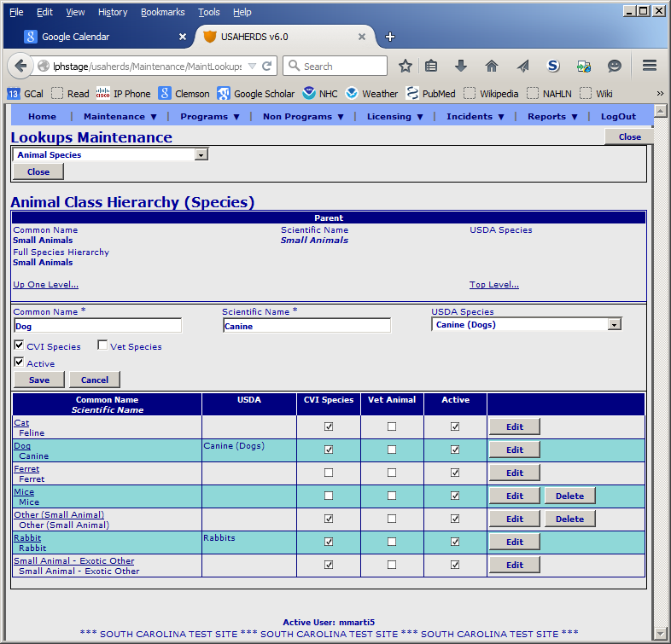

In general, a careful reading of any error messages will point out what is missing in the list of required species settings. If the missing piece is in the standard—such as a legitimate USDA code not listed in the standard—then a change needs to be proposed to the standards committee and the schema edited. (Version 2 of the USAHA standard includes more robust handling of other species. A future release of Civet will use that to allow *any* USDA codes to be sent, even the odd ones.) Otherwise, one of these settings may need attention. When in doubt, email your log file with an explanation of the failure. (Help/Send Error Log)

## Handling Failures

The one guarantee I can make on Civet is that it will break; especially when used in a new environment for the first time. A few things will help figure out the problem.

Once you get the program to run and show its login box (or inbox if running in StandAlone mode) most of the error messages will go to Civet.log. Send or post that log together with as specific a description of what you were doing when things went wrong. If the error occurred while opening and displaying a file, send (posting real CVIs would be bad) the original file will allow me to reproduce the problem. If the problem involves configuration, tab order, email, etc., sending or posting copies of those the relevant config or template file(s) will also help. Finally, if you can locate the corresponding output file (filename including the certificate number and ending in ".cvi", send that along as well. This is peer-to-peer support, so be patient.

# Using Civet

You finally have Civet running correctly. Now what? The user interface of Civet is designed to make it seem very simple. It really doesn't try to do much. But it tries to do it efficiently and more importantly help the user be more efficient. There is just a bit of basic work-flow to follow. The required workflow may not be intuitive. It is based on the need to delay uploading the data to HERDS in case we need to go back and make edits, add pages, etc. So in versions 3-4 of Civet, saving the CVI and uploading it to USAHERDS are two distinct work-flow steps.

There are two main windows that make up the entire user interface. The first thing that opens is a work list or "Inbox" view listing files in various states of completion. The first to open is the "Inbox" itself. This is a list of the files you have placed in that folder. Other views show files that have been processed and need to be emailed and/or submitted to USAHERDS. More on why the multiple steps later.

The other important window is the Edit dialog. This window is where the transcription takes place. Depending on the state of the file being opened it may be in read-only mode but is usually where editing takes is done.

## Main Window Views

The main window consists of a menu bar, a button bar (with all of two buttons) and a list of files. The list of files changes based on your selection from the View menu. You start out in "To Be Entered." This gives just the filename, save date, and size. From here you can open one or more files for transcription. There are a number of ways to open files. Selecting one row and clicking the open E:\EclipseJava\Civet\src\edu\clemson\lph\civet\res\open.png button or picking "Open File(s)" from the File menu will open that file. Selecting more than one file with <Control>click will open all of them at once. The edit dialog will step you through them in turn. With no file selected, either the open button or menu choice will bring up a file select dialog that might be useful if you must open a file from an alternate location (not recommended routinely.) Clicking the open all E:\EclipseJava\Civet\src\edu\clemson\lph\civet\res\openmulti.png button will open all files in the Inbox. This is a good option if you keep up with the work and don't have too many files built up. "Open All Files" in the File menu does the same. Finally, you can double click on a file in the list to open it.

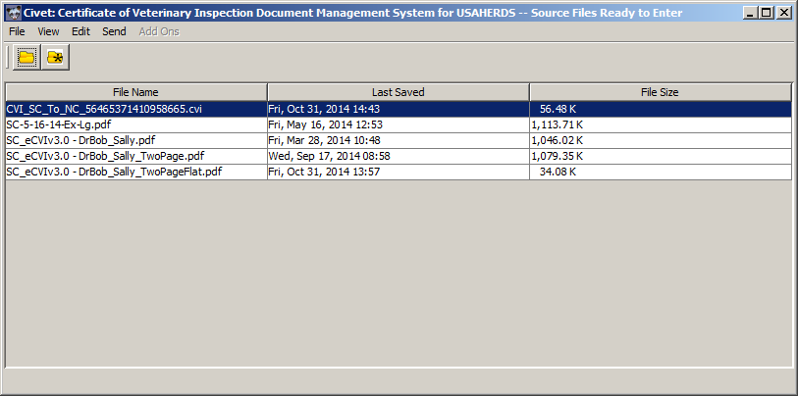

Civet Main Window

Once files are transcribed, the lists get more interesting but serve the same function. "Entered CVIs Ready to Upload to HERDS" lists the USAHA Standard XML (.cvi) files you have created by transcribing in the previous step. This shows some of the information you entered such as the from and to states, species, vet, dates issued and received and any errors. From this list you can select some and use the Send menu to "Submit Selected CVIs to USAHERDS" or "Submit All CVIs to USAHERDS." This uses USAHERDS' web service to add the file to the external files queue. The CVIs will show up in HERDS once the queue is processed based on your schedule set up in HERDS. The reason for this being a separate step from saving at the end of transcription is that the CVIs are still editable at this point. To edit one use any of the open methods from the InBox discussion. Normally you would edit only one. Once uploaded, any editing must be done in USAHERDS directly.

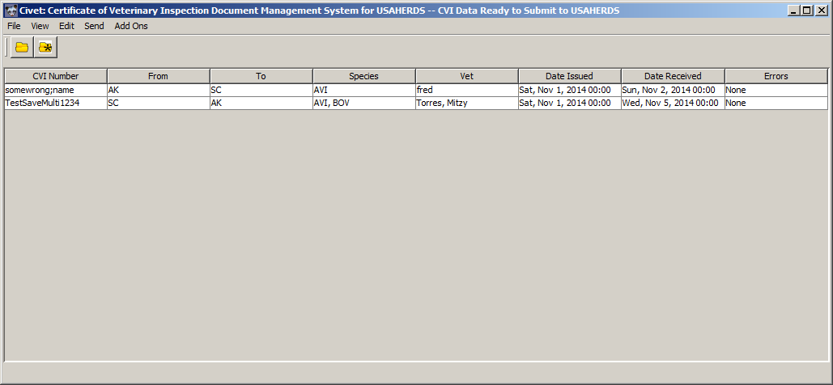

Civet Main Window Ready to Submit

Email is similarly handled from lists. One list shows all the export CVIs waiting to be sent to other states' state veterinarians or their designees. Another list shows the import CVIs with errors being returned to the states of origin with cover letters listing the errors found. The send menu for these views just sends everything. If demand exists to send selected, we could add that function (for a fee—just kidding—or pizza!)

Two menus don't normally appear. The Edit menu housed a few housekeeping edits in earlier versions and is now turned off. The "Add-Ons" menu is more interesting. In order to make Civet flexible there is a package called "add-ons" that is empty by default. Any class added to the CLASSPATH that implements the Add-On interface automatically gets added to this menu. We use that to put back some "illegal" direct database access in our South Carolina implementation. We now do a separate build for local use and omit the Add-Ons menu from the main build. If you eventually need Add-Ons, you will need to build with this feature enabled.

The Help menu has two choices. The About Civet choice is mostly useful for figuring out which version and build you are running. Sometimes we need this to know if a problem was from an earlier version and has been fixed. The second choice is just a convenience way to send your Civet.log file to me via the email subsystem in Civet. It opens a small box to type a description of whatever issue you are having. It then prompts for your email credentials, if not already entered, and sends me an email. Of course this only works if the problem is something *other than* the email subsystem!

And that is about it for the main window. Not much to it, by design.

## The Edit Window

When you open one or more files using any of the above methods, the edit dialog opens. This one dialog represents four years of experimentation and programming.

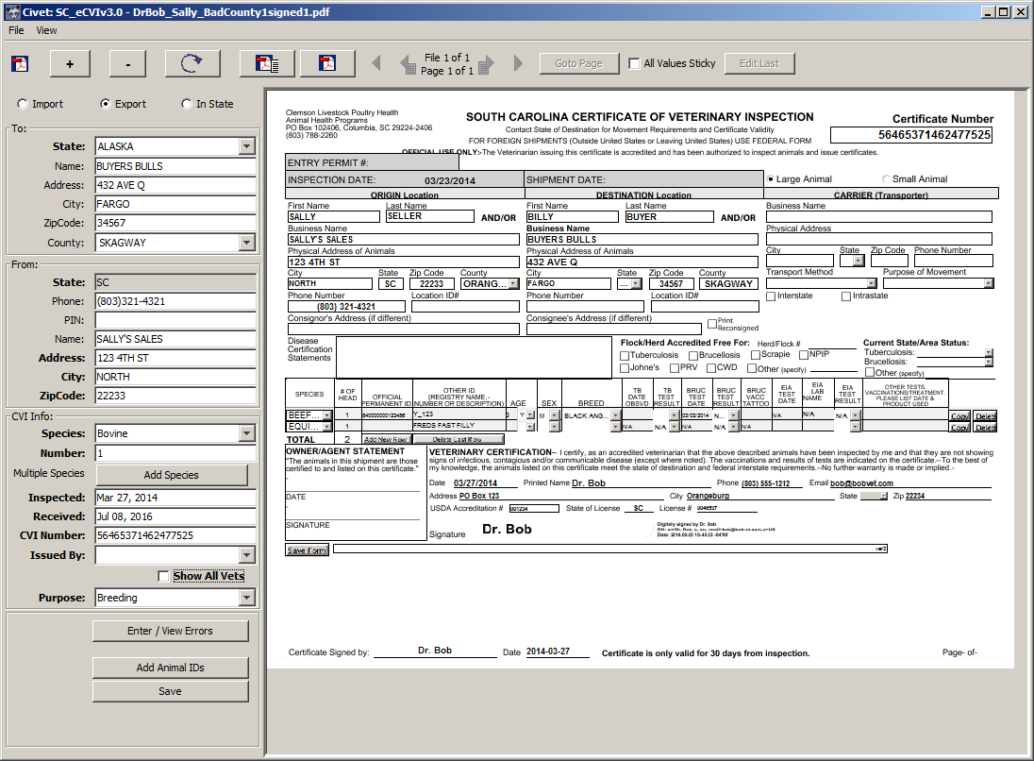

The Civet Edit Window

The information starts on the Title Bar. This displays the source filename of the file currently being displayed. If opening multiple files, this helps keep track of which one you are on.

The menu bar on the dialog is mostly useless. It has save and close in the File menu and Minimize All in the View menu.

The button bar is busy on this form. The first thing you see is an icon showing the mode. This will usually be E:\EclipseJava\Civet\src\edu\clemson\lph\civet\res\pdf.gifto show you are looking at a PDF. Even if the file you opened was an image such as JPEG or GIF, it was converted to a PDF as it opened. This way you are looking at what will get emailed out and attached as a file in USAHERDS. If the icon is E:\EclipseJava\Civet\src\edu\clemson\lph\civet\res\stdXml.gif it means that the file is already in the form of a USAHA Standard XML file. What you see is the PDF that was attached in that standard. The good news is that most of the data will already be filled in. (NOTE: we have done very minimal testing of how a .CVI file generated in one state will look when opened in the receiving state's copy of Civet. Our goal is to get most CVIs in this format eventually.)

The + and – buttons zoom in and out on the view of the PDF. The E:\EclipseJava\Civet\src\edu\clemson\lph\civet\res\rotate.gifbutton rotates 90 degrees clockwise. (Click twice for 180 and three times for 90 degrees counterclockwise.) The E:\EclipseJava\Civet\src\edu\clemson\lph\civet\res\pdf.gifbutton (not the icon) will open the current file in your default PDF application which is probably either Acrobat Reader or Acrobat Pro. This can be useful for hard to read scans and is essential if you open something that just displays an error or blank page. The latter two cases are common with the free version of the JPedal library. The ability to open in Acrobat salvages these files. One solution for unfriendly PDF files is to open in Acrobat and choose "Save As Image" (I like PNG). Select your CivetInBox folder. Acrobat will save each page as a PNG image file. These can then be opened in Civet. It will turn them into individual PDF files for attachment and emailing. (And if they are really one CVI you can, of course use add to previous if you open them all at once with the multi-select feature.)

The E:\EclipseJava\Civet\src\edu\clemson\lph\civet\res\pdfPage.gif button opens just the current page in Acrobat. This is useful for multiple page scans if one page is hard to read. This is the behavior of the previous Open in Acrobat button.

Next comes a small navigation section that you will ignore most of the time. The most complicated part of the code, and—I hope—the simplest part of using the program, is moving through a stack of CVIs processing each page of each one. This display shows you where you are and allows you to manually step out of sequence if you want to review the last page, preview the next, etc. If you know the page number you want, click the Goto Page button and enter the page number. (This is here for big multiple CVI files that may have been partially completed. The program doesn't handle that well. This button lets you quickly get back to where you were so it can't know when you are done. You have to manually move the complete file to your Completed folder. So please don't scan more into one PDF than you are sure you can do in one session.)

As you move from one CVI to the next, especially if you have scanned a whole stack, you will often find series of CVIs with similar information. Checking the All Values Sticky check box causes Civet to retain most values when you save one page and move to the next. You can then manually overwrite anything that has changed. With All Values Sticky checked and with data in the form, the CivetAltTabOrderMap is used instead of the main tab ordering. You can configure it to skip those fields that, in your experience, usually remain unchanged. This only saves a few taps of the Tab key, but they add up over time. Shift-Tab moves backward and does not skip any fields so skipped fields are not hard to enter and change when necessary.

Once you have completed at least one CVI, it will reside in the "Entered CVIs Ready to Upload to HERDS" box. The Edit Last button is a convenience tool to let you quickly open the last CVI you saved in a new dialog without losing your place in the current one. This was added because sometimes you will see details in a later CVI that allow you to figure out what the vet was trying to write in the last one. You can quickly make that fix and save the last one even as you work on the current page.

Civet is by design not symmetrical. Each state needs more information about its end of the movement than it does about the other end. (Version one didn't even have fields for the other state's name, address, zipcode or PIN.) A trio of radio buttons at the top of the editing column sets the "direction" of the CVI to Import, Export, or In State. The meaning of the top two panels switch based on the direction. The top panel is always the other state, the second panel is always your "home state." Premises lookup only operates on the home state. Another change based on this choice is the Veterinarian field. For Import certificates it is just a free-text field. For Export certificates, it is a pick list of veterinarians from your USAHERDS or VetTable.csv lookup source.

Other than the State itself, none of the fields in the Other State panel are required. Complete as much as your staff feel is useful for finding, counting, or other management of your CVI files. The fields are fairly self-explanatory. The state-specific County pick-list has been populated from a list of standard county names that is, or will be, common to all standard USAHERDS installations. There is a nearly many to one relationship between zip code and county. Civet uses the U.S. Census bureau's mapping of zip code to county to "guess" the county. Or, if provided, it can be selected from the list. (Note: Civet no longer collects other state PIN. These were seldom provided and county was more important.)

The Home State panel—labeled "To:" in import and "From:" otherwise—is much more interesting. Here we are dealing with premises that we keep track of in our databases. The program attempts to find premises information for you based on what you type. In our experience in South Carolina, the most commonly provided item that can be used to search the database is phone number. Thus Phone is the first field you encounter. The Phone field expects a ten digit phone number. You can but don't need to type any punctuation that you want. The program only uses the digits and reformats them to "(AAA)EEE-NNNN" anyway. (Does anyone still call the first three digits after the area code "the Exchange"? I remember when I didn't have to dial them!) When you tab or click out of this field, the system searches your USAHERDS database for that phone number associated with one or more premises. If it finds one, it fills in the rest of the information. If it finds more than one, it opens the premises search box filled with the results. You chose the correct one from the list. (In Stand Alone mode, the search is against other premises you have entered in Civet using a local .CSV file.)

The PIN field in the Home State panel is more interesting than the one in Other State. This field is linked to the premises search dialog. As with Phone, if you type a PIN (or USAHERDS LID) it will search for that identifier and fill in the rest. In fact, it *expects* to find a value and warns you if it can't. But you can also search manually by typing <Control>F while in this field. This brings up a "search by example" dialog. Typing as much information as you have in this box and clicking Search performs a search similar to that in the Premises Search feature in USAHERDS. **NOTE: If you type too broad a search here you may see the program "freeze" This bug should be fixed in a new release of Civet soon.**

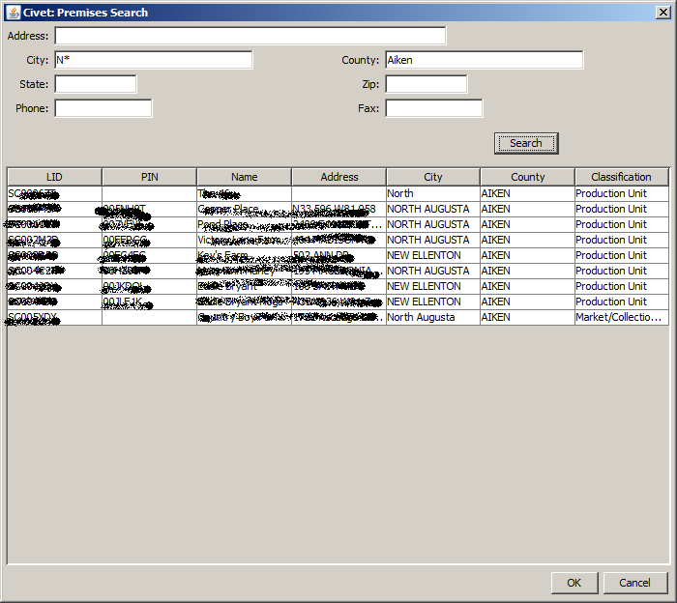

Civet Premises Search Dialog

Selecting a row from the returned premises will enter this PIN or USAHERDS LID in the PIN box. Tabbing or clicking out of that field will fill in the rest of the premises information.

Similar lookup takes place as you leave the Address, City, and Zip Code fields. Single matches complete the panel, multiple matches open the Search Dialog for you to pick.

**NEW FEATURE:** A hidden field in the home state panel holds a county pick-list. This is populated from the zip code as with the other state's county or from the USAHERDS premises if selected by any of the mechanisms provided. To see the county pick list, click on the City label. The city box will change to the county pick list. To revert simply click on the label that now reads "County."

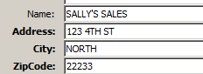 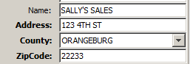

Either state's county may come in directly in a CO/KS eCVI, another state's .CVI file, etc. If that county is not found in the CountyTable.csv file it can't be loaded to USAHERDS. Instead the state and county name will be saved to a file named BadCounties.txt. This file contains counties whose names were either missing from CountyTable.csv or, more likely, were spelled differently. You can account for these by adding them to the CountyAliasesTable.csv file. This file has three columns. A two character state abbreviation, the name of a county as it may come in from outside sources and the name as it appears in USAHERDS. This file initially contains translations of all the census bureau county spellings that differ from those in HERDS. You can add rows but should not change or remove existing rows. ZipTable.csv is the census bureau mappings and will almost never need editing or addition unless you encounter a zip code for which you know the county that is missing from the file. (CAUTION editing this file in Excel will likely cause problems by converting zip codes to numbers and losing any leading zeroes.)

The CVI Info panel has a few tricks up its sleeve as well. The vast majority of CVIs are for a single species. (There is even lack of consensus on whether multiple-species CVIs are even legitimate.) Species is selected from a list. The list is populated from the SpeciesTable.csv file that is, in turn, populated from your USAHERDS AnimalClassHierarchy table, using only those with "CVI Species" flagged true and USDA Species assigned. Note: The USDA Species Code must also appear in the ExternalCodeValues table in USAHERDS. As of Civet5, all of the official species codes are included by default to avoid failure when receiving standard code values in CO/KS or other electronic data formats.

Following Species is Number. This is the total number of this species on this CVI. In version one of Civet we only tracked numbers, not individual IDs. Now that at least some of the individuals will have IDs entered, we have some identified animals and some anonymous "group" animals. The Number field should have the *total* number of this species. If some are ID'd, the group count will be reduced by the number with IDs.

If you do have multiple species, the Add Species button will clear the Species and Number fields for you to enter additional. The only clue that your data were not lost is a label reading "Multiple Species" next to the Add Species button.

Inspected and Received are the dates of the inspection and when the state received the CVI. (Still working on what the Received date should mean when we exchange already filled .CVI files. First state's received date or the receiving state's received date. Neither is part of the USAHA standard of course. Received date is stored in a metadata extension to the standard along with error information.) These dates can be entered in any number of formats. (Not European-military DD/MM/YY, because for the first 12 days of each month it is impossible to differentiate from the more common US-civilian MM/DD/YY) If the program can read this as a date, it displays it in long MMM DD, YYYY format so you have an instant check of how it read what you typed.

**NEW Feature:** When opening any file type that includes the electronic data, Received date defaults to the date the file was most recently accessed. DOS/Windows does not save a last written date and most email systems retain the original created date when you save from email. But they update the last accessed date to the date saved from the email. But if you open the file the next day, this date will change. So be aware of that. It is still more likely to be accurate than the previous "today" default value.

CVI Number is just free text. In versions one and two of Civet this checked for uniqueness. Loss of direct database access made that feature impossible. We now maintain a text file listing of CVINumbers issued through Civet to reduce but not eliminate duplicate CVI Number errors in USAHERDS. You will need to check Maintenance/External Message Queue/Civet for errors periodically.

Issued By is the issuing veterinarian. This field is a chameleon. In Import mode it is just a text box for you to type a name. But for Export and In State, it assumes you know all of your own vets. By default, it only lists vets with active level two National Accreditation. Checking the Show All Vets box turns off accreditation checking. We have not implemented a level one National Accreditation check because we do not enter small animal certificates in South Carolina. If there is enough demand for this feature, it can most likely be added.

Finally Purpose is a list based on CVI Purposes in USAHERDS by way of PurposeTable.csv. The default list in USAHERDS is sort of a "purpose of the health inspection". The USAHA eCVI standard treats purpose as "purpose of interstate movement" which better tracks the ADT usage.

Last but not least comes the Action Buttons panel.

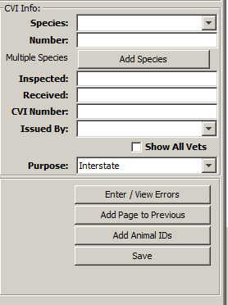

Civet Action Button Panel

Here you enter any errors found on the certificate with the Enter/View Errors button that opens the Errors dialog. The list in this box comes from the CVIErrorTypes table of USAHERDS by way of the ErrorTypeTable.csv file. This table is not currently supported by the Lookups Maintenance feature in USAHERDS. It is a simple matter to create or update with direct database access.

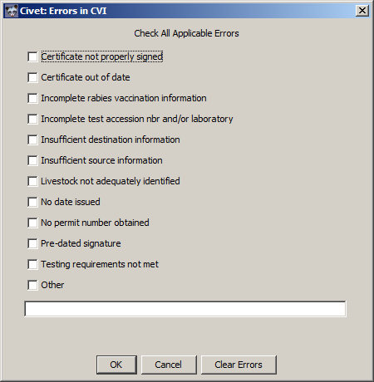

Civet Errors Dialog

The Add Animal IDs button opens the animal ID dialog.

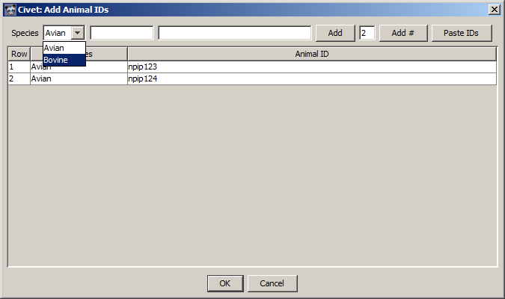

Civet Add Animal IDs Dialog

This box lets you enter one or more IDs for each species you have added. The unusual layout takes some explaining. The boxes aren't labeled to save space. The first white text box if for the "prefix" and the second is for the "number". The two values are combined to make the identifiers added. When you click the Add button, the contents of the two boxes are combined and added. The prefix value remains and the focus goes back to the number. This allows rapid entry of NUES numbers from the same sequence even when they are not in order or complete. If the prefix is "840", it will fill in any needed zeros to get to fifteen digits. The last white text box is for a number. If you put a value (integer) here and click the Add # button, a sequence starting with the prefix/number will be added. For this to work, the at least the end of the number field must be interpretable as a number. It tries to be smart about leading zeros, etc.

The Paste IDs button will enter a series of IDs for the species selected. These can be copied from one column of an Excel sheet, a text file with one ID per line, etc.

The Save button saves the data entered to a USAHA standard XML file in the To Be Filed folder. It also saves it to the appropriate To Be Emailed Out or To Be Emailed Errors folder. This standard file contains two Attachments. The first is the original PDF file from which you were working. If this was a multi-page PDF, the PDF saved is just the current page. The second attachment is a little bit of metadata. That is data *about* the data in the CVI rather than the data *in* the CVI itself. This metadata includes the list of errors, if any, and the date received. Finally, if all pages in the current file have been saved, the original file is moved to the CivetOutbox folder. You will probably clear this folder out from time to time once you are confident the data and file are safe in USAHERDS.

After you save, it there are additional pages to be transcribed, you will sometimes see that the current page is really a continuation of the previous CVI. The Add Page to Previous button will show in these cases and will do as it says. Clicking this button simply adds this page to the PDF attached to the previous saved CVI. (Previously, you could not add IDs from this screen. If the continuation page included IDs you would need to use the Edit Last button.) Once the page was added the program immediately moved on to the next page. Everything is about speed. This changed in version 3.18: It is now configurable. If the CivetConfig.txt file contains "openAfterAdd=true" (or yes) then the CVI with the newly added page is opened in a new dialog on top of the main one. (Exactly the same as if you had clicked the "Edit Last" button. Otherwise, it behaves as before

Once the last page of the last file is saved, a message will pop up and the dialog will close. Then it is time to go to the Entered CVIs, and Email views to submit to HERDS, and email to other states. The email functions will ask for your *Email* user name and password. It will then attempt to email out to all the states that have the type of CVIs (Export or Error). If the state has no Email listed, you will get a notice to that effect and need to deliver the CVIs by other means. Only a couple of states do not have emails in our list.

## Workflow

The normal workflow with Civet flows down the view and send menus.

* Receive paper and image CVIs
* Optionally sort so that related CVIs are together. The Edit form can be made to retain values between CVIs so if a whole stack come from one farm, it is easy to skip over the repeating information.
* Scan the paper CVIs to PDF. Keep the number in any one PDF to as many as can easily be processed in one brief session and that doesn't create too large a PDF for your scanner, email, network or other systems to handle.
* Place all CVIs in the CivetInbox folder
* Start Civet and login (USAHERDS login credentials. Must have Civet Service permissions.)
* Default view is of this Inbox. Select one or more files (<ctrl>click to add to selection). Select only as many as you expect to process in a session.
* Open Edit form by clicking the folder button or selecting File Open.
* Transcribe each page of each CVI. Use Add to Previous for additional pages of multipage CVIs.
* When all pages of all files are complete Edit will close.
* Select View Unsent Outbound CVIs and confirm list
* Select Send Outbound CVIs Email
* Select View Unsent Inbound Error CVIs
* Select Send Inbound Error Letters Email
* Select View Entered CVIs Ready to Upload to HERDS
* Select Send All CVIs to USAHERDS (We leave this step until last because they are still editable until submitted to USAHERDS. Just in case an issue is found they are still here to edit.)

# Known Issues (Bugs)

Civet is homemade software. I fix bugs that are significant enough to matter. If they result in bad data, I definitely try to fix them as soon as they are pointed out. Other issues result in weird behavior and may require some manual work-arounds. If these affect enough people, are easy enough to fix, or both, I'll tackle them.

## Editing Saved Files

The ability to edit already saved files is a minor feature, not part of the normal workflow. Some behaviors are still quirky.

You can only edit files that have not yet been submitted to HERDS. Any further changes must be made through the USAHERDS application itself. Only the copy in the To Be Filed folder is editable. If the same CVI is also still in one of the To Be Mailed folders, that copy will be updated at the time the file is re-saved.

Changing species results in duplicates. The system doesn't "know" which species to change and so it behaves as if you had clicked the Add Species button. Probably will not be able to fix this but will work on a "Change Species" dialog as a work-around.

~~This feature is meant only for minor changes. If you change the CVI number, the file will get saved under the new name but the old copy will remain. The only way to deal with this is to delete the original from the To Be Filed and To Be Emailed folders manually (using Windows Explorer, etc.) If you change an incoming CVI to an outgoing CVI, all manner of things are likely to fail. It is better to manually delete these files and start over.~~ Resolved in version 3.18

Changing the direction from import to export or intrastate caused so many problems that it now gives up and just blanks out the existing data. A TO-DO item is to retain the animal IDs. This did not make it in time for the first Civet5 release.

## Editing Forwarded CVI Files

The same issues as editing save files exist but may be more severe because of the reversal of from and to states and different states' use of species codes.

## Deleting Saved Files

I know, it would be convenient to be able to delete files from the Civet UI. I may add that sometime in the future.

## Character Entities in HERDS Data

Somewhere between USAHERDS and Civet there is a breakdown in communicating special characters that cannot be included in XML data. These include <, >, @, ' and ", as well as some characters that can only be represented in higher UNICODE, not ASCII. Those characters get special encoding when making XML. If these are included in any of the lookup tables the system may fail to update.

# Robot Mode

Discontinued

# Extractor

Extractor.jar is a separate executable command line utility. It can be used to get the PDF file attachment out of a .cvi standard XML file. This is no longer distributed with Civet and will be less and less needed as time goes by. Let me know if you have use for it. Open a command window and run the program:

C:> java –jar Extractor.jar [Filename].cvi

You will get a file [Filename].cvi.pdf and a text file [Filename].cvi.meta.txt (the latter is the date received and any errors stored as an attachment in the standard XML.)

Tip: to open a command window where your .cvi files are located hold down the Shift key and right-click on the folder. One of the choices will be "Open Command Window Here".

# CO/KS (States') eCVI PDF Issues (Advanced Topic)

The States' eCVI PDF allows vets to enter information into a printable PDF document that also contains the data in XML format. This uses a standard called XML Forms Architecture (XFA). The data can be extracted in XML format. That extraction can be done in Adobe Acrobat or in software code, as Civet does. In order to import those data into USAHERDS (or StateVet) they must be converted to the USAHA standard format XML. That is the job of an XML Transform. (CO_KS_eCVI_to_Standard2.xsl). For elements that are just text, this is easy—for a computer anyway. But for fields that must conform to a fixed list of codes it is trickier. A mapping from the form's codes to the standard codes is needed. If the form has a code that the standard lacks, we must assign it to "Other." Even that isn't too bad. But it gets worse when the form allows free-form text in a field that must map to a fixed code list. There is no way to anticipate everything a vet could ever write. Computers are not intelligent, just because we can read it and know what the vet meant doesn't mean the computer can. So what to do? The default is to just assign "Other" to any unknown string. Later releases of Civet are getting better about doing that and warning the user that there was an unknown code. But there must be a better way.

If you control your eCVI templates and have a copy of Adobe LiveCycle Designer, you can fix the problem at the source by ensuring that the fields that must be coded allow only established codes and those codes are mapped.

Open the template in LiveCycle. Spend an hour or two learning your way around. (Just being honest here!) What you are looking to do is edit the Object of each field that causes mapping problems. The ones we've seen are Purpose of Movement, and Spp in the Small Animal table. You want to be sure "Allow Custom Text Entry" is unchecked.

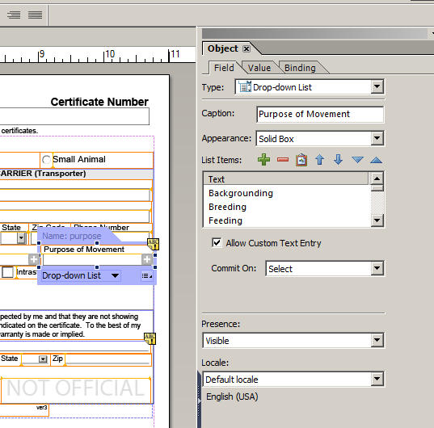 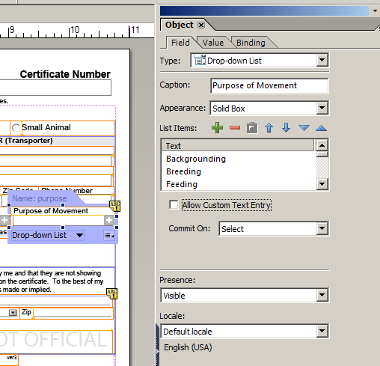

Of course, disallowing free-text means the list must include everything your vets feel they need. You can add to the available list by clicking on the + button. And typing the display value.

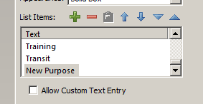

What goes in the XML is either this string, or a bound code. For Purpose of Movement it is just the string.

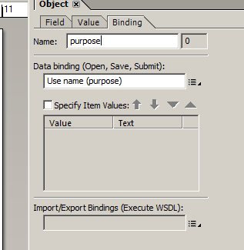

Getting to the small animal species is trickier. It is hidden! In order to navigate to the right object, you need to open the Hierarchy Window and expand the tree nodes species, small, table, and item.

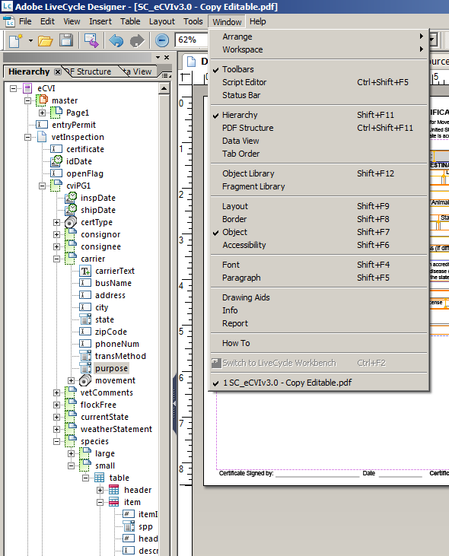

You can then select the node spp and edit its Object, List Items and Binding

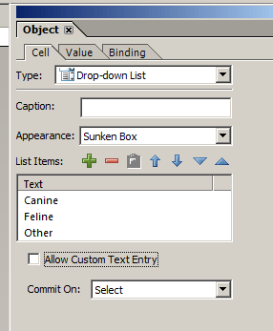 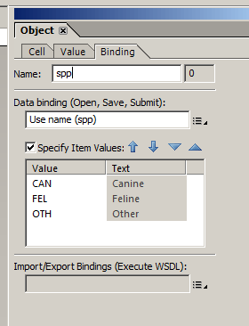

Save the form and distribute as usual.

You now have a form that has only a set list of values for Purpose of Movement and Species (Large animal species didn't allow free text before, unless you had changed it.)

Any new values or codes you added will still map to "Other" unless you edit the transform files. There are complicated XML but the changes needed are pretty simple copy and paste operations in NotePad++, etc.

You will find the section that looks like:

<xsl:template name="PurposeMap">  
 <xsl:param name="purpose"/>  
 <xsl:choose>  
 <xsl:when  
 test="translate($purpose, $smallcase, $uppercase) =   
 translate('Backgrounding', $smallcase, $uppercase) ">other</xsl:when>  
 <xsl:when  
 test="translate($purpose, $smallcase, $uppercase) =   
 translate('Breeding', $smallcase, $uppercase) ">breeding</xsl:when>  
 <xsl:when  
 test="translate($purpose, $smallcase, $uppercase) =   
 translate('Feeding', $smallcase, $uppercase) ">feeding</xsl:when>

Simply copy one of the three row sections from <xsl:when> to </xsl:when>, paste it into a new row, and edit the word in single quotes, e.g. 'Feeding') and the text between the > and < (e.g. >feeding<) to the wording in the form and the standard code respectively. And save. Make sure your editor doesn't change the file extension. Change the name if you want, but be sure to update CivetConfig.txt to match.

A similar edit to SpeciesBreedTrans.xsl will add new species codes:

<xsl:when test="$species ='CAN'">CAN</xsl:when>  
 <xsl:when test=" $species ='CANINE'">CAN</xsl:when>  
Here I added 'CANINE' in addition to CAN as codes for dogs. (Note: in the actual SpeciesBreedTrans.xsl you will find that I made the test case insensitive the way it is for the Purpose of Movement above.

# Preview Mode (Advanced Topic)

Some users are confused by the fact that Civet's native file format—an XML data file with an extension of .CVI—doesn't open when double-clicked in Windows. They get error messages from their email client that say things like "Windows is unable to open the attached file." To deal with this, Civet has yet another "mode" of operation. This is not supported by the installed Civet5.exe. Let me know if you need this and I will try to add the functionality.

# Experimental Menu (Advanced Topic)

As much as Civet is "homemade software", some features are even more raw experimental hacks. These are normally hidden from outside users in an "Add-ons" menu that you will only see if you read the source code (or I send out the wrong version.) Sometimes one of these becomes useful enough to share but not to claim as prime-time. Those go in the Experimental folder.

## VSPS CSV File Import

One of the headaches we all face is VSPS. This free (as in beer, not as in speech) solution for veterinarians to create eCVIs does not yet support the standard data format. It is however possible to download at least partial data in the form of a comma-separated-values file (they call it "Excel" but it is CSV). Some of the data in this file are very uncontrolled. So Civet just does the best it can.

The first step is to download the files from VSPS. For our volume I do this monthly. You may need to go weekly. I grab one file with all the imports and another with the exports. Save them as .csv files. DO NOT open in Excel. Excel will change things around the way it likes them. 840 numbers become scientific notation, all the quote marks go away, etc. Civet was trained on the raw .CSV file structure and won't work on what Excel output even if you save as .CSV. You can save these in the main Civet folder or a dedicated folder. If you set the CivetConfig.txt line

vspsDirPath=C:\\My Home\\Civet\\VSPSData\\

to point to a dedicated folder then the file-open dialog will start in the right place. Otherwise it starts in your Civet install folder.

Note: Civet will NOT be able to extract a full, valid CVI's worth of data from the VSPS download. Our goal was to get enough information for valid animal movement statistics, CVI counts, and a basic search capability.

## Email Only

There are some certificates—small animals in South Carolina—that we do not wish to index or upload to USAHERDS but that receiving states would like to receive as PDF file attachments to email. The Email Only menu item lets you select one or more CVIs to email without indexing. The only data to be entered is the receiving state. As each page is saved the dialog moves to the next. When finished, they are all emailed to their respective states. If you have not previously logged into your email system this session, you are prompted for email system credentials.

The input files may be individual PDFs, multiple CVIs in one PDF, or image files. The files are displayed one page at a time and converted to one page PDF files for emailing. There is no provision for multi-page certificates. Because no certificate number is entered, the filename to send is based on the original filename in the form FF_to_TT_OriginalFilename[(page)].pdf where FF is the state sending and TT is the state receiving and [(page)] is the page number if the original file was more than one page long. This helps ensure that each file in the send folder is uniquely named.

The default input path is set in the CivetConfig.txt line

EmailOnlyInputPath=C:\\My Home\\Civet5\\EmailOnlyIn

The files to be emailed go in a folder set in the CivetConfig.txt line

EmailOnlySendPath=C:\\My Home\\Civet5\\EmailOnlySend

The body of the email sent is provided in the text file set in CivetConfig.txt line

EmailOnlyMessage=C:\\My Home\\Civet5\\EmailOnlyMessage.txt