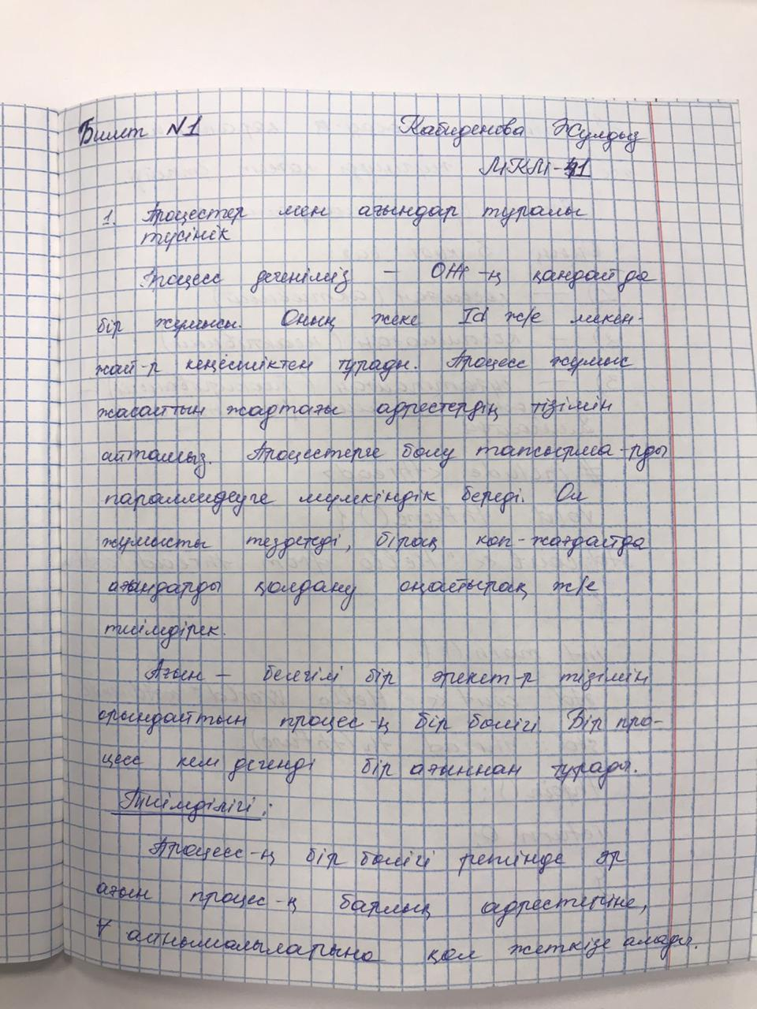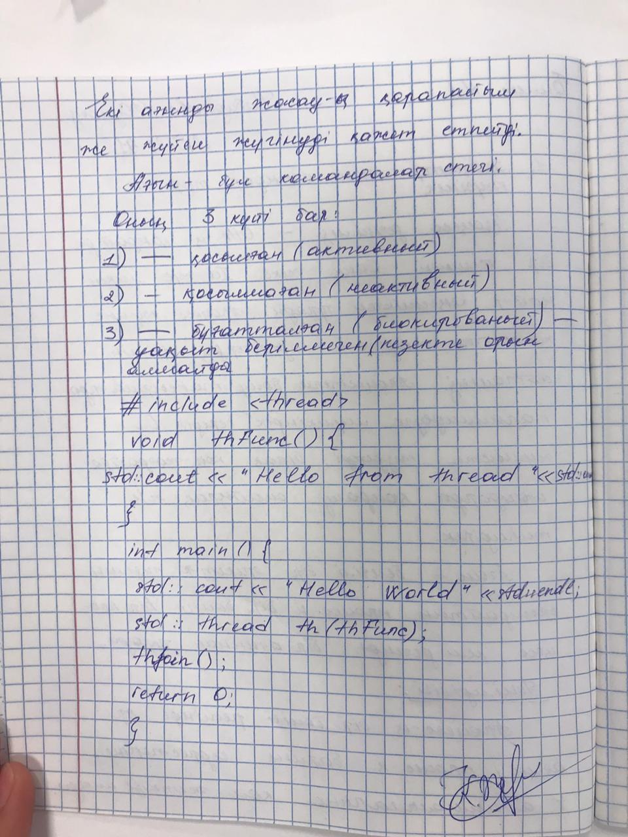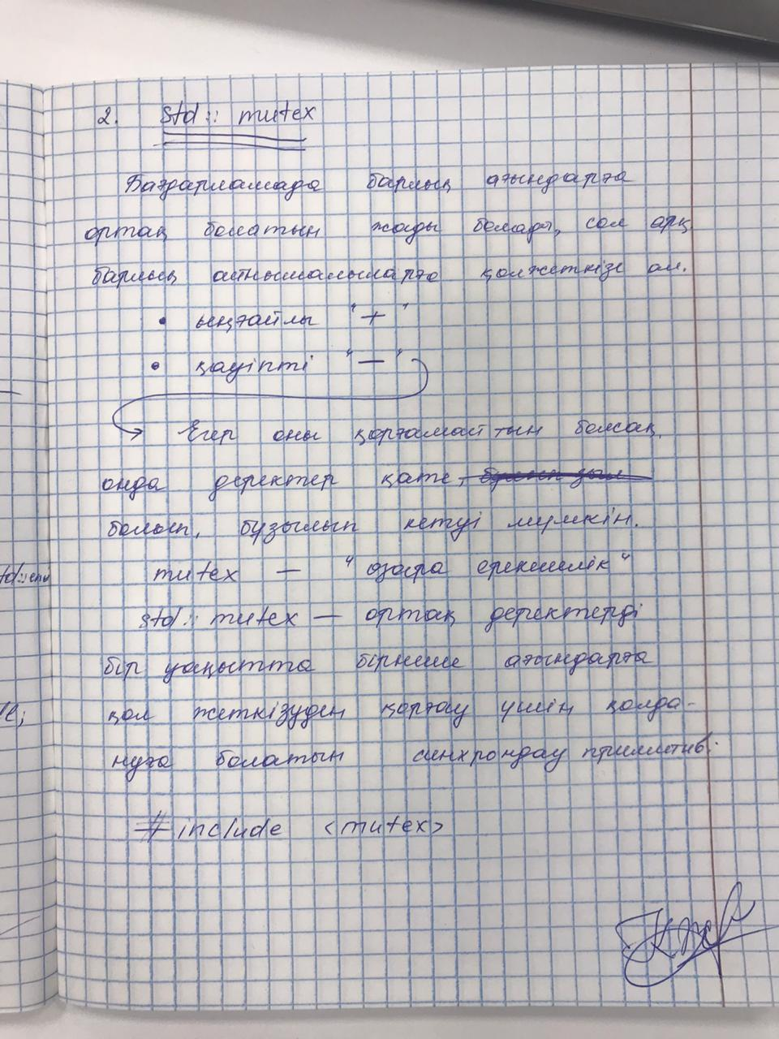

#include <iostream>

#include <thread>

#include <mutex>

#include <chrono>

std::mutex mtx;

void Square(char c){

//mtx.lock();

for(int i=0; i<10; ++i){

for(int j=0; j<10; ++j){

std::cout << c;

std::this_thread::sleep_for(std::chrono::milliseconds(20));

}

std::cout << std::endl;

}

std::cout << std::endl;

//mtx.unlock();

}

int main(){

//Square('*');

//Square('#');

std::thread t1(Square,'*');

std::thread t2(Square, '#');

t1.join();

t2.join();

return 0;

}