**Information about Project**

**Respected Sir/Mam here is all details about Learner’s Academy**

**In first step I have planned three sprints (Sprint-1, Sprint-2, Sprint-3)**

**Sprint – 1**

**SPRINT – 1**

* Story
* Setup working directory & setup project.
* **Task – 1**
* Create a maven project archetype must be (maven-archetype-webapp).
* Create Java source directory with name Java and resource directory with resource name.
* **Task – 2**
* Create package with name servlets inside Java directory.
* Add maven dependency for servlets, mysql.

In first Sprint I have completed following tasks :-

* Created mavan project in intellij IDE with archetype (maven-archetype-webapp).
* Set-up tomcat server with project.
* Created Java source directory.
* Created resources directory.
* Created package with name servlets.
* Added servlets dependencies and mysql dependencies.

**Sprint – 2**

**SPRINT – 2**

* **Story**
* **C**ode to display login page and dashboard page.
* **S**etup database.
* **Task – 1**
* Create index.jsp page under webapp directory.
* Write html code for design login page.
* Create dashboard.jsp page under webapp directory.
* Write html code for design dashboard page.
* **Task – 2**
* Create database in mysql with name learner_academy.
* Create tables (class, class_teacheers, students, subjects, teachers) with foreign key for connecting each other.

**In second Sprint I have completed following tasks :-**

* Created index.jsp page under webapp directory and wrote code for input boxes and login button.
* Created dashboard.jsp page under webapp directory and wrote code for displaying five buttons (Show Students, Show Subjects, Show Teachers, Show Classes, Log Out).
* Created database with name learner_academy.
* Created tables (students, subjects, class, teachers and class_teachers) with primary key and foreign key.
* Insert data into tables.

**Sprint – 3**

**SPRINT – 3**

* **Story**
* Code to validate login username and password.
* Code to show buttons for showing data.
* **Task – 1**
* Create login handler servlet and write code to check input data is valid or not.
* If login credentials are correct then redirect to dashboard page if incorrect then print error message.
* Create servlets for display data of teachers, classes, students and subjects from database.
* Create try catch block for handling errors.
* **Task – 2**
* Create logout servlet for logout from dashboard.
* **Feature – 1**
* All data related to teachers should be displayed on html page.
* All data related to students should be displayed on html page.
* All data related to subjects should be displayed on html page.
* All data related to class should be displayed on html page.

**In third Sprint I have completed following tasks :-**

* Created servlet with name login_handler and wrote code for handling login actions if login credentials are invalid then it will redirect to index.jsp with error message else redirect to dashboard.jsp.
* Created servlet with name Students and wrote code for connecting with database and for display data of students table.
* Created servlet with name Subjects and wrote code for connecting with database and for display data of subjects table.
* Created servlet with name Teachers and wrote code for connecting with database and for display data of teachers table.
* Created servlet with name Classes_Handler and wrote code for connecting with database and for display data of class table.
* Created servlet with name Logout for logging out from web-app.

**Concepts are used in development –**

|  |  |
| --- | --- |
| HTML | Used for create web-pages. |
| MySql | Used for create database. |
| JAVA | Used for backend code. |
| Servlets | Used for retrieving data from mysql and show on html page. |
| Tomcat | Used for run app on server. |
| Git/GitHub | Used for upload code on GitHub. |

**Screenshots of output :-**

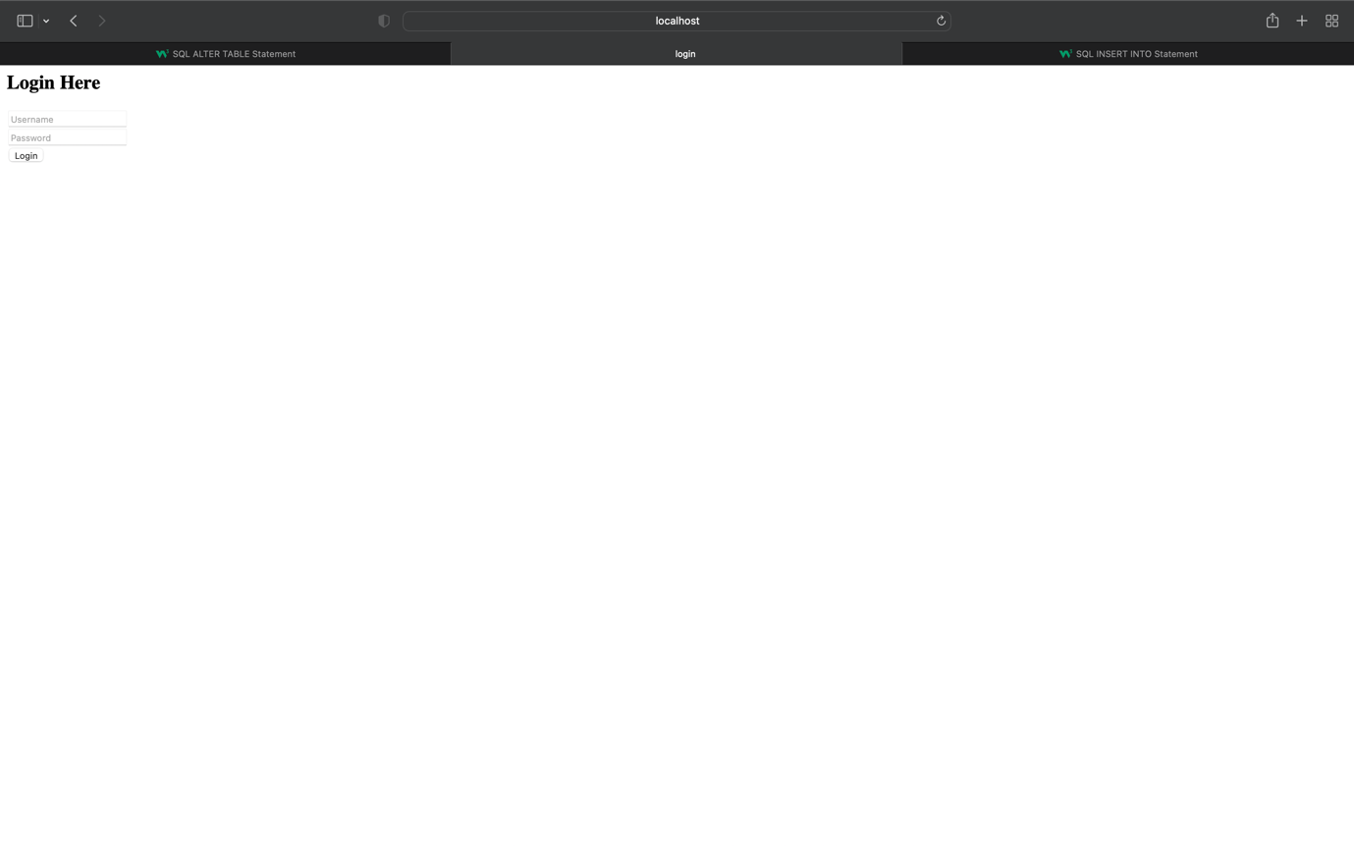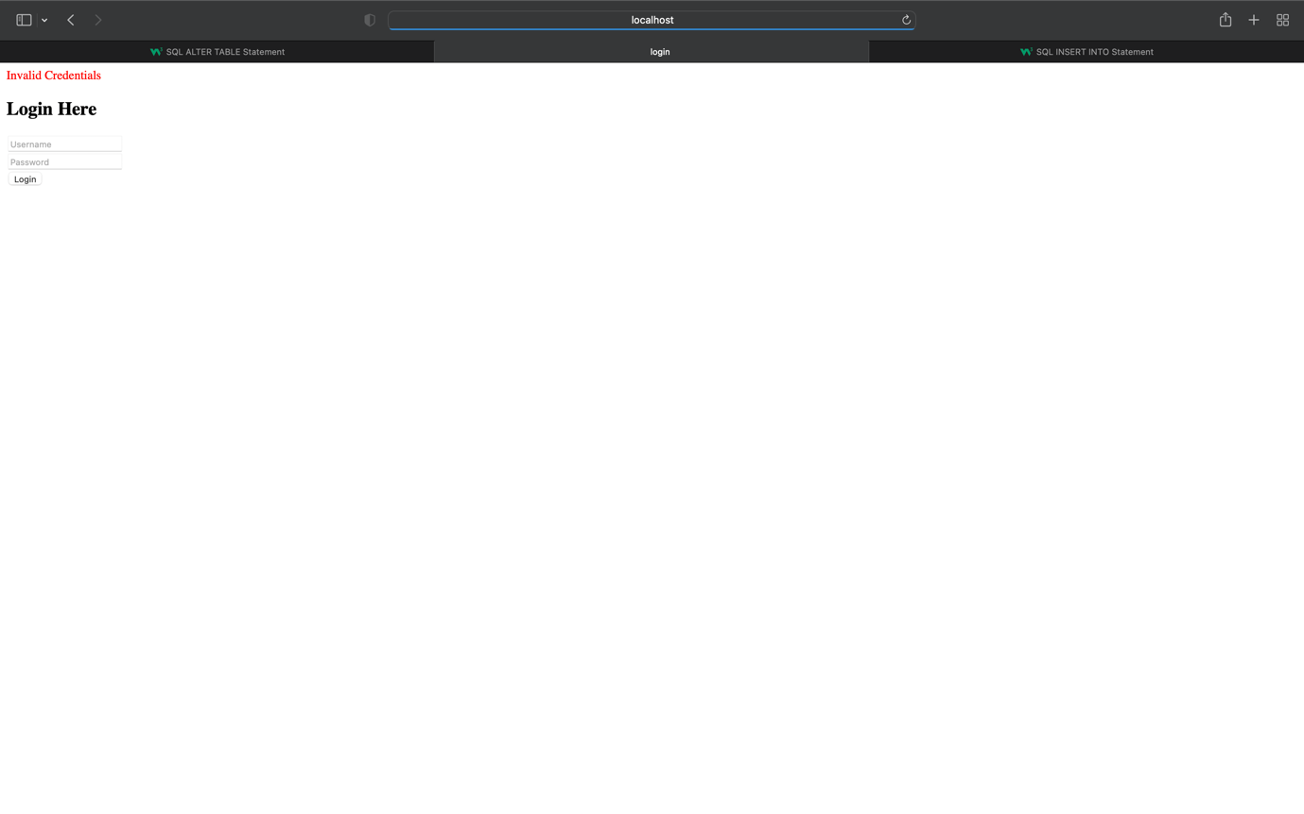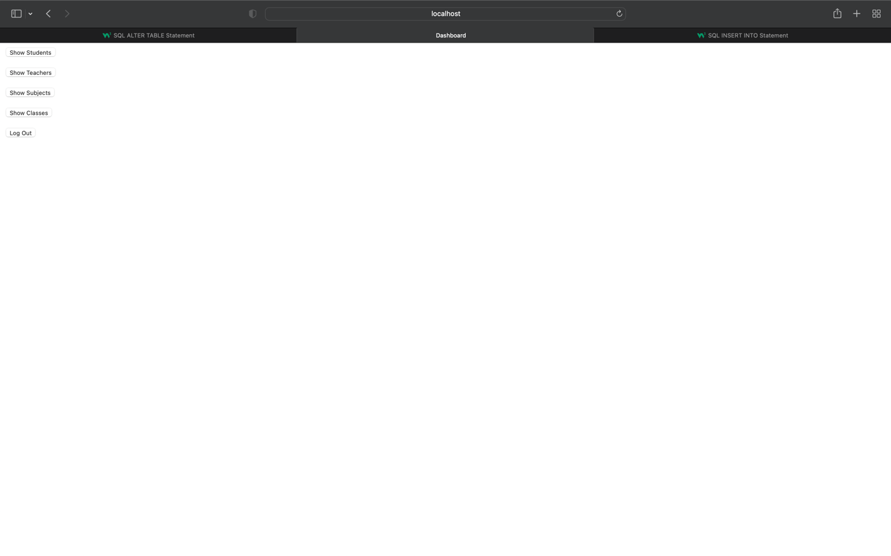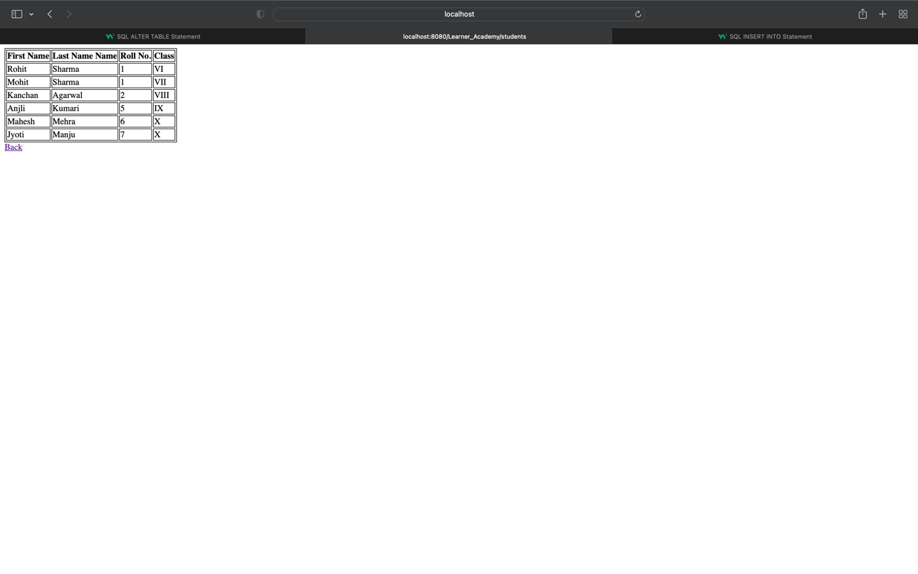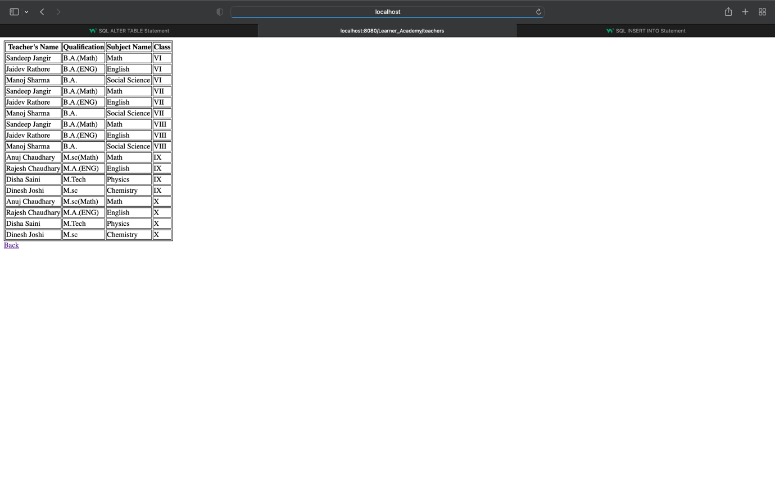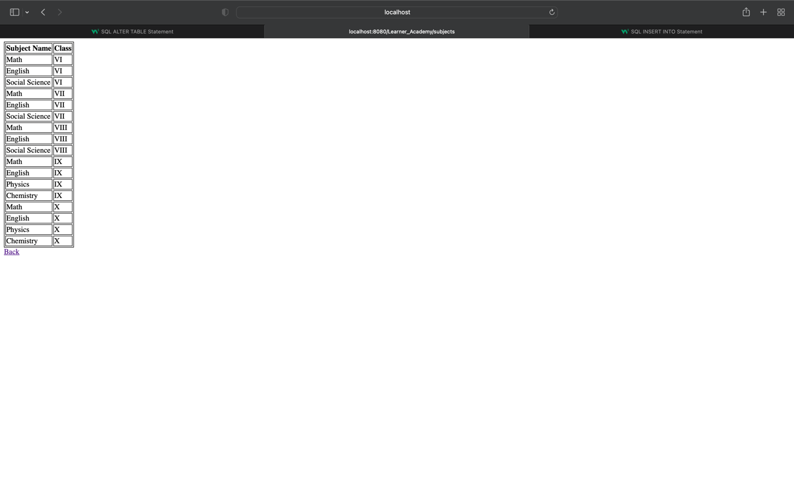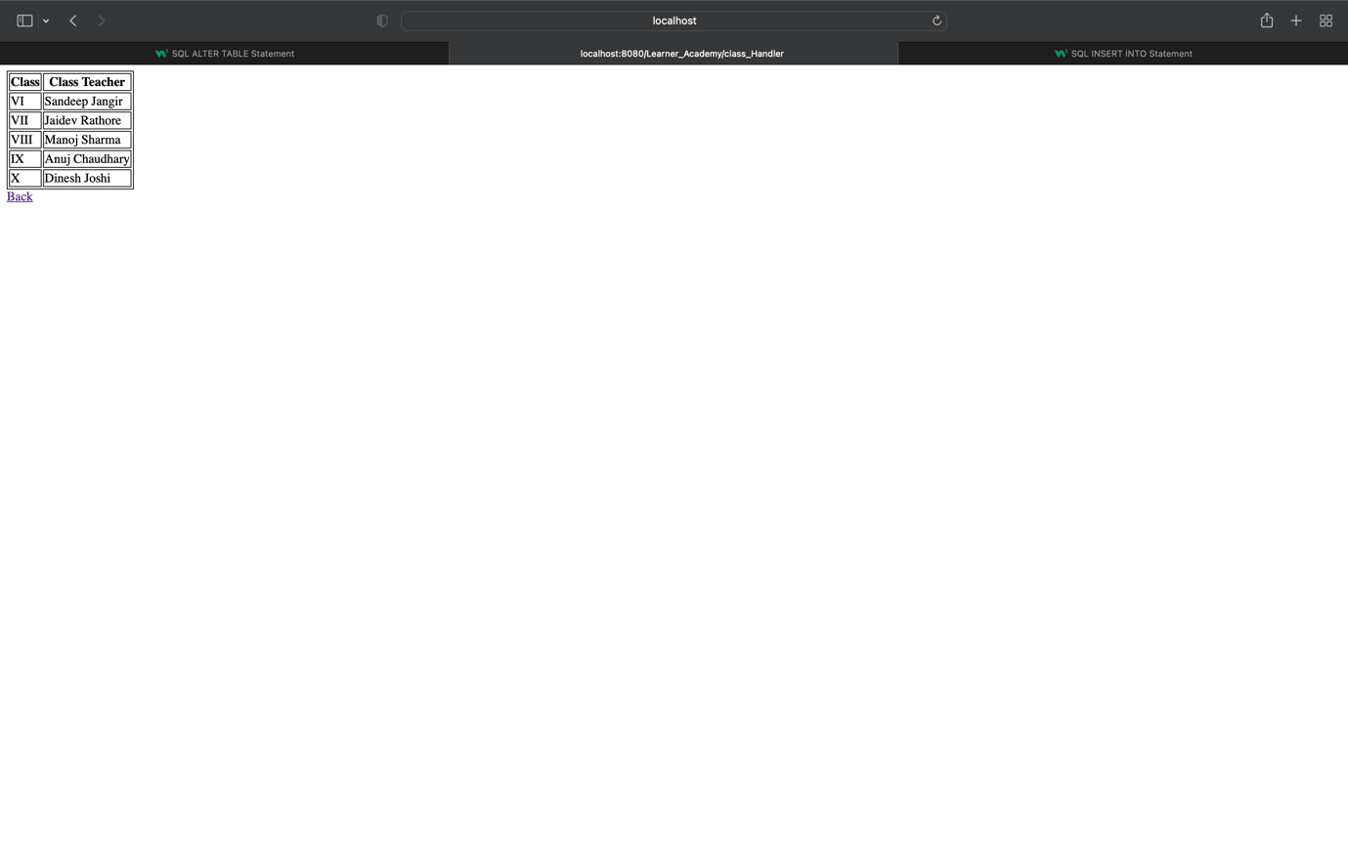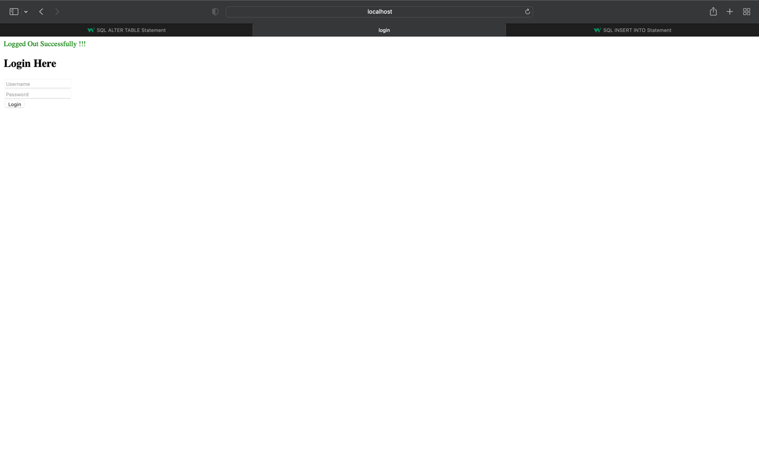

**GitHub Link - https://github.com/mkmaheshmehra/Learner-s-Academy**

**Name – Mahesh**

**Thank you Sir/Madam**