**Information About Project**

**Respected Sir/Mam here is all details about LockedMe.com application**

**In first step I have planned two sprints ( Sprint-1 & Sprint-2 )**

**Sprint – 1 :**

**Sprint - 1**

* **Story**
* Code to display the welcome screen, it should display the welcome screen.
* **Task – 1**
* Welcome screen should display the name of application and the developer name.
* The details of the user interface such as option to displaying the user interaction information.
* **Feature – 1**
* Display the options for user interaction :
* Option to display files.
* Business level operations.
* Option to close application.
* **Feature – 2**
* Feature to accept the user input to select one of the options listed.

**In first Sprint I have done following points :**

* ***I have set my working directory and then started working on the project.***
* ***Implement code for displaying welcome screen which includes application name and the developer name.***
* ***Implement three options***
* ***Display files***
* ***Business level operations***
* ***Exit from application***
* **Implement Scanner class for taking user’s input and work on it.**
* **Here user can interact with the application which is an command line based application.**
* **In this process three methods are defined.**

|  |  |
| --- | --- |
| **welcomeScreen()** | **This method prints application name and developer’s name.** |
| **optionScreen()** | **This method prints three options (Display files, Business level operations & exit from application )** |
| **innerOptionScreen()** | **This method prints four options which are (Create new file, delete a file, search a file & return to main context )** |

**Sprint – 2**

**Sprint – 2**

* **Story – 1**
* The first option should return the current file names in ascending order. The root directory can be either empty or may contain few file or folders.
* **Story – 2**
* The second option should return the details to the user interface such as options displaying the following.
* **Task – 1**
* Create a method to add a file to existing directory list.
* You can ignore the case sensitivity of the file name.
* You can also give an option to write in file.
* **Task – 2**
* Create a method to delete a user specified file from the existing directory.
* Display the message if file is not found.
* You can use case sensitivity to ensure that right file is deleted.
* **Task – 3**
* Create a method for search user specified file.
* You can use case sensitivity on file to search a right file.
* Print a message on successful action.
* Print the message if action is failed.
* **Task – 4**
* Option to navigate back to the main context.
* **Task – 5**
* Option to exit the application.

**In Sprint – 2, I have completed following tasks –**

* **Develops following methods –**

|  |  |
| --- | --- |
| **createFile(String filename)** | This method checks if a file already exists with given name then it will not create again and prints the message else creates new file with given name. |
| **deleteFile(String filename)** | This method will delete the file with given name if file not exists then it will print message of file not found. |
| **searchFile(String filename)** | This function search the file in directory and prints the message. |
| **displayFiles()** | This method will print all file’s name in ascending order. |
| **Write(String filename, String data)** | This method will writes given data in file if file exists else prints message. |

**In main method objects of all classes are created and also invoked methods of respective classes.**

**Concepts are used in development –**

|  |  |
| --- | --- |
| **File Handling** | File handling is used for create, delete, search and display all files. |

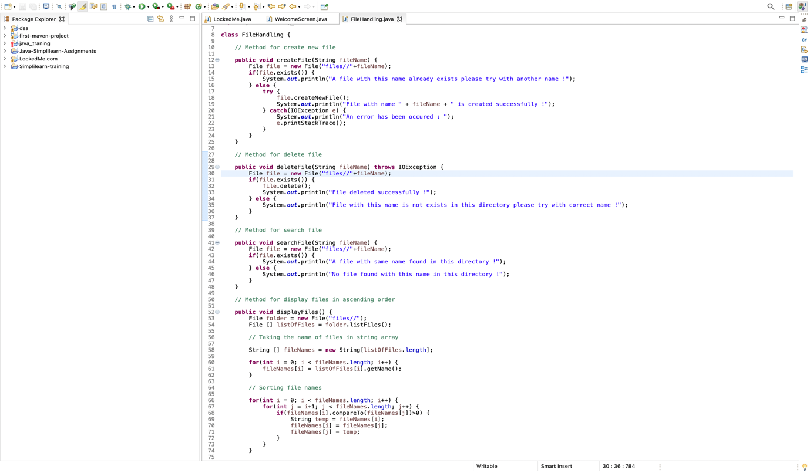

|  |  |
| --- | --- |
| **Scanner class** | Scanner class is used for taking inputs from user. |
| **Switch case** | Switch case is used for handle all operations according to user’s input. |
| **While loop** | While loop is user for executing switch case again and again while user don’t want to exit application. |

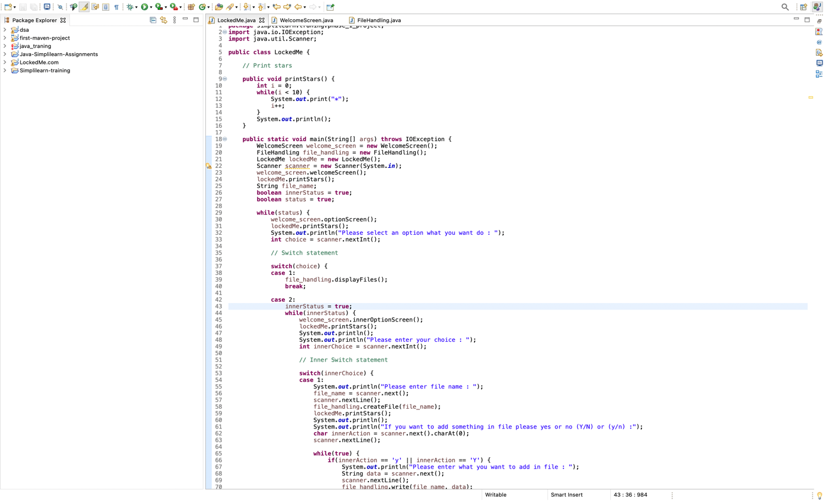

|  |  |
| --- | --- |
| **Bubble Sorting** | Bubble Sorting is used for sorting the names of files and prints in ascending order. |

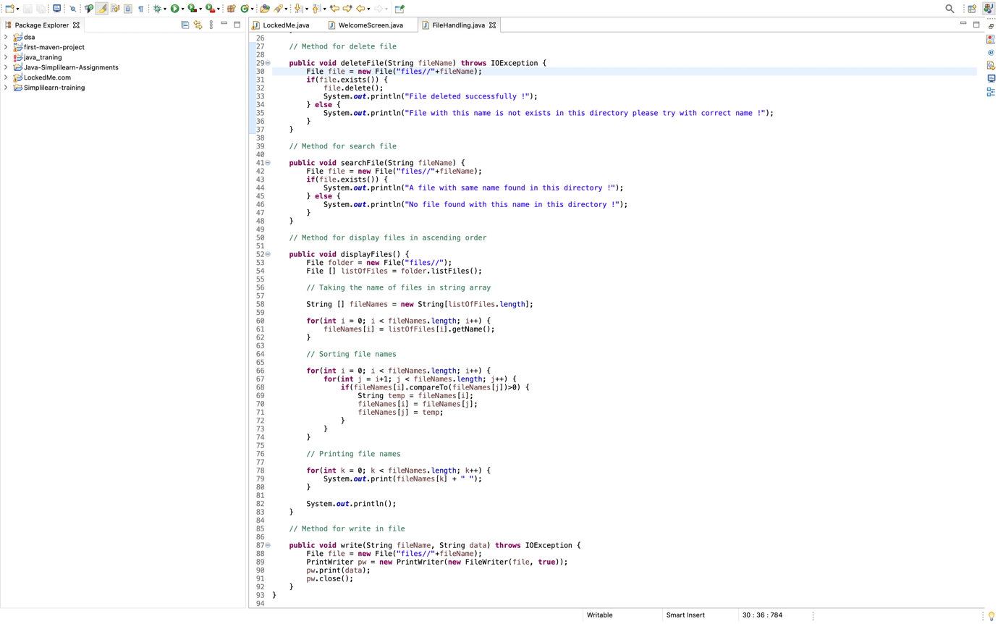

**Screen Shot of final output –**

