

**Green University of Bangladesh**

**Department of Computer Science and Engineering (CSE)**

**Faculty of Sciences and Engineering**

**Semester: (Summer, Year:2022), B.Sc. in CSE (Day)**

**CLP-02**

**Course Title:** Data Structure And Algorithm

**Course Code: CSE 106 Section: PC-213 DC**

**Student Details**

|  |  |  |
| --- | --- | --- |
| **Name** | | **ID** |
| **1.** | **Md Masud Rana** | **213902101** |

**Submission Date: 17-08-2022**

**Course Teacher’s Name: Md. Sultanul Islam Ovi**

**Problem 04:** Below Tree I am considering for Masud

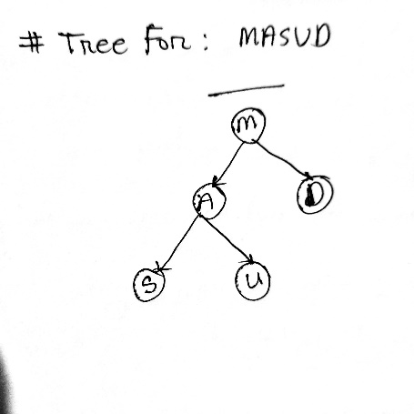

**Input Screenshot:**

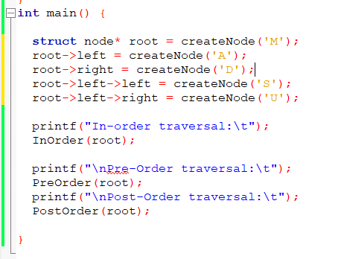

**Output screenshot :**

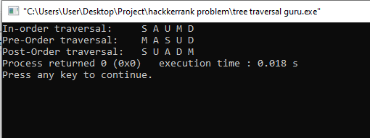

**Problem 01:** Below Tree I am considering for GREEN

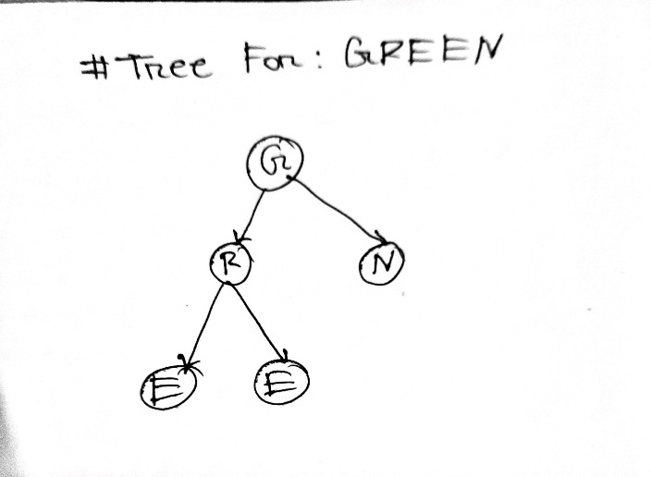

**Problem Input Screenshot :**

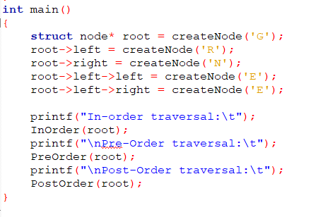

**Problem Output Screenshot:**

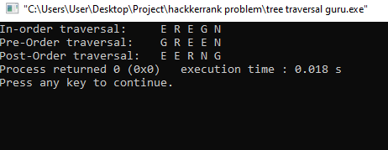

**Problem 05:** Below Tree I am considering for 213902101

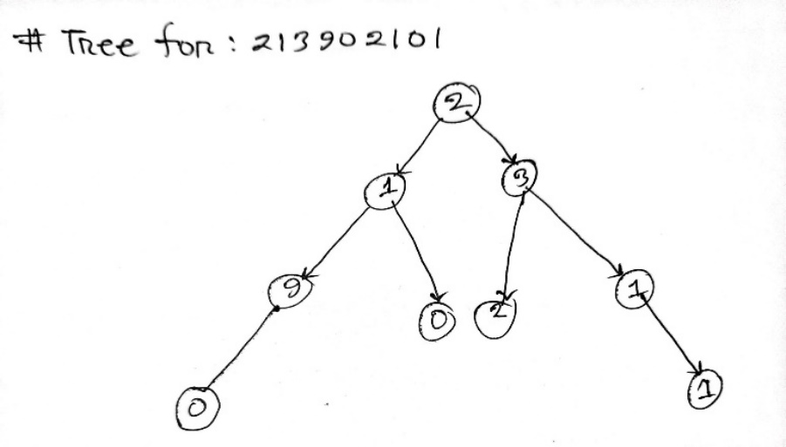

**Input Screenshot:**

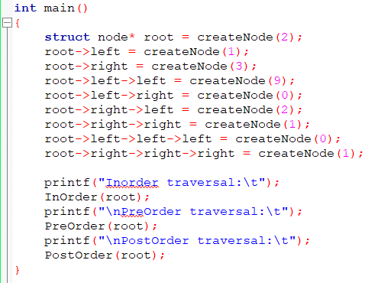

**Output Screenshot:**

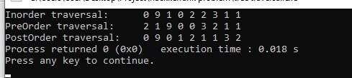

**Problem 1.3:** Below Tree I am considering

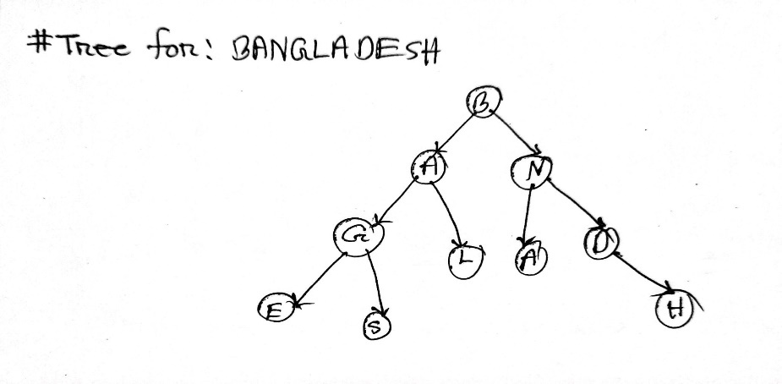

**Input Screenshot:**

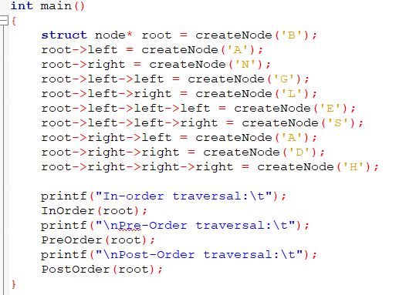

**Output Screenshot:**

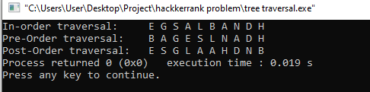

**Problem 1.2 : I am considering below Tree**

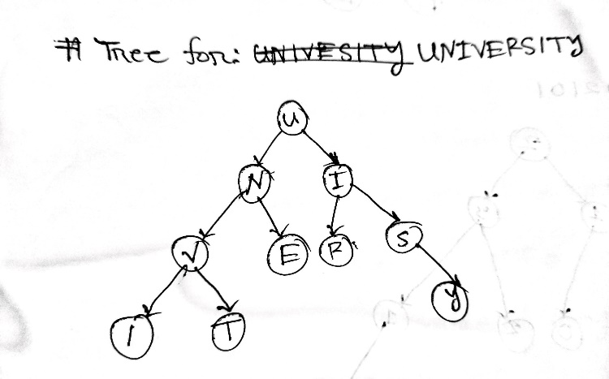

**Input Screenshot:**

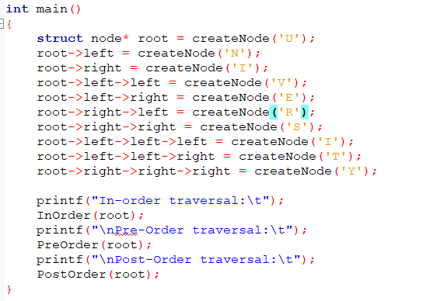

**Output Screenshot :**

