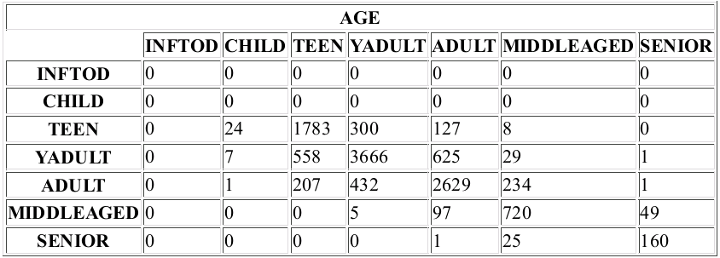
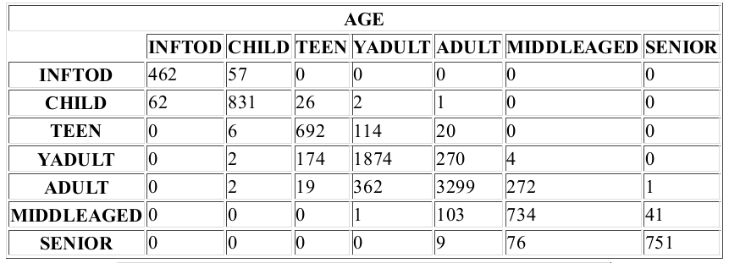
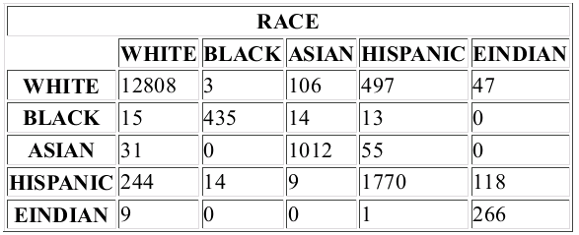
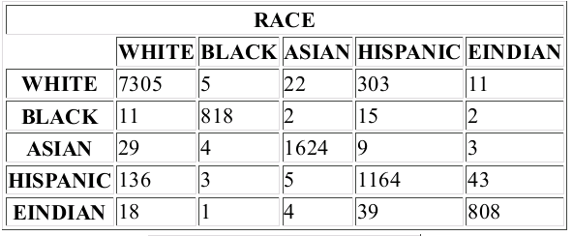
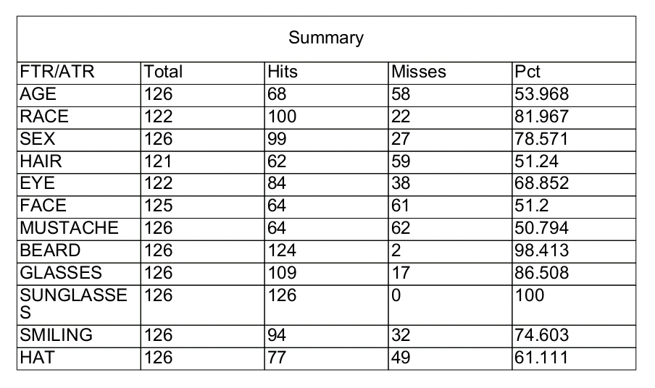
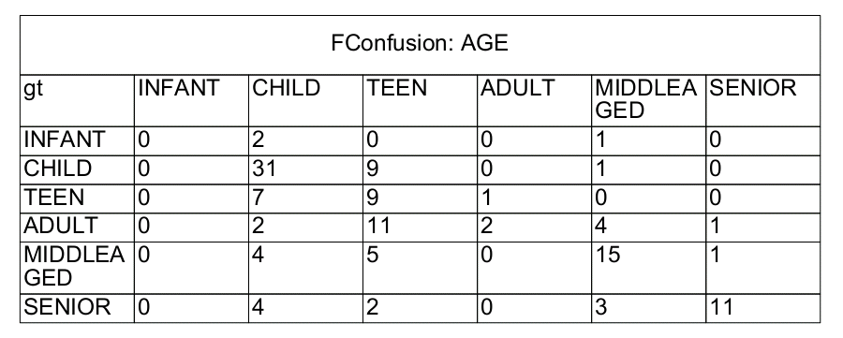
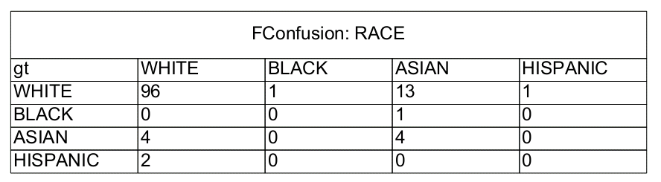
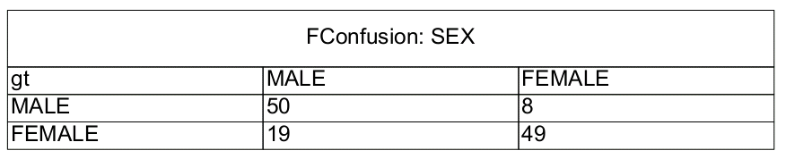
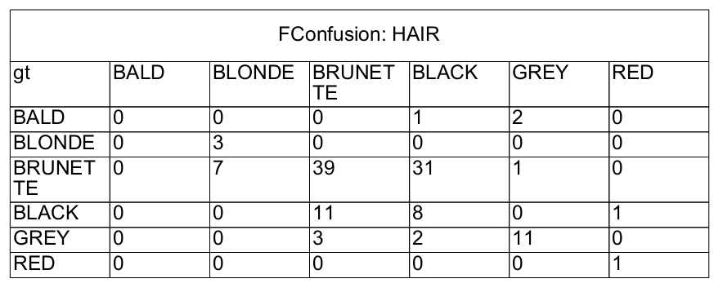
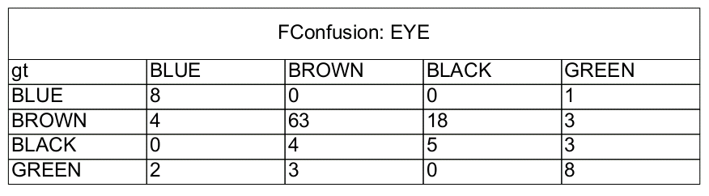
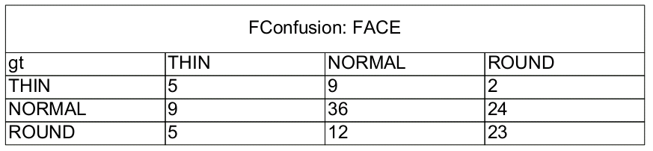
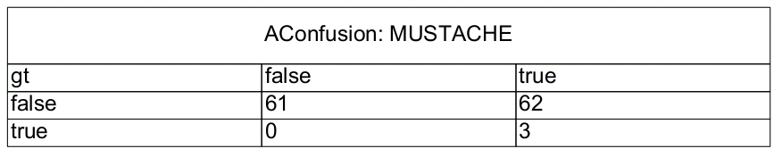
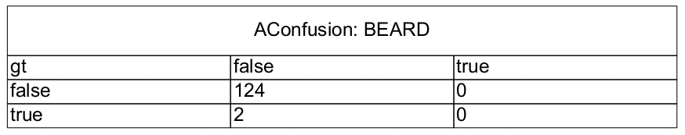
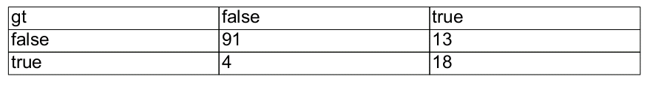
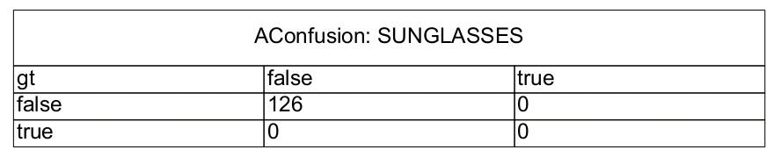
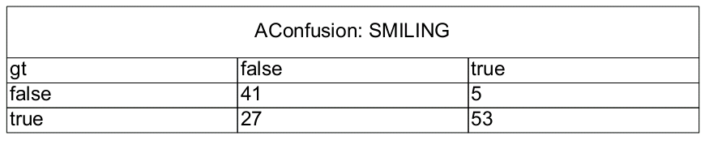
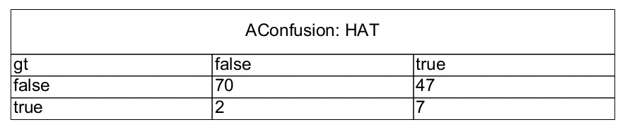
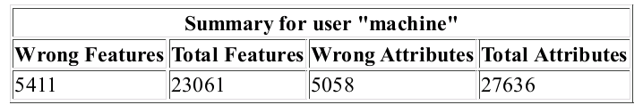
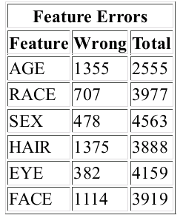
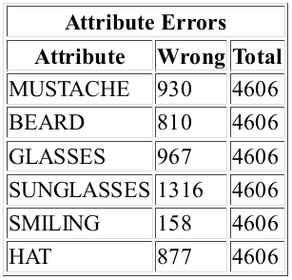
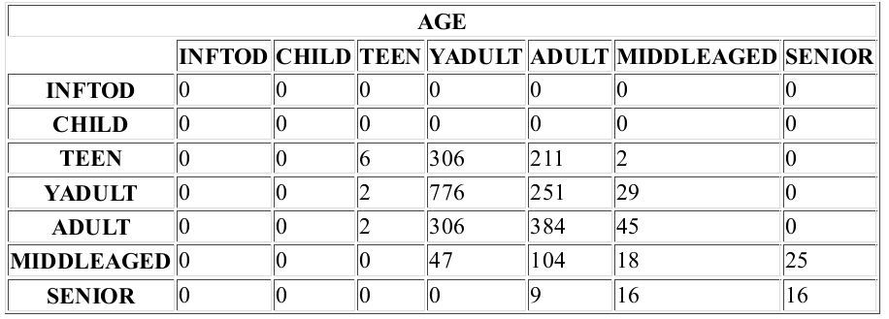
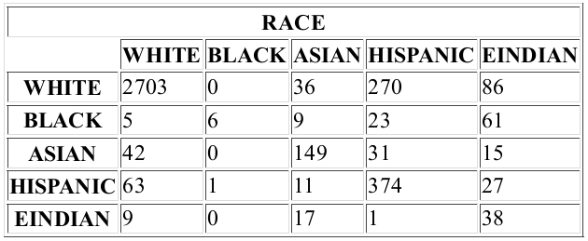
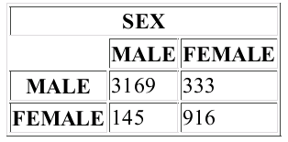
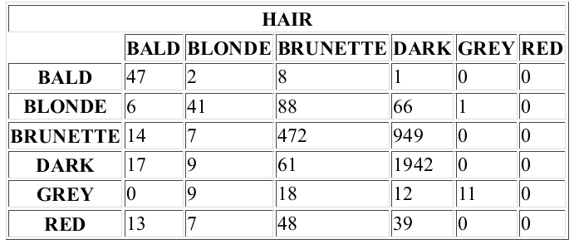
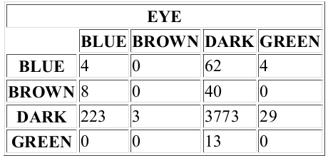
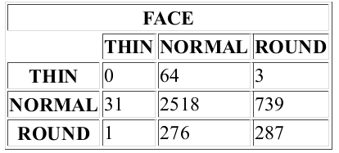
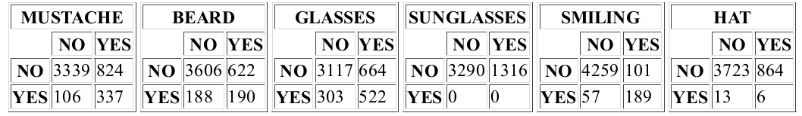
Q3 Progress Report: Multimodal Knowledge Acquisition and Management (MKAM) N00014-11-C-0474
Noah S Friedland, The Friedland Group, Inc.
Lenhart K Schubert, University of Rochester
Total Phase II Baseline budget: $.........
Amount incurred to date: TBD
Projected amount to completion: TBD

General Overview
In the third quarter of the MKAM Baseline
Image Understanding:
NLP and alignment:
In this quarter the emphasis was on
- main algorithm development: further implementing and linking up the major caption processing stages, and conversion of image-derived features into a form suitable for the caption-image alignment process;
- support system development: enhancing the major subsystems that the various stages of the processing system draw on, especially the TTT (template-to-template tree transduction system), and the EPILOG KB and inference engine.
- Lexical knowledge development: Extensive efforts were devoted to semi-automatic creation of lexical axioms for the relationship between nominal terms (such as party and social event, or grandmother and woman) and the basic entailments of verbs (such as that someone who smiles is probably pleased, or that someone who is swimming is in a body of water). These efforts have been based respectively on WordNet and Verb Net (with additional reference to FrameNet and other resources).
The first two development and integration efforts have reached the point where some sample captions, input as quoted strings, are transformed fully automatically into sets of canonicalized formulas, i.e., minimal assertions that easily fit with the EPILOG background knowledge. A few inferences based on the automatically stored assertions have also been successfully tried, setting the stage for automatic inferencing of the features that will enable alignment. The alignment code itself has not yet been tested, because not enough of the background knowledge has been built up for deriving all the features of persons mentioned in the caption that are needed for alignment, and some interfacing problems with the EPILOG system remain to be resolved. The point we have reached is best appreciated from an example. For the caption "Grandma Lillian and Uncle Moshe at Tanya's graduation party,", the automatically derived list of canonical assertions is the following:
((PARTY0.SK ((NN GRADUATION.N) PARTY.N)) (PARTY0.SK PERTAIN-TO TANYA.NAME)
((SET-OF GRANDMA_LILLIAN.NAME UNCLE_MOSHE.NAME) AT.P PARTY0.SK)).
Thus we have three claims, viz., that PARTY0.SK (an automatically created Skolem constant) is a graduation party, that this party pertains to Tanya, and that the set consisting of Grandma Lillian and Uncle Moshe is at the party. An example of an inference that was then obtainable by EPILOG was that there exists an event of Tanya graduating. This will further lead to the inference that Tanya is probably an teen or young adult – one of the features, namely age bracket, that will be the basis for caption-image alignment.
The lexical axiomatization work has so far proceeded separately from the NLP and alignment work, but axioms are being created in a form understood by EPILOG, and thus suitable as background knowledge for the NLP system in future.

Schedule and Milestones [I haven't had a chance to try to do this -LKS
Provide schedule and milestones per the SOW, with the actual milestones and deliverables:
Table : Q3 Tasks and Milestones
Task | Description
3.1 Alignment algorithm | The contractor shall develop preliminary alignment algorithms similar in functionality to Markov Random Field (MRF) and Markov Logic Network (MLN) algorithms and integrate them into the MKAM system. The goal of the algorithms is to compute a most probable set of correspondences between image-derived entities and caption-derived entities, based on probabilistic (soft) constraints. Once such correspondences have been computed, information about corresponding entities derived from the image and caption can be fused as well. For example, an individual found in the image and classified as a female teen could plausibly correspond to an individual referred to in the caption as "Tanya", and described as being at her high school graduation party (allowing the inference that she is probably a teenager), while that same image individual is unlikely to correspond to another person referred to in the caption as "Grandma Lillian", and even less likely to one referred to as "Uncle Moshe". The alignment problem is a difficult one because the image may contain more or fewer individuals than are mentioned in the caption, and neither image-derived nor caption-derived features are fully trustworthy, and because inference based on linguistic knowledge and world knowledge (such as typical family relationships, ages, features such as likely eyewear, hair color, facial hair, etc.) need to be brought to bear in adjudicating among possible alignments. The capabilities of the system for interpreting language and making inferences will contribute crucially to alignment
3.5 Secondary NLP Enhancement | The contractor shall perform output refinement using pattern transduction. Refinement of caption parses, and hence of caption interpretations, is essential because of the high error-rate of state-of-the-art parsers. Refinement will be achieved by exploiting the fact that many errors are systematic, so that systematic parse-tree transformations can be used to correct many errors. For example, in the phrase "Tanya and Grandma Lillian at her high school graduation party", the modifying prepositional phrase following the noun phrase "Grandma Lillian" will typically be attached to that noun phrase by current statistical parsers -- inviting the inference that it is Grandma Lillian's high school graduation party. The tool used in the parse tree transformations will be an implementation of a tree rewriting language "TTTT" (tree-to-tree-transduction), developed as part of this project.
3.6 Secondary IU Enhancement | The contractor shall augment the classification algorithms. As we begin to consider larger data sets, increased functionality, and larger diversity of subjects, e.g. people of different gender, age, and racial backgrounds from different places on earth, we will need to revise the semantic classification algorithms to ensure that they are still effective. Like before, this will be a highly empirical exercise that will involve trial and error to find the best combination of classification techniques.

Main algorithm development: the processing pipeline
To recap from the Q2 report, a key capability we are developing for MKAM is the ability to use knowledge in explicit symbolic form to align caption and image individuals, and make further inferences about them.

Some of the algorithmic stages implemented since the previous report
- Conversion from image-derived features (with probabilities) to a “lispified” form suitable for alignment. The image-derived features are in tabular form, with feature values and corresponding probabilities in adjacent rows; the lispifying algorithm pairs each feature value with its probability, and also replaces the feature-value combinations with EPILOG predicates; for example, the partial table for the image ”grandma-moshe.jpg”
Human4
AGE 0to3 4to11 12to17 18to25 26to39 40to55 55plus
fage=52.13 0.095 0.1784 0.2082 0.0854 0.0206 0.2254 0.187
RACE WHITE BLACK ASIAN HISPANIC EINDIAN ARAB
0.3844 0.0802 0.1757 0.144 0.2156 0
SEX MALE FEMALE
0.5312 0.4688
HAIR BALD BLONDE BRUNETTE DARK GREY RED
0.0428 0.148 0.2923 0.3059 0.1021 0.109
EYE BLUE BROWN DARK GREEN
0.2736 0.3247 0.2677 0.134
is transformed into alternating EPILOG predicates and probabilities
(GRANDMA-MOSHE.JPG
(HUMAN4 PERSON.N 0.99 BABY-OR-TODDLER.N 0.095 CHILD.N 0.1784 TEEN.N
0.2082 YOUNG-ADULT.N 0.0854 YOUNGISH-ADULT.N 0.0206 MIDDLE-AGED.A
0.2254 SENIOR.N 0.187 RACIALLY-WHITE.A 0.3844 RACIALLY-BLACK.A 0.0802
RACIALLY-ASIAN.A 0.1757 RACIALLY-HISPANIC.A 0.144
RACIALLY-EAST-INDIAN.A 0.2156 RACIALLY-ARABIC.A 0 MALE.N 0.5312
FEMALE.N 0.4688 BALD-HEADED.A 0.0428 BLOND-HAIRED.A 0.148
BROWN-HAIRED.A 0.2923 DARK-HAIRED.A 0.3059 GRAY-HAIRED.A 0.1021
RED-HAIRED.A 0.109 BLUE-EYED.A 0.2736 BROWN-EYED.A 0.3247 DARK-EYED.A ...)
An analogous structure will be derived by EPILOG inference, and the two parallel structures will serve as input to the alignment algorithm.
- Scoping of tense, quantifiers, and coordinators. This task was the largest single task undertaken in Q3. Quantifier scoping is a long-studied, very difficult problem in computational semantics. Numerous papers and several PhD theses have been written on the subject, a recent example being the work of Mehdi Hafezi Manshadi, a soon-to-graduate PhD student under James F. Allen's supervision. The data collected and annotated in the course of Manshadi's work provided us with an empirical basis for a new heuristic algorithm. This goes beyond any existing algorithm in handling not only the scopes of all quantifiers (more accurately, determiners like the, my, some, all, most, …) but also of coordinators like and and or, and of tense. For example, the algorithm achieves the following transformation from an unscoped logical form (ULF) to a scoped (but still indexical) logical form (ILF):
(:I (:F COLL-OF GRANDMA_LILLIAN.NAME UNCLE_MOSHE.NAME)
(:P AT.P
(:Q THE.DET
(:L X
(:I (:I X (:F (:F NN GRADUATION.N) PARTY.N)) AND
(:I X PERTAIN-TO TANYA.NAME))))))
(THE.DET Y
(:I (:I Y (:F (:F NN GRADUATION.N) PARTY.N)) AND
(:I Y PERTAIN-TO TANYA.NAME))
(:A (:F COLL-OF GRANDMA_LILLIAN.NAME UNCLE_MOSHE.NAME)
(:L Z (:I Z AT.P Y))))
Note the introduction of variables like Y and Z (the latter is a renaming of a lambda-variable), and the “lifting” of the determiner the to the front of the formula from its original embedded position.
- Various algorithms supporting the use of TTT. For example, since there is overlap between the reserved symbols of the match-syntax of TTT and the logical syntax of EPILOG (e.g., the asterisk '*' denotes a Kleene -star match-symbol in TTT and an episodic operator in EPILOG), logical expressions to be matched must first have certain of their reserved symbols “hidden”, and after matching, “unhidden”. Also, new algorithms were needed for iterative application of TTT rules to sets of formulas, achieving transformations such as canonicalization.
- Various algorithms supporting the use of EPILOG. For example, algorithms were implemented for inferentially deriving relevant properties of caption-persons; the algorithms pose questions to EPILOG about the degree of certainty of each of the properties potentially usable for alignment, such as how likely is the person to be a child, or a teenager, etc., or to be racially Asian, or to be gray-haired, etc. The methods of inserting knowledge into EPILOG, and requesting answers to questions, has also been revised. This proved a difficult issue (and further work is required), since the package system of Common Lisp is quite intricate and counterintuitive.

Support system development

TTT
The template-to-template tree transduction system has been greatly streamlined over the past quarter, mainly to increase its efficiency. A. Purtee, the main developer of TTT, has implemented ways of compiling patterns and converting input list structures into “nodal trees” so that exhaustive matching (trying all patterns on all subtrees of an input) can be avoided. Various modes of operation, such as repeated rule application at all structural levels until convergence, and rule applications only at the root level, are now implemented and easily usable. This development has been a major boon to the caption processing project, which relies at multiple stages on template-based tree transformations.
Apart from further developing the TTT system itself, we have formulated many rules for logical-form transformation. To provide some idea of the concise formulation of the rules, here is an excerpt from the current rule base for canonicalizing logical forms:
; strip off the speech-act wrapper
(/ (_* ((! exists exist some some.det) _! _?
((_! (! say.v tell.v) _? (that _!1)) (! [**] [*] [@]) _!2)) _*1)
(_* _!1 _*1))
; Skolemize a restricted existential; use a conjunction in order to make
; the same substitution in both conjuncts, but another rule breaks it up.
; Here the Skolem is based on the type (if any) specified in the restrictor,
; which will be extracted from the second (optional) argument of 'new-skolem!'
(/ (_* ((! exists exist some some.det) _! _!1 _!2) _*1)
(_* (subst! (new-skolem! _!1) _! (_!1 and _!2)) _*1))
; Separate surface conjuncts
(/ (_* (_! (! and and.cc) _+) _*1)
(_* _! _+ _*1))

EPILOG and KB for caption processing
The main advances in the development of the inference engine itself have been in automatic error reporting, forward inference, repair of various minor problems, and most importantly, improvements in the interfacing between the EPILOG package and users of that package; for instance certain difficulties caused by not “interning” symbols occurring in a list structure handed to EPILOG for processing have been resolved by development of recursive interning algorithms.
The general kb currently supporting caption processing is still small – about 65 general axioms, but the axioms provide knowledge that is generally useful for making the inferences that will enable caption-image alignment (with emphasis on the family photo domain). Here are a few examples:
; Knowledge about gender and personhood
; ~~~~~~~~~~~~~~~~~~~~~~~~~~~~~~~~~~
; Every person is a male or a female, but not both
(s '(all x (x person.n) ((x male.n) or (x female.n))))
(s '(all x (x male.n) (not (x female.n))))
; Every male and female is a person
(s '(all x (x male.n) (x person.n)))
(s '(all x (x female.n) (x person.n)))
; Knowledge about interpersonal relations, gender, and age
; ~~~~~~~~~~~~~~~~~~~~~~~~~~~~~~~~~~~~~~~~~~~~~~~
; Grandmothers are females
(s '(all x (all y (x grandmother-of.n y) (x female.n))))
; Grandmothers are usually seniors
(s '(all x (all y (x grandmother-of.n y)
((adv-s (with-certainty .8)) (x senior.n)))))
; Grandmothers may be middle-aged
(s '(all x (all y (x grandmother-of.n y)
((adv-s (with-certainty .15)) (x middle-aged.a)))))
; Grandmothers may very occasionally be youngish adults
(s '(all x (all y (x grandmother-of.n y)
((adv-s (with-certainty .05)) (x youngish-adult.n)))))
; Uncles are males
(s '(all x (all y (x uncle-of.n y) (x male.n))))
; Uncles are quite possibly seniors
(s '(all x (all y (x uncle-of.n y)
((adv-s (with-certainty .25)) (x senior.n)))))
; Uncles are rather likely middle-aged
(s '(all x (all y (x uncle-of.n y)
((adv-s (with-certainty .35)) (x middle-aged.a)))))
; Activities indicating age bracket
; ~~~~~~~~~~~~~~~~~~~~~~~~~~
; One who plays is probably a child
(s '(all x (all e ((x play.v) @ e)
((adv-s (with-certainty .6)) (x child.n)))))
; Someone who graduates is probably a teen or young adult
(s '(all x (all e ((x graduate.v) @ e)
((adv-s (with-certainty .6)) (x teen.n)))))
(s '(all x (all e ((x graduate.v) @ e)
((adv-s (with-certainty .4)) (x young-adult.n)))))

Lexical knowledge development

Relations among the senses of nouns (and some nominal phrases)
Our approach to deriving axioms from WordNet sense hierarchies has been to randomly sample hypernym chains in WordNet, using as starting points nouns sampled from the Brown corpus. The idea is to focus on those nouns that are apt to be encountered in ordinary language (keeping in mind that WordNet contains large collections of nouns in very specialized domains, such as chemistry and biology).
Many hypernym relations in WordNet are naturally interpretable as logical implications (general conditionals); for example, since “dog” is a hypernym of “poodle”, we can assert that every poodle is a dog, or in the infix style of EPILOG, with quantifier restrictors:
(all x (x poodle.n) (x dog.n)).
However, many of the hypernym relations aren't so straightforward, and we have formulated various hypotheses about the conditions under which hypernym relations can be “safely” axiomatized. Much of this has to to with the mass/count distinction. It turns out that if two definite count nouns occur at 2 points in a hypernym chain, the word senses in between can rather safely taken to be related in the above implicative way; similarly for pairs of mass nouns bracketing off a portion of a hypernym chain. Various other regularities have been noted, and we should soon be in a position to extract and judge the quality of thousands of axioms. The work has mostly been done by a graduate student and an undergraduate intern.

Verb entailments
Building up a large body of verb entailments is more difficult. However, the project of meta-axiomatizing Verb Net classes, allowing for predicate parameters or modifier parameters, is proceeding steadily thanks to the work of another talented graduate plus undergraduate student team.

Image Understanding Algorithms

