Coursework “Introduction to the Eyetracking Method”

**Background of the study** (adopted from Albl-Mikasa, M. et al., 2020)

Societal developments and increased mobility introduce additional challenges to translators’ activity that can complicate bilingual processing and potentially increase their cognitive load. One of these is the global spread of English as a lingua franca (ELF), with the result that a growing volume of translations has to be provided for text that are given by non-native speakers of English (Albl-Mikasa 2017, 370). In our study, the comparison between the linguistic processing of authentic ELF texts and their edited versions (edited English, or EdE) is introduced as a new, ecologically valid approach to measuring cognitive load. Furthermore, comparisons between experts and non-experts performing a translation task can help to identify the influence of training and experience on the management of cognitive load. Finally, new insights are expected into the potential ‘cost’ of the processing of ELF input based on multiple quantitative (EEG and Eyetracking) and qualitative measures. Thus, the main purpose of the study is to find objective physiological measures of cognitive load during the processing of written ELF and EdE texts.

**Experimental procedure**

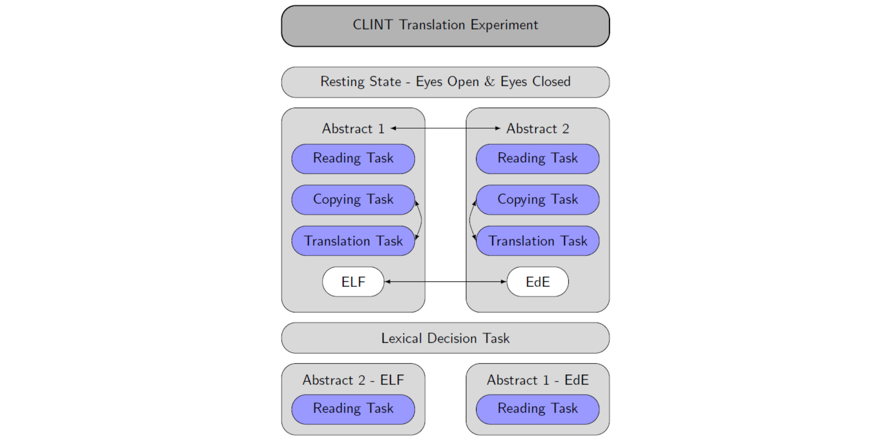Accordingly, experiments focusing on language and cognitive processing during written tasks were designed for the project (Figure 1). It consists of three main tasks: an input control task (reading), an output control task (copying) as well as an interlingual task (translating). Two different texts are used, one of which is presented in the ELF and the other in the EdE version (abstract 1 & 2 for the written-language experiment). The assignment of texts, conditions, and order of texts are randomized as indicated by the arrows in Figure 1.

These experimental procedures rely on within-group comparisons to assess cognitive load induced by ELF and language tasks of various levels of complexity. Translators and MA and BA students specializing in translating participate in the experiment whereas multilingual controls with similar levels of language exposure underwent the same experimental procedure.

In the reading task, participants have to read an ELF or EdE abstract and respond to questions to assess reading comprehension. To simulate a natural reading condition, participants can control the reading speed by pressing a response button to see the next sentence. Afterwards, participants copy type or translate as much source text as possible within a fixed time window of five minutes. The presentation of the stimuli in the translating and copying tasks is sentence-by-sentence, an adaptation of the work environment in CAT tools, which can be assumed to be familiar to translation professionals and students. The copying task serves as a control condition to assess brain activity related to motor preparation and output. In the translating task, the process of L2 to L1 translation is added to the participants’ cognitive workload. After a lexical decision task (i.e., word vs. pseudoword) which was unrelated to the main project and targeted at evaluating intra- and interlingual language processing as a function of language expertise, the same abstracts are presented again but in the other version (EdE or ELF). This procedure captures reading- related indices of cognitive load using the same text material. During all tasks in the written-language experiment, eye-tracking measurements have been taken to assess differences in pupil dilation, fixation duration, number of fixations, and regressions related to processing ELF and EdE.

Figure 1. Experimental procedure of the written-language experiment of the CLINT project.

**Details of the Eyetracker** (copied from Hollenstein et al., 2018, we use the same Eyetracker and same lab setup)

The EyeLink 1000 tracker processes eye-position data, identifying saccades, fixations, and blinks. Saccades are detected by the velocity and acceleration of the eye movements. Here, SR-research default system parameters have been used to define saccades: an acceleration threshold of 8000° per sec2, a velocity threshold of 30° per sec, and a deflection threshold of 0.1°. Fixations were defined as time periods without saccades. The dataset therefore consists of (x,y) gaze location entries for individual fixations. Coordinates were given in pixels with respect to the monitor coordinates (the upper left corner of the screen was (0,0) and down/right was positive). We also provide raw sample data that can be used to validate fixation detection settings. Further, a blink can be regarded as a special case of a fixation, where the pupil diameter is either zero or outside a dynamically computed valid pupil, or the horizontal and vertical gaze positions are zero.

**What we did so far**

We wrote a MATLAB script (added in the folder) for the reading task that extracts the fixations measured by the eye tracker during each sentence. Then we compare the x- and y-coordinates of the fixations with the word boundaries assessed by the Psychtoolbox. For both x- and y-axis we implemented a parameter that defines how much deviation is allowed from the word boundaries to still stand for this word. Those parameters can be set along with the path settings in the beginning of the script.

We created a results table that has following variables:

* id: ID of subject
* group: group of subjects
* text: which of the two abstracts was read
* condition: if the abstract was in ELF or EdE
* time: if the text was the first in the experiment or the second
* sentence: in which sentence the fixation was
* type: fixation on “word” or “unknown”, “regression” for words that already had a fixation before
* word: which word it was
* duration: duration of the fixation
* avgPS: average pupil size
* wordNumber: number of word in the sentence

For text, condition, and time we used the information in the variable event from the file *\*_ET.mat* that refers to:

* 101 = text 1, condition = EdE, time = first
* 102 = text 1, condition = ELF, time = first
* 103 = text 2, condition = EdE, time = first
* 104 = text 2, condition = ELF, time = first
* 105 = text 1, condition = EdE, time = second
* 106 = text 1, condition = ELF, time = second
* 107 = text 2, condition = EdE, time = second
* 108 = text 2, condition = ELF, time = second

For the variable sentence we used the trigger 21 – 24 (text 1 in EdE to text 2 in ELD) in the variable «event» as start of a new sentence. The latencies of the word start trigger were used to compare those of the eye tracking fixations to assure to be within the same limits. The latencies of the fixations can be found in the variable eyeevent.fixatons.data in which the first column refers to the start latency and the second column to the end latency.

For type and word, we compared the fixation within each sentence to the word boundaries found in “wordbounds_reading”. If it was within a word, we extracted the specific word from the variable “sentences_ue”.

Duration of the fixation is just the difference of the first and second column in eyeevent.fixation.data and avg.PS the sixth column.

**What is next**

Based on those variables we created a results table (readingFixations.csv) that could be further processed in R to evaluate the sum of all fixation duration in all sentences of a text, total number of fixations, and regressions. Those measures are expected to somewhat be influenced by different levels of cognitive demands (ELF vs. EdE) and language / reading expertise (translators vs. bilinguals).

But I just saw this summary in Hollenstein et al. (2018): “Based on a previous eye-tracking corpus we have extracted the following eye-tracking features in MATLAB (code available in the data repository (Data Citation 1)): (I) gaze duration (GD), the sum of all fixations on the current word in the first-pass reading before the eye moves out of the word; (II) total reading time (TRT), the sum of all fixation durations on the current word, including regressions; (III) first fixation duration (FFD), the duration of the first fixation on the prevailing word; (IV) single fixation duration (SFD), the duration of the first and only fixation on the current word; and (V) go-past time (GPT), the sum of all fixations prior to progressing to the right of the current word, including regressions to previous words that originated from the current word. For each of these eye-tracking features we have additionally computed the pupil size. Furthermore, we have extracted the number of fixations and mean pupil size for each word and sentence. Fixations that were shorter than 100 ms were excluded from the analyses, because these are unlikely to reflect fixations relevant for reading, however, the raw eye-tracking data are available to assess further potential eye-tracking features.” So I will for sure have a look at those MATLAB scripts that Hollenstein et al. (2018) mention.

Literature:

Albl-Mikasa, M., Ehrensberger-Dow, M., Hunziker Heeb, A., Lehr, C., Boos, M., Kobi, M., Elmer, S. (2020). Cognitive load in relation to non-standard language input. *Translation, Cognition & BehaviorTranslation, Cognition and Behavior*, *3*(2). <https://doi.org/10.1075/tcb.00044.alb>

Hollenstein, N., Rotsztejn, J., Troendle, M., Pedroni, A., Zhang, C., & Langer, N. (2018). Data descriptor: ZuCo, a simultaneous EEG and eye-tracking resource for natural sentence reading. *Scientific Data*, *5*, 1–13. https://doi.org/10.1038/sdata.2018.291