Notes on NMR spectroscopy:

speaq2.0 has a nice pipeline:
https://journals.plos.org/ploscompbiol/article?id=10.1371/journal.pcbi.1006018

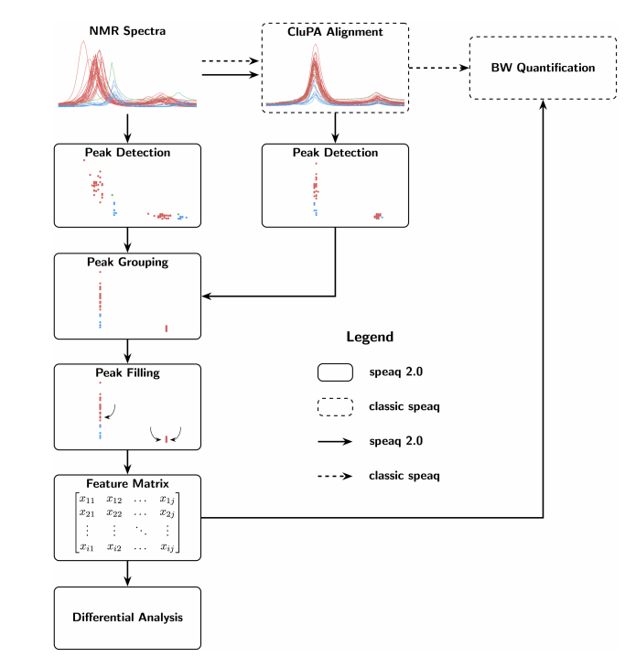
- Also mentions http://www.hmdb.ca/downloads as a source for downloading source metabolite data. Must notify authors if data is used for commercial purposes though.
- Comparison is done with MetaboAnalyte for peak grouping.

