Setting Up JBookTrader in Eclipse

These instructions refer to setting up JBookTrader in Eclipse version 3.3.0 under Windows.

Created by: Eugene Kononov
Last updated: Feb 21, 2008

1. Download the latest version of JBookTrader from http://code.google.com/p/JBookTrader/downloads/list and unzip the contents of the downloaded archive to any destination directory, such as C:\

2. In Eclipse, click File | New | Java Project, specify Project name and the Contents options as shown, and click Next:

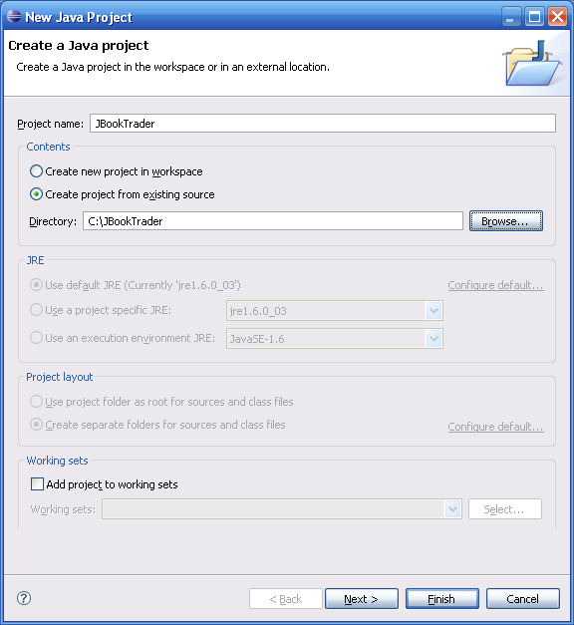

3. The New Java Project dialog will appear. Change Default output folder to JBookTrader/classes, and click the Libraries tab.

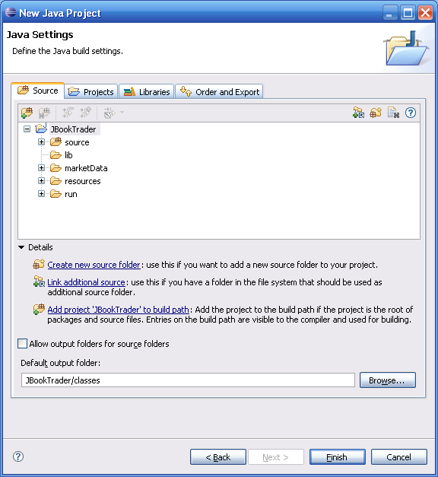

- On the Libraries page, make sure that all JAR files are listed as follows, and click Finish

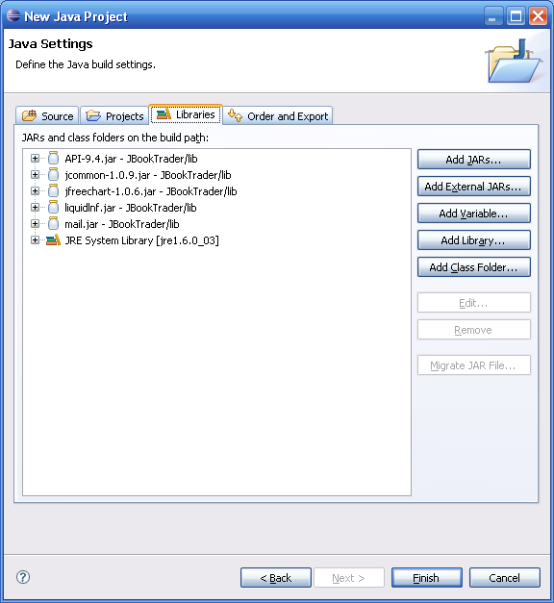

- Click Window | Preferences from the main menu. The Preferences dialog will appear. On the left navigation pane, select Java | Compiler | Errors/Warnings. On the right navigation pane, select Potential Programming Problems | Serializable class without serialVersionUID, set the selection in the corresponding combo box to Ignore as shown, and click OK:

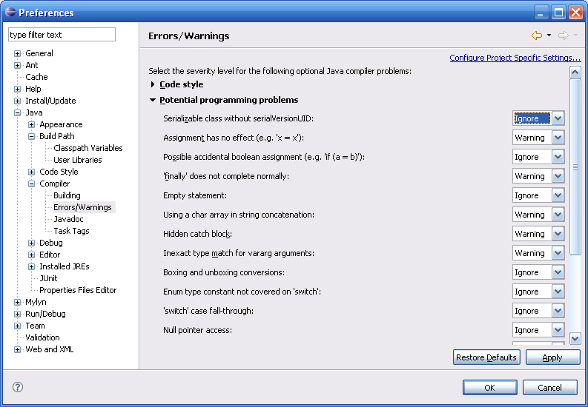

- When the Error/Warning Settings Changed dialog appears, click Yes

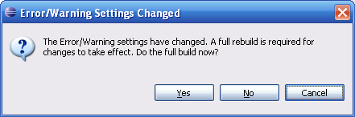

- Eclipse will build the project and report 0 errors, 0 warnings, 0 infos

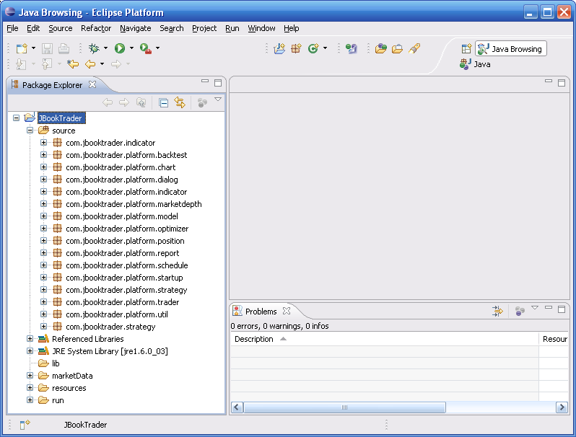

- Click Run | Open Run Dialog from the main menu. The Run dialog will appear. On the left navigation pane, select Java Application and click the New launch configuration button (the top leftmost button on the left navigation pane). Specify the Name, Project, and Main class as shown:

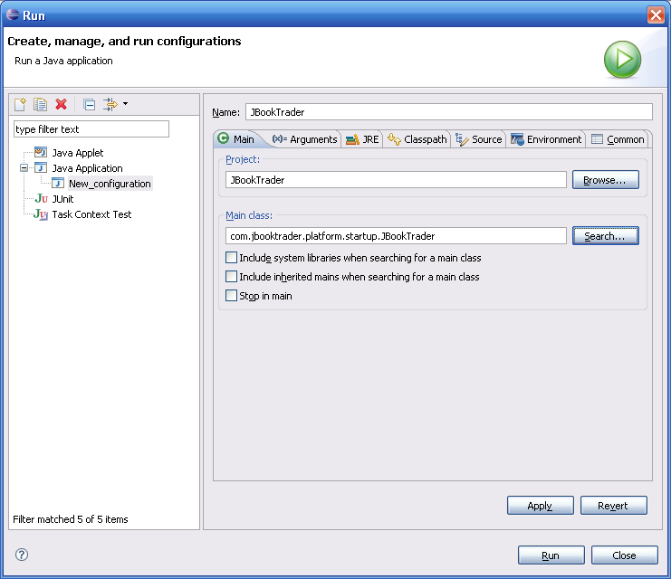

- Click the Arguments tab. In the Program arguments edit box, specify the directory where JBookTrader archive was unzipped. In the VM arguments edit box, specify the maximum Java heap (70% of the total physical memory is recommended)

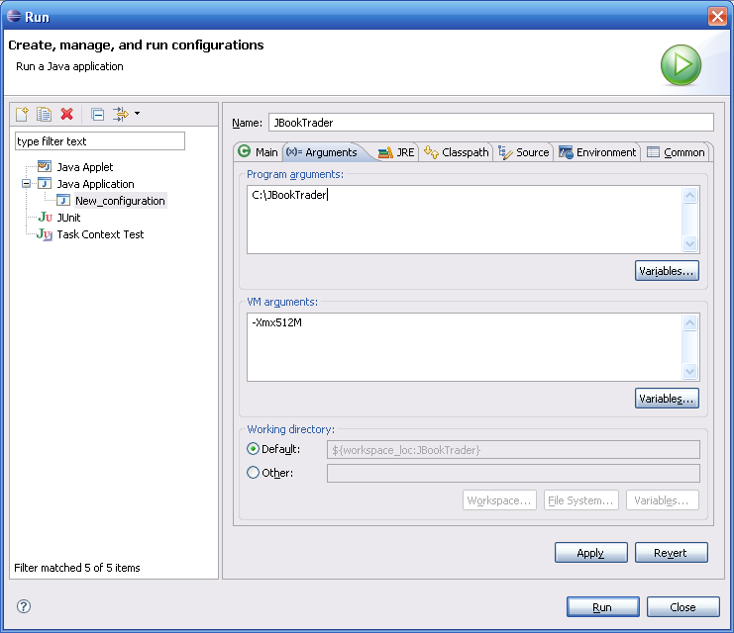

- Click the Classpath tab, select User Entries, and click Advanced button

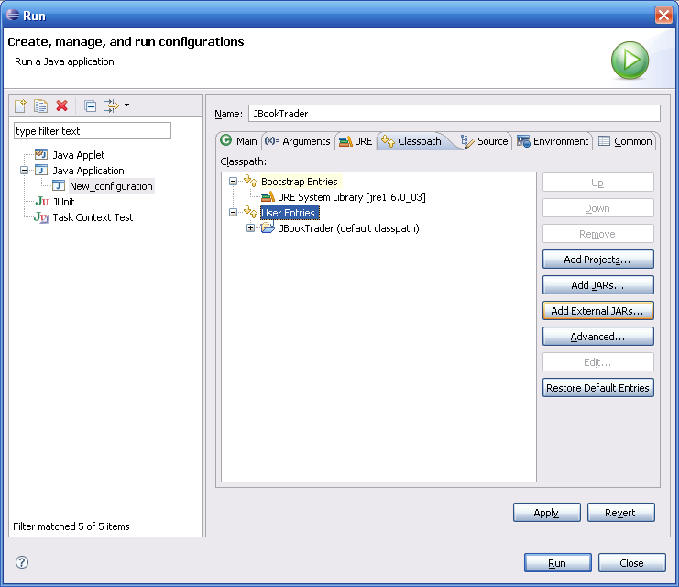

- Advanced Options dialog will appear. Select Add Folders and click OK

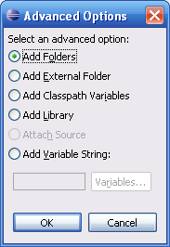

- Folder Selection dialog will appear. Select resources folder and click OK

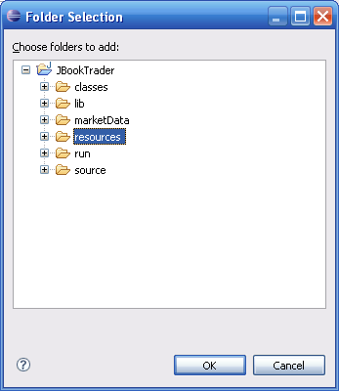

- The Run dialog will list User Entries as shown. Select Apply and Run.

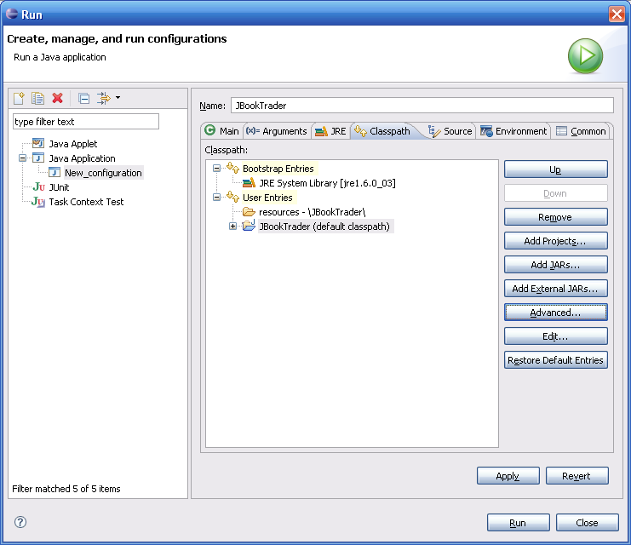

- Eclipse will start JBookTrader:

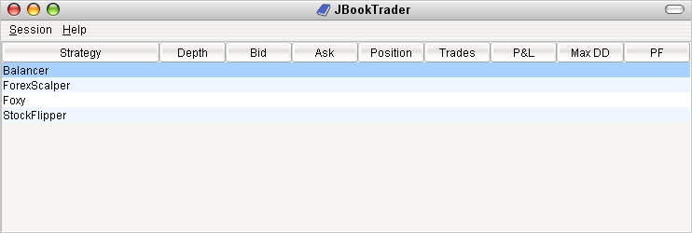

This completes the setup.

