JBookTrader

User Guide

Last Updated: Saturday, November 07, 2026 by Eugene Kononov

1. Summary

JBookTrader is a fully automated trading system (ATS) that can trade various types of market securities during the trading day without user monitoring. All aspects of trading, such as obtaining prices, analyzing price patterns, making trading decisions, placing orders, monitoring order executions, and controlling the risk are automated according to the user preferences. The central idea behind JBookTrader is to completely remove the emotions from trading, so that the trading system can systematically and consistently follow a predefined set of rules.

The features include strategy back testing, strategy optimization, intraday data retrieval, and real time trading via the Interactive Brokers API.

JBookTrader is intended for software developers. It is not an "off-the-shelf" product that can be installed and run. Instead, JBookTrader provides a framework for developing automated trading systems and requires a certain amount of programming knowledge and experience. The users can modify any part of the source code, implement their own trading strategies, and customize the system in any way. If you are not a software developer or if you don't have much experience programming in Java, JBookTrader is probably not for you.

2. System Requirements

To use JBookTrader, you need the following:

- A universal brokerage account with Interactive Brokers
- An Interactive Brokers market data subscription to the securities of interest (such as stock or futures)
- Virtually any operating system (such as Windows, Mac OS, or Linux)
- Java runtime environment, version 1.5 or higher

3. Installation

JBookTrader is distributed in a singe archive file (JBookTrader.zip). The latest version is available at http://code.google.com/p/jbooktrader/downloads/list. To install JBookTrader on your machine, simply unzip the contents of the JBookTrader.zip file to any destination directory on you machine, such as C:\JBookTrader. To setup JBookTrader in a Java IDE (such as Eclipse), follow the steps in the document JBookTrader.Eclipse.doc located in the /docs directory of the distribution.

4. Running JBookTrader

To run JBookTrader:

- Start TWS normally and log in to your account (use simulated account until you get comfortable with JBookTrader)
- Make sure that the “Enable ActiveX and Socket Clients” option is checked:

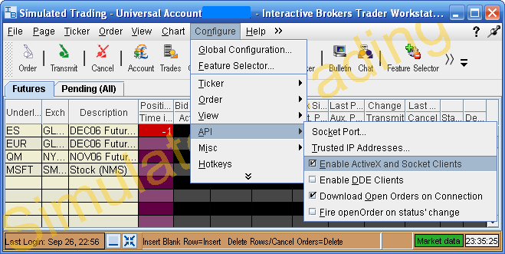

- Start JBookTrader

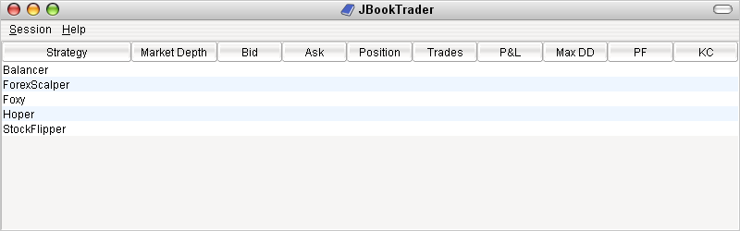

- Verify that JBookTrader can connect to TWS
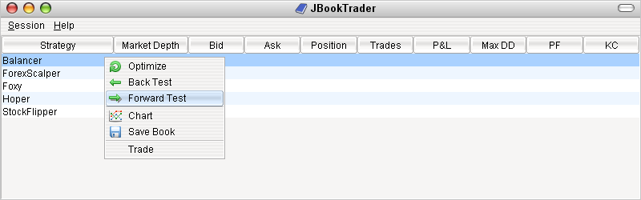

5. JBookTrader Operations

Once started with the trading strategies specified, JBookTrader does not require user monitoring or even user presence. During the trading day, JBookTrader will continuously monitor the price action for the specified securities, determine if the predefined trade entry/exit conditions have been met, place the trades, monitor their execution status, and record all events in a report file.

6. Back Testing

Back testing is evaluating your trading strategy performance using historical market data. JBookTrader distribution comes with a sample historical data set.

To run a back test, right click on the strategy and select Back Test:
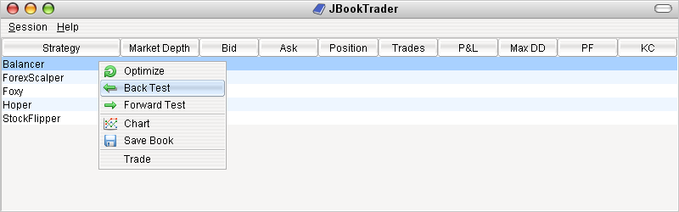

JBookTrader will pop up a file dialog. Select a historical data file:
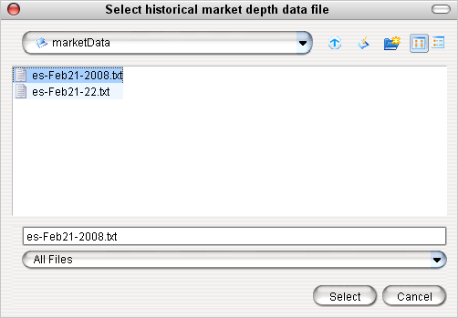

After the historical data file is loaded, JBooktrader will run the test and display the results:
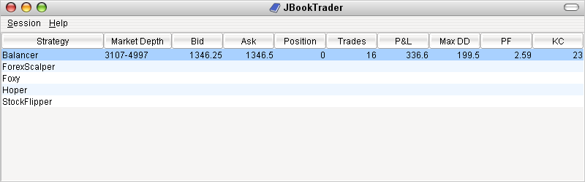

7. Forward Testing
Forward testing is evaluating your trading strategy performance using live market data. In the forward testing mode, JBookTrader will connect to TWS and run the strategy, but no actual trade orders will be submitted. This makes it possible to run JBookTrader against real TWS account without making any trades. Although a paper trading account can also be used, the data feed from that type of account is unreliable.

To start a forward test, right click on the strategy and select Forward Test:
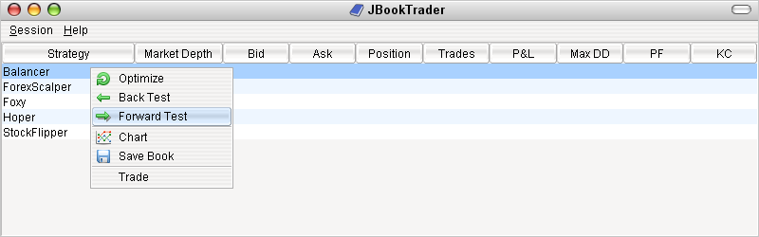

8. Strategy Optimization
Strategy optimization is a search for a set of strategy parameters that results in the best strategy performance. JBookTrader uses multiple measures of performance. You can select a particular measure to be used in the search.

To start a strategy optimization, right click on the strategy and select Optimize:
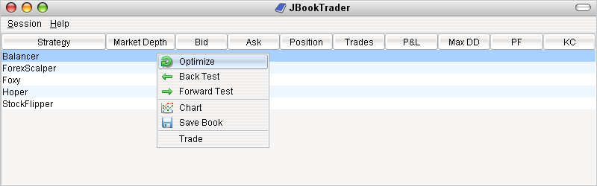

In the strategy optimizer dialog, select optimization options and click Optimize button:
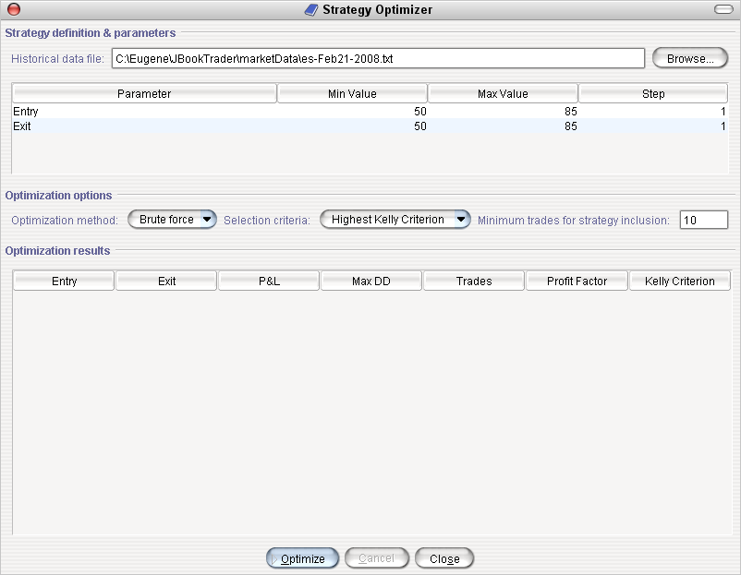

After completion, results will be shown:
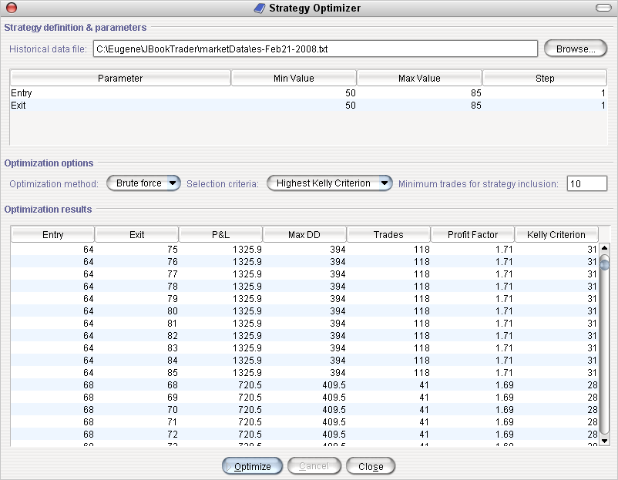

9. Strategy Performance Chart

In discretional (manual) trading, charts are used to before a trading decision is made. Since JBookTrader is a fully automated trading system, there is no one to actually look at the chart. The system makes all decisions. However, the charts are still very useful for strategy evaluation after the period of trading.

To display a strategy performance chart, first run a strategy in one of the three modes: Back Test, Forward Test, or Trade. Next, right click on the strategy and select Chart:

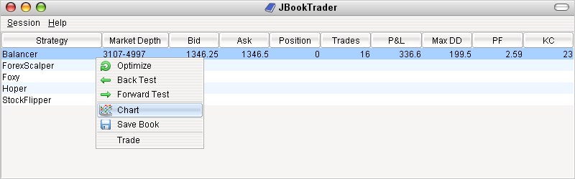

The strategy performance chart will be displayed:

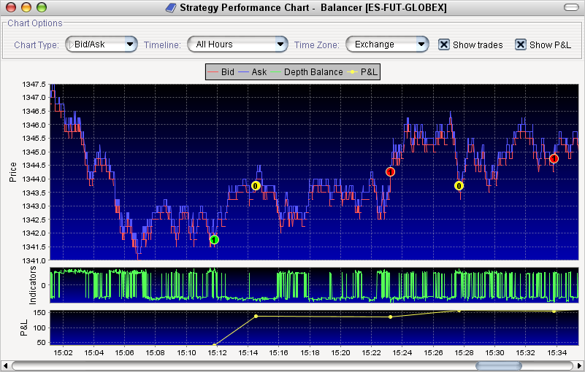

The chart

10. Recording Market Data

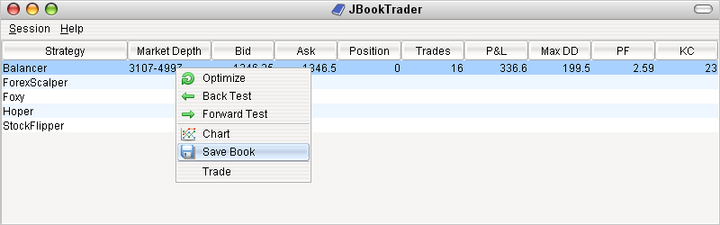

11. Trading
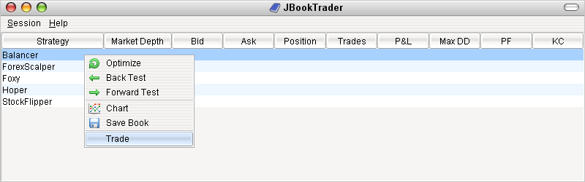

12. Reporting

All major activities that JBookTrader performs during the trading day are logged into a dedicated log file in HTML format (EventLog.htm). Additionally, every strategy creates its own log file, which is named after the class where this strategy is implemented. For example, if the strategy is defined in a class MyStrategy.java, the corresponding strategy report will be named MyStrategy.htm.

The event report can be used at the end of the trading day to diagnose and debug any potential problems that occurred during the day. The event log typically looks like this:

????

The strategy log can be used to evaluate the strategy performance. Although the log is in HTML format for easy viewing, it is formatted in a way to easily import it into a spreadsheet (such as MS Excel) to analyze the strategy performance during the day and to construct the charts, if needed. A typical example of a strategy log:

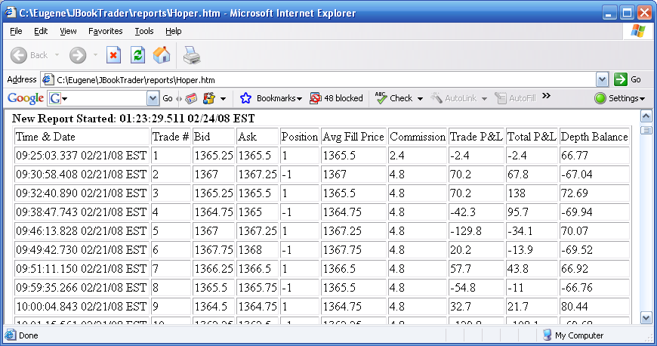

The type of information logged in either event report and the strategy report can be customized by the user.

13. Technical Support

JBookTrader technical support is provided by the author and the users of this software in the JBookTrader Discussion Group

