**Breath Alcohol Indicator User Manual**

1. Indicator should be powered by a 7 Volt – 9 Volt voltage source with the positive terminal connected to the red flying lead and the negative terminal connected to the black flying lead.
2. Upon powering up the red LED should come on to indicate that the sensor is heating up.
3. The user must then wait the pre allocated amount of time (approximately 3 minutes) until the sensor has reached the appropriate operation temperature. This will occur when the green LED turns on.
4. Once the sensor is ready the user should blow directly onto on the sensor for a period of time around 5 seconds. As result the corresponding LEDS will light up;

Green – Low breath alcohol reading.

Yellow – Medium breath alcohol reading.

Red – High and potentially dangerous breath alcohol reading

Take the highest lit value of the three as your breath alcohol reading.

1. The user should wait approximately 10 seconds after all of the alcohol LEDs have gone off before blowing on the sensor again to ensure accuracy.

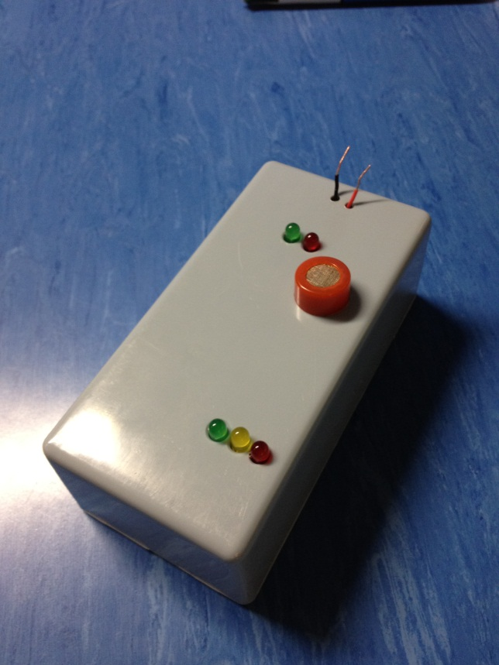

Alcohol Concentration Indicators

Alcohol Sensor

Power On/Heating LED

Ready LED

Positive Terminal

Negative Terminal