**University of Canterbury**

12

**Velocity Determination of Rifle and Pistol Ammunition**

**Chronograph**

**Matt Kokshoorn Project Supervisor: Stewart Hardie**

***Executive Summary***

This report details…

Table of Contents

1. Introduction 4

2. Design Process 5

3. Problem Identification 6

4. Research 7

4.1. Ammunition Behaviour and Properties 7

4.2. Firearm Layout and Dimensions 8

4.3. Existing Methods of Velocity Determination 9

4.4. Required Data and User Interface 10

4.5. Existing Market 11

5. Requirements Specification 14

6. Concept Generation 16

6.1. Method of Velocity Determination 16

6.2. Electrical 17

6.3. Mechanical 17

6.4. Microcontroller 18

6.5. Software 18

7. Design 20

7.1. Electrical 20

7.2. Mechanical 20

7.3. Microcontroller Specifications 20

7.4. Microcontroller Software 20

7.5. App Software 20

8. Discussion 21

9. Conclusion 22

10. References 23

11. Appendix 25

# Introduction

Talk about goal to design a chronograph.

# Design Process

(Introduce Topic)  
Engineering Design…  
  
(Talk about situation needed for)  
  
(Discus Design Method to take i.e. Waterfall)  
The design procedure for this project can be seen below in Figure 1. This process is generally used for engineering product designs much like this one. Due to the nature of this assignment the core steps will involve; problem identification, research, requirements specification, concept generation and design. This will allow the

(Discuss Benefits of such a process)

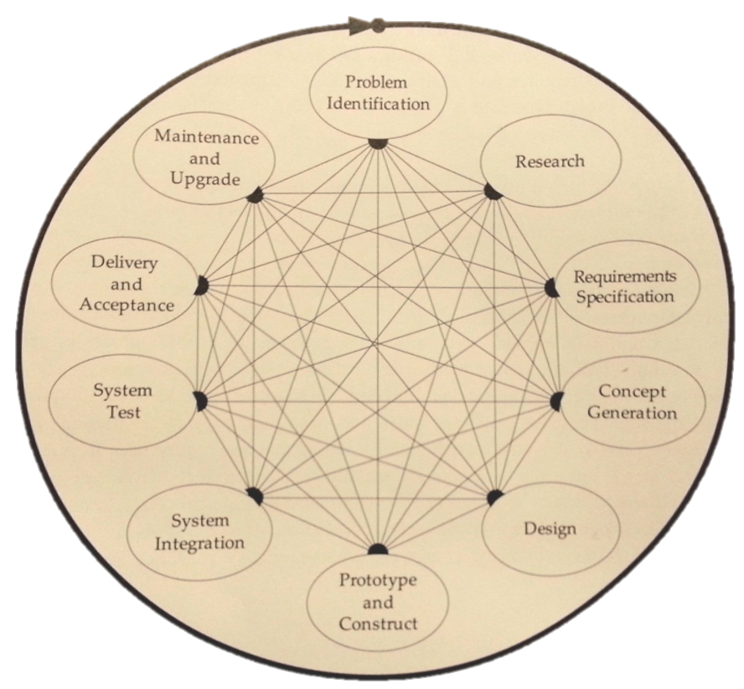

Figure 1 - The Engineering Design Process [1]

# Problem Identification

In the field and at shooting ranges it is important for firearm owners to know the velocities of the ammunition they are firing. Knowing such data is beneficial to the owner for a number of reasons. It can lead to the early indications of a fault within the firearm or ammunition. Detecting a serious issue early can prevent further damage to the firearm and can save the owner a significant amount of cost. This can also prevent serious safety hazards to the user. Should a malfunction occur within a firearm and not be detected, repeated use could lead to fatal repercussions.

Airgun owners also pay attention to velocity data as it can lead to performance optimisation. Many CO2 and Gas operated firearms produce peak velocities at particular pressures. Likewise Firearm owners that reload their own ammunition find velocity data of particular interest. Statistics of velocities can lead to indications towards greater quality ammunition refills.

There are also legal obligations in some areas regarding ammunition velocities and hunting. Similarly some airgun competitions require firearm velocities to be limited due to safety concerns [2].

(Current Chronographs…)

In summary there exists a need for firearm owners to record and observe ammunition velocity data while in the field. This need can be identified for hunters, competitors and hobbyists for a range of firearms including airguns, rifles, and pistols carrying a variety of loads.

# Research

In order to successfully conceive a solution to the problems previously discussed research must be undertaken into the concepts surrounding existing chronographs. This research should provide adequate material to generate an appropriate set of requirement specifications and make informed conceptualisations.

## Ammunition Behaviour and Properties

**Velocity**The velocity of ammunition as it leaves the barrel of a firearm is known as the muzzle velocity. From this point onwards the velocity of the projectile will quickly diminish due to the drag of air. The muzzle velocity can be measured in a number of ways but should be done so as close to the muzzle as possible as to obtain a reliable results. Typical ranges of velocities that can be expected of three different forms of firearms can be seen be seen below in Table 1.

Table 1 - Typical Ammunition Velocities for a Range of Firearms [3]

|  |  |  |
| --- | --- | --- |
| Firearm Type: | Typical Muzzle Velocities (FPS) | Typical Muzzle Velocities (m/s) |
| Paintballs | 200-300 | 50-91 |
| Pistols | 750 - 1300 | 228 -396 |
| Rifle | 1900 - 4000 | 580-1200 |

**Dimensions and Materials**The maximum diameter of the ammunition being fired can be determined form the calibers of the firearm. The caliber of a gun refers to the inside diameter of the barrel. Both rifle and pistol ammunition is typically metallic whereas paintball usually comprise of a dye filled gelatin. A list of caliber ranges can be seen below in Table 2.

Table 2 - Typical Calibres for a Range of Firearms [3]

|  |  |  |
| --- | --- | --- |
| Firearm Type: | Typical Caliber (Inches) | Typical Caliber (mm) |
| Paintballs | 0.68 in | 17.3 mm |
| Pistols | 0.22 in - 0.45 in | 5.6 mm - 11.4 mm |
| Rifle | 0.17 in - 0.45 in | 4.3 mm – 11.4 mm |

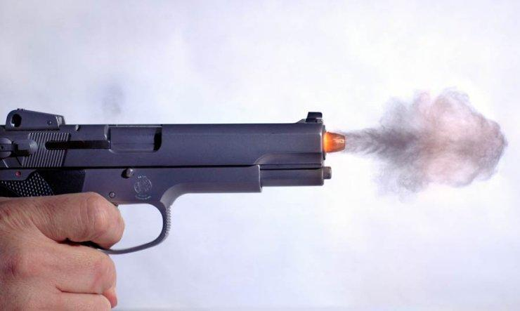

Figure 2 – Frame of Projectile Leaving Pistol Barrel Shot with a High Speed Camera [4]

**Potential Interference**As can be seen above in Figure 2, ammunition can often fire out some residual gunpowder. This should be an important consideration for the development of a chronograph as it, depending on the method of measurement, could negatively affect sensor equipment.

## Firearm Layout and Dimensions

The firearm layout is an important consideration for designing a general use chronograph. Of particular interest is the placement of scopes and moving components. If a chronograph were to be mounted on the end of such a fire arm it is important both for safety and practical reasons to investigate the various designs it could be mounted to.

**Scope/Sight Positioning**Rifles, pistols and paintball guns share the common sighting method of lining up two points running along the upper portion of the barrel as can be seen in Appendix 1, Appendix 2 and Appendix 3. A mounted chronograph should take to avoid interfering with the sightings. Additionally riffles often feature an attachable scope above the trigger portion of the barrel Appendix 2.This is a larger piece of equipment and lies above the default sighting system of the rifle. By avoiding interference with the sights will also ensure there is no interference with the scope.

**Barrel Clearances**The mounting of a chronograph would require a safe and firm point of contact to the firearm. Both rifles and paintball guns maintain a circular barrel at the bullet exit point with no moving components as can be seen in Appendix 2 and Appendix 3. Issues could potentially arise from the reloading mechanism and shape of many pistols due to the rectangular shape and moving parts (see Appendix 1).

## Existing Methods of Velocity Determination

There are many methods of

**Ballistic Pendulum**

The Ballistic pendulum is an oldest method of velocity determination. It involves a projectile being shot into a mass at the bottom of a pendulum. From the displacement of the pendulum from equilibrium, the momentum and therefore the velocity of the bullet can be determined. This method has been outdated by more modern chronographs and any attempt to modernise still requires knowledge of the projectiles mass. Additionally there are clear safety concerns surrounding such a chronograph.

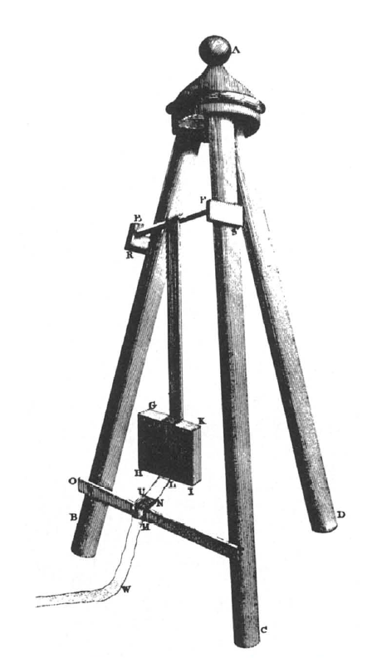

Figure 3- Basic Ballistic Pendulum Design [5]

**Optical Detection**Optical detection of projectiles is a relatively simple concept. They consist of a series of light emitting source each being directed towards a photosensitive device such a photo transistor. [6] When a moving mass passes between source and the sensor the state of the photosensitive device will change. By using two or more of these in in succession the time delay between each state change can be recorded by using a microcontroller. From here the velocity of the projectile can be determine by knowing the distance between the two sensors. This method could easily be applied to a barrel mounted chronograph at little expense and complexity. Optical methods do however have the drawback of not reliably operating in all lighting conditions.

**Electromagnetic (Induction)**This method of velocity determination uses electromagnetic sensors to detect a passing mass leaving the muzzle of a firearm. Since sensors utilise the effects of a mass disrupting a magnetic field the ammunition is not required to be metallic. Electromagnetic chronographs have been found to be not as accurate as optical sensors but are typically still within 1% accuracy [7].

**Acoustic**Acoustic methods of velocity determination involve measuring the difference in time between the sounds of the bullet leaving the barrel and hitting a set target at a known distance [8]. The velocity of the projectile can then be calculated by,

**(Equation 1)**

where d is the distance from end of the barrel to target, is the time the projectile hits the target and is the time the projectile leaves the barrel. This method has the advantage that it could be used for both metallic and non-metallic ammunition and it could easily be integrated into a mountable device using microphones. The clear drawback of this method is that it requires knowledge of target distance and also determines the average velocity of the projectile as opposed to the desired muzzle velocity.

**Doppler Detection**This method of velocity determination is most different from those previously discussed that rely on distance over time or momentum calculations. Instead this uses a Doppler radar placed in near proximity to the firearm. This is typically done by beaming a microwave signal towards a moving object and then analyzing the frequency shift of the reflecting signal. While this method can be extremely accurate it also involves high precision equipment that can be quite costly. [9]

## Required Data and User Interface

The velocities obtained from the chronograph need to be processed and displayed to the user. Many firearm owners not only require a data log of velocities but also an assortment of statistical measurements such as; high/low velocities, extreme spread average velocity and standard deviation [10].

(Interface Requirements) (Need for PDA Upload) (Smartphone Stats)

## Existing Market

There are currently a range of chronographs available for purchase. The most commonly used methods of velocity determination are optical, electromagnetic and Doppler however many of these products are limited to non-barrel mounted designs. To effectively develop a competitive product the retail prices and designs of some of the current leading products must be researched.

**The MagnetoSpeed V1 Ballistic Chronograph**The MagnetoSpeed chronograph is the leading product for electromagnetic based sensors. It retails at $250US ($308.26NZ as of 27/8/2012) and claims to be within 1% accuracy. It is able to be mounted to both pistols and rifles and offers a backlit LCD display connected to sensor via a 3.5mm data and micro SD card uploading. It is stated to work with barrels up to 1 inch (25.4mm) in diameter [11]. The LCD display shows statistical measurements of Maximum, minimum average and standard deviation. It also allows bad shots to be deleted and bullet types to be changed. The only apparent drawback of the MagnetoSpeed is the trend increasing error with decreasing ammunition velocity. This means that although the electromagnetic sensor is able to detect velocities of non-metallic projectiles such as paintballs the margin of error could be significant. The MagnetoSpeed chronograph is relatively new product and has been receiving a number of good reviews.

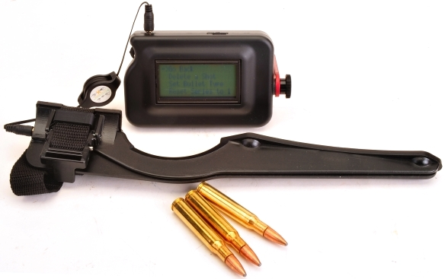

Figure 5 - Product Photo of the MagnetoSpeed V1 Ballistic Chronograph

**The ProChrono Pal Chronograph**The ProChrono Pal Chronograph is a popular product among New Zealand fire arms store such as Gun City and NZ Hunter. The ProChrono Pal Chronograph (shown in Figure 4) uses optical velocity determination techniques and has an operational velocity range form 21- 7,000 fps (6.4 ms-1 – 2133ms-1). It retails at $299 NZ and run off a single 9V alkaline battery using approximately 15mA. Its display simply shows a single velocity with no statistical information.

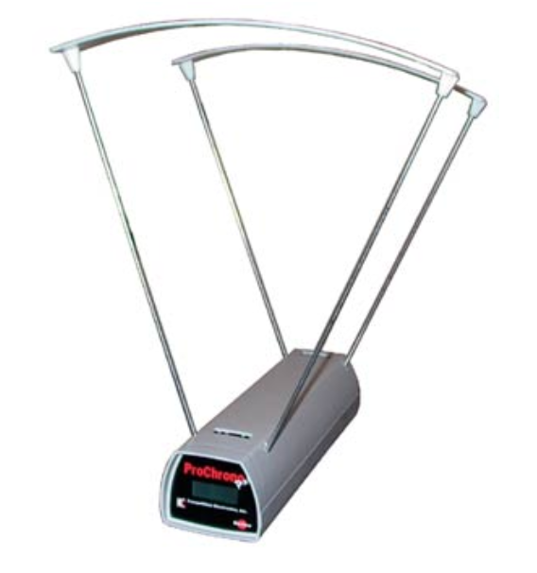

Figure 4 - Product Shot of the ProChrono Pal Chronograph [12]

Despite the clear disadvantage of not being able to be mounted to a barrel and taken into the field, its memory capacity is limited to 99 shots and has clear limitations regarding user interfacing. Interestingly enough the ProChrono series and similar non mountable products seem to be the only Chronograph being sold in majority of New Zealand’s firearm stores.

**X Cortech X3200 Shooting Chronograph**The X Crtech X3200 Shooting chronograph is designed for smaller ammunitions (__~__) however uses techniques that could be applied to…

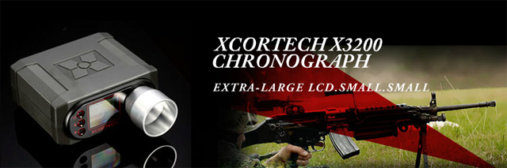

[**http://www.evike.com/product_info.php?products_id=30446**](http://www.evike.com/product_info.php?products_id=30446)

<http://www.shootingchrony.com/>

(Find one More Product)

# Requirements Specification

The requirements specifications should contain the full set of criteria that will ideally be satisfied by a successful final design. To develop a successful ammunition chronograph there is a clear set of features and requirements that will be needed to compete with existing products. These can be split into both specifications of the chronograph and considerations that should be taken into account.

**Functionality**

* The chronograph must be able to determine the velocity of the ammunition to an equal or higher precision to that of other chronograph products.
* The chronograph must be able to be accurately used for a range of ammunitions being fire from paintball guns, pistols and rifles.
* **Not have external light effect it.**

**LOW LIGHT ENVIROMENTS**

**Interface**

* The chronograph must have display for data to be shown. This data should include a range of statistical information processed from the velocities.
* The data from the chronograph must also be able to be relayed to a PDA/Smartphone and resultantly allow graphing of the data. **REALTIME**
* The user interface should be easy to operate and allow for deletion of ‘bad shots’ and the changing of ammunition types so that statistical accuracy can be preserved.

**Electrical**

* The chronograph must be able to be supplied by a light portable power source capable of supplying the chronograph for at least one day in the field without requiring recharging.
* The Chronograph should incorporate a light source so that the screen can be seen.

**Mechanical Specifications**

* The chronograph must be light and portable and easily mountable onto the barrels of pistols rifles.
* It must be able to be used for a range of ammunition dimensions from paintballs rifles rounds and pistol rounds.
* The mounted component of the chronograph safely secured to the barrel so as to not interfere with shots and sightings/scopes.
* The mounted component must also be designed in such a way as to minimise the effects of any disturbances from environmental conditions and residual gunpowder/dust leaving the barrel prior to the ammunition.
* All componentry of the chronograph that does not require user operation must be encased so that the final design of the controller is robust and visually appealing.

**Economic**

* The cost of the chronograph should be minimised so that the product can be sold at a competitive price.
* The chronograph should appeal to the market and stand out as an attractive product.

**Sustainability**

* The chronograph should compromise of materials that are not damaging to the environment and are able to be recycled at the end of the products life.
* The production of the chronograph should be done in a way that it supports adequate working conditions for employees.
* The product should be designed to maximise product lifetime.

The electrical comments should be designed to ensure electrical power efficiency. It should incorporate the use of rechargeable sources of power.

# Concept Generation

By evaluating the range of different options available with respect to the requirements specifications a clearer picture of a product design can be established. The key design options relate to the; method of velocity determination, microcontroller design, mechanical design, user interface and power supply. For each component of the chronograph design concepts should generated and evaluated against the requirements specifications.

## Method of Velocity Determination

Methods of velocity determination as indicated by section 4.1.3 include; ballistic pendulum, optical detection, electromagnetic, acoustic and Doppler radar detection. The ballistic pendulum and acoustic detection methods are not practical due to their mechanical nature and required knowledge distance to target respectively.

As a result, there remain three feasible sensor methods that could be used; electromagnetic, optical and Doppler radar. Each method has its own advantages and disadvantages that should be compared to the requirement specifications. Each method is vastly different and extends beyond the requirement specifications. As result the concepts can be evaluated by use of an analytical hierarchal process incorporating a decision matrix as outlined by “Design for Electrical and Computer Engineers” [1]. The selected design criteria reflect both the requirement specifications and additional elements that will lead to a successful product. The pairwise comparison matrix to determine the weighting can be seen in Appendix 4. The resulting evaluation matrix can be seen below in Table 3.

Table 3 - Decision Evaluation Matrix for Method of Velocity Determination.

|  |  |  |  |  |
| --- | --- | --- | --- | --- |
| Criteria | Weighting | Electromagnetic | Optical Detection | Doppler Radar |
| Accuracy | 0.13 | 4 | 7 | 9 |
| Uniqueness | 0.06 | 5 | 8 | 8 |
| Mount ability | 0.28 | 6 | 4 | 4 |
| Simplicity | 0.19 | 3 | 8 | 1 |
| Cost Effectiveness | 0.10 | 4 | 7 | 2 |
| Safety | 0.24 | 5 | 4 | 7 |
| Score |  | 4.66 | 5.69 | 4.83 |
| Normalised Score |  | 0.45 | 0.55 | 0.47 |

Due to the feasible design, low cost and uniqueness of a mounted product version, optical detection has been decided to be the optimal method of velocity determination.

## Electrical

**Sensors**  
Optical velocity determination will require two or more photo coupled devices in succession located at the end of the firearm muzzle. The photo electric devices must be capable of quickly reacting to the break in coupling. For this reason photodiodes should be used over photoconductive devices as they can react within a few nanoseconds versus the photoconductor response time of around 50ms (**Reference Paul Gaynor’s notes**). Given the response time of the photo sensitive device the minimum ammunition length that can be detected can be calculated by Equation 2.

(Equation 2)

The sensor also requires a light emitting device that corresponds to the required wavelength and frequency of the photodiodes. The source should also be selected to minimise power consumption so to keep the chronograph to high level of sustainability and maximise life as per the requirement specifications. This could be done either using a directional LED or a laser diode. Both the sensor and the light source should be designed to minimise the interference of external natural light.

The photosensitive devices should then be wired as a voltage divider network and be fed into the logical inputs of the microcontroller.

**User Interface**A display should be chosen to minimise power consumption. This can be done using an organic light emitting diode (OLED) display. An OLED display also generates its own light so will require no additional backlight to be seeing the display in low light environments. The biodegradable nature of the display will also reduce environmental impact at the end of the chronographs lifetime.

In order for the user to interact with the chronograph a number of buttons will need to be used. The number of buttons will depend on the complexity of the software. Electrically the buttons will need to be configured in voltage divider network and fed into a logical input of the microcontroller. Buttons will be required both for navigation on the display, to turn the chronograph/display off and put it into standby mode.

**Power Supply**In order increase overall sustainability of the chronograph it should incorporate a means of power supply that is rechargeable. This would most easily be implemented by use of a low voltage lithium ion battery. **REGULATION, CAPACITOR --> STABILITY**

## Mechanical

In order for the design to meet the requirements specifications the sensor must be mounted near the end of the barrel in a safe manner that does not impede aiming mechanisms. For the optical sensor to operate, the ammunition will need to pass between the light source and the photo sensitive device. This means that the surrounding casing and mechanical structure of the sensor should extend from the barrel in a circular fashion, allowing more than enough room for the largest ammunition to pass through. The largest ammunition has been determined in section 4.1.1 to be the paintballs with a typical diameter of 17.3mm. For this to be done without interfering with the sights or scope the mechanical design of the sensor should not extend above the barrel as this would impair vision if a scope were not being used.

The mechanism for securing the chronograph the barrel of the gun needs to be secure to ensure the chronograph is safe from moving into the path of the bullet. This will need to be done either by means of an adjustable strap of screw clamp. The mechanical structure should also be designed so that the distance between the sensors is not subject to change. This will increase accuracy by ensuring that the velocity will not deviate with time.

## Microcontroller

**Processor**Using optical detection will require a microcontroller with a processing speed great enough to detect change in states of both photoelectric devices. As a measure of redundancy the microcontroller CPU clock cycle should actually be several times greater than the minimum. This can be mathematically calculated by Equation 3 with maximum rifle ammunition velocity of 1200 m/s (section 4.1.1.)

(Equation 3)

**Communications**Furthermore for the product to meet the requirement specifications the microcontroller should be able to relay information to a PDA/PC for graphing functionality the microcontroller requires supporting communications hardware. Judging by current trends seen in section ____ it is clear that the number smartphone users are rapidly increasing while PDA ___. This suggests that the most popular technique to achieve this may be to upload the data to a smartphone. This could be done via a smartphone/device system such as Bluetooth or near field communications. Since Bluetooth is a more commonly used form of real time communication…

**I/O Considerations**Another important consideration in the microcontroller selection will be selecting a device with an appropriate number of I/O ports. Inputs include at least 2 sensors, and the buttons. The outputs will include the number of ports required to interface with the display peripheral.

## Software

**Microcontroller**The microcontroller will primarily need to be programmed to detect the change in state from each of the photo sensitive devices. This could be done either by polling or more accurately by use of interrupts. The microcontroller will then have to use a timer mechanism to measure the time between each sensor and use this along with knowledge of the fixed distance between the sensors to calculate the muzzle velocity. The data will hen need to be stored in non-volatile memory such as EEPROM or Flash memory. The controller will then need to add this velocity to the statistical calculations. Additionally the microcontroller will need to check for any wirelessly connected device so that the data can be transferred in real time.   
The microcontroller software will also need to support the device being put into standby mode by push of a button. This should turn the I/O off (Sensors and display) and put the CPU into an idle state to conserve battery life. Likewise it will need to detect a button corresponding to the display being on or off.

The software also needs to allow for the changing of bullet types so that different ammunitions can be recorded and compared separately at any one time. Additionally functionality should be included to allow the removal of any bad shots from the data tables.

Calibration Settings

**App**In order for the microcontroller to upload data to a PDA or Smartphone, software must be implemented to receive and process the information in real time. The software will involve the receiving of velocity data, statistical calculations and multiple display functions. The display functions need to incorporate multiple graphing types including; ______.

# Design

Using the previously discussed concepts a complete proposal of the planned chronograph can be designed to meet the requirements specifications.

## Sensor Design

Utilising 655nm the laser ZD1955.

**Supply**Two 3.7V 200mAH <https://www.sparkfun.com/products/8483> in series

**Regulator**

<http://www.jaycar.com.au/productView.asp?ID=ZV1505>

**Laser**Operates at 2.4V and 40mA  
  
**Detector**

[www.worldstartech.com/pdf/detector.pdf](http://www.worldstartech.com/pdf/detector.pdf) as photo diode

<http://www.optodiode.com/pro_06.html> as narrow wavelength detector. $18.99US each

## Electrical Design

BLAH

## Mechanical Design

BLAH BLAH

## Microcontroller Design

Blah BLAH

## Microcontroller Software

BLAH BLAH

## Application Software

BLAH BLAH.

# Discussion

# Conclusion

# References

|  |  |
| --- | --- |
| [1] | R. M. Ford and C. S. Coultson, Design for Electrical and Computer Engineers; Theory,Concepts and Practice, New York: McGraw-Hill, 2008. |
| [2] | AIRSOFT AUCKLAND INC., "Muzzle velocity limits," [Online]. Available: http://www.airsoftauckland.co.nz/muzzle-velocity-limits. [Accessed 23 8 2012]. |
| [3] | Gun City, "Gun City - Worlds Largest Dedicated Gun Store," [Online]. Available: http://www.guncity.co.nz/. [Accessed 23 8 2012]. |
| [4] | Orble, "Gunshot in Slow Motion," 3 28 2007. [Online]. Available: http://www.photosfan.com/bullet/. [Accessed 23 8 2012]. |
| [5] | J. Thomas B. Greenslade, "The Balistic Pendulum," *The Physics Teacher,* vol. 29, no. 6, pp. 415-416, 1991. |
| [6] | N. G. and J. Paulter, "Reference Ballistic Chronograph," *Optical Engineering,* vol. 48, no. 4, pp. 1-4, 2009. |
| [7] | Real Guns, "The MagnetoSpeed Chronograph," [Online]. Available: http://www.realguns.com/articles/391.htm . [Accessed 22 8 2012]. |
| [8] | M. Coutaney, "Acoustic methods for measuring bullet velocity," *Applied Accoustics,* vol. 69, no. 10, pp. 925-928, 2008. |
| [9] | A. A. Gedeon, "Muzzle Velocity Chronograph". United States Patent 4030097, 2 Feb 1976. |
| [10] | Rifle Accuracy Reports, "Chronograph matches bullet speed with small shot groups for accuracy," [Online]. Available: Rifle-Accuracy-Reports.com. [Accessed 22 8 2012]. |
| [11] | MagnetoSpeed, "Magnetospeed V1 Ballistic Chronograph," 2012. [Online]. Available: http://www.magnetospeed.com/products/magnetospeed-v1-ballistic-chronograph. [Accessed 22 8 2012]. |
| [12] | Outdoor Supplies, "Shooting Sundries," [Online]. Available: http://www.outdoorsupplies.co.nz/Sundries.htm. [Accessed 2012 8 22]. |
| [13] | SAI Guns and Ammo, "Taurus Product Range," [Online]. Available: http://www.guns.co.nz/pages/products/pistols/taurus.htm. [Accessed 2012 8 23]. |
| [14] | SAI Guns and Ammo, "Marlin Product Range," [Online]. Available: http://www.guns.co.nz/pages/products/rifles_rf/marlin.htm . [Accessed 22 8 2012]. |
| [15] | KiwiPaintball, "SW1," [Online]. Available: http://www.kiwipaintball.co.nz/product.php?productid=17529&cat=0&page=&featured=Y. [Accessed 23 8 2012]. |

# Appendix

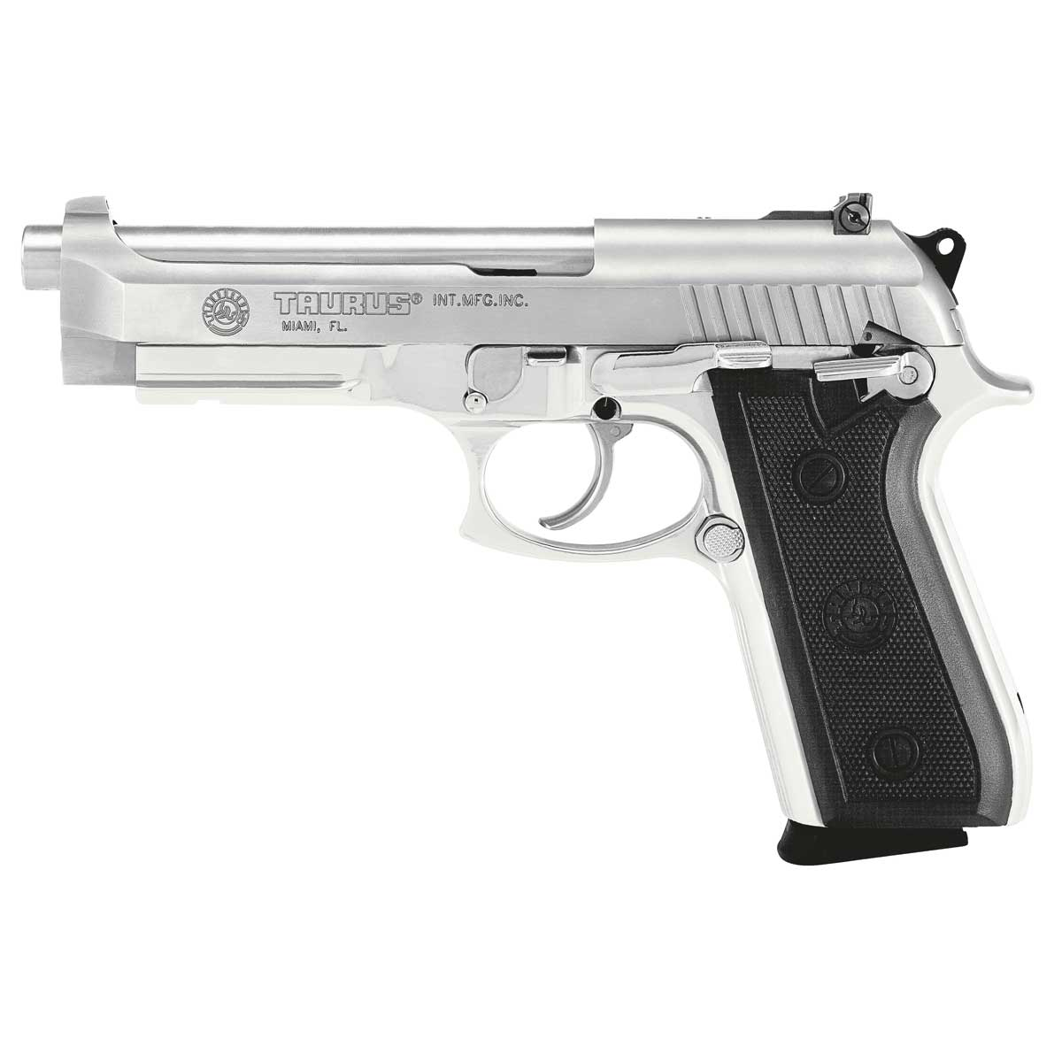

Appendix 1 – Product Shot of the Taurus PT99 Stainless Pistol [13]

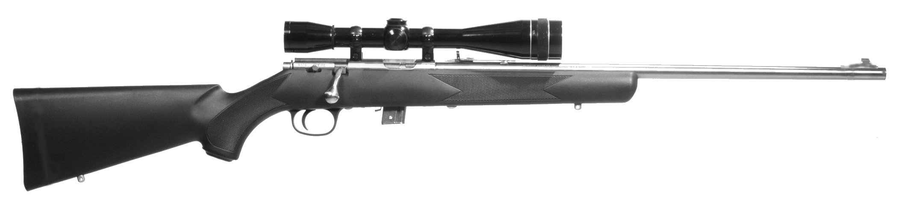

Appendix 2 - Product Shot of the Marlin 980S Rifle [14]

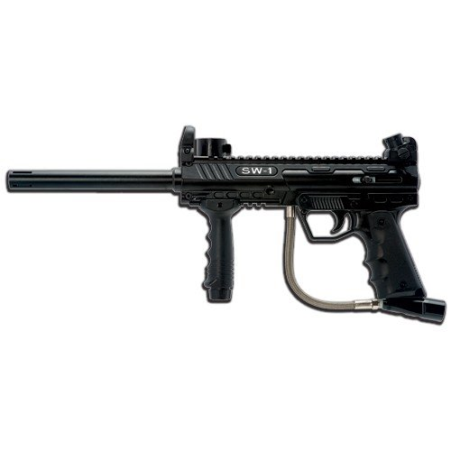

**Appendix 3 – Product Shot of the SW1 Milsim Marker** [15]

|  |  |  |  |  |  |  |  |  |
| --- | --- | --- | --- | --- | --- | --- | --- | --- |
|  | Accuracy | Uniqueness | Mount ability | Simplicity | Cost Effectiveness | Safety | Geometric Mean | Weighting |
| Accuracy | 1 | 2 | 0.5 | 0.5 | 2 | 0.5 | 0.87 | 0.13 |
| Uniqueness | 0.5 | 1 | 0.25 | 0.5 | 0.5 | 0.33 | 0.40 | 0.06 |
| Mount ability | 2 | 3 | 1 | 2 | 2 | 1 | 1.89 | 0.28 |
| Simplicity | 2 | 2 | 0.5 | 1 | 1 | 2 | 1.32 | 0.19 |
| Cost Effectiveness | 0.5 | 2 | 0.5 | 1 | 1 | 0.25 | 0.66 | 0.10 |
| Safety | 2 | 3 | 1 | 0.5 | 4 | 1 | 1.64 | 0.24 |

Appendix 4 - Pairwise Comparison of Selection Criteria for Velocity Determination Method