1. **Introduction**

During these past few years, the growth of communication through peer to peer (P2P) systems has been increasing day by day. This software is embedded in various devices like laptops, tablets and mobile phones. These devices can allow users to share the data like audio, text, and multimedia files through a P2P network. Without using any intermediate hardware, users will be able to send and receive the content in a wireless network. In P2P network, each node acts as a server or a client node. Peer nodes receive the data request and sends it to the central server, whereas the server node processes the request and sends back response to the users. P2P network provides efficient transmission of data with low cost and less power consumption. There are many file sharing technologies out of which WiFi and Bluetooth are popular. Napster, Gnutella, Fast track and OpenFT are some other technologies.

**Overview**

Section2 describes the popular technologies, WiFi and Bluetooth, that are built based on the P2P network. Section 3 includes other technologies such as Napster, Gnutella, Fast track, OpenFT and Section4 concludes the paper.

**2. Major Technologies**

**2.1. WiFi technology**

WiFi technology is a wireless technology used for network connectivity. According to the IEEE standards, WiFi is represented as the Wireless Local Area Network. To provide high speed transmission of data, WiFi uses radio technology. With this technology, users can connect to the network anywhere within in the range. The area where internet can be accessed with this technology is called a WiFi hotspot.

This technology allows users to transfer their data such as audio, video and data files securely without any physical connection. This system constitutes five modules. The files which are shared among the users are stored in a sharable folder. Initially to establish the connection, handshaking signals are passed using a Request Response handler. The Searching module searches, if a specific file is present in the peers based on the file name. The Downloading module helps to download if the particular file searched for is found. The Chat application module provides chatting facility among the users. The communication among all the nodes happens through the central peers.

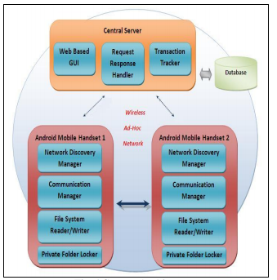

Figure1.System Architecture of WiFi Technology

Request for the data is carried by the receiver node and forwarded to the central server. In the same way, response is sent back to the receiver node from the server which finally provided to the user.

**2.2. Bluetooth Technology**

Bluetooth is a peer to peer communication technology which is similar to WiFi, but it just allows transmission of data with in short distances (few meters). Data is shared between the devices in a secured way by creating a Personal Area Network also known as PAN. As data transmission is done within the short range, the microchip used consumes less power and cost less. Devices that exchange data within the short range include mobile phones, PCs, Tablets, Laptops, Digital Cameras, etc.

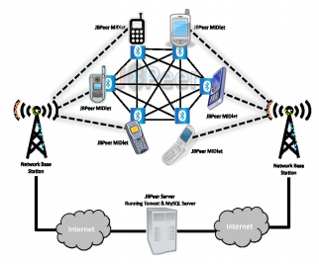

Figure2. System Architecture of Bluetooth Technology

WiFi can transmit the data at the rate of 11 megabits per second. Whereas, data is transferred at the rate of 3 megabits per second between the devices that are connected through Bluetooth. So Bluetooth is slow in data transmission when compared to WiFi. Transmissions of video files is very slow in Bluetooth. WiFi is best suited for communication among the systems in a network unlike Bluetooth which is good for communication between two specific nodes.

**3. Other Technologies**

**3.1. Napster**

Napster technology is an efficient way to share the music files among the users through a wide area network. It has a client-server architecture which coordinates the movement among individual users. According to the system architecture, the central server manages the documents of the clients who are enrolled with the system. When the user requests for a particular record, in response to that, the central server provides the list of records that matches the request. This server maintains an index of all the music files. So to retrieve any record, user need to send a request to this server which sends the port and IP location of the client. By using the Napster application, we can make a direct association with the host and download a document.



Figure3. Illustration of the Napster Architecture

A single client server architecture was implemented when this model was introduced, which is named as Napster. Although it is applicable only for MP3 music files, the design of these component is popular because of its greater user control. Later, Napster was implemented even for non music files by using Open Nap servers but that was not successful.

**3.2. Gnutella**

Gnutella is implemented using a network of peers. Instead of a central index directory it maintains a single flat index directory which helps in searching the particular contents in the system. In this system architecture, nodes are connected in a peer to peer network or in an ad-hoc topology manner. Each node acts as a client as well as a server. So every node has the responsibility of both server and client. It raises the issues as a client and also responds as a server.

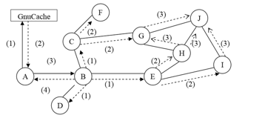

Figure4.System Architecture Gnutella network

To add a new node into this network, it must verify the address of that node if it is already existing in the network. This verification can be done by GnuCache, which helps in finding the address of the nodes and forwards the request to the GNUTELLA CONNECT. So the node may accept or reject the request. It sends GNUTELLA OK if it accepts the request or forwards a response back to the server node if it rejects the request.

**3.3. FastTrack**

One of the latest technology with peer to peer architecture is FastTrack. This model is developed to solve the issues in Gnutella and Napster. It has a hybrid architecture which uses a combination of different network topologies to maintain two tiers of control. The first tier is made up of a collection of nodes like in a centralized topology and the second tier is designed with a decentralized topology network.

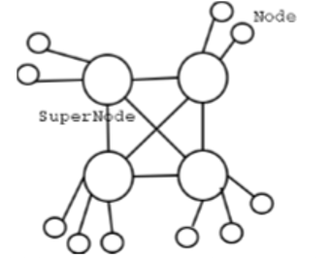

Figure5.Network topology representation in FastTrack

In this approach, each of the nodes gets the request to search in the database index, which contains the data about all the files shared by its surrounded nodes. If the search matches with the content in the files, it sends a reply back to the node, where the request is originated. This way of sending and receiving data is similar to Gnutella. This network is made of high speed super nodes, so sending and receiving are more reliable using this technology.

**3.4. OpenFT** This approach has a decentralized three-level network of nodes, such as search nodes, index nodes and ordinary nodes. Network structure and level of anonymity of this model is similar to FastTrack, but OpenFT is more optimized when performance is considered. Instead of a two tier architecture as in FastTrack, it has a three tier architecture of nodes. The categorization of nodes is done based on the bandwidth of the network and memory consumption.

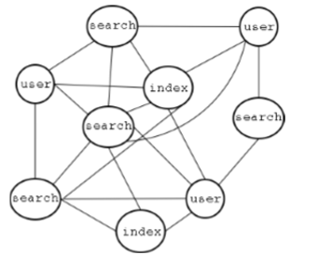

Figure6.System Architecture of OpenFT model

The tier1 constitutes user nodes, which are connected to many search nodes. The file sharing information is updated through these user nodes. The Second tier constitutes of search nodes which acts as actual servers in this approach. So it has to maintain the indexes of files, which are shared by the user nodes. The Third tier constitutes a small group of nodes, which must be available most of the time and should be highly reliable. A node can behave as an index node and also a search node.

**4. Conclusion**

This paper discussed about many technologies involved in peer to peer file sharing. These technologies supports the data transfer through various devices. Bluetooth and WiFi are the latest technologies which consumes less power and are provided at low cost. The data transmissions using technologies is efficient and secured. Other file sharing technologies like Napster, Gnutella are also efficient in transferring data but are not as popular as WiFi and Bluetooth.

**References**

[1] Dhamale, S., Mate, P., Ohal, P., and Pawar, R., *Peer To Peer Content Sharing On Wi-Fi Network For Smart Phones*, IOSR Journal of Computer Engineering, Volume 10, Issue 5 Mar – Apr, 2013, Pages 06-09.

[2] McNamara, G., and Yang, Y., *Creating a mobile P2P file sharing environment over Bluetooth*, published in Pervasive computing and applications, Third International conference, Alexandria, 6-8 October 2008, Pages 863-868.

[3] Buyya, R., Hoong Ding, C., and Nutanong, S., *P2P Networks for Content Sharing,* Technical Report, GRIDS-TR-2003-7, Grid Computing and Distributed Systems Laboratory, University of Melbourne, Australia, December 2003.

[4] Chandrasekar, A., Chandrasekar, K., Ramasatagopan, H., *An energy conserving P2P file sharing model for mobile devices*, proceeding MobiDE ’12 proceedings of the Eleventh ACM international workshop on Data Engineering for Wireless and mobile access, New York, NY, USA, 20102, pages 66-73.