**Capstone 2 Final Report:**

**Creating a dynamic asset allocation strategy based on economic regime similarity**

Matt Kosik

**Problem Statement:**

Portfolio construction is a heavily researched area within finance. Since Modern Portfolio Theory became popularized in the 1950s, many other construction methods have been proposed, each with their own advantages and disadvantages. One of the main assumptions made across most models is that future asset returns will have a similar distribution to historic returns. The problem then becomes how to best measure historical returns. In practice, a wide variety of methods are used. I propose a new method that only measures historic periods that are economically similar to the present. The new model outperforms traditional mean-variance optimization results out of sample across a variety of measures and looks promising for further research.

**Data:**

The data used in this project can be broken down into two categories, Asset Returns and Economic Variables.

Asset Returns

In general, macro economic variables should drive financial returns of broad asset classes more predictably than that of specific sectors or individual securities. Therefore, I chose to investigate the proposed portfolio construction model on a three asset portfolio consisting of the most commonly held asset classes: Equities, Bonds, and Commodities.

* Equities – S&P 500 Index
  + Sourced from Yahoo via pandas_datareader
* Bond – 10y US Treasury Total Return
  + Sourced from St. Louis Federal Reserve via FREDapi
  + Manually converted to total return form assuming bonds purchased at par
* Commodities – GSCI (Goldman Sachs Commodity Index)
  + Sourced from www.koyfin.com via csv download

Across three groups, daily data were available from about 1980 – 2020. This should be sufficient to capture multiple economic cycles. As we can see below, both Equity and Commodity returns are negatively correlated with realized volatility. This is consistent with commonly held beliefs. We can use the fact to improve our model predictions.

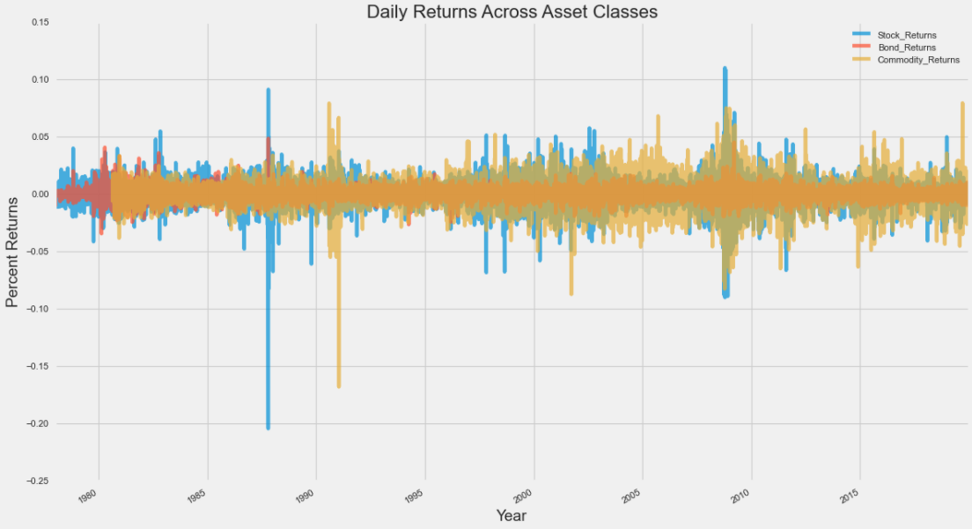

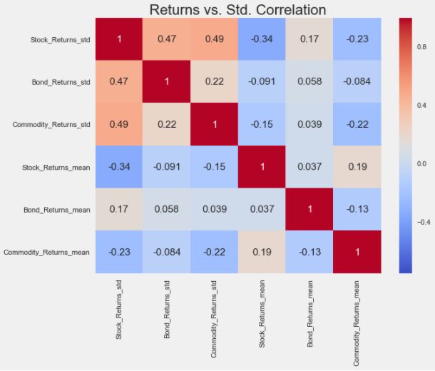

Economic Variables

A variety of monthly economic indicators were chosen to paint a broad picture of the US economy.

* Labor Market
  + **Unemployment Rate** – via FREDapi
  + **Non Farm Payrolls** – via FREDapi
* Prices
  + **Core PCE Rate** – via FREDapi
  + **Core CPI** – via FREDapi
  + **U Mich. Inflation Expectations** – via FREDapi
* Business
  + **Industrial Production** – via FREDapi
  + **ISM PMI Composite** – via Quandl
* Consumer/Housing
  + **U Mich. Consumer Sentiment** – via FREDapi
  + **Housing Starts** – via FREDapi
* Market Rates
  + **3 Month Yield** – monthly average via FREDapi
  + **10y – 2y Treasure Curve** – monthly average via FREDapi
  + **5y5y Forward Treasury Rate** – monthly average via FREDapi

Economic Variable Correlation Dendrogram:

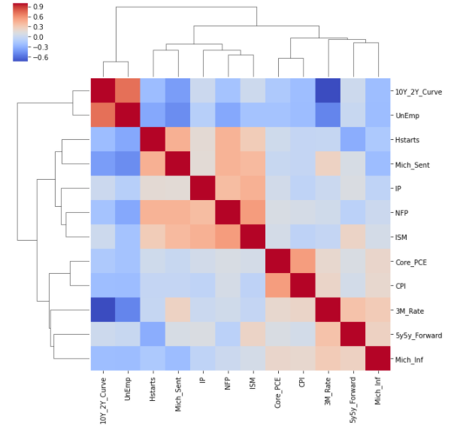

These 12 economic variables were then each standardized. Additionally, I created a 3y Z-Score series for each variable as well as a change of Z-Score. The resulting combined 36 variables were then used as the input to the model. The period of asset returns and economic variables was then split into a training and test set on January 1st, 2006. This split point was somewhat arbitrary; I wanted to make sure the Dot-Com bubble was included in the training set and the 2008 Financial Crisis was included in the test set.

It is also important to note that the frequency of the data is different, daily returns vs. economic events happening once a month on different days. I wanted to preserve as much information as possible, so I kept the discrepancy and dealt with it in the modeling phase.

**Model**

The allocation problem can be defined as follows:

I assume the role of a constrained, long only investor who needs to make an asset allocation decision on the first of each month. The allocation is assumed constant with daily rebalancing throughout the month. I will choose the allocation based on the economic information released over the course of the prior month.

As if construction weren’t hard enough, scoring or ranking investment results presents additional complications. Traditionally, some function of reward per risk measure is used, with the Sharpe ratio being the most common metric. Maximizing the Sharpe ratio as a means of portfolio construction or a metric of portfolio returns has many well documented problems. However, for the sake of simplicity, I will be using it for both in this project, amongst many other simplifications and assumptions.

My proposed dynamic algorithm solution is:

1. At the end of each new month of the test set, compile all relevant economic indicators from the month and perform the appropriate feature transformations.
2. Calculate “distance” from the recent month to each historical month in the training set.
3. Based on “distance”, group N nearest neighbor months of historical returns into subset.
4. Calculate mean and standard deviation of daily asset returns from subset.

5a. If return volatility is greater than max volatility threshold, calculate and apply Minimum Variance Construction and apply weights to following month.

5b. If returns volatility is less than max volatility threshold, calculate and apply Max Sharpe Construction and apply weights to following month.

I will also apply the following investor constraints:

* No short sales
* No leverage
* Fully invested, (sum of weights = 1)
* Minimum position = 10%

Steps 5a/5b are used to incorporate the fact that periods of high volatility traditionally coincide with negative returns for Equities and Commodities. Typically, investors could reduce total exposure during these volatile time periods, but our fully invested constraint prevents this. Therefore, I choose a different portfolio construction method to help reduce predicted losses during these volatile periods. I selected a threshold of 95% of the realized historic volatility from the entire training set. Both Minimum Variance and Max Sharpe optimizations were done with the cvxpy package.

I decided to use the standard Euclidean “distance” measure for the Nearest Neighbor algorithm. I couldn’t find any literature suggesting a different measure for this application, nor could I come up with an intuitive reason why a different measure would outperform.

The final model parameter to tune is the number of neighbors to form the subset. The selected number of neighbors must balance being too few that it overfits the small subset or being too many that it trends towards the mean of the entire training set. To get an idea, I further split the training set multiple times into training and validation sets and measured the realized Sharpe ratio using my dynamic algorithm across a number of different N possibilities.

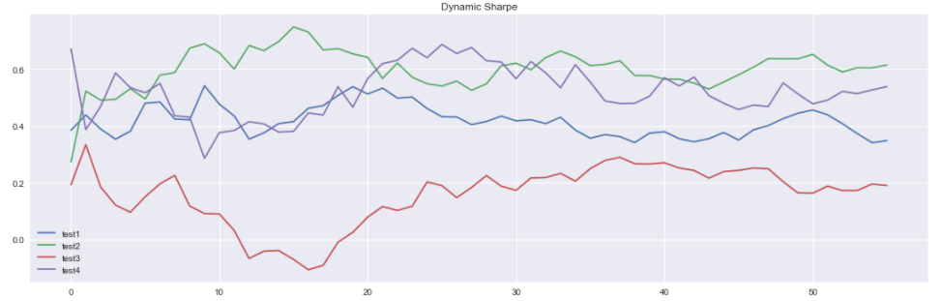

The result above shows that between 30 and 40 neighbors, I get a good mix of high Sharpe and good stability. Stability is important for the robustness of the model, you don’t want drastically different results for a small change in N. I decided to go with N=36 months (3y of data in subset).

**Results**

While the absolute realized Sharpe ratio of my allocation strategy is important, I also wanted to get a sense of how my algorithm would compare against traditional alternatives. I chose two common competitors.

* **Base Weights** – a general static portfolio consisting of 60% Equities, 30% Bonds, and 10% Commodities
* **Static Optimal Training Portfolio** – generally suggested by Modern Portfolio Theory, calculate maximum Sharpe weights for entire historic period and apply going forward. This was calculated as 13.2% Stock, 70.2% Bonds, and 16.6% Commodities from the training set.

My dynamic algorithm outperformed these two competitors across a variety of commonly cited metrics.

|  |  |  |  |
| --- | --- | --- | --- |
|  | **Dynamic Algo** | **Base Weights** | **Static Optimal Training Portfolio** |
| CAGR | 5.36% | 5.57% | 3.60% |
| Returns | 5.43% | 6.09% | 3.71% |
| Std | 6.45% | 11.57% | 5.87% |
| Sharpe | 0.842 | 0.527 | 0.632 |
| Max Drawdown | -13.4% | -38.6% | -16.8% |
| Sortino | 1.229 | 0.734 | 0.914 |
| Calmar | 0.400 | 0.144 | 0.214 |

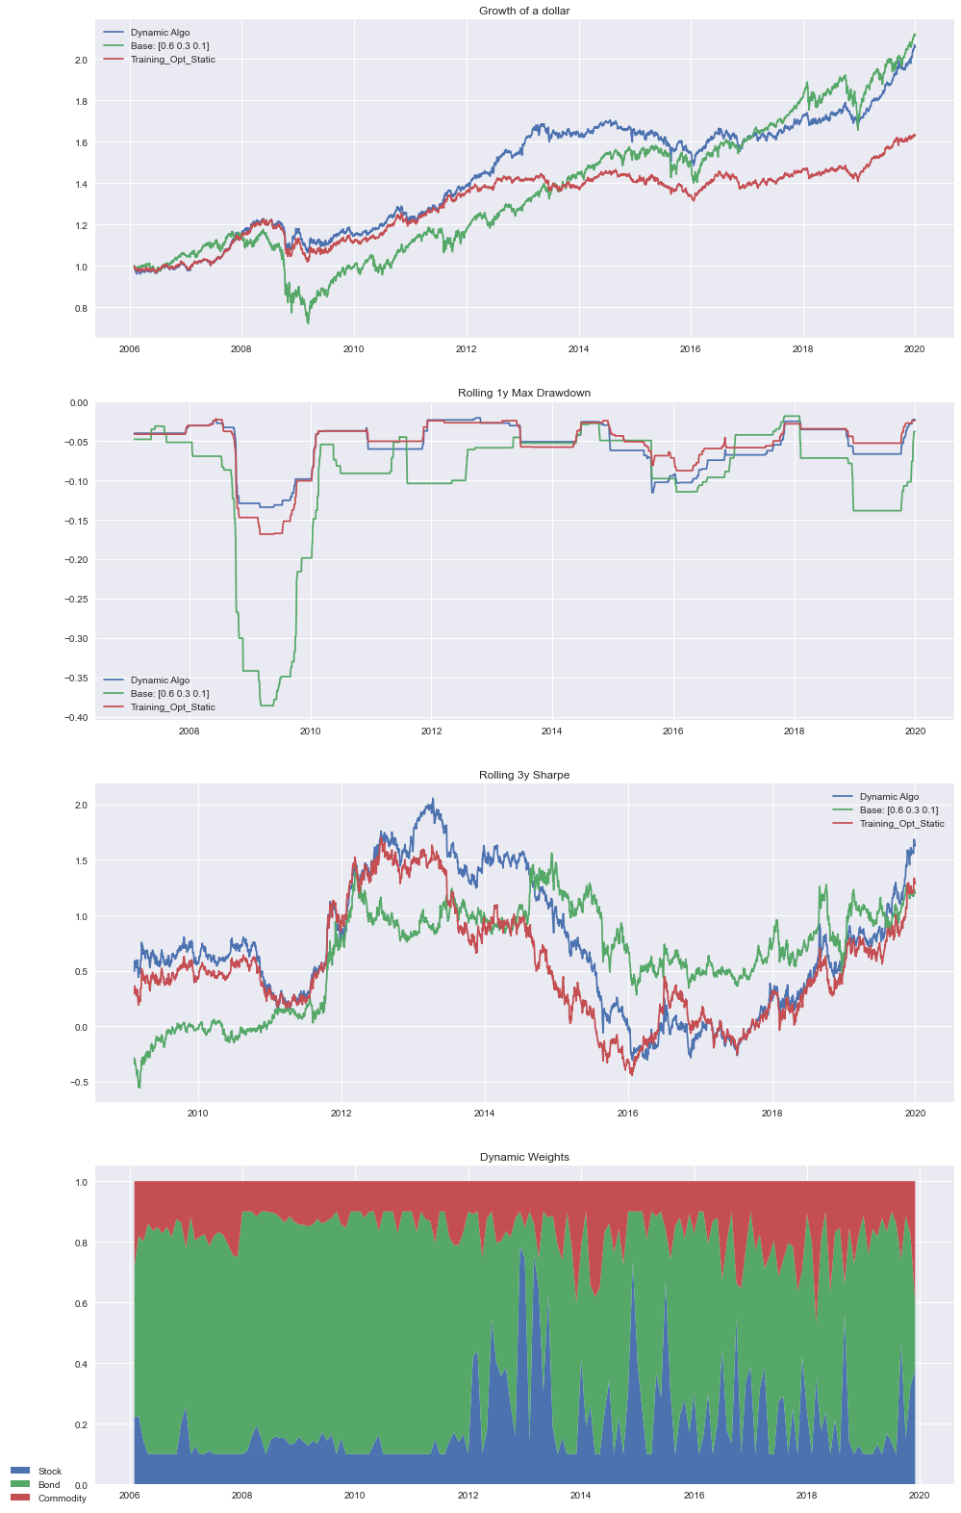

**Conclusion**

The proposed dynamic algorithm was successful across a number of different metrics. It had the highest Sharpe ratio in the test period, which was the metric I decided to construct the portfolio around. The allocation strategy helped significantly reduce the max drawdown as compare to the commonly recommended 60/30/10 portfolio. The resulting weights went through a few volatile months but was relatively stable throughout.

Interestingly, the algorithm even outperformed the best possible static portfolio created from the ex-post returns (Dynamic Algorithm Sharpe: .842; Best ex-post Sharpe: .819). This represents a comparison to the best static portfolio strategy had all the returns been known ahead of time and is a very strong result.

**Further Research**

This project was a great first step into rethinking the portfolio allocation problem. I successfully showed that a dynamic algorithm based on economic regime similarity could outperform even the best possible static portfolio with returns known ahead of time. This opens the door for a variety of deeper investigation, which can easily be incorporated into similar framework I have already built.

The first extension would be to incorporate transaction costs into the model. This would lower the returns on the higher turnover dynamic model but this could be incorporated into the optimization process. Additionally, I could use and expanding window and create new features to incorporate more variables and training data into the model. Lastly, I could incorporate a separate function that would predict the best possible Sharpe for the upcoming period. This would help classify the overall investment environment as good or bad and help determine how aggressive the weights would be skewed towards higher risk assets.