1. List terms that have frequencies of 4 or more in doc1

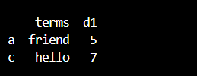

2.Find terms that contain letter 'a' in doc3

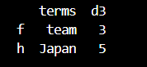

3.Find terms that start with letter 's' in doc5



4.List all term frequencies of doc3, but not the ones for team

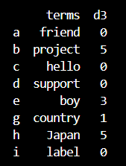

5.Find the terms with the highest and lowest term frequencies in docs 2 and 4

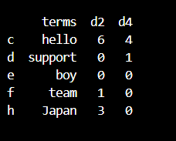

6. Find terms that not included in docs that have the label classification

