**Image Manipulation Assignment Report**

**Manohar Kowthavarapu (11554625)**

**Section-1:**

Below is the my_flip1 method that takes image as an input and returns the mirror image.

def my_flip1(lena_image):

  print("Mirror Image")

  cv2_imshow(lena_image[:, ::-1, :])

Below is the my_flip2 method that takes image as an input and returns the rotated image with grey in colour.

def my_flip2(lena_image):

    radius = math.radians(270)

    image = np.uint8(np.zeros(lena_image.shape))

    image_height = image.shape[0]

    image_width  = image.shape[1]

    image_midx, image_midy = (image_width//2, image_height//2)

    for i in range(image_height):

        for j in range(image_width):

            x = round((i - image_midx) * math.cos(radius) \

            + (j - image_midy) * math.sin(radius)) + image_midx

            y = round(-(i- image_midx) * math.sin(radius) \

            + (j - image_midy) * math.cos(radius)) + image_midy

            if ( x >= 0 and y >= 0 and x < image_height and y < image_width):

                image[i,j,:] = lena_image[x,y,:]

    print("Rotated Image with Grey in color")

    cv2_imshow(image[:, :, 1])

Below is the upper_quardant method that takes image as an input and return the 1/4th of the right upper quadrant image.

def upper_quadrant(lena_image):

  image_height, image_width = lena_image.shape[:2]

  image_x, image_y = (image_width // 2, image_height // 2)

  upper_quadrant_right_image = lena_image[0:image_y, image_x: image_width]

  print("Top Right 1/4th upper quardant of image")

  cv2_imshow(upper_quadrant_right_image)

**Section-2:**

Output result for the given above methods.

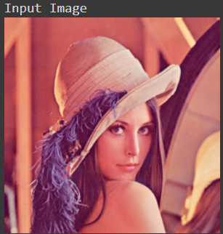 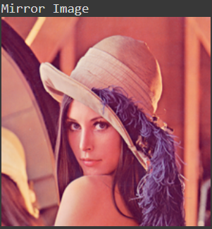

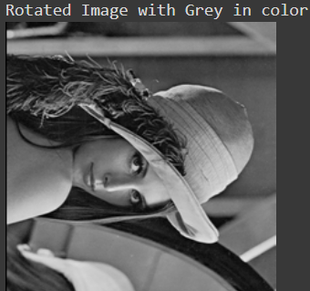 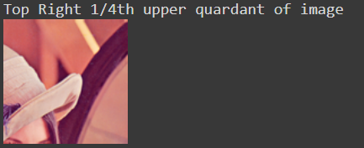

**Section-3:**