Image Manipulation Assignment

In this assignment, you will program functions that uses matrix manipulation to modify images. Prepare a word or a PDF report that implements the functions listed below. Your report will have the following three sections. Section one will list the Python code of your functions. Section two will have screenshots of the executions (testing) of your functions in Python. Section three will have comments on your experiences implementing the Python functions.

- Design a Python function my_flip1 that takes as a parameter an RGB image and then displays its flipped still RGB version as illustrated in the next example. For instance, figure 1 is the input image and figure 2 is the displayed (output) image.
- Design a Python function my_flip2 that takes as a parameter an RGB image and then displays its flipped gray color version (rgb2gray) as illustrated in the next example. For instance, figure 1 is the input image and figure 3 is the displayed (output) image.
- Design a Python function upper_quadrant that takes as a parameter an RGB image and then displays its upper quadrant (one fourth of the image) as illustrated in the next example. For instance, figure 1 is the input image and figure 4 is the displayed (output) image.

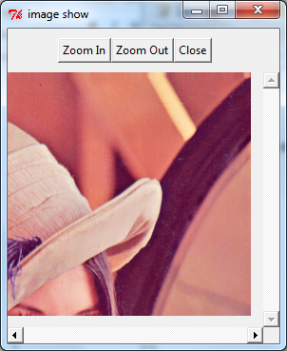
Figure 4
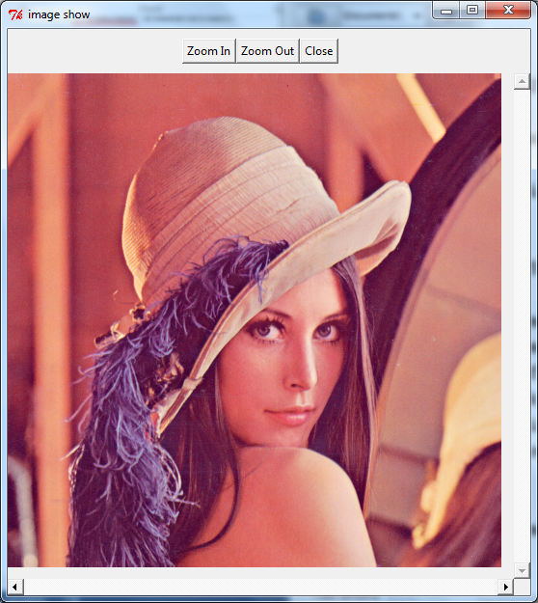
Figure 1
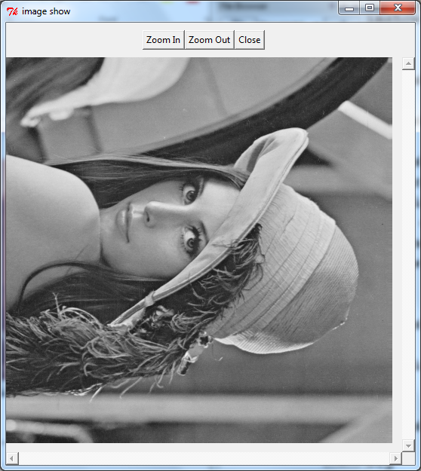
Figure 3
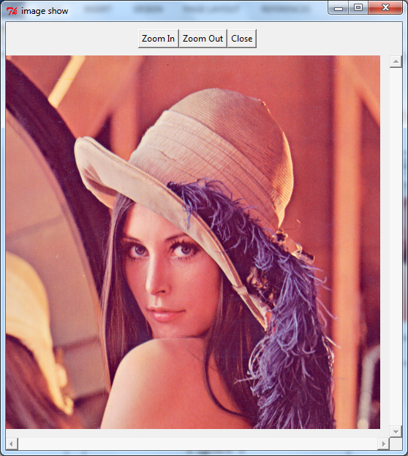
Figure 2

