Table A (These numbers are up to date as of 1/2/24)

Trees

|  |  |  |  |  |  |  |
| --- | --- | --- | --- | --- | --- | --- |
| SPECIES | ALIVE 2013 | DEAD 2018  (DN) | TOP KILLED  (DR) | CANOPY  (LN) | CANOPY  + BASAL  (LR) | PERCENT SURVIVAL |
| Total TR % | 2546 | 0.36724 | 0.20031 | 0.33385 | 0.9858 |  |
| ARBMEN | 126 | 30 | 39 | 25 | 32 | 0.76190 |
| ARCMAN | 50 | 32 | 0 | 18 | 0 | 0.36000 |
| HETARB | 531 | 263 | 223 | 38 | 7 | 0.50470 |
| PSEMEN | 630 | 416 | 0 | 214 | 0 | 0.33968 |
| QUEAGR | 362 | 64 | 57 | 188 | 53 | 0.82320 |
| QUEDOU | 75 | 4 | 0 | 70 | 1 | 0.94666 |
| QUEGAR | 359 | 36 | 11 | 228 | 84 | 0.89972 |
| QUEKEL | 72 | 20 | 14 | 26 | 12 | 0.72222 |
| UMBCAL | 341 | 70 | 166 | 43 | 62 | 0.79472 |

Table B

SAPLINGS

|  |  |  |  |  |  |  |
| --- | --- | --- | --- | --- | --- | --- |
| SPECIES | ALIVE 2013 | DEAD  2018  (DN) | TOP  KILLED  (DR) | CANOPY  (LN) | CANOPY  + BASAL  (LR) | PERCENT SURVIVAL |
| Total SA % | 2614 | 0.49655 | 0.28347 | 0.21193 | 0.00420 |  |
| ARBMEN | 158 | 84 | 39 | 35 | 0 | 0.46835 |
| ARCMAN | 11 | 9 | 0 | 2 | 0 | 0.18181 |
| HETARB | 177 | 76 | 49 | 51 | 1 | 0.57062 |
| PSEMEN | 573 | 531 | 0 | 42 | 0 | 0.07329 |
| QUEAGR | 417 | 116 | 122 | 179 | 0 | 0.72182 |
| QUEDOU | 3 | 0 | 2 | 1 | 0 | 1.00000 |
| QUEGAR | 17 | 2 | 9 | 6 | 0 | 0.88235 |
| QUEKEL | 3 | 3 | 0 | 0 | 0 | 0.00000 |
| UMBCAL | 1245 | 477 | 520 | 238 | 10 | 0.61686 |

Numbers on ppt slide above are out of date

Current totals as of 1/2/24 below

Overall /5978

N13 N18.DN N18.DR N18.LN N18.LR

1.0 0.41334895 0.27233188 0.26564068 0.04867849

N13 18.DN 18.DR 18.LN 18.LR

5978 2471 1628 1588 291

>

All TR/2688

N13 N18.DN N18.DR N18.LN N18.LR

1. 0.3675595 0.2094494 0.3221726 0.1008185

N13 .18DN .18DR 18.LN 18.LR

2688 988 563 866 271

All SA/ 3290

N13 N18.DN N18.DR N18.LN N18.LR

1.000000000 0.450759878 0.323708207 0.219452888 0.006079027

N13 18.DN 18.DR 18.LN 18.LR

3290 1483 1065 722 20

Table C

|  |  |  |  |  |
| --- | --- | --- | --- | --- |
| **Crown** | **Resprout** | **Live/Dead** | **Fates** | **Resprouting** |
| Live | Yes | Live | GC | Yes |
| Live | No | Live | GC | No |
| Dead | Yes | Live | T+R | Yes |
| Dead | No | Dead | Dead | No |

Figure A. (Old isoclines – updated below)

On the left is percentage of survival across species, via resprouting, crown survival or a combination of both outcomes with increasing trunk size. On the right is percentage of individuals with crown survival (excludes top-killed individuals but includes those with crown survival + resprouts). The red lines are isoclines of survival at each level of fire severity

Figure B (old binomial models- updated below)

Predicted post fire outcome as a function of size. On the left is all fire levels and on the right is mod and high fire severity. Lines represent binomial regression analysis for each outcome, Died, Top-killed, Crown survival, plotted on one graph, (we can also use a multinomial regression and get nearly identical results -should we use those instead?)

Updated Isoclines

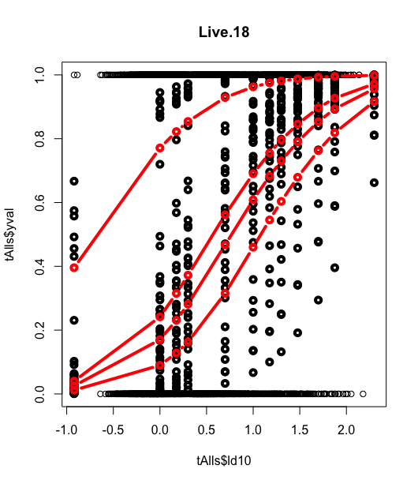 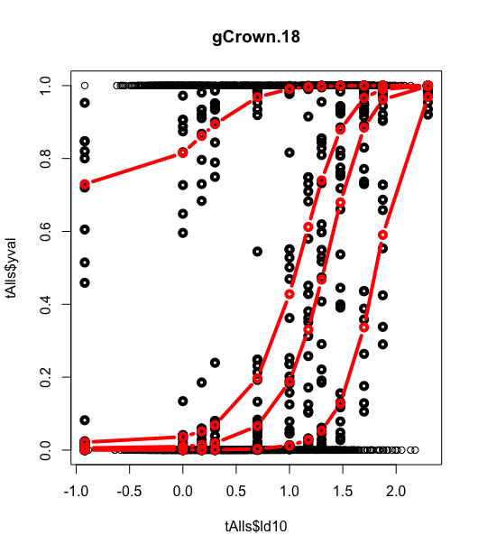

Updated Binomial model

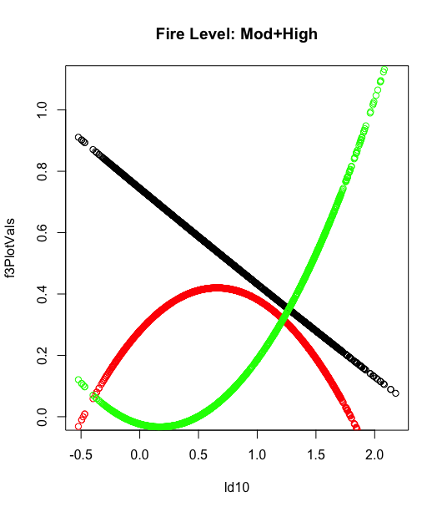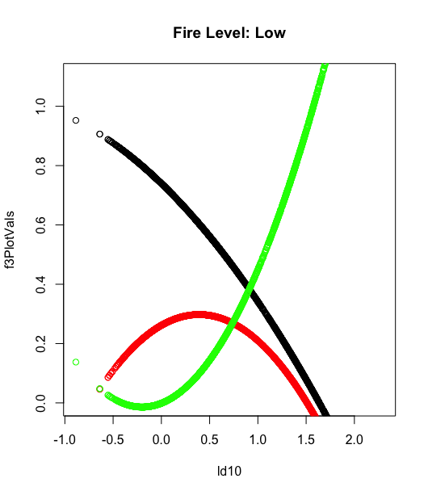

Updated Multinomial model

