AWS configuration

To start with Amazon Web Service (AWS), you need to have the following two information:

1. An account with AWS and
2. Credentials generated from AWS (Access Key ID and AWS Secret Access Key)

To learn more about the credentials, please consult this resource - <http://docs.aws.amazon.com/general/latest/gr/aws-sec-cred-types.html#access-keys-and-secret-access-keys>.

Once you have credentials generated and ready to be used, you need to input them on Maestro. To do so, click on the Cloud on the left hand menu blade, then go to AWS tab and you will have a screen like this:

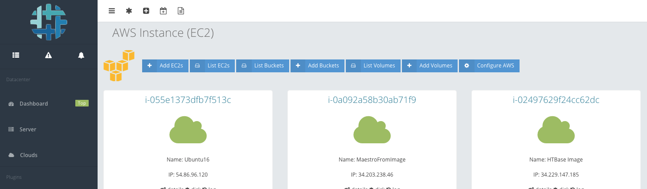

Fig. #1: AWS menu items in Maestro

Click “Configure AWS” from the top menu and you will have a screen asking for Access Key ID and AWS Secret Access Key.

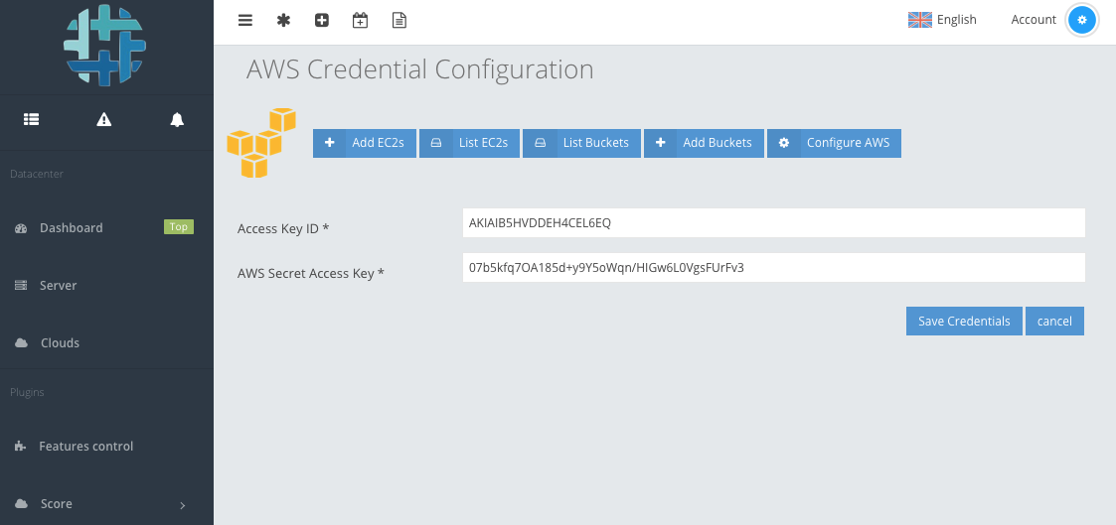

Fig. #2: Configuring AWS into Maestro

Input the information to appropriate fields and hit “Save Credentials” button. At this point, Maestro has the authority to access your AWS account and perform different operations.

AWS SDKs

You need to have the following SDKs installed on your controller machine to perform different operations on AWS:

1. Boto3
2. AWS CLI 2.0

You can install boto3 executing the following command:

pip install boto3

The official github page for AWS Python SDK - <https://github.com/boto/boto3>

and for AWS CLI, execute the following one:

pip install awscli

Reference page for AWS CLI 2 - <http://docs.aws.amazon.com/cli/latest/userguide/installing.html>

Once you have AWS CLI2 installed, check the installation by running the following commad:

aws –version

and it should output - aws-cli/1.11.134 Python/2.7.6 Linux/4.4.0-31-generic botocore/1.6.1

Now you must configure credentials, region and output format. To do so, run

aws configure

and it will ask you four different information:

1. Access Key ID
2. AWS Secret Access Key
3. Region and
4. Output format

Now go to ~/.aws/ and check the configuration files.

AWS features integrated into Maestro

So far, the following features have been implemented:

1. Create EC2 Instance

EC2 Instance can be created via Maestro. One controller image and four different client images are available to start an instance.

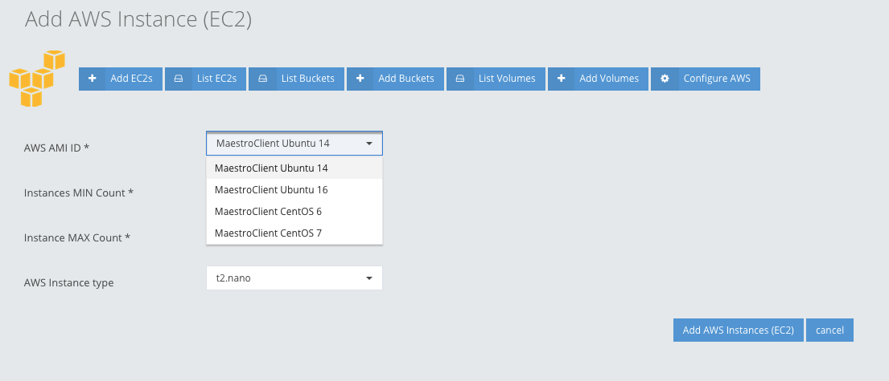

Fig. #3: Add an EC2 Instance

1. List AWS Instances

This page list all the instances available on AWS account with the following functionality:

1. Details – describes the details of the instance
2. Disk – this feature allows to change the disk size or disk type.

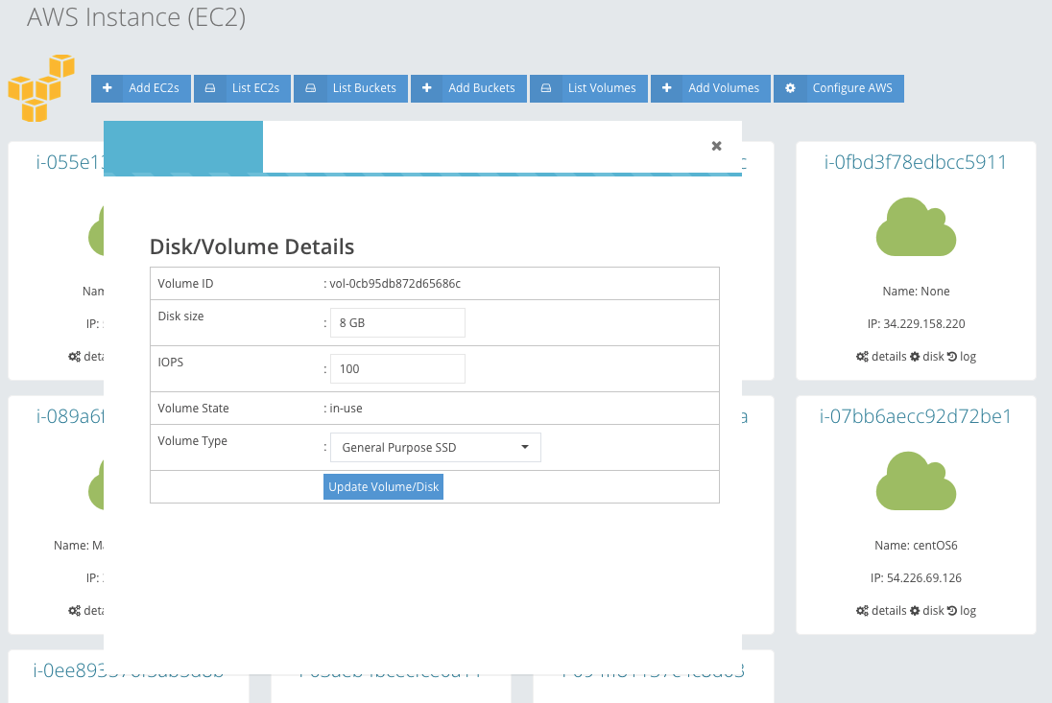

Fig. #4: Change size and type of a volume

1. Log – fetch the available log for an instance
2. Add Buckets

This allows to add a S3 Bucket to AWS directly from Maestro:

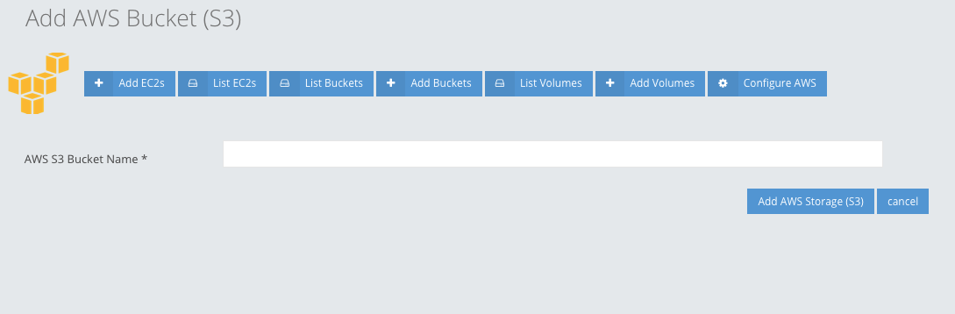

Fig. #5: Add a S3 bucket

1. List Buckets

List all the buckets available o AWS.

1. Add Volumes

This feature allows Maestro user to add an EBS Volume. These volumes are created separately (not attached to any EC2) and available to be used in different cases. Four different types of disks can be created with different size options.

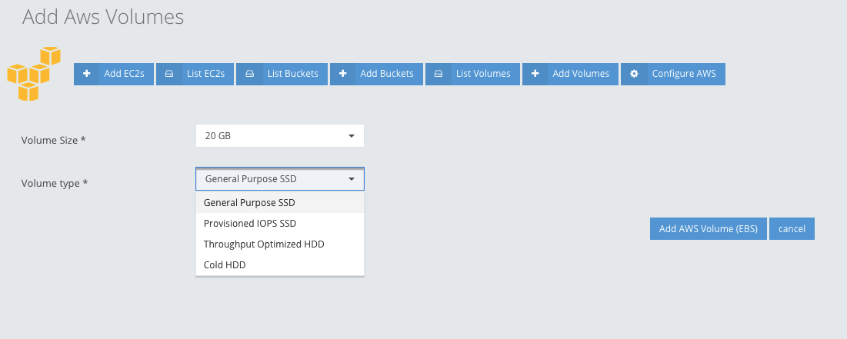

Fig. #6: Add an EBS Volume

1. List Volumes

It lists all the available volumes from AWS. It does not include the volumes that are in use.

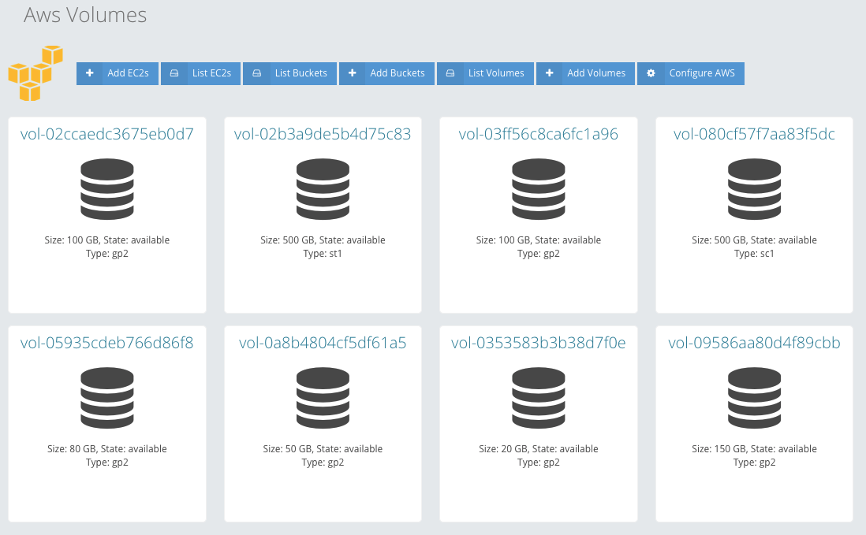

Fig. #1: List all available volumes

1. Configuration

This feature allows Maestro user to change the AWS credentials - Access Key ID and AWS Secret Access Key.

Source Code - AWS

Source code is available at:

PHP - /usr/share/htvcenter/web/base/server/cloud/class/\*

Python - /usr/share/htvcenter/web/base/server/cloud/script/\*

HTML - /usr/share/htvcenter/web/base/server/cloud/tpl/\*

CSS - /usr/share/htvcenter/web/base/server/cloud/css/cloud.css