Azure configuration

To start with Azure by Microsoft, you need to have the following two information:

1. An account with Azure and
2. Credentials generated from Azure (Subscription ID, Client ID, Secret Key and Tenant ID)

How to get Azure Subscription ID - <https://blogs.msdn.microsoft.com/mschray/2016/03/18/getting-your-azure-subscription-guid-new-portal/>

How to get Azure Client ID and Secret Key - <https://msdn.microsoft.com/en-ca/library/bb676626.aspx>

How to get Azure Tenant ID - <https://stackoverflow.com/questions/26384034/how-to-get-the-azure-account-tenant-id>

Once you have credentials generated and ready to be used, you need to input them on Maestro. To do so, click on the Cloud on the left-hand menu blade, then go to Azure tab and you will have a screen like this:

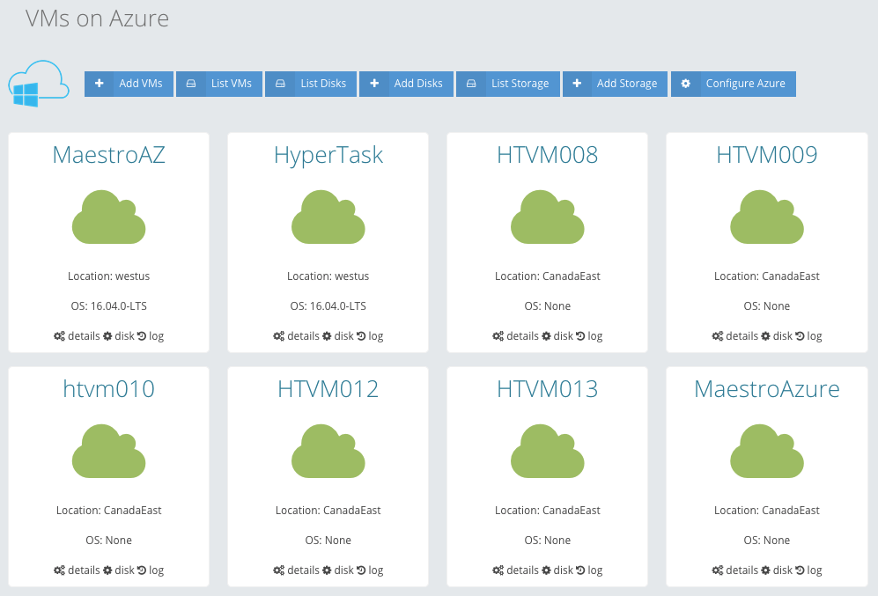

Fig. #1: Azure menu items in Maestro

Click “Configure Azure” from the top menu and you will have a screen asking for Subscription ID, Client ID, Secret Key and Tenant ID.

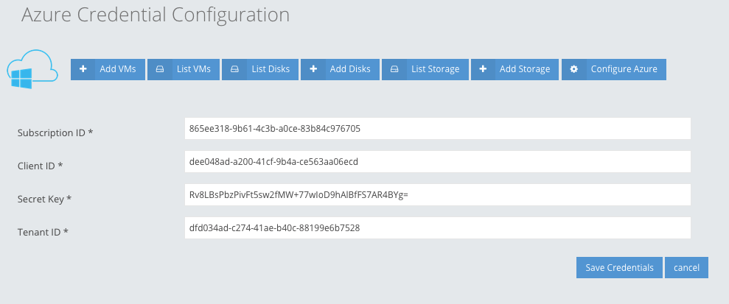

Fig. #2: Configuring Azure into Maestro

Input the information to appropriate fields and hit “Save Credentials” button. At this point, Maestro has the authority to access your Azure account and perform different operations.

Azure SDKs

You need to have the following SDKs installed on your controller machine to perform different operations on Azure:

1. Azure Python SDK
2. AZ CLI 2.0

You can install Azure Python SDK executing the following command:

pip install azure

The official github page for Azure Python SDK - <https://github.com/Azure/azure-sdk-for-python>

Although, Azure Python SDK can be installed via pip, I would recommend installing it directly from github:

git clone git://github.com/Azure/azure-sdk-for-python.git

cd azure-sdk-for-python

python setup.py install

Azure python SDK is not stable yet, installing it via pip installs the older version where github has the latest changes.

and for Azure CLI 2.0, execute the following one (you must have curl installed for it):

curl -L https://aka.ms/InstallAzureCli | bash

After this, execute the following command:

exec -l $SHELL (it will restart your shell command prompt)

Reference page for Azure CLI 2.0 - <https://docs.microsoft.com/en-us/cli/azure/install-azure-cli?view=azure-cli-latest>

Once you have Azure CLI 2.0 installed, check the installation by running the following commad:

az –version

and it should output –

azure-cli (2.0.14)

acr (2.0.10)

acs (2.0.13)

appservice (0.1.13)

batch (3.1.1)

billing (0.1.3)

cdn (0.0.6)

cloud (2.0.7)

cognitiveservices (0.1.6)

command-modules-nspkg (2.0.1)

component (2.0.7)

configure (2.0.10)

consumption (0.1.3)

container (0.1.8)

core (2.0.13)

cosmosdb (0.1.11)

dla (0.0.10)

dls (0.0.12)

eventgrid (0.1.2)

feedback (2.0.6)

find (0.2.6)

interactive (0.3.7)

iot (0.1.10)

keyvault (2.0.8)

lab (0.0.9)

monitor (0.0.8)

network (2.0.12)

nspkg (3.0.1)

profile (2.0.10)

rdbms (0.0.5)

redis (0.2.7)

resource (2.0.12)

role (2.0.10)

sf (1.0.6)

sql (2.0.9)

storage (2.0.12)

vm (2.0.12)

Python (Linux) 2.7.6 (default, Oct 26 2016, 20:30:19)

[GCC 4.8.4]

Python location '/home/htbase/lib/azure-cli/bin/python'

Make sure the list has the correct versions and paths for different packages.

Azure features integrated into Maestro

So far, the following features have been implemented:

1. Create VM

VM can be created via Maestro. One controller image is already available on Azure to start a VM. Creating VM from image requires less parameters where creating VM without image asks more.

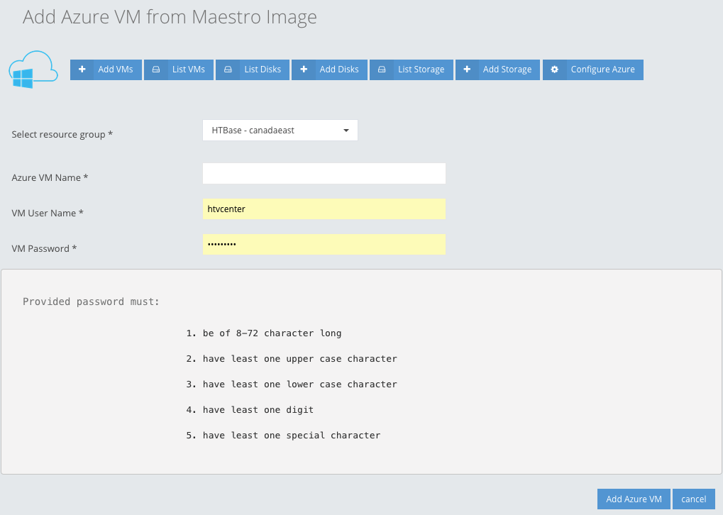

Fig. #3: Add a Virtual Machine from Maestro Image

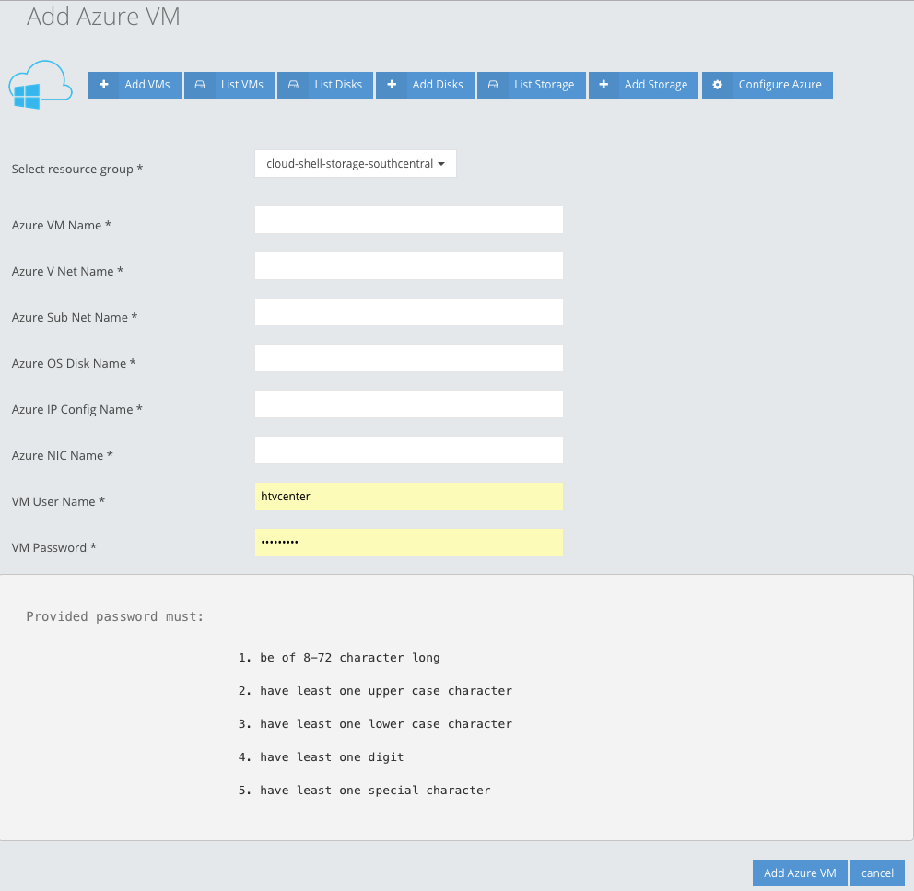

Fig. #4: Add a Virtual Machine

Selecting a proper Resource group is very important. You must follow the password specification correctly otherwise VM creation will result in fail.

1. List Azure VMs

This page list all the VMs available on Azure account with the following functionality:

1. Details – describes the details of the instance with start/stop and terminate button.
2. Disk – this feature list all the disks attached to the VM. It allows to resize the OS disk size. You must input the disk size in gigabyte (GB). You can also attach an available disk to this VM. All the disks will appear in the dropdown (make sure that the disk you trying to attach is in available mode).

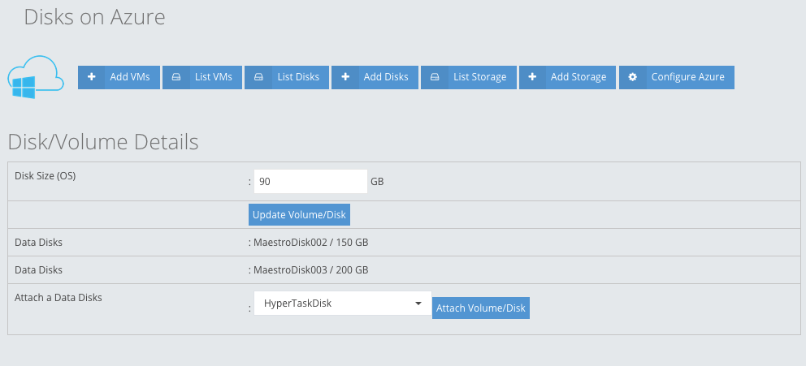

Fig. #5: Change size and type of a volume

1. Log – fetch the available log for a resource group
2. Add Storage

This allows to add a Storage in Azure directly from Maestro:

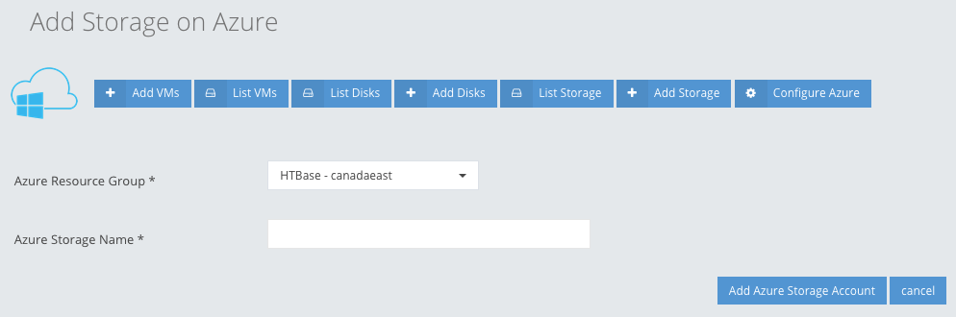

Fig. #6: Add an Azure Storage

1. List Storage

List all the Storage available on Azure

1. Add Disks

This feature allows Maestro user to add a disk. These disks are created separately (not attached to any VM) and available to be used in different cases. Disks can be created with different size options.

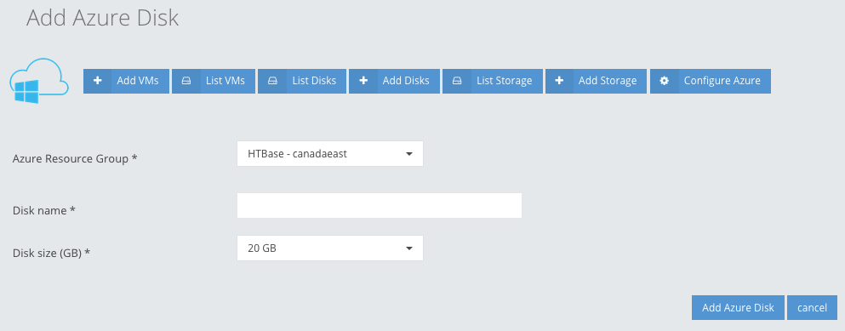

Fig. #7: Add a Disk on Azure

1. List Disks

It lists all the available disks from Azure. It includes OS disks from different VMs.

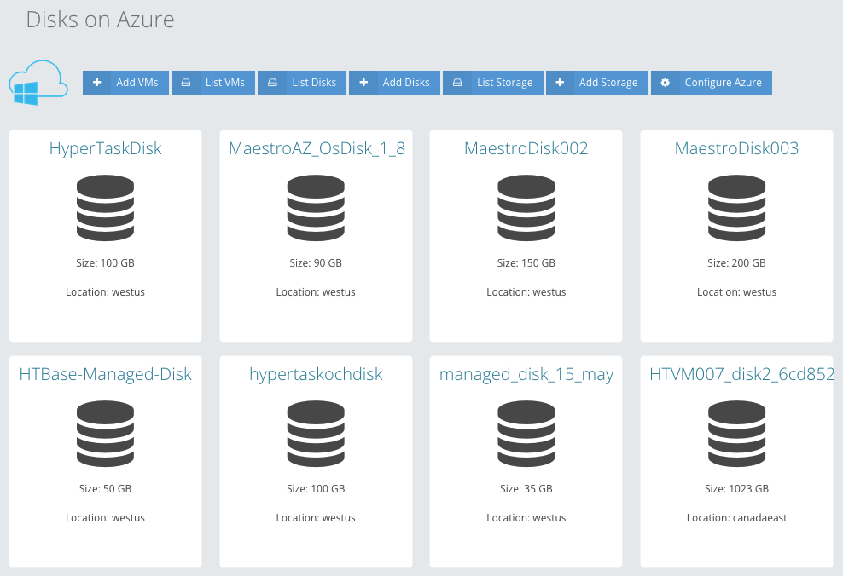

Fig. #8: List all available volumes

1. Configuration

This feature allows Maestro user to change the Azure credentials – Subscription ID, Client ID, Secret Key and Tenant ID.

Source Code - Azure

Source code is available at:

PHP - /usr/share/htvcenter/web/base/server/cloud/class/\*

Python - /usr/share/htvcenter/web/base/server/cloud/script/\*

HTML - /usr/share/htvcenter/web/base/server/cloud/tpl/\*

CSS - /usr/share/htvcenter/web/base/server/cloud/css/cloud.css