Slackbot configuration

To start a slackbot, you need to have a registered account with Slack. Once you have an account with Slack, you have the option to “create a new bot user” (<https://api.slack.com/bot-users>). There you provide the bot name (in our case, we provided “maestro”).

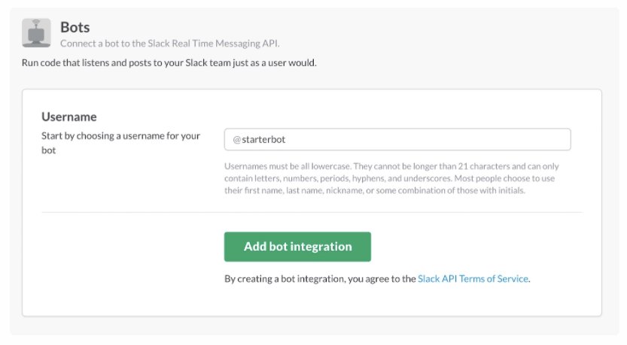

Fig-1: Starting a bot user on slack

On the next screen, it will provide you the **SLACK_BOT_TOKEN** along with few other options (upload a logo etc.). Keep the **SLACK_BOT_TOKEN** handy as you will need it to integrate the bot with Maestro.

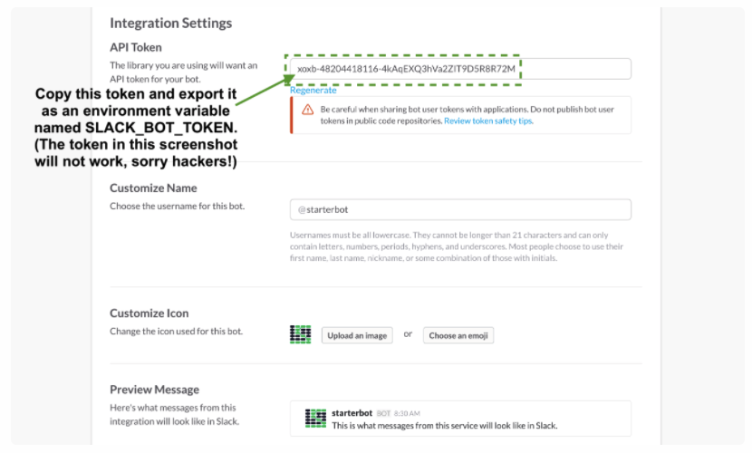

Fig-2: Access token from Slack bot

At this point you have created a slack bot and you have the access token information. Now it’s time to integrate the bot with Maestro. Login to Maestro, go to “Features Control => Misc (tab)”:

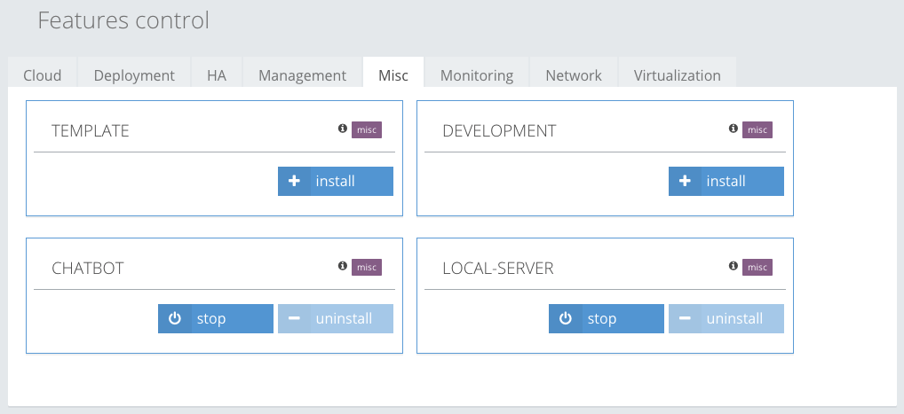

Fig-3: ChatBot Plugin in Maestro Features Control

Look for the CHATBOT plugin, install the plugin if it is not installed already. Once you have the CHATBOT plugin installed, go to “Misc 🡺 chatbot 🡺 Execution” from the left menu.

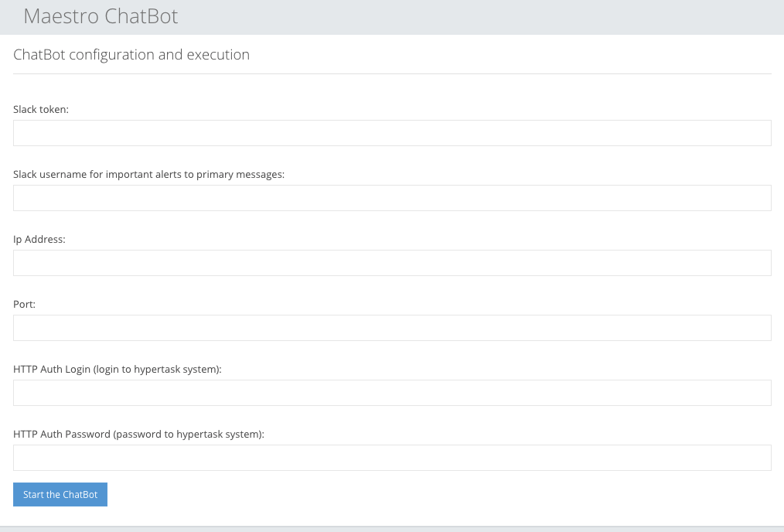

Fig-4: Maestro Slack bot integration form

Here you need to provide all the information and hit the “Start the ChatBot” button and you will have the slack bot integrated with Maestro.