­

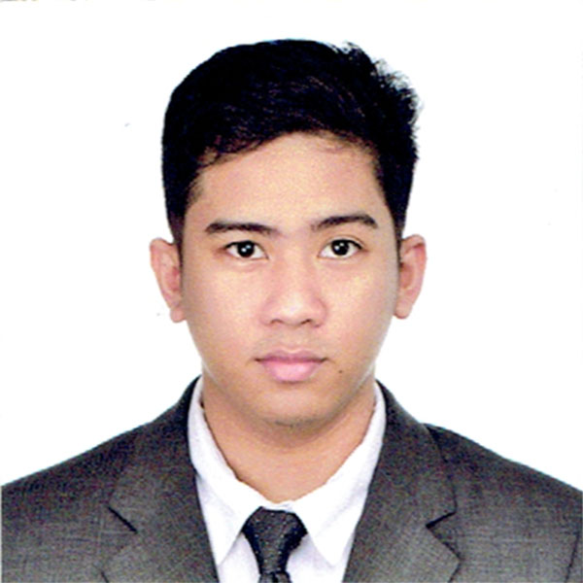

# **ASPE, MARK JOSEPH L.**

B11 L5 SRCC Magic Circle Housing Pingkian 2

Brgy. Pasong Tamo Q.C.

0977-298-9445

[markjoseph.aspe@gmail.com](mailto:markjoseph.aspe@gmail.com)

## OBJECTIVE

Seeking a position in life to utilize my skills and abilities to achieve professional growth to a progressive organization that provides an opportunity to capitalize my technical skills and abilities.

## EDUCATION

* TERTIARY: Technological Institute of the Philippines SY: 2010-2014

(Bachelor of Science in Information Technology)

(4th Year Undergraduate Thesis Student)

* SECONDARY: Ramon Magsaysay (Cubao) High School SY: 2006-2010
* PRIMARY: Cubao Elementary School SY: 2000-2006

## TRAININGS

* Zuitt Learning Institute Incorporated AUGUST – PRESENT

(Full Stack Development Bootcamp)

* American Tesol Institute FEB-MAR. 2018

(Creative Web Design (13 Days))

(Web Development (14 Days))

**EXPERIENCE**

**ADJUDICATOR,** Philippine Health Insurance Corporation

January 2019 – Present

* Checks for completeness/correctness of all forms attached documents requirements.
* Reviews Accuracy Data of all attached documents.
* Checks the Medical Evaluation decision of the Facility/Hospital Claims either the claim is Passed or for Return to HCI (RTH), Failed or Excluded Claims.
* Applies a deficiency statement and denial to a claim as possible.
* Releases RTH/Denial Claims documents for generation of letters to BAS RTH releasing unit.
* Releases of Good Claims to payment approval stage for generation of voucher

**Data Encoder (SG6)**, Philippine Health Insurance Corporation

August 2018 – December 2018

* Responsible for Counter Checking, Sorting, Filing and Inventory of claims.
* Responsible for Encoding all data that needs organizing & filing.
* Responsible for Reviewing/Checking of deficiencies or errors and correct any incompatibilities if possible and check output.
* Perform any other office tasks that management requires assistance with.
* Comply with data integrity and security policies.
* Ensure proper use of office management and address any malfunctions.

**TS/X STEEL DETAILER**, Zoe Detailing International Inc.

August 2014 – February 2018

* Preparing detail drawings in accordance to structural and architectural design drawing standards using SDS/2 and Tekla Structures.
* Preparing Approval & Construction Drawing of Steel Erection Plans, Elevations, Details & Sections in compliance with company’s drafting standards.
* Preparing Approval & Fabrication Drawing of Structural and Miscellaneous Steel in compliance with company’s drafting standards.
* 3D Modelling Member Stick of Beams, Columns and Handrails.
* 3D Modelling of Handrails.
* Responsible for paper-based filing, documents, reports and organization systems for records.
* Responsible for the maintenance of the computers and everyday back-up of files.

**IT Intern**, Fusion BPO Services Phil. Inc.,

November 2013 – February 2014

* Responsible for the troubleshooting, testing, repairing, assembly and disassembly of computers.
* Network monitoring.
* Updating MySql Server database.

**SKILLS AND INTERESTS**

* Proficient in repairing, assembly and disassembly of computer.
* Very Good at Front End Development: HTML5, CSS3, Bootstrap and Javascript.
* Very Good at Back End Development: MongoDB, Express JS, React & NodeJS.
* Very Good at Content Management System (CMS) using Wordpress.
* Good at Multi-Media design using Adobe Fireworks and Photoshop.

*“I hereby certify that the above information is true and correct in the best of my knowledge and belief”*