**Pre-requisites:**

1. Custom image building for heat software deployment:

pip install git+https://git.openstack.org/openstack/diskimage-builder  
git clone https://git.openstack.org/openstack/tripleo-image-elements  
git clone https://git.openstack.org/openstack/heat-templates  
export ELEMENTS_PATH=tripleo-image-elements/elements:heat-templates/hot/software-config/elements  
disk-image-create vm \  
 fedora selinux-permissive \  
 heat-config \  
 os-collect-config \  
 os-refresh-config \  
 os-apply-config \  
 heat-config-cfn-init \  
 heat-config-puppet \  
 heat-config-script \  
 -o fedora-software-config.qcow2

glance image-create --name=fedora-software-config --disk-format=qcow2 --container-format=bare < fedora-software-config.qcow2

1. Create a nova keypair for ssh to server
2. 9-sd-write-file.yaml hot template

**Steps:**

1. Create stack:

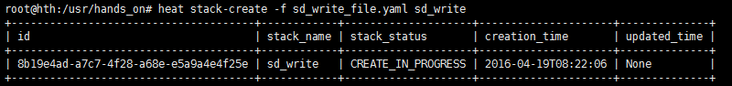

1. List resources of stack

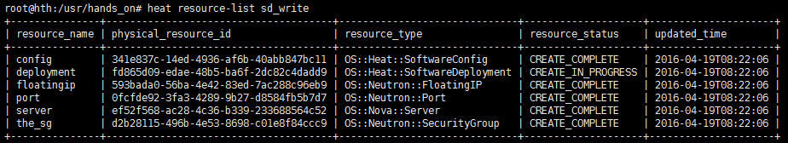

1. Show nova server

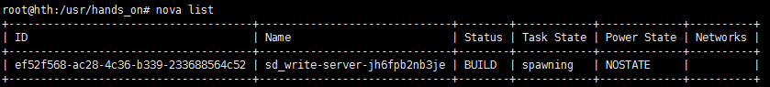



1. Show the software deployment

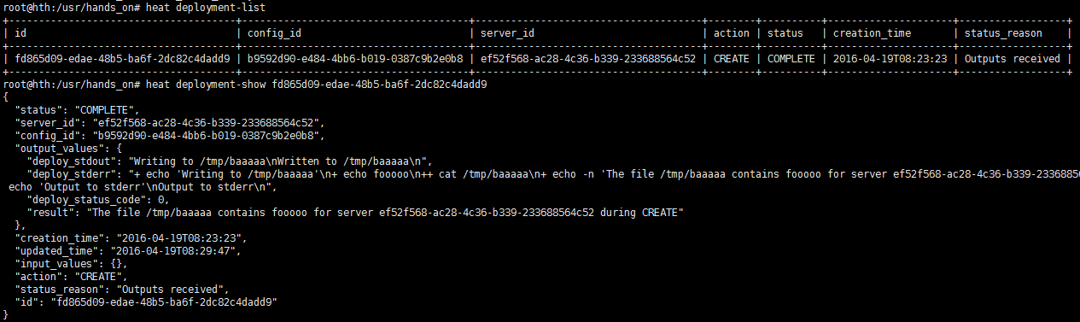

1. List stack

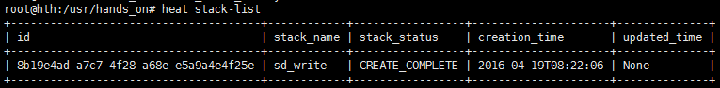

1. Ssh to the server with keypair

