Comprehensive Analysis Report - RIS Files
Report Date: 2026-08-26 05:37:16
Source Folder: E:\paper8\002_Duplicated_Remove_output
RIS Files Processed: 1
- - unique_records.ris

1. Executive Summary
Total Records | 1644
With DOI | 1644 (100.0%)
With Abstract | 1194 (72.6%)
Relevant Abstracts | 13 (0.8%)
With Citations | 0 (0.0%)
Total Citations | 0
Average Citations | 0.00
Year Range | 2005 - 2026
With DB Field | 0 (0.0%)
Number of Sources | 8

2. DB Field Analysis
DB Value | Count | Percentage (%)
No DB Field | 1644 | 100.0

3. Source/Database Breakdown
Source | Records | With Abstract | Percentage (%)
MDPI | 780 | 778 | 47.4
Other Publisher | 440 | 324 | 26.8
Elsevier | 197 | 0 | 12.0
Springer | 83 | 58 | 5.0
Nature | 54 | 32 | 3.3
IEEE | 48 | 0 | 2.9
Taylor & Francis | 40 | 0 | 2.4
Science | 2 | 2 | 0.1

4. Field Structure Analysis
Total fields detected: 98
Field Code | Records | Percentage (%)
TY | 1644 | 100.0
TI | 1644 | 100.0
DO | 1644 | 100.0
DB | 1644 | 100.0
AU | 1634 | 99.4
PY | 1616 | 98.3
JO | 1546 | 94.0
AB | 1194 | 72.6
10 | 1 | 0.1
11 | 1 | 0.1
12 | 1 | 0.1
13 | 1 | 0.1
14 | 1 | 0.1
15 | 1 | 0.1
16 | 1 | 0.1
17 | 1 | 0.1
18 | 1 | 0.1
19 | 1 | 0.1
20 | 1 | 0.1
21 | 1 | 0.1
22 | 1 | 0.1
23 | 1 | 0.1
24 | 1 | 0.1
25 | 1 | 0.1
26 | 1 | 0.1
27 | 1 | 0.1
28 | 1 | 0.1
29 | 1 | 0.1
30 | 1 | 0.1
31 | 1 | 0.1
32 | 1 | 0.1
33 | 1 | 0.1
34 | 1 | 0.1
35 | 1 | 0.1
36 | 1 | 0.1
37 | 1 | 0.1
38 | 1 | 0.1
39 | 1 | 0.1
40 | 1 | 0.1
41 | 1 | 0.1
42 | 1 | 0.1
43 | 1 | 0.1
44 | 1 | 0.1
45 | 1 | 0.1
46 | 1 | 0.1
47 | 1 | 0.1
48 | 1 | 0.1
49 | 1 | 0.1
50 | 1 | 0.1
51 | 1 | 0.1
52 | 1 | 0.1
53 | 1 | 0.1
54 | 1 | 0.1
55 | 1 | 0.1
56 | 1 | 0.1
57 | 1 | 0.1
58 | 1 | 0.1
59 | 1 | 0.1
60 | 1 | 0.1
61 | 1 | 0.1
62 | 1 | 0.1
63 | 1 | 0.1
64 | 1 | 0.1
65 | 1 | 0.1
66 | 1 | 0.1
67 | 1 | 0.1
68 | 1 | 0.1
69 | 1 | 0.1
70 | 1 | 0.1
71 | 1 | 0.1
72 | 1 | 0.1
73 | 1 | 0.1
74 | 1 | 0.1
75 | 1 | 0.1
76 | 1 | 0.1
77 | 1 | 0.1
78 | 1 | 0.1
79 | 1 | 0.1
80 | 1 | 0.1
81 | 1 | 0.1
82 | 1 | 0.1
83 | 1 | 0.1
84 | 1 | 0.1
85 | 1 | 0.1
86 | 1 | 0.1
87 | 1 | 0.1
88 | 1 | 0.1
89 | 1 | 0.1
90 | 1 | 0.1
91 | 1 | 0.1
92 | 1 | 0.1
93 | 1 | 0.1
94 | 1 | 0.1
95 | 1 | 0.1
96 | 1 | 0.1
97 | 1 | 0.1
98 | 1 | 0.1
99 | 1 | 0.1

5. Abstract Quality Analysis
Abstracts were checked for relevance by comparing word overlap with titles and keywords.
Status | Count | Percentage (%)
Has Abstract | 1194 | 72.6
Relevant | 13 | 0.8
Potentially Irrelevant | 1181 | 71.8
No Abstract | 450 | 27.4

6. Top 10 Most Cited Articles
No citation data available.

7. Visual Analysis
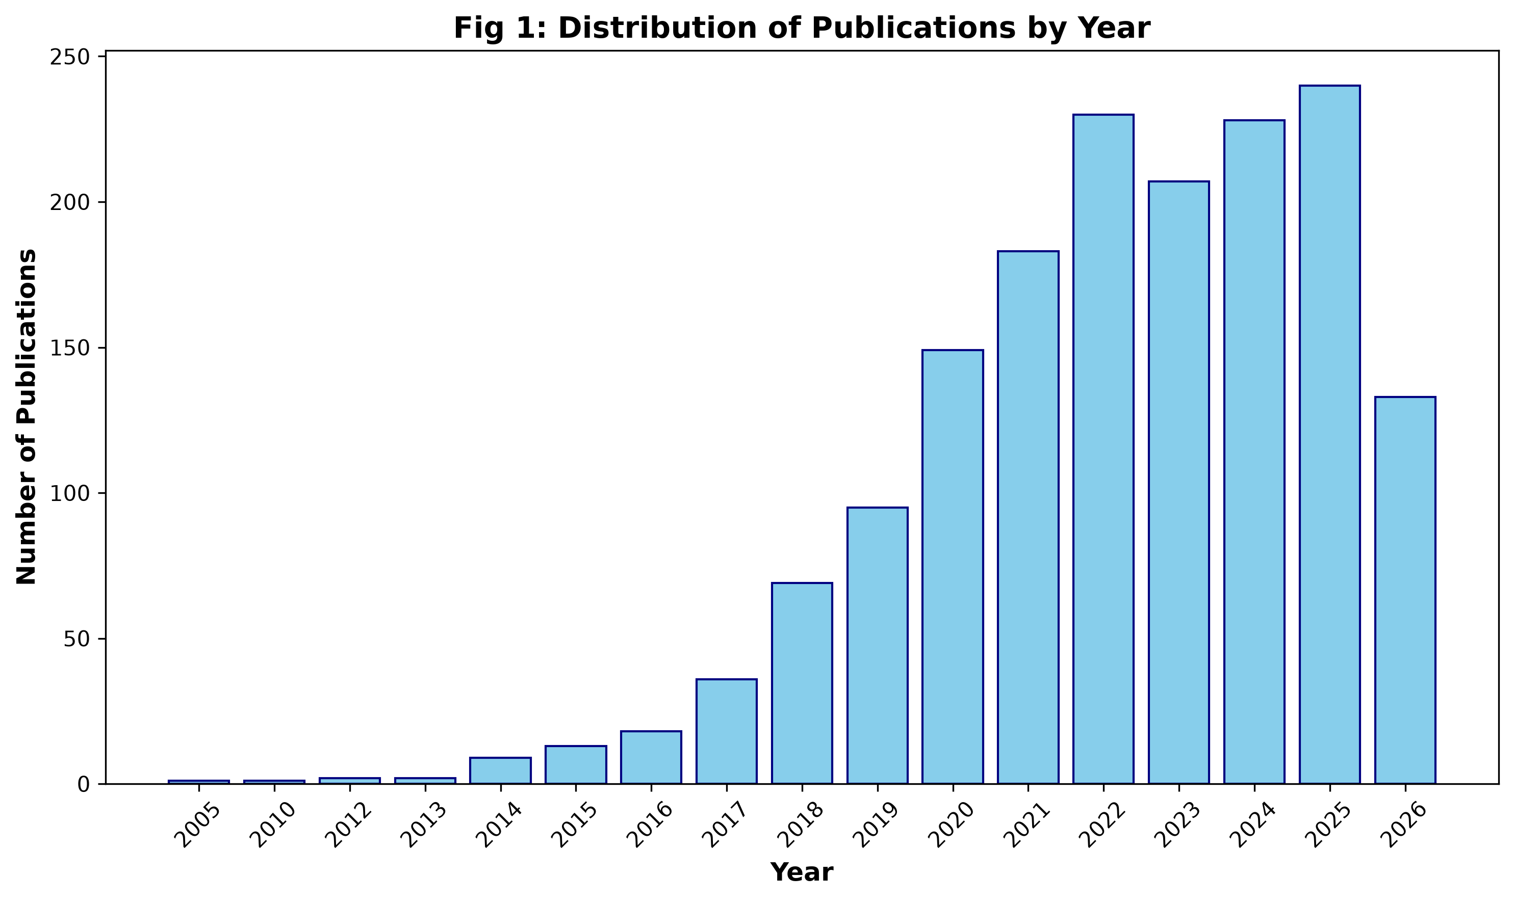

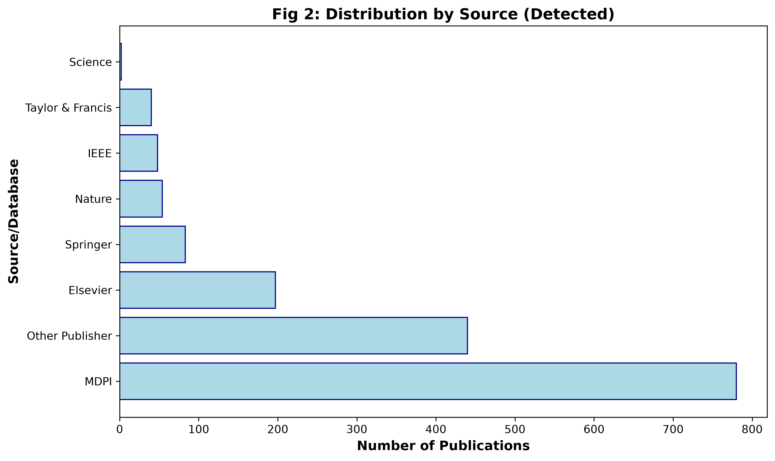

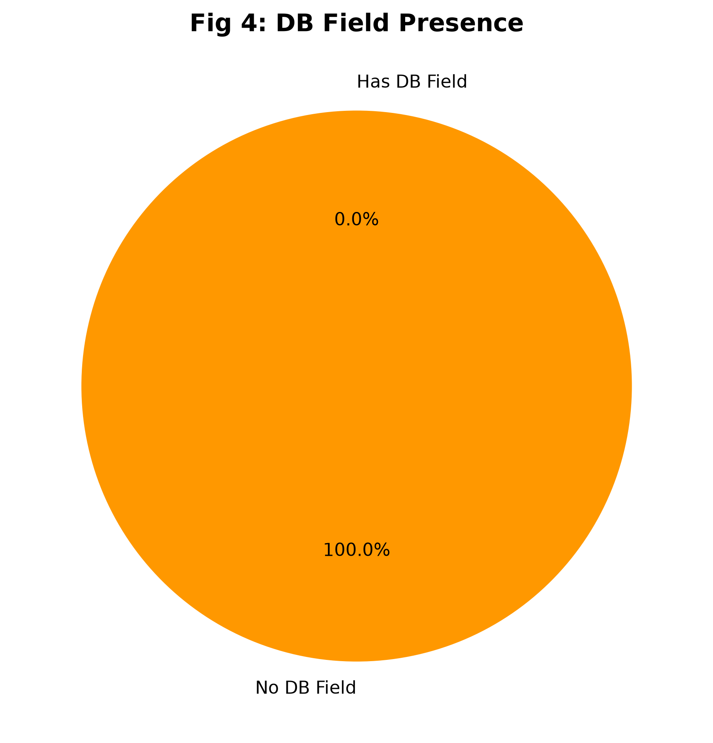

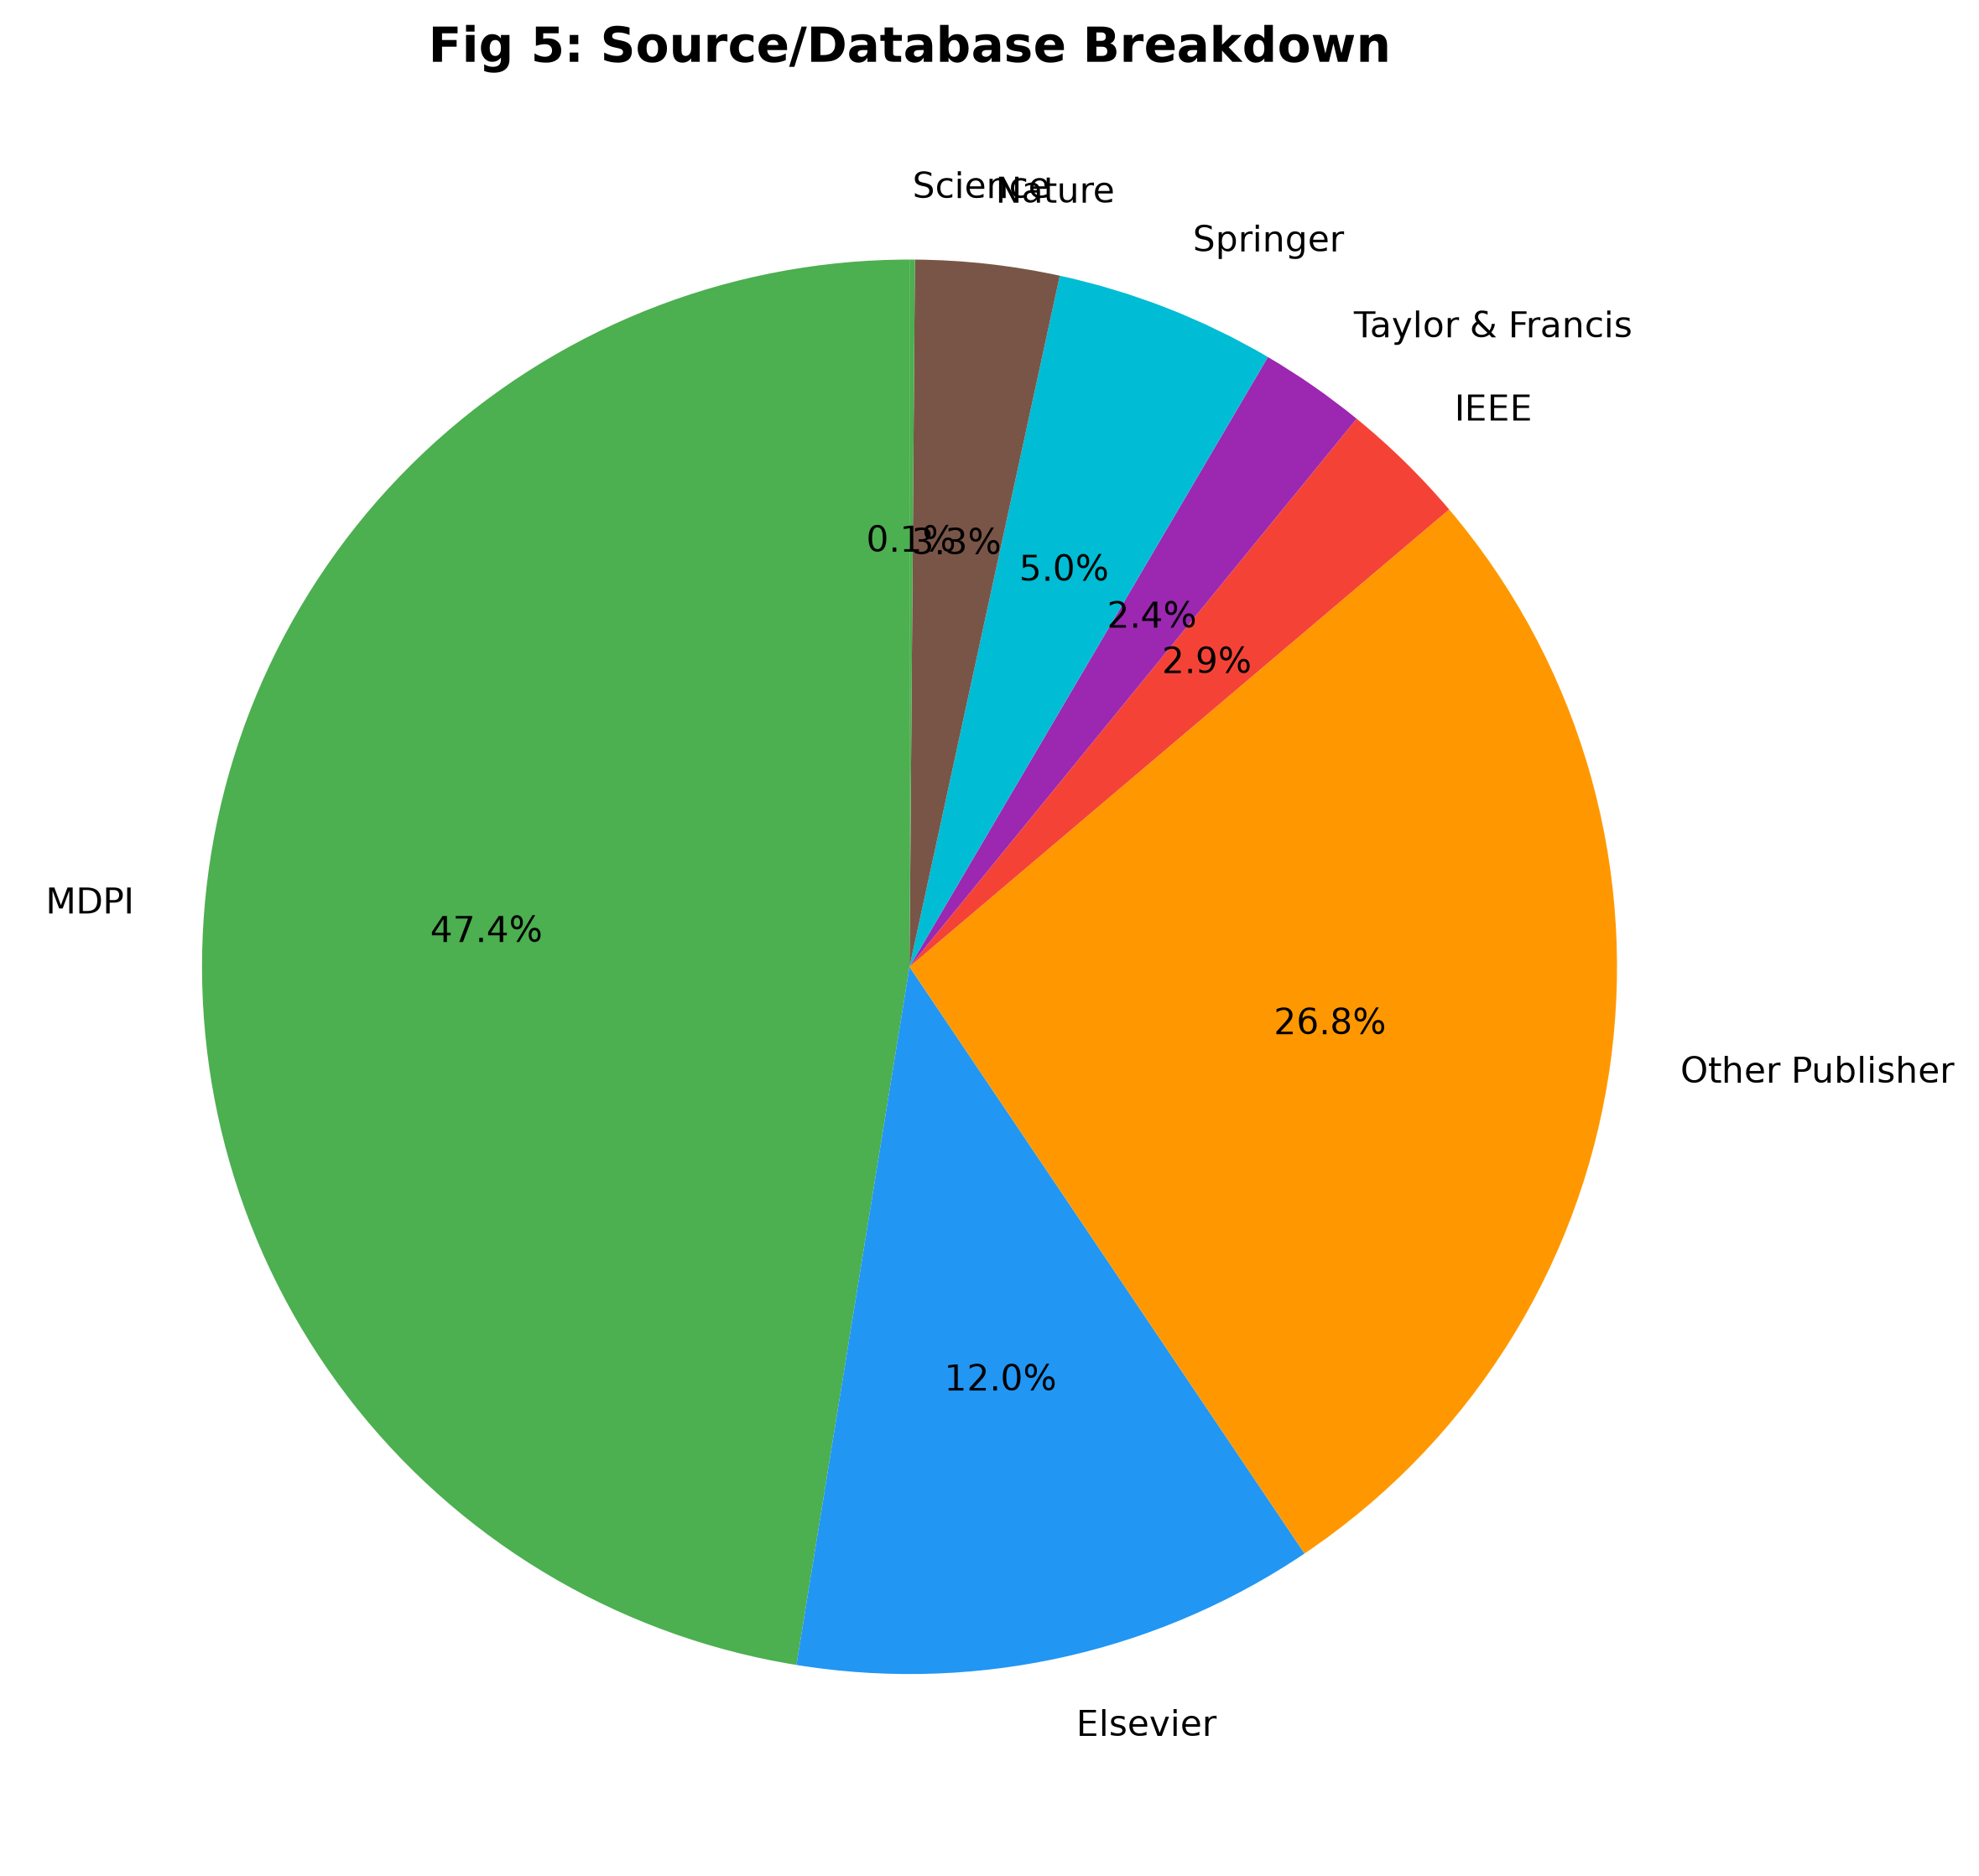

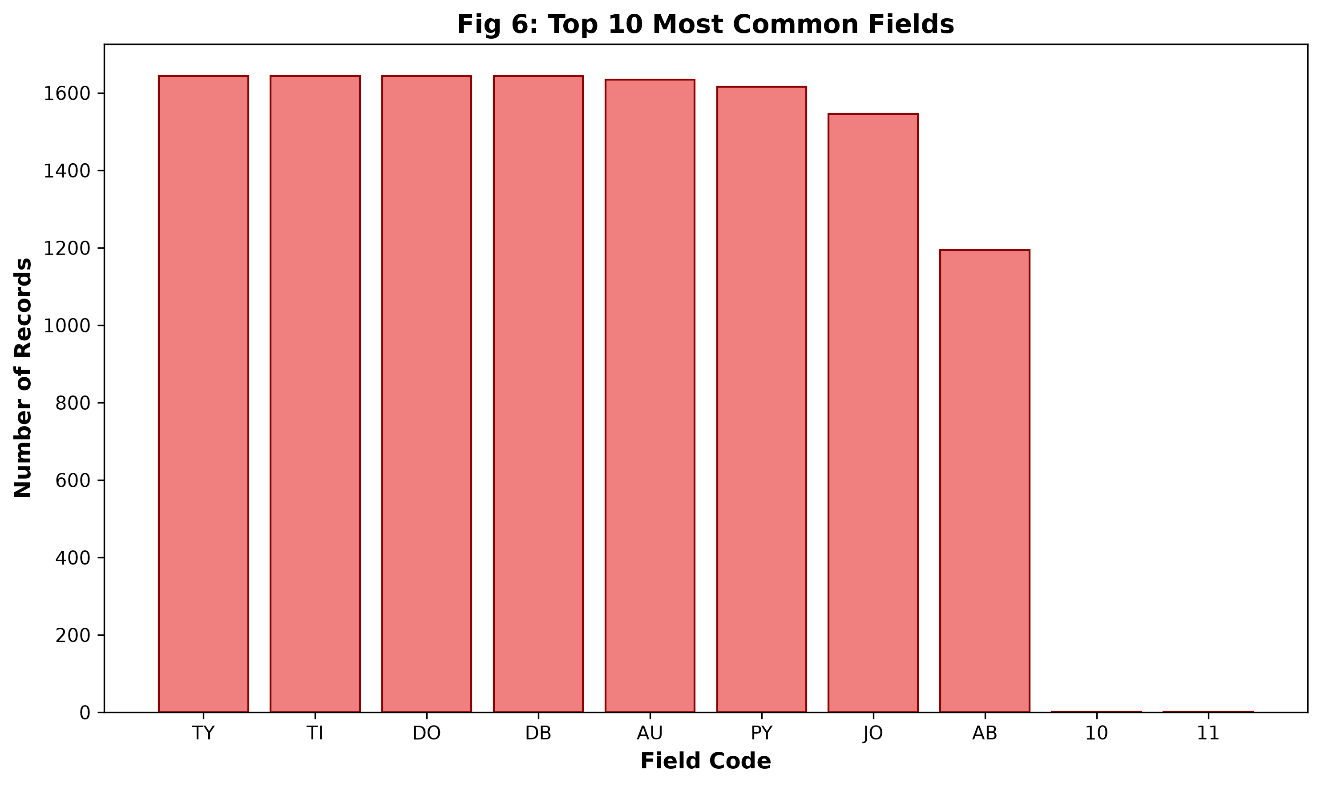

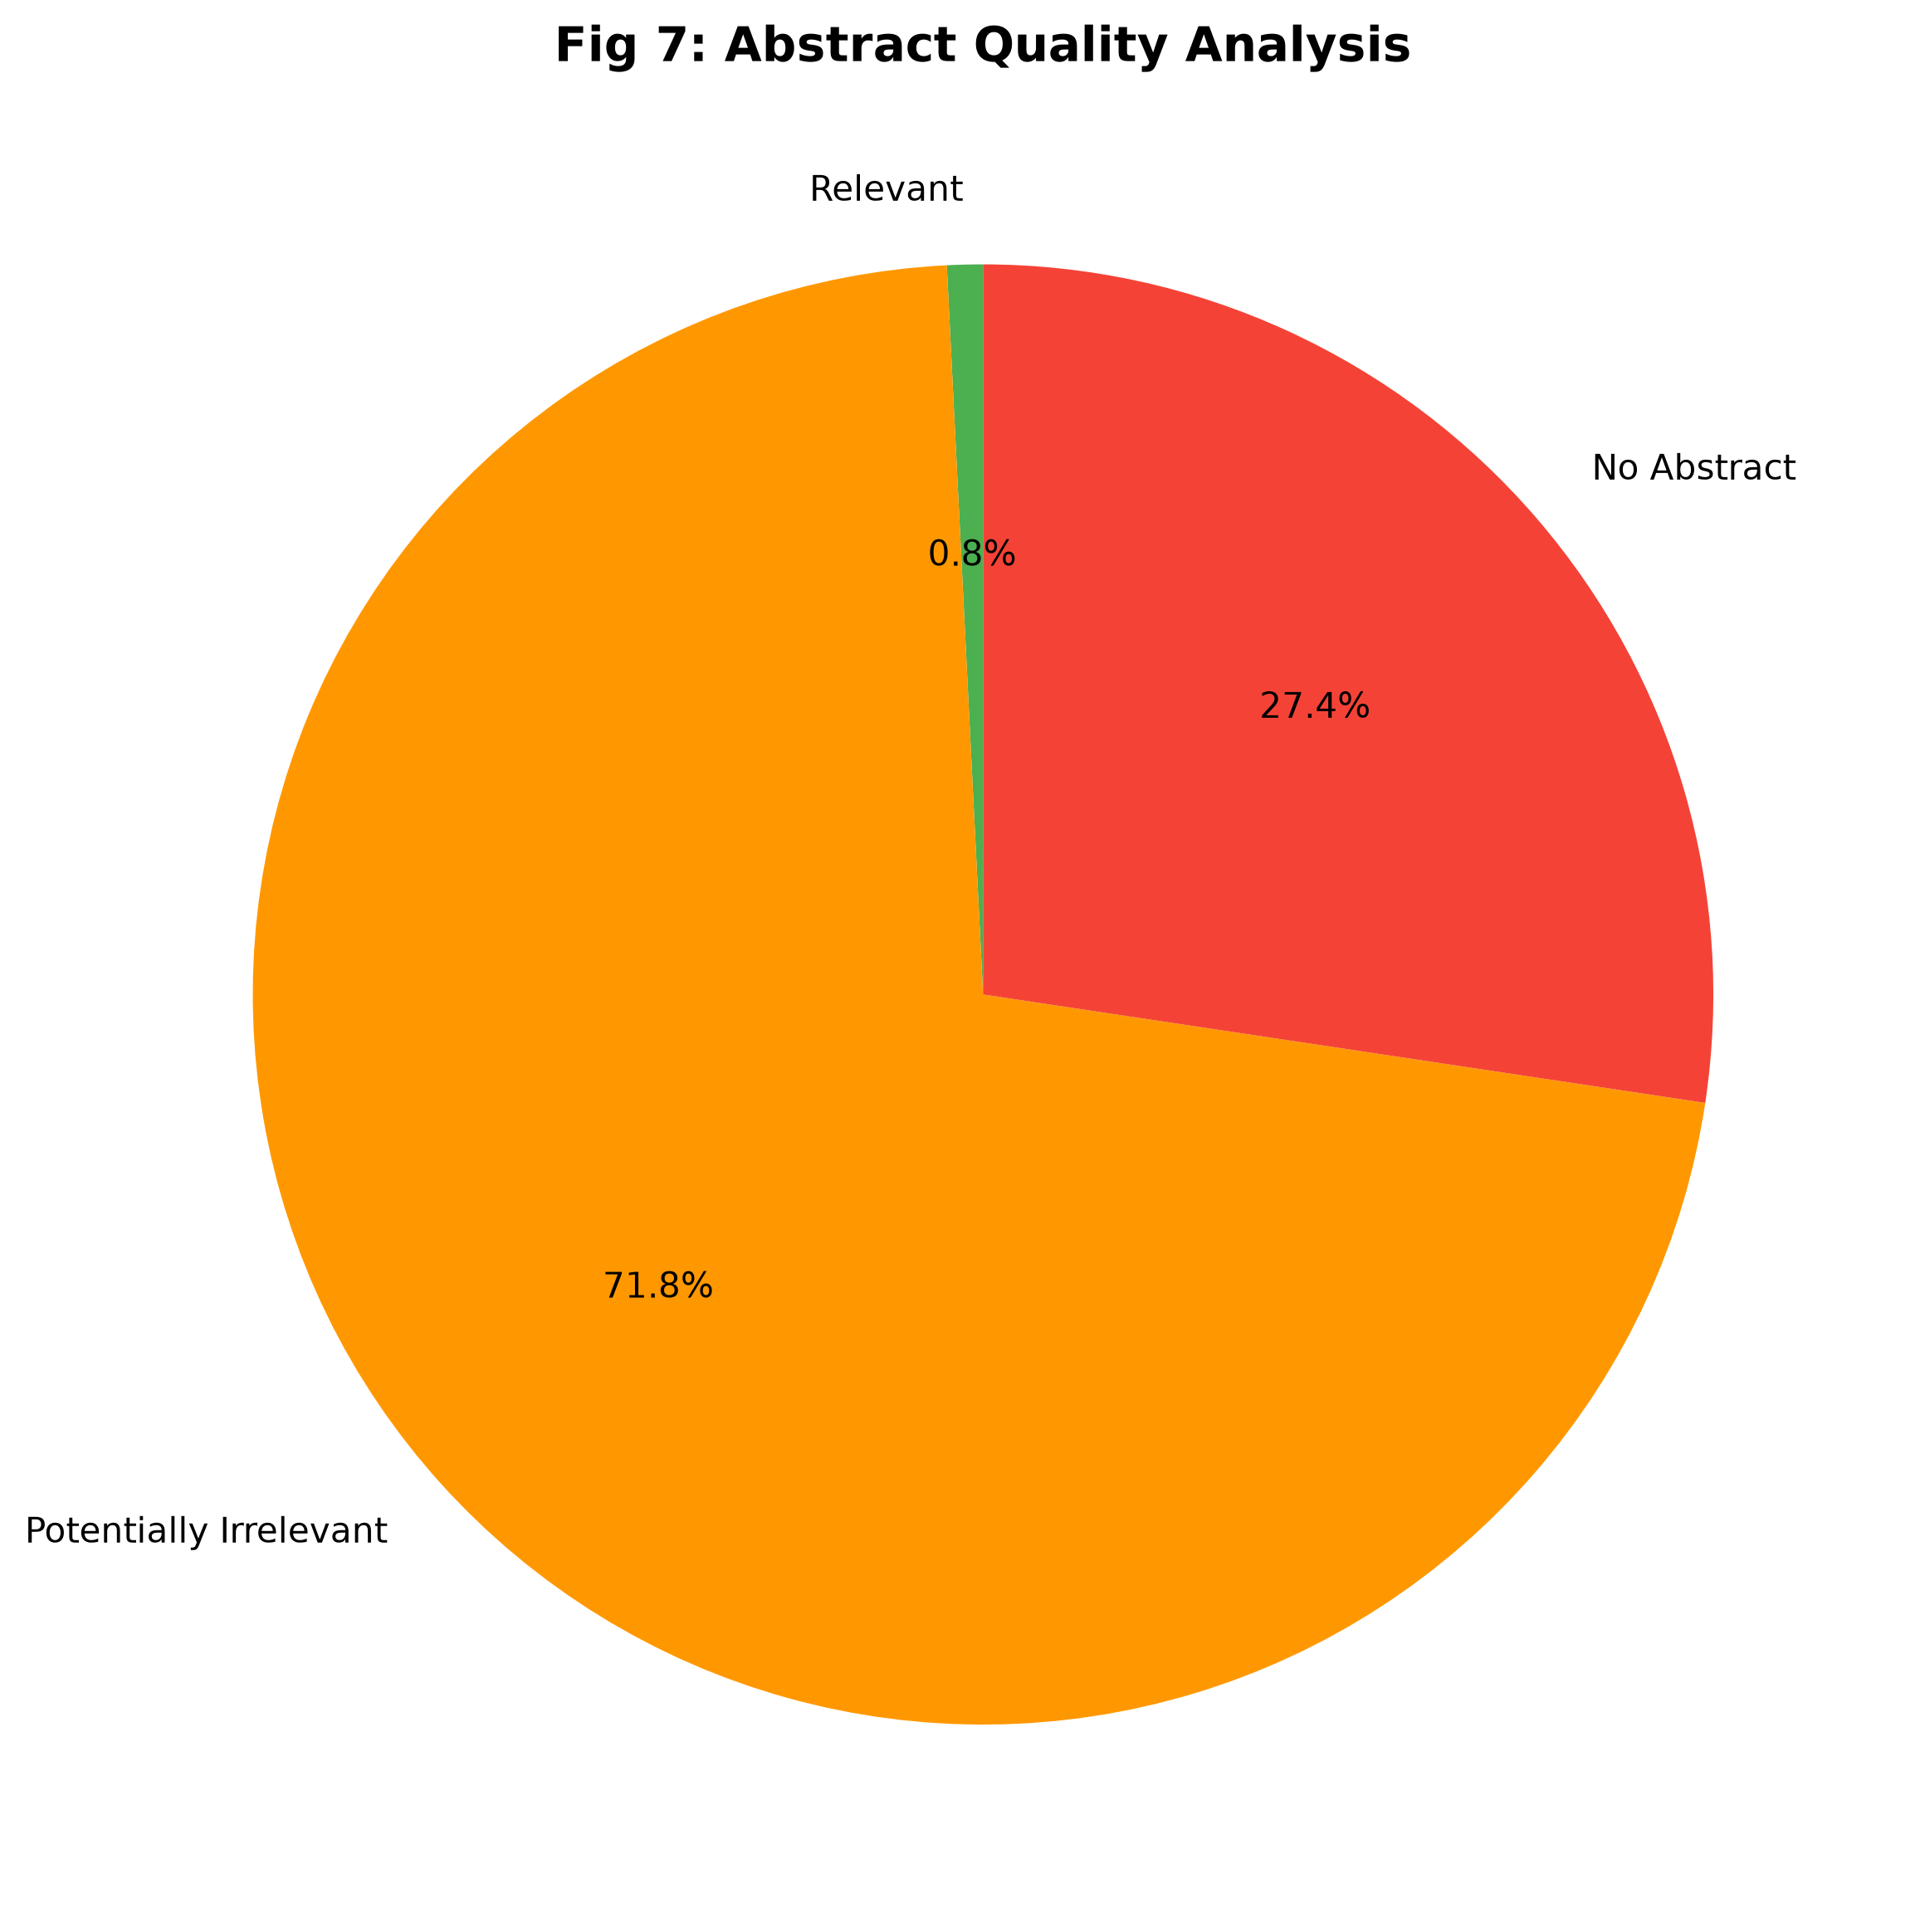

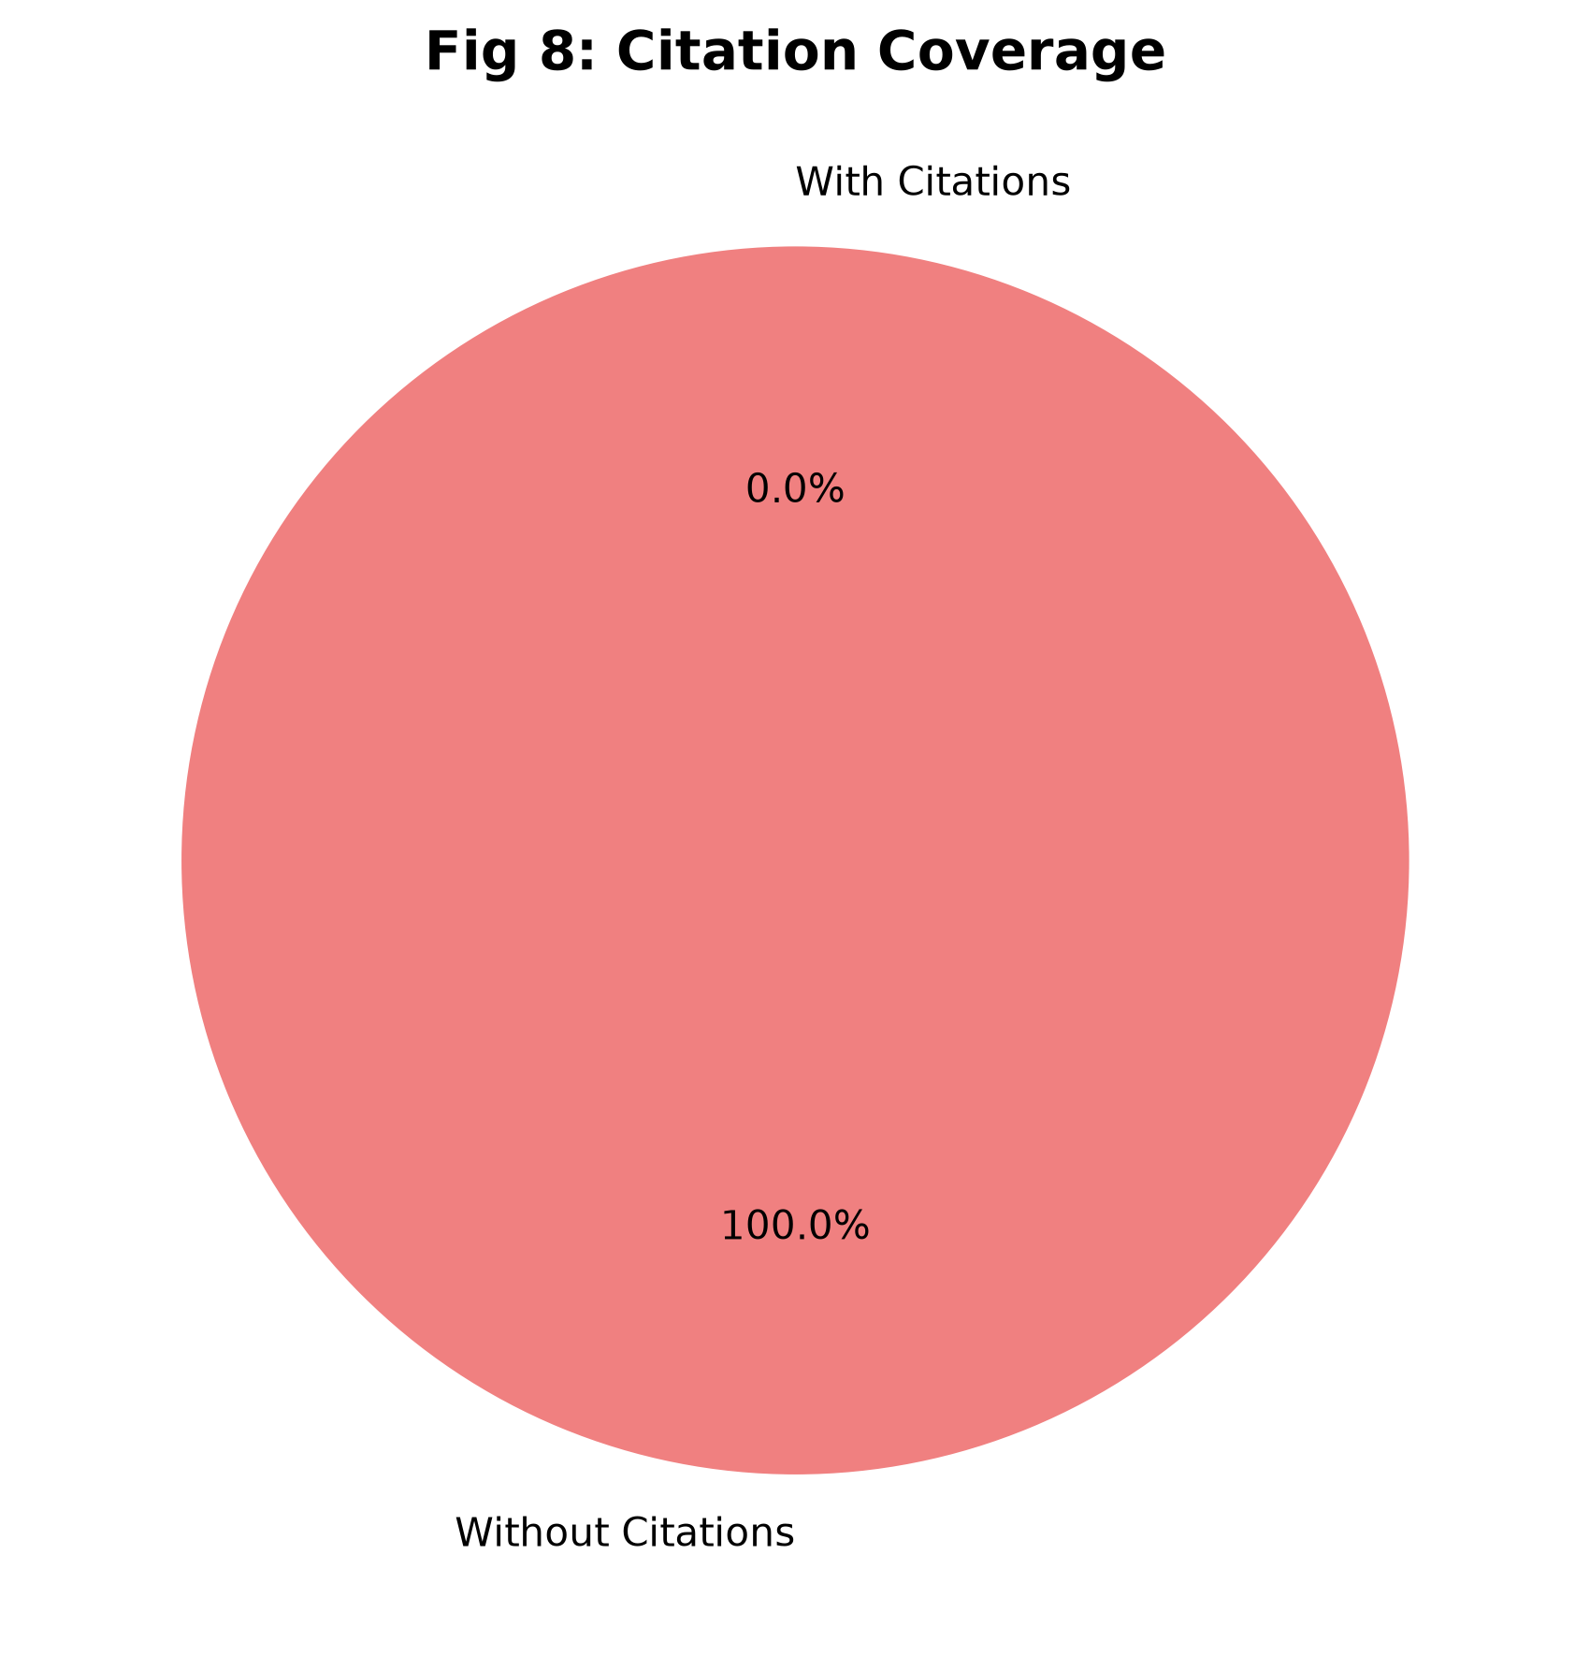

8. Output Files
The following files have been generated:
- 1. records_with_db.ris - Records that have DB field
- 2. records_without_db.ris - Records without DB field
- 3. summary_statistics.csv - Tabular summary
- 4. source_breakdown.csv - Source breakdown

9. Methodology
Analysis was performed using the following methods:
- 1. DB field detection: Records are checked for existing DB field
- 2. Source detection: Based on DOI prefix patterns and URL indicators
- 3. Dynamic field detection: All fields are identified automatically
- 4. Abstract quality check: Word overlap similarity between Title-Abstract and Keywords-Abstract
- 5. Citation analysis: Distribution and statistics of citations

